PRESS RELEASE 12 January 2024

Design Team Appointed for next phases of Trinity Wharf project.

Wexford County Council have appointed Ayesa (formerly ByrneLooby) as the Design and Construction Services provider for the next phases of the Council’s flagship urban regeneration project at Trinity Wharf in Wexford Town with works to start on site by Q4 2024.
The transformational project is being funded under ‘Call 2’ of the Urban Regeneration and Development Fund (URDF) which has been established to part-fund projects aimed at enhancing urban areas to make them more attractive places in which to live, work, visit and invest. The URDF aims to facilitate a greater proportion of residential and commercial development, supported by infrastructure, services and amenities, within the existing built-up areas of larger urban settlements.
The 10-acre Trinity Wharf project is central to Wexford County Council’s ambitious plans to attract foreign direct investment and high-quality employment opportunities to County Wexford. With overall project investment estimated at €120 million, including more than €24 million of public investment, the huge regeneration project is central to the long-term regeneration and enhancement of Wexford town and environs by creating a new urban quarter for the south of Wexford town with new links to the Crescent and town centre, as well as improving access to the waterfront.
The Council acquired the site in 2016 and prepared a masterplan and preliminary designs for the creation of a high-quality mixed-use development of modern office space, hotel accommodation, multi-storey carparking, a landmark cultural and events multi-use building together with dozens of residential units, a new marina and a boardwalk linking Trinity Wharf to Paul Quay and the Crescent.
Speaking at the announcement, Cathaoirleach of Wexford County Council, Councillor John Flemming described the appointment as a truly significant milestone in Wexford’s economic development. “Today’s appointment of a renowned Engineering and Architectural Design Team means that Wexford County Council’s ambition to develop Trinity Wharf as a multi-use regeneration project of regional scale has taken a significant step in delivering this project for the people of Wexford and further afield. The transformation, regeneration, and redevelopment of Trinity Wharf will have a major positive impact in prosperity and economic activity here in County Wexford and beyond, lifting a central part of the town out of dereliction and providing a first-class public amenity,” said the Cathaoirleach.

Mayor of Wexford Councillor John Hegarty also welcomed today’s announcement. “Regeneration projects such as Trinity Wharf are a rare opportunity to take neglected areas and provide more attractive places in which to live, rest, work, visit, and invest, bringing a benefit the whole community,” said the Mayor. “This is a major multi-use development project that will greatly enhance the quality of life for people in Wexford while taking an under-utilised remarkably situated brownfield site and transforming it to bring opportunity and renewal to an historic part of Wexford Town deserving of a new lease of life” he added.
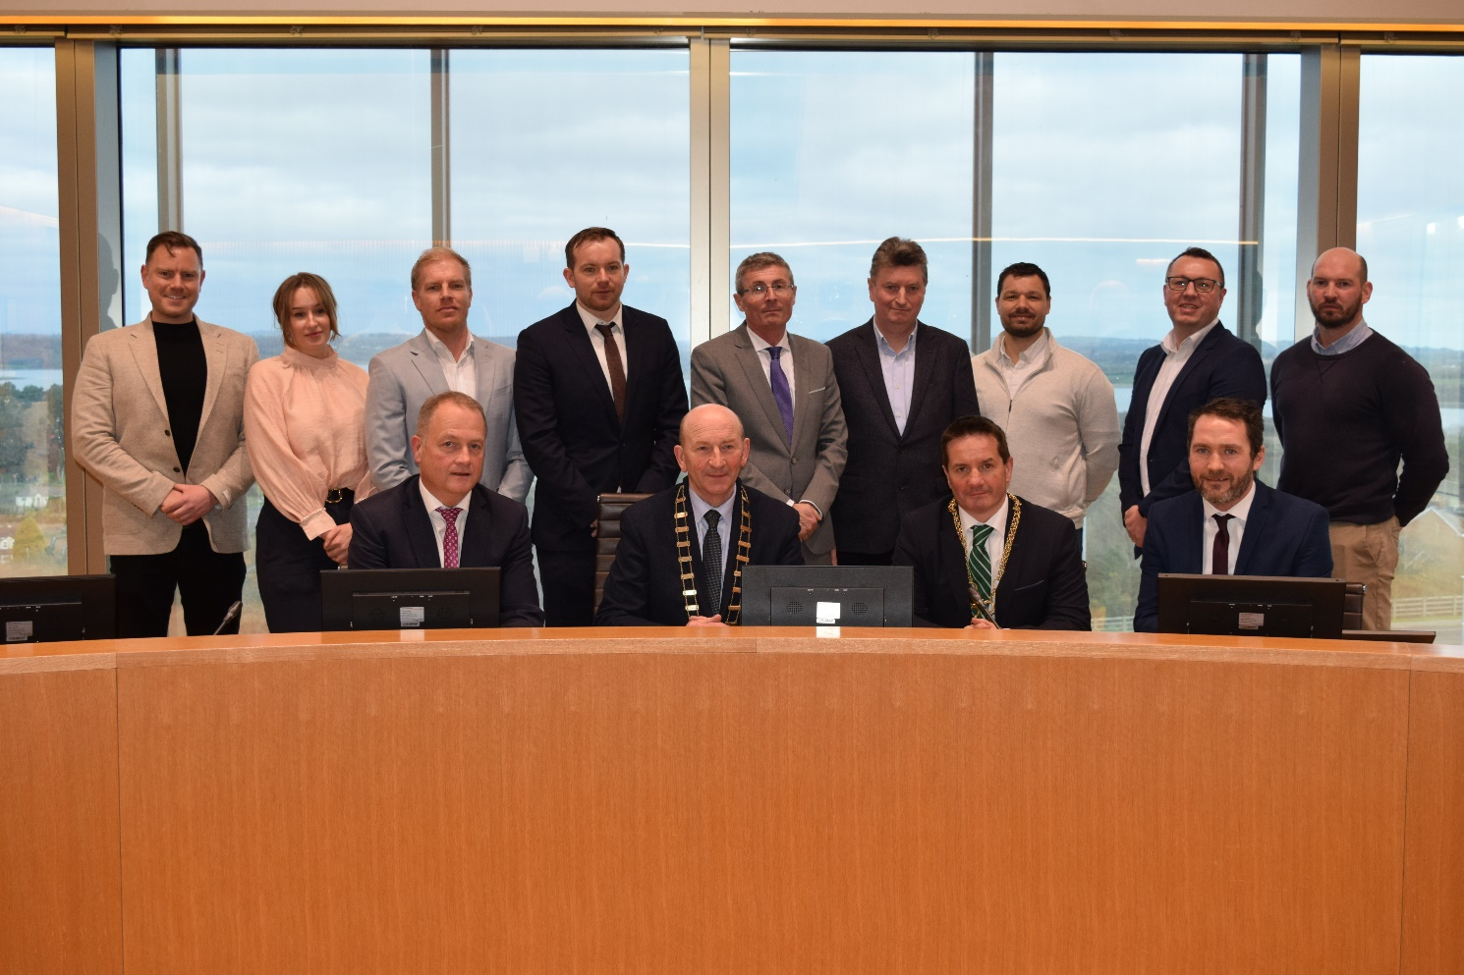
Back row (L to R): Luke O’Connor (Ayesa); Dana Stepanceva (Ayesa); AJ Browne, (AtkinsReális); Eddie Taaffe (WCC); Paul McEvoy (ORHT); Ben Mong (AtkinsReális); Gary Smyth (ORHT); Michael Malone (WCC) Front row (L to R): Tom Enright (Chief Executive, Wexford County Council), Cllr. John Flemming (Cathaoirleach of Wexford County County), Cllr. John Hegarty (Mayor of Borough District of Wexford), Martin Gohery (Ayesa)
Chief Executive of Wexford County Council Mr. Tom Enright described Trinity Wharf as one of the most exciting and ambitious economic developments projects ever proposed in the County.

“Trinity Wharf is a prime example of how the local authority has integrated a diverse set of- economic, social, and recreational needs into a generational opportunity to deliver a progressive and modern multi-use development project that can transform the economic and social landscape of the county,” said Mr. Enright.

Commenting on their appointment, Luke O’Connor Design & Build Lead for Ayesa said "Ayesa, with our delivery partners, is delighted to play a crucial role in the regenerative project for Wexford town. Beyond designing and constructing sustainable structures, our involvement aims to craft a sustainable legacy for businesses, the town, and its citizens. We take pride in being part of this significant development, working in close partnership with Wexford County Council and all stakeholders to ensure positive impacts for generations to come.”
ENDS

Note for Editor

The URDF projects were chosen after a rigorous assessment process, overseen by a project advisory board consisting of Government departments, State agencies and national and international experts in areas such as building, architecture and planning.

In total, the department received 76 project proposals. Each local authority submitted at least one application.

All selected projects support the National Planning Framework’s ‘national strategic outcome’ of compact growth, a particular focus of the second call for URDF proposals.

Trinity Wharf is a phased project. Phase 0 is the foundational phase currently under construction. Phase 0 is integrated with the overall project, focused on providing access and utility connections from the existing public realm to the new development. After Phase 0 is complete, the next Phases 1-3 will deliver the main elements of Trinity Wharf.

Ayesa are the Design Team lead and their delivery partners include AtkinsReális and O'Reilly Hyland Tierney & Associates (ORHT), whose representatives also attended the Contract Signing.

