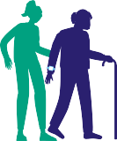

 

**Healthy Age**

**Friendly Homes**

Pilot Evaluation

**Executive Summary**

**Report**



###### Table of Contents

Minister foreword 4

Acknowledgements 6

1. Background 7
2. Themes 13
3. Research Findings 18
4. The Voice of Older People 27
5. Case Studies 30
6. Key Recommendations & Pathway to Phase 2 37
7. Appendix 40

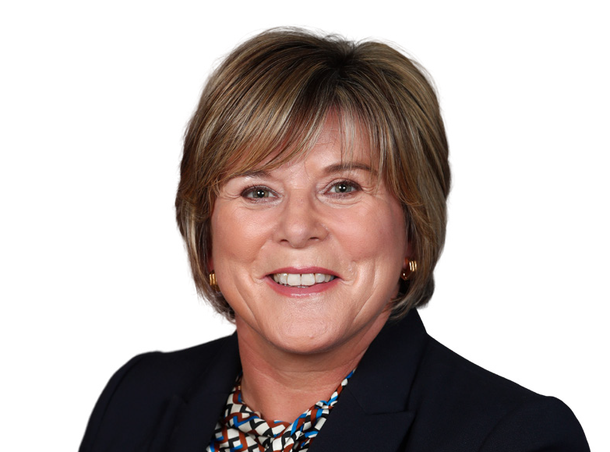**Forewords**

Minister Mary Butler TD

Minister of State in Department of Health with responsibility for Mental Health and Older People.

Older people want to age well in the comfort of their own homes and communities, and it is important that the supports they need to do so are in place. Building on the significant

increases of recent years, our investment in older persons services, including residential care and home support services, have seen a 30% increase in funding since 2020. This brings our overall investment in older persons’ services to over €2.6 billion in 2024.

I am committed to ensuring the provision of high-quality, person-centred, and integrated health and social care services. It is important that we implement such supports for older people in keeping with Sláintecare’s vision, to deliver the right care, in the right place, at the right time.

The Healthy Age Friendly Homes programme is one such initiative which is helping us achieve this vision. Having overseen its development from an initial pilot across nine sites in 2021, to a full national rollout in 2024, I am delighted to present this pilot evaluation report.

Research conducted by Maynooth University outlined in this report demonstrates the positive improvements the programme has achieved in older peoples’ quality of life, self- reported health status, loneliness, social supports, self-efficacy, and functional ability.

Importantly, the voice of the older person is present throughout, and highlights the person- centred approach the programme takes in all aspects of supporting older people to live independently.

Fundamental to the success of the programme has been the active collaboration between the Department of Health and other government departments and agencies, including the Department of Housing, Local Government and Heritage, the HSE, Local Authorities, and the Sustainable Energy Authority of Ireland (SEAI), in addition to the relationships established with local care teams.

Healthy Age Friendly Homes is a wonderful example of Sláintecare in action, working across multiple sectors and government departments to deliver a truly person-centred care programme that tailors supports to the needs of each person.



**Mary Butler TD**

Minister Alan Dillon TD

Minister of State with responsibility for Local Government and Planning, Department of Housing, Local Government and Heritage.

The Healthy Age Friendly Homes Programme represents a new way of working to support ageing in place, thereby addressing the strategic objectives set out in the Programme for Government and its vision for an Age Friendly Ireland.

Healthy Age Friendly Homes was established as a unique model of support co-ordination that demonstrates innovation in the integrated nature of the service, bringing together health and housing to deliver a bespoke model of service provision that responds directly to consultation with older people on their needs and preferences. The model exemplifies excellence in public services by fostering an integrated approach among local government, health, and community services. It works cross-sectionally to achieve the policy objectives of several government departments.

The policy context for delivery of Healthy Age Friendly Homes is Housing for All, specifically Pillar 2, which sets out to increase the housing options available to older people to facilitate ageing with dignity and independence, including an emphasis on rightsizing and health supports for ageing in place.

Healthy Age Friendly Homes has great potential to be a major component in the broader strategy to prepare society for the projected increase in the older demographic.

I commend Meath County Council and Age Friendly Ireland Shared Service for hosting this innovative programme, and all 31 Local Authorities for their critical participation in the delivery of this service.



**Alan Dillon TD**

###### Acknowledgements

This report was written by:

Dr Adrienne McCann

Principal Investigator,

Innovation Value Institute, Maynooth University

Acknowledgements

The authors would like to thank all who agreed to partake in the research and be interviewed and sharing their views.

In the first instance, on behalf of Chief Executive Kieran Kehoe, host of the Age Friendly Ireland Shared Service, and Sláintecare in the Department of Health, we offer deepest thanks to Minister of State for Mental Health and Older People, Mary Butler TD and Minister of State for Local Government and Planning, Alan Dillon TD, for their continued support, time, and encouragement.

Sincere thanks are also extended to members of the National Oversight Group and the Evaluation Sub Committee for their guidance, support, and leadership. A special thank you to all the people involved in the compilation of this final report. Their enthusiasm, integrity and goodwill are reflected in this excellent piece of work.

National transformative programmes that extend across a number of sectors require strong leadership and in that regard we would like to acknowledge the key partners and

contributors for agreeing, at strategic level, to embark on this cross-departmental innovative programme including the County and City Management Association (CCMA), Chief Executives of the 10 host Local Authority Programme areas – Cork County Council, Dublin City Council, Fingal County Council, Galway City Council, Galway County Council, Limerick City & County Council, Longford County Council, South Dublin County Council, Tipperary County Council and Westmeath County Council. We would also like to acknowledge the immense support provided by the Directors of Services and their staff in each of these local authorities for their unwavering support through the implementation phase to date.



•

I I

1

I

I

•

I;i,.

**1**

## Background

#### I

I

? **11** •

I I

Healthy Age Friendly Homes is a new support co-ordination service designed to enable older people to remain living in their own homes and to reduce the need to transfer to long- term residential care. The service is delivered directly by Local Government with funding from the Department of Health, as it supports the Sláintecare objectives of facilitating early intervention, reducing demand on acute services, and delivering the vision of the right care, at the right place, at the right time, by the right team.

Funding for a pilot programme was approved by Sláintecare in December 2020 and following an accelerated development process, including a thorough and open recruitment process, Phase 1 of the Programme was fully operational by May 2021.

During Phase 1, local coordinators were based in nine local authority sites around the country and worked within those catchment areas. **The nine pilot sites included: Dublin City, Fingal, South Dublin, Longford, Westmeath, Tipperary, Galway City and County, Limerick City and County and Cork County.**

The local coordinators undertake home visits to older people living in the community and conduct assessments aligned to the four domains of housing, health, community/social supports, and technology to aid ageing in place.

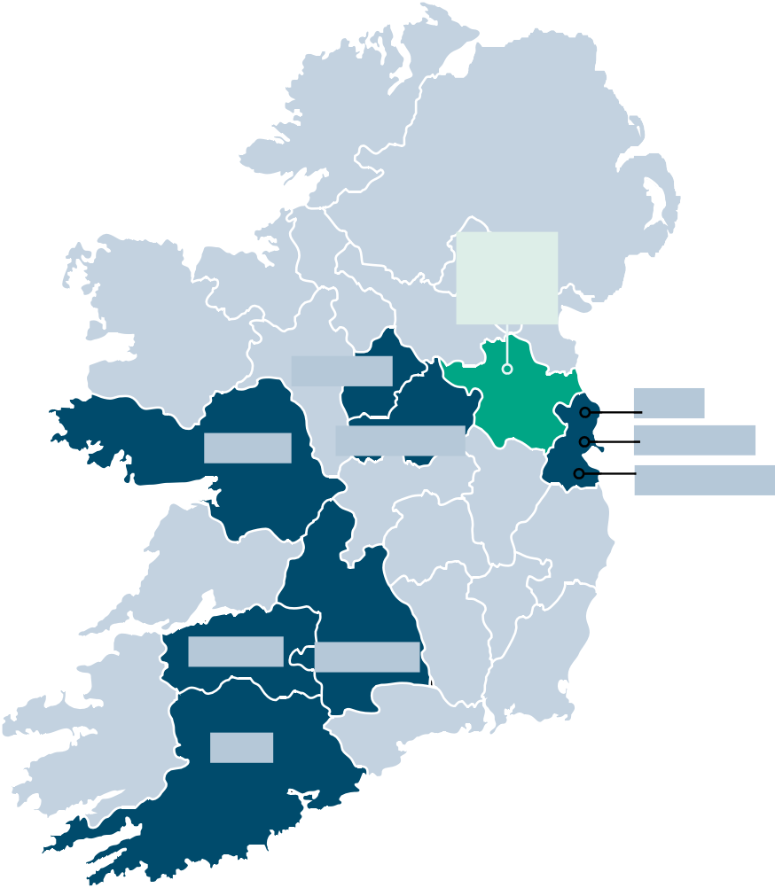The coordinators agree a personal plan with each individual older participant and support them to access a range of services which include

housing adaptation grants, home energy improvements, healthcare appointments, befriending and community services, or technology supports.

The Programme collaborates with a

broad spectrum of agencies and services, including personnel in Local Government, health and social care services, transport, community and voluntary groups, Gardaí, elected members, and others.

**Galway**

**Longford**

**Westmeath**

**Meath: Shared Services**

**Fingal Dublin City**

**South Dublin**

**Limerick Tipperary**

**Cork**

**Healthy Age Friendly Homes has four key aims:**



**1**

**2**

**3**

**4**

Enable older people to continue living in their homes or in a home more suited to their needs

(Rightsizing)

Live with a sense of

independence

and autonomy

Be and feel part of their

Community

Support the avoidance of early or premature admission to long term

residential care

Policy Context

Ireland has the fastest ageing population in the EU. 40% of the population is now aged over 45, and the over 65 population grew by 35% between 2013 and 2022 – nearly double that of the EU average. The population is also predicted to live longer, resulting in increased prevalence of chronic illness, multi-morbidity and a greater demand on health and social care services.

Evidence points to the fact that the majority of older people desire to remain independent and living in their own home for as long as possible. Independent living has been associated with an increased sense of self-reliance, self-esteem and self-management. Supporting older people to live independently at home has also been associated with reduced hospitalisations and their associated costs. Research suggests that housing conditions, such as colder or older homes, may contribute to poorer health outcomes in older populations.

Increasing evidence points to improvements to the built environment, through home modifications, contributing greatly to a reduced need for carer support.

These demographic and environmental challenges, as well as the predicted savings associated with supporting older people at home are key drivers in health and housing policy. Government policy is to ‘*support older people to live in their own home with dignity and independence, for as long as possible*’. This is a key commitment of the Programme for Government and is aligned with the Sláintecare vision of providing quality and safe care closer to home. Through its focus on social inclusion and improving housing options for older people, Healthy Age Friendly Homes is also aligned with Housing for All, and the joint policy statement Housing Options for Our Ageing Population. It also contributes to the Government’s Climate Action Plan through its partnership with the Sustainable Energy Authority of Ireland (SEAI). The programme’s approach is also informed by the WHO’s Housing and Health Guidelines.



Female

Male

**40%**

**3,273** Home Visits

**6,908**

Supports Delivered

Pilot Programme Timeline

**2023**

**MAR**

**2021**

**JUN**

**60%**

###### Pilot Programme Overview & Participant Profile

Self-Referral into the Programme

**46%**

**2,133** Participants

**77**

**103**

Average Age

Age of Oldest Participant

**Housing Conditions & Living Arrangements**

* **37%** of programme participants report that they live with a significant other/partner while just over half of participants live alone.
* **11%** of programme participants live in their own home with another family member and

**1%** reported “other” living arrangements.

* **74%** of programme participants own their own home.
* **19%** reside in Local Authority / social housing.
* **4%** of participants are private tenants.
* **3%** reported “other” housing.

Two thirds of participants reported living in an urban area (defined as either part of a town, city, or peri-urban). The remaining third live in a rural area (defined as living on the outskirts of a town, in a village or a remote area).

**5%**

**19%**

**25%**

**11%**

**21%**

**16%**



**5%**

**24%**

**17%**

**54%**

Semi detached Bungalow Detached

End of terrace Mid terrace Apartments*

**The majority of homes were 3-bedroom properties:**

 1 Bed

 2 Bed

 3 Bed

4 Bed +

*\*varying between ground, mid and top floor apartments*.

In relation to heating of the home the following findings were made:

of participants who have an immersion tank do not have any insulation on the tank.



**9%**

**77%** of immersion tank owners have a lagging jacket.

**14%** have factory fitted insulation installed on their immersion tank.





### 74%

receive either electricity or Gas Allowance.

**84%**

have a chimney in their home.

**65%**

use an **electric immersion** for hot water in summer.

**<3.5%**

**7%**

**18%**

**Fuel Types for Heating**

**41%**

**35%**

**17%**

**37%**

**18%**

**Fuel Types for**

**Hot Water**

**31%**

Oil Gas

Solid Fuel Electricity

Oil Gas

Solid Fuel Electricity Solar panels

When asked how possible it is to make ends meet in their home, 34% of participants reported “some difficulty”, with 5.5% of this reporting “great difficulty”.

# 2



## Themes







**6,908** supports have been provided relating to the four key themes: Housing, Health, Community and Technology supports. The majority of supports provided related to Housing.

Housing Health Technology Community

11%

16%

61%

12%

Housing

*“It was nice that someone came to my home. ( ) I felt*

*more, I could think better in my own house. I wasn’t in an office where I didn’t know anybody, and I wasn’t worried about trying to get there and trying to get back.”*

Housing adaptations including Housing Adaptation Grants (HAGs), Mobility Aid Grants (MAGs) and Housing Aid for Older People Grant (HOPs), SEAI grants and BER energy assessments were the

most common areas of need identification in the assessments under the Housing domain.

HAGS

SEAI Grants

HOPS MAGS

Bills Advice

LAAWS

LPT Online Access & Printing SEAI BER Energy Assessment

Maintenance Adaptation Grant

Rightsizing Heating Application

Other Heating / Fuel Panic Button Door Locks Home Alone

27%

27%

24%

21%

11%

4%

4%

3%

21%

20%

7%

6%

4%

4%

2%

1%

1%

0% 5% 10% 15% 20% 25% 30%

Health

Social Welfare Schemes (27%) and contact information and linkages to an Occupational Therapist (25%) were the predominant Health supports provided. The graph below shows seventeen various supports related to Health that the Local Support Coordinator assisted the participant with.

Social Welfare Scheme Occupational Therapist

Primary Care Public Health Nurse Meals on Wheels

Health Information I Quality of Life

Home Help Transport Homecare

GP

Fair Deal Physiotherapist Audiologist Optician Repsite Medical Card

Bed Occupancy / Pressure Mat

12%

11%

10%

9%

8%

6%

5%

4%

2%

2%

2%

2%

1%

14%

17%

25%

27%

0% 5% 10% 15% 20% 25% 30%



*“And I want to say one thing as well, my husband was waiting about 6 years for hearing aids, now it turns out there was a mix up anyway in the thing, but Anne investigated it for us and he has his hearing aids and all now.”*

Community

Introduction to a local community group was the most common community support provided, followed by Befriending services, with library services the third highest support.

Community Group Befriending Service

Library Community Garda Physical Activity

Day Care Alzheimer Society

Education Crime Prevention Community Grants

37%

0% 5% 10% 15% 20% 25% 30% 35% 40%

23%

18%

9%

8%

8%

7%

5%

3%

1%

Technology

Home Technology Aids such as smoke detectors and carbon monoxide alarms accounted for 78% of the technology supports provided to the participants. Assistive Technologies such as Pendant Personal Alarms and Fall Detectors accounted for 21%,

1%



Other

Assistive

21%

78%

Home

and a further 1% recorded as "Other".

Technologies

Technology Aids



*“The most positive I think is the fact in knowing that there is people willing to, to do what you’re doing. That you know that there is support out there,*

*and that there is people interested and involving themselves.”*

Other

30

31

34

155

666

823

1556

Fall Detector

Pullcord

Natural Gas Detector

Pendant/Personal Alarm

Carbon Monoxide Alarm

Smoke detector / alarm

0 200 400 600 800 1000 1200 1400 1600 1800

*“I had support from her and all that yes; and then we sent in the forms and she kept in touch at all times to see, did we hear anything back (…) she offered us a whole lot more. She asked us did we need ‘Meals on Wheels’ or do we need home help or did we need to get in touch with anything, you know, with the doctors or did we need to join any clubs or anything. Oh, she was fairly comprehensive.”*

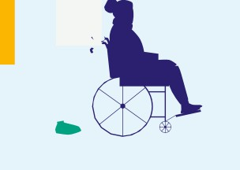

•

I I

•

I

I

I

**3**

## Research Findings

Cl I I

-

##### 11 •

I I

Research participants were drawn from each of the nine local authority areas. The majority (65%) were categorised as urban dwellers (town centre/city/peri-urban) and 35% categorised as rural (outskirts/ village/remote).

Overview of Findings

At baseline, participants presented with moderate to strong overall scores, reporting quite positive levels of quality of life, good levels of health, and showing robust levels of self- reported health. Participants had quite strong abilities to cope with change and stresses in life as well as good social support around them. Beyond these, participants experienced low levels of loneliness and had high levels of self-reported functional abilities.

**The findings show that participant scores improved in 6 of the 7 measurements. The categories where participants showed improvements included:**

* *Self-Efficacy*
* *Quality of Life*
* *Self-Reported General Health Status*
* *Health Status*
* *Social Support*
* *Loneliness*
* *Functional Ability*



*“I recommend it for the simple reason that, you know, people might not know that things like this exist; you know like grants and (….) it’s nice to find out that there are actually bodies out there that are willing to help.”*

The table below presents the summary findings and illustrates how the various measures of health status, wellbeing and activity have developed amongst participants over the period before and after intervention.

|  |  |  |
| --- | --- | --- |
| **Outcome Measure** | **Change** | **Description** |
| **Self-Efficacy** | **↑** | Improved capacity to cope with daily hassles and adapt to stressful life events. |
| **Quality of Life** | **↑** | Increased levels of control, autonomy, pleasure, self-realization. |
| **Self-Reported General ↑** Increased levels of self-reported health status.  **Health Status** | | |
| **Health Status** | **↓** | Slight decrease in state of health. |
| **Social Support** | **↑** | Increased levels of social support. |
| **Loneliness** | **↑** | Positive outcome of reduced levels of loneliness. |
| **Functional Ability** | **↑** | Marginal increase in functional ability. |

Positive improvements were seen across all outcome measures except health status which showed a slight decrease in this ageing cohort. It should be noted here that interviews took place at an approximately 6-month interval, spanning the harsher winter months which would be expected to impact on older peoples’ health. In addition, he slight decline in health status is offset by participants’ self-reported general health status which showed positive improvements. This indicates participants had a more positive outlook on their health status and that they considered themselves healthier than they were 6 months prior.

Overall, these scores illustrate a positive pattern showing that research participants had overall better levels of health and wellbeing at the completion of this research

Self-Efficacy

Support from the HAFH programme had a significant impact on the self-efficacy levels of participants. There was an increase of 4.5% which is evidenced by the improvements in their self-reported ability to achieve goals, overcome difficulties, and cope with unexpected events.

**Participants feel more optimistic about coping with the demands of life at the time of the second interview.**

**Cope with Unexpected Events**

**Overcome Difficulties**

**Achieve Goals**

**All Saw an Increase**

The average baseline self-efficacy score of participants was 30.9. This can be considered a relatively high score. Following intervention, the self-efficacy score was recorded at 32.7.

* Those with ***Higher*** levels of self-efficacy increased by 15% to a total of 78%. This is a very encouraging trend which shows increases in respondents’ self-reported ability to achieve goals, overcome difficulties and/or cope with unexpected events.
* The ***Lower*** self-efficacy group stayed the same, at 3%. This would suggest that there is a minority of participants with an ongoing lower ability to achieve goals, overcome difficulties and/or cope with unexpected events. This may represent a group with potentially more complex needs requiring greater aid in these areas going forward.

 Quality of Life

Participants experienced an increase in Quality of Life measurements of 2.2%, representing higher levels of **Control, Autonomy, Pleasure, and Self-Realisation.**

This can be seen as an overall improvement in the quality of life of participants over the preceding 6 months and a positive trajectory of change.

**All Quality of Life categories improved, meaning participants feel more optimistic about coping with the demands of life at the time of the second interview.**

The average Quality of Life score at baseline was 23 out of a possible 36. Being approximately two-thirds of the potential maximum, this can be considered a positive baseline score.

**Most notably:**

Respondents reported an improved “Sense of fulfilment of their potential” in their lives.

An improvement in how “free from

interference” those surveyed feel.

A small improvement in how “happy” the participants feel.

Participants’ “ability to participate in

their environment” is the lowest measurement.

**Self Realisation**

**Autonomy**

**Pleasure**

**Control**

Self-Reported General Health Status



**Participants considered themselves overall slightly healthier after the 6 months between interviews.**

The average baseline *General Health Status* score self-reported by participants was 66.8 out of 100. At Time 2 this rose to 68.6, an increase of 1.8%.

Health Status



At the beginning of the research project, the average participant’s health status was measured at 9 out of 25.

A score of **5** would show the **best possible health on this scale**, and so this first starting point of 9 can be seen as an indicator of good participant health at the outset of the research project.

**Participant Health Status declined slightly over time, reflecting greater reported problems relating to: Mobility, Usual Activities, Discomfort or Pain, and Anxiety or Depression.**

Whilst the follow-up results proved an overall slight decline in self-reported health status, the scores recorded post-intervention did still prove a resilient and robust level of health.

 Social Support

The level of *Social Support* received by participants increased by 2%.

Importantly, those reporting ***Strong*** levels of Social Supports increased by 9% to a total of 56% of all participants in the six month period.

**Overall levels of social support improved.**

* Specifically, these participants felt that people showed *slightly higher levels of interest* in them.
* A greater number of participants (17%) found it *Very Easy* to get help from neighbours.
* That being said, participants who had *No One* to rely on, also increased by 5%.

Those who were found to be experiencing ***Poor*** social support increased by 3% to a total of 16%.

Taken together, these results would suggest that those who had experienced *Moderate* social support prior to intervention tended towards keeping or improving their position over time. However, caution must be taken due to the sizable proportion of participants who showed poorer levels of social support during this time.

Loneliness



Participant loneliness improved by 2% overall. The number of people measured as *Not Lonely* increased by an added 5%, bringing this group to a total of 71% of all participants.

Not Lonely Lonely



29%

71%

**Overall levels of loneliness improved.**

The greatest source of loneliness measured at Time 2 was a ***“lack of companionship”***, with a combined 43% of participants feeling lonely either *sometimes* or *often* as a direct result of lack of companionship.

How often do you feel isolated from others?

|  |  |  |  |  |  |  |  |  |  |  |
| --- | --- | --- | --- | --- | --- | --- | --- | --- | --- | --- |
|  |  |  | |  | | |  | | | |
| 64% | | | | | 25% | | | | 11% | |
|  |  |  | |  | | |  | | | |
| 66% | | | | | | 25% | | | | 9% |
|  |  |  | |  | | |  | | | |
| 57% | | | 27% | | | | | 16% | | |
|  |  |  | |  | | |  | | | |

ow often do you feel left out?

How often do you feel that you lack companionship?

0% 20% 40% 60% 80% 100%

 Rarely  Sometimes  Often

The average level of loneliness at baseline was 4.7, an overall low score which would place participants in the *Not Lonely* category.

At Time 2, loneliness levels improved by 0.2 to an average of 4.5 (where a decrease shows lower levels of loneliness).

The results demonstrate a positive improvement, with a 5% fall in the *lonely* population to 29%.

 Functional Ability

Overall Functional Ability, as measured through activities of daily living (ADL) and instrumental activities of daily living (IADL), rose slightly by 0.5% overall. These results suggest an increasingly robust and improved level of functioning on the part of the research participants.

**Participants had a slightly greater ability to conduct daily tasks.**

The average functional ability score increased by 0.4 points from **66.2** at baseline to **66.6**. A

**maximum score** of **76** was possible at both times.

IADL are those activities performed by a person to live independently in a community setting, such as housekeeping, preparing meals, shopping, using the telephone, taking medications correctly and managing money.

Following the second stage of interviews:

42% of participants said that they had difficulties doing household chores with 46% receiving help to do these.

17% stated they had difficulties preparing hot meals, and a little over a quarter of participants stated that they received help in preparing hot meals.

A very high number of participants could make phone calls with only 6% reporting difficulty doing this with only 2% needed help to conduct a telephone call.

9% reported difficulty taking medication with 3% needing help to take the medication.

Finally, 9% reported difficulties managing money (such as paying bills) and 15% showed that they receive help to manage their money.



###### Impact of Housing Adaptations

The research evidence also supports a link between completion of housing adaptations and improved health and wellbeing of participants. The below table details the differences between the participant’s baseline and post-intervention results under the various measurement scales that were applied in this research.

The overall average differences between the measurement outcomes over time are also highlighted on the final column of the table for comparison.

**These measurements are categorised based on the various adaptations that were completed, including:**

1. Housing Adaptation Application
2. Housing Application Grant (HAG)
3. Housing Aid for Older People (HOP) scheme
4. Mobility Adaptation Grant (MAG)
5. Local Authority Adaptation Works Scheme (LAAWS).

* Generally, it was found that participants who received one of these supports demonstrated **improved** measurement outcomes when compared to the average overall sample score. This was particularly the case for the measures in relation to *Quality of Life* and *Self-Efficacy*.
* The most impactful housing adaptations on quality of life were MAGS and LAAWS, which were associated with a 10.2% and 9.7% improvement, respectively.
* Participants who completed the Housing Adaptation Grant Application showed the most comprehensive measurement improvements during the 6 month period.

|  |  |  |  |  |  |  |
| --- | --- | --- | --- | --- | --- | --- |
| **Outcome Measurement** | **Adaptation Applications** | **HAGS** | **HOPS** | **MAGS** | **LAAWS** | **Average Change** |
| **Quality of Life** | **3.5%** | **2.0%** | **4.4%** | **10.2%** | **9.7%** | **2.2%** |
| **General Health Status** | **3.4%** | **-3.7%** | **1.6%** | **6.7%** | **-7.5%** | **1.8%** |
| **Self-Efficacy** | **7.3%** | **6.1%** | **5.9%** | **0.0%** | **2.5%** | **4.5%** |
| **Social Support** | **-0.8%** | **2.0%** | **0.3%** | **9.5%** | **7.1%** | **2.1%** |
| **Loneliness** | **1.3%** | **4.0%** | **0.0%** | **3.7%** | **5.6%** | **2.2%** |
| **Functional Ability** | **2.7%** | **-1.7%** | **0.7%** | **-0.4%** | **-3.9%** | **0.5%** |
| **Health Status** | **-0.5%** | **-0.3%** | **-4.7%** | **-4.0%** | **-4.0%** | **-2.4%** |

*\* Note: Changes are measured in overall %*

**Has anything changed for you as a result of the Local Support Coordinator coming out?**

*"Yes he really…he got things moving for me. I had been as I said I was supposed to get the house done and the windows were supposed to be done, and*

*I was supposed to get a grant, I had applied for a grant. And nobody was coming out and he…whatever he did you know within a couple of weeks somebody came out and inspected the house and it was great.*

*No he was very good, very helpful."*

###### Rightsizing

Of the 26 participants who reported they would consider moving, the following were key factors which would influence their decision to move. The below table highlights the elements considered most important in a participant considering moving home.

|  |  |  |  |
| --- | --- | --- | --- |
| **Move Influence Factors** | **Not Important** | **Important** | **Very Important** |
| Existence of more age friendly housing in the desired area | 15% | 27% | 58% |
| Home not designed/adapted for future needs | 12% | 46% | 42% |
| Comfortable Living Space | 8% | 50% | 42% |
| Home too large for current needs | 23% | 42% | 35% |
| Home too expensive to heat and/or maintain (utility bills) | 19% | 46% | 35% |
| Desire to be closer to friends/support network/community | 15% | 50% | 35% |
| Need to be closer to amenities / services / shops | 35% | 42% | 23% |
| Garden too large to maintain | 31% | 50% | 19% |
| Wish to use home to help meet future healthcare costs | 62% | 23% | 15% |
| Concern of stress of the process of moving | 50% | 35% | 15% |

The following move factors all ranked less than 15% in the very important scale:

* Desire to be closer to children or other relatives
* Current home part of Fair Deal Scheme
* Wish to pass on my home to next generation.
* Emotional attachment to current home
* To move abroad
* Don’t feel secure in my home anymore.

# 4



## The Voice of

**Older People**







The qualitative research conducted in this study gave valuable insights into the participant’s perspective of the *Healthy Age Friendly Homes* Programme and the impact that the Programme has had on their lives.

* This has made it possible to identify the elements of the Programme which participants felt were most effective and those which can be improved upon.
* Beyond this, the qualitative research allowed the participants an opportunity to voice their opinions in their own words and in doing so have a role in shaping the future direction of the Programme.

54 participants were interviewed in the baseline survey and 51 participants interviewed in the follow-up survey.

**The home visit by the local coordinator followed by ongoing contact and support was considered highly beneficial by participants.**

**Participants identified Housing Adaptations, Mobility Supports and Technological Supports as the most common and helpful supports they received.**

Elaborating on these, participants specified the practical and health benefits these supports have brought about. These included *greater comfort, security, and reduced fall hazards in their daily lives*.

Many participants were eager to avail of more supports in the future and felt that the HAFH Programme was aiding them in this regard.

Those participants who declined supports did so as they felt for the time being, they had no need of them. Encouragingly however, they saw the benefit of the Programme, kept the contact details of the local coordinator, and showed the possibility of future participation if supports were needed.

A thematic analysis of interview responses identified a number of salient themes which appeared during the follow-up qualitative interviews, including:

* The value of the role of local coordinator.
* The usefulness of the information provided by the *HAFH* Programme.
* The benefits gained by participants through availing of Programme supports.

Some of the most persistent barriers to obtaining supports identified by participants included form filling/paperwork, delays, and costs.

Going forward participants were eager to recommend the Programme to family, friends, and those most in need of supports. Overall participants saw the positive value of the HAFH Programme.

Value of the Local Coordinators Home Visit

Participants found great value in the home visit from the local coordinator. Most remarked that they were happy to welcome the coordinator into their homes and participate in the interviews. None of the research participants expressed any discomfort at the home visit. This initial face- to-face meeting helped to create a rapport between the older person and the coordinator, which in turn engendered a real sense that someone was listening and intending to respond to their home support needs.

HAFH Programme Information

The Programme information provided by the local coordinators was largely seen by the participants as relevant and thought-provoking. It helped clarify and solidify their understanding of what supports were available to them. The information also helped illustrate the practical health benefits of such supports as they related directly to their own current and future needs.

Home Supports

The most common house adaptations included bathroom/shower modifications, installation of stairlifts and new boilers. Some participants also availed of mobility supports such as handrails and walkers. Others availed of assistive technology supports, such as personal alarms/watches or computer tablets to support safety, security, and communication needs. The health benefits of these supports were very apparent with participants indicating that they increased levels of safety and provided reassurance and comfort in their daily lives. More significantly, receiving these effective supports confirmed the value of the Programme to participants and this has spurred many into considering applying for further supports which are required for their ongoing and future needs.

Measurement Improvements Linked to the *HAFH* Programme

This research has outlined evidence to suggest that the provision of supports through the Healthy Age Friendly Home (HAFH) Programme can bring about comprehensive improvements in the wellbeing of older people. These areas include *Quality of Life*, *Self-reported General*

*Health Status, Self-Efficacy*, *Social Support*, *Loneliness,* and *Functional Ability*. Collectively, these improvements are indicative of an increased capacity to live independently and to age in place. This being so, the HAFH Programme can be considered an effective means of supporting both government policy and the preference of the majority of older people which is to age in place.

*“[The coordinator] was very thorough, insofar as she took note of all the points that were raised, and (….) she gives good feedback especially there were a few things I had asked her to look into and she did that now, she, she did a great job.”*

**Would you recommend the programme to a friend?**

*“Oh I would indeed yea, I would, I’d be very happy to do it. And it’s one of the best services around that we have come across”.*



•

I I

•

I

I

I

**5**

## Case Studies

Cl I I

-

##### 11 •

I I

The following case studies offer an insight into how the Healthy Age Friendly Homes (HAFH) Programme operates to support participants. These case studies also outline the positive outcomes that have been generated for individuals.

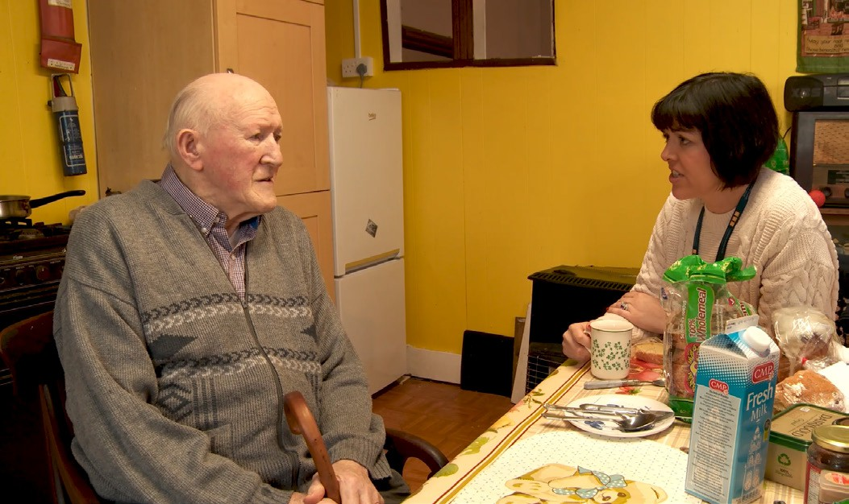**Peter**

Peter is in his 80s and hasn’t availed of any health or housing supports

previously. He was recently registered as blind and has significant hearing loss. The gas cooker in his kitchen has him lifting gas cylinders up the stairs from the lower floor. The electrical system in his home

is very old with burnt out plug sockets, a broken ensuite light, and a considerable

amount overloaded extension leads. In addition, all sockets are low to the ground reducing accessibility and acting as a trip hazard. Peter wishes to remain as independent as possible while continuing to live in the family home.

**Actions**

The local support coordinator through their initial one-to-one needs assessments and follow-up face-to-face visits put into action a comprehensive array of supports which covered the following:

* Peter was referred to the National Council for the Blind of Ireland (NCBI) who provided him with a text-to-read device which enables him to read newspapers and his post.
* Peter was also referred to an Occupational Therapist who provided him with a shower chair, Mowbray toilet frame and support bars were installed.
* A successful HOPS application was made to upgrade the electrics in his home and these works were completed in January 2023. Peter had to move out of his home for a week while these works were taking place and the coordinator helped him source suitable accommodation. The coordinator also negotiated with the electrician, who originally wanted them to move out for two weeks.
* Through a successful HAGS application, a custom-made stairlift was installed in December 2022 which spans three floors. All three of Peter’s siblings can now access all floors safely.
* He was assisted in applying for fuel allowance and a household benefits package, both of which were approved and have made a huge difference to his household budget.

**32** Healthy Age Friendly Homes Pilot Evaluation

* A free home energy assessment survey and report were completed and Peter now qualifies for the Warmer Homes Scheme based on his fuel allowance approval.
* Tunstall Emergency Response provided Peter with assistive technology in the form of a personal alarm device (the Pebble).

**Key Outcomes**

* Electrical modifications to home ensuring safety.
* Installation of stairlift ensuring accessibility to all floors of the home.
* Reduction in domestic expenses.
* Availing of state supports.

**Impact**

The transformation in Peter’s situation highlights the importance of an older person’s living environment on their health and wellbeing. Peter’s previous hazardous living arrangements combined with his sight and hearing loss were likely to have eventually resulted in injury and hospitalisation. Having not availed of any health or housing supports prior to referral into the programme, his declining health status and unsafe housing conditions may have ultimately led to Peter requiring residential care.

Peter now lives in a safe and accessible home. The suite of electrical upgrades including a rewired heating system and raised sockets make for a safer warmer home, whilst new external lighting and the custom stairlift greatly improve mobility and accessibility. In addition, the installation of a cooker switch enables him to replace his gas cooker with an electric stove, eliminating the burden and risks of hauling gas cylinders up the stairs.

Peter has now also availed of the fuel allowance, easing some of his concerns regarding affordability of fuel and he is more confident he can now heat his home. Finally, assistive technology in the form of the Pebble personal alarm provides Peter with greater security and reassurance in the comfort of his own home.

**In Peter’s own words:**

*‘Now with all the help here from Marie and the grants it makes life very very comfortable & takes away all the danger & I feel more relaxed’.*

*‘It’s totally transformed my life now’.*

*‘Stay at home in my home quite safely and comfortably’.*

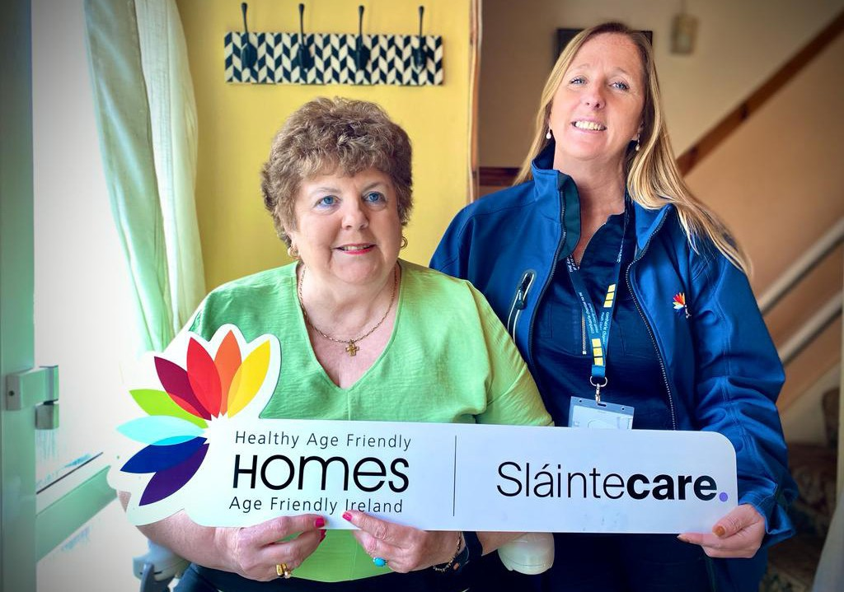**Geraldine**

Geraldine is a 65-year-old lady living in her own home. Her health condition affects her mobility and as a result has

had to move her bed downstairs and use a commode due to her inability to access the upstairs of her house. Geraldine

was referred into the programme by a HSE occupational therapist within her primary care team.

**Actions**

The Local Coordinator visited Geraldine’s home and worked with her to put a personalised support plan in place:

* The local coordinator assisted in making a Housing Adaptation application for a stairlift and an accessible shower. In Geraldine’s presence they contacted the LPT office in the Revenue Commissioners and helped her gather all of the necessary documentation.
* The local coordinator took pictures of the stairs and bathroom and printed them for Geraldine. These were used to facilitate a quote from contractors for the works. The coordinator then brought the completed application to the housing support team for submission. This application was subsequently granted.
* Geraldine was also assisted in making applications to the Local Authority Bin Waiver Scheme and the SEAI Warmer Homes Schemes. Both applications were granted.
* The local coordinator liaised with the local Care and Repair team to have two smoke alarms and a carbon monoxide alarm installed.
* Geraldine received a monitored pendant alarm from the Family Resource Centre through the Senior Alert Scheme.
* An application was made to the Department of Social Protection for the state pension, which was approved and will begin when Geraldine turns 66.

**Key Outcomes**

* Installation of home modifications and technology supports.
* Increased mobility and accessibility in the home.
* Reduced domestic expenses.
* Secured approval for state pension.

**34** Healthy Age Friendly Homes Pilot Evaluation

**Impact**

Geraldine’s journey demonstrates the range of supports available to older people through Healthy Age Friendly Homes. Geraldine received supports ranging from structural modifications to the home, to reducing the burden of domestic expenses such as bin charges, and installation of assistive technology such as alarms and monitors. Finally, assistance with the application for the state pension helped to give greater financial certainty and removed any potential worry surrounding it. Important in all of this was overcoming the barrier of paperwork associated with the application process.

These supports will provide her with a safer and less hazardous home environment. Geraldine can now use the stairlift for greater mobility in her home and the accessible bathroom will make her day-to-day routine more comfortable. She will also enjoy greater safety with the installation of the smoke and carbon monoxide alarms as well as greater security with the monitored pendant. This will reduce these stresses in her life. Combined, these supports provided Geraldine with a greater sense of independence and will have a very positive impact on her ongoing Health and wellbeing.

**In Geraldine’s own words:**

*‘I feel a lot of the time I was losing my self-worth if you like. I just* *couldn’t do my basics’.*

*‘It’s given me back my dignity’.*

*‘If I hadn’t been referred to this programme, I wouldn’t know how I could have managed so it has really enhanced my life’*

*‘I can’t thank the Age Friendly People enough’.*

**Frank**

Frank is a 76-year-old gentleman who lives independently in a rural area and is in fair health. Frank was referred into the programme by a local council representative. He has good family support, and they live nearby. He cycles into town twice weekly to meet friends, which is a mile away from his house. Frank’s home is a 200 year old family house which sits on an acre of land and which is in very

poor condition. Amongst others, the house has a tin roof which is leaking, has no heating and an unusable bathroom. Furthermore, the house is made hazardous by uneven floors throughout and a leaking chimney.

**Actions**

The Local Coordinator visited Frank’s home and carried out a needs assessment putting an individualised support plan and actions in place.

* The local coordinator completed a Social Housing Application with additional documentation and submitted it to the local council.
* A Clerk of Works Report indicated that the property was not suitable for habitation and required too many renovations/repairs, the cost of which the adaptation grants could not cover.
* Following this, an application for the provision of a modular home was made to the Local Authority.
* Over a six-month period the coordinator maintained communication with the local representative progressing the modular home application. Frank and his sister were kept fully updated on progress by the coordinator throughout.
* The modular home was subsequently delivered, and essential water and electricity services connected.
* Frank also applied for a panic alarm as he lives alone.

**Key Outcomes**

* Rehoused to a more suitable modular home.
* Avoidance of potential hospitalisation.
* Prevention of eventual need for residential care.

**36** Healthy Age Friendly Homes Pilot Evaluation

**Impact**

Frank’s story highlights the innovation and comprehensiveness of supports which can be facilitated through Healthy **Age Friendly Homes**. Frank is now living in a well-lit, safe, and warm modular home which consists of a bedroom, kitchen, sitting room and bathroom.

Every step in the process to achieving this successful outcome was with the assistance of the local coordinator. These steps included the home application, the monitoring of its progress and the confirmation of its outcome. During this time, the local coordinator provided Frank with regular updates, thereby reducing any stress endured.

Without having to deal with the hazards presented by his previous dwelling, Frank will doubtlessly live a healthier life in his new home. Importantly, this home is on the same site as his previous dwelling, meaning Frank will be able to continue living close to his family. This will no doubt be of great benefit to his mental health and wellbeing. Without these supports it is likely that Frank's previous unsafe living circumstances would have resulted in declining health and/or injury, leading to hospitalisation or his entering residential care.



**6Key**

**Recommendations & Pathway to Phase 2**

**38** Healthy Age Friendly Homes Pilot Evaluation

Healthy Age Friendly Homes should be scaled up using a population health approach and rolled out nationally.

* Following the publication of the Healthy Age Friendly Homes interim report, a business case was subsequently prepared and a successful bid for funding in the Budget 2023 resulted in the Healthy Age Friendly Homes Programme receiving funding for national rollout.
* The Programme will be scaled up nationally, to ensure all older people in Ireland will have the opportunity to age in place and have access to the supports provided by the Programme.
* Using a population-based approach, each local authority in the country (31) will host at least one local coordinator, with some areas receiving additional coordinators based on local population need.
* Regional managers will be responsible for overseeing the programme in six regions aligned with the six HSE Health Regions to ensure alignment with health and social care services. Partnerships with key stakeholders will also be scaled to ensure service provision across the country.

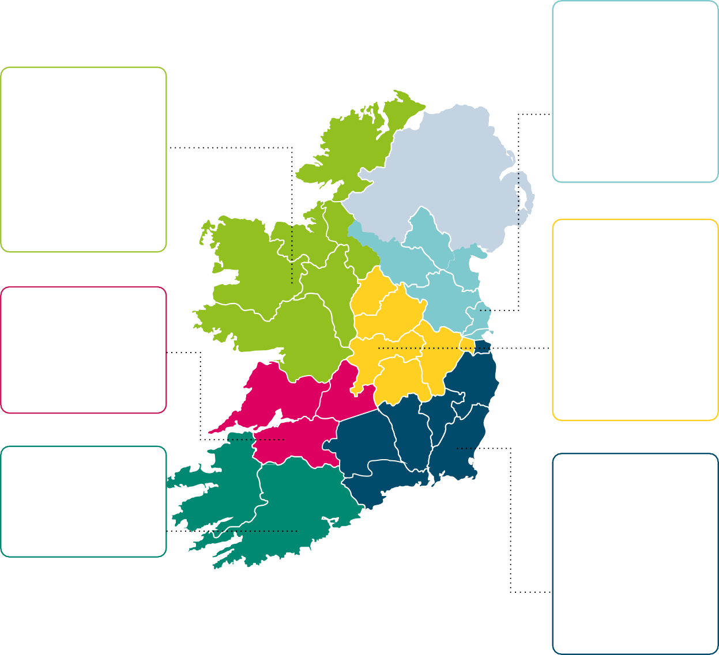

**Dublin & North East 7 Coordinators**

**West & North West 10 Coordinators**

Donegal Leitrim Sligo

Roscommon Mayo Galway

2

1

1

1

2

3

Monaghan Louth Meath Cavan Fingal Dublin City

1

1

1

1

2

1

**Dublin & Midlands 9 Coordinators**

**South West**

**5 Coordinators**

**Dublin & South East 9 Coordinators**

|  |  |
| --- | --- |
| **Mid West**  **4 Coordinators** |  |
| Clare | 1 |
| Limerick | 2 |
| Tipperary North | 1 |

|  |  |
| --- | --- |
| Longford | 1 |
| Westmeath | 1 |
| Offaly | 1 |
| Laois | 1 |
| Kildare | 2 |
| South Dublin | 2 |
| Dublin City | 1 |

|  |  |  |  |
| --- | --- | --- | --- |
| Kerry | 2 | Wicklow | 1 |
| Cork | 3 | Carlow | 1 |
|  |  | Wexford | 2 |
|  |  | Kilkenny | 1 |
|  |  | Tipperary South | 1 |
|  |  | Waterford | 1 |
|  |  | DLR | 1 |

Phase 2 Evaluation should take place over a three-year period.

* This research could explore an in-depth cost benefit analysis to explore health care utilisation savings to the HSE.
* As noted in the results section, many participants were still awaiting housing modifications to be completed at the 6 month follow up. A longer follow up period could be utilised to examine the full effects of home modifications on participants health and wellbeing. Given the wait times of approximately 2 years on the warmer homes scheme however, it may prove difficult in re-engaging participants after an extended period.

Participants with more complex health needs should be prioritised and provided more targeted supports.

* Many older people in this cohort were experiencing ongoing health issues during their participation. Those with poorer self-reported health and mobility status received on average less supports than those who reported no issues.
* This cohort could be prioritised and supported to avail of services and perhaps require more one-to-one support to walk them through what is available to them. In addition, they may need more encouragement or information on the benefits or services to make an informed decision.

The programme framework should be expanded from four domains to six to reflect the broad scope of support provided by coordinators.

* The pilot phase of the Healthy Age Friendly Homes Programme has provided significant insights into its current structure, centred around four key domains: Health, Housing, Community and Technology.
* Feedback from participants and Local Coordinators strongly suggests the necessity to broaden the scope of the programme. It is recommended that the existing framework be expanded to encompass **six key domains** by including **’Climate Action’ and ’Financial Awareness’**.
* Incorporating these additional domains will enhance the programme’s capacity to identify and better offer support in these critical areas, thereby facilitating more comprehensive reporting and outcomes across all key domains.

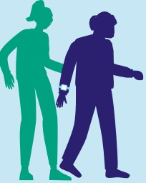

I

I

•

I I

I

**7**

•

I

## Appendix

#### I I

**11** *or*

-

I I -

###### Healthy Age Friendly Homes Programme

**Chief Executive**

Meath County Council

**National Age Friendly Ireland Shared Service**

**Healthy Age Friendly Homes Programme**

1 National Manager

6 Regional Programme Managers 44 Local Coordinators

Programme delivered across 31 LAs 1 National Administrator

14 Administration Staff

**Chief Officer of Shared Service National Manager HAFH**

**Regional Manager**

Dublin & North East Fingal x 7

**Regional Manager**

Dublin & Midlands Offaly x 9

**Regional Manager**

Dublin & South East Wexford x 9

**Regional Manager**

South West Cork County x 5

**Regional Manager**

Mid West Limerick x 4

**Regional Manager**

West & North West Mayo x 10

**National Administrator Staff**

**Officer**

**Local Coordinators**

Monaghan x1 Louth x1 Meath x1 Cavan x1 Fingal x2 Dublin City x1

**Local Coordinators**

Longford x1 Westmeath x1 Offaly x1 Laois x1 Kildare x2

S. Dublin x2 Dublin City x1

**Local Coordinators**

Wicklow x1 Carlow x1 Wexford x2 Kilkenny x1 Tipperary S. x1 Waterford x1 DLR x1

**Local Coordinators**

Cork x3 Kerry x2

**Local Coordinators**

Clare x1 Limerick x2 Tipperary N x1

**Local Coordinators**

Donegal x2 Galway x3 Leitrim x1 Mayo x2 Roscommon x1 Sligo x1

**Admin Staff**

x14

Research Evaluation Team:

* Dr Adrienne McCann, Principal Investigator, Innovation Value Institute, Maynooth University
* Mr. Tom Hall, Research Assistant, Innovation Value Institute, Maynooth University

Healthy Age Friendly Homes Team:

* Catherine McGuigan, Chief Officer, Age Friendly Ireland
* Mark Harrington, National Manager, Healthy Age Friendly Homes Programme
* Sylvia McCarthy, Communications and Network Manager, Age Friendly Ireland
* Dr Emer Coveney, National Programme Manager, Age Friendly Ireland
* Joanne Husband, Assistant Staff Officer, Healthy Age Friendly Homes Programme
* Elizabeth Kenny, Clerical Officer, Healthy Age Friendly Homes Programme
* **Local Coordinators, Programme Staff & Programme Participants:**
  + Edel Byrne
  + Mary Carey
  + Aoife Dunphy
  + Mary Gillan
  + Anthony Holmes
  + Francis Kane
  + Eimear McCormack
  + Danielle Monahan
  + Ann Moran
  + Marie Nolan
  + Jillian Robinson
  + Tracey Thompson

Oversight Group:

Jackie Maguire (Chairperson), Chief Executive (former), Meath County Council Catherine McGuigan, Chief Officer, Age Friendly Ireland

Mark Harrington, National Manager, Healthy Age Friendly Homes Programme Sarah Treleaven, Principal Officer, Department of Health

Andrew Hannigan, Assistant Principal | Department of Health

Rosaleen Harlin, Communications Lead, Sláintecare, Department of Health Barry Lynch, Director of Services, Meath County Council

Neil Kavanagh, Assistant Principal, Department of Health

Patrick O’Sullivan, Principal Officer, Department of Housing Local Government and Heritage Paul Benson, Principal Officer, Department of Housing, Local Government and Heritage Laura Behan, Principal Officer, Department of Housing, Local Government and Heritage Declan Meally, Director of Business and Transport, Sustainable Energy Authority of Ireland

Des Mulligan, Service Improvement, National Integrated Care Programme for Older People, Health Service Executive

Evaluation Sub Committee:

Catherine McGuigan, Chief Officer, Age Friendly Ireland

Mark Harrington, National Manager, Healthy Age Friendly Homes Programme Dr Emer Coveney, National Programme Manager, Age Friendly Ireland

Professor Deirdre Desmond, Department of Psychology and Assisting Living and Learning Institute, Maynooth University

Eimile Holton, Research Assistant, Department of Psychology and Assisting Living and Learning Institute, Maynooth University

Caroline Creamer, Innovation Value Institute and The International Centre for Local and Regional Development (ICLRD), Maynooth University

Dr Niamh Hennelly, TILDA, Trinity College Dublin Georgia Lalor, TILDA, Trinity College Dublin

Biddy O’Neill, Health Promotion Manager, Department of Health Dr Mark Ward, TILDA, Trinity College Dublin

This Programme also set out to identify ways in which we could use data more effectively to streamline services such as capturing participant data through software, conducting needs analyses, conducting gap analyses through mapping, and taking a population-based planning approach. In that regard we would like to thank:

* Simon McCabe, Head of Information Systems | Meath County Council
* Amanda O’Brien, GIS Officer | Meath County Council
* Paul Dunne, Meath County Council IT Department
* Sean Mulligan, Meath County Council IT Department
* Dr Paul Kavanagh, Health Intelligence Unit, HSE
* Dr Thiago Hérick de Sá PhD, Age-friendly Environments, Department of the Social Determinants of Health, Division of UHC/Healthier Populations in the World Health Organisation

**Notes:**

**Notes:**