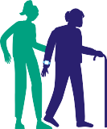

 

Healthy Age Friendly Homes

Pilot Evaluation

Healthy Age Friendly

Age Friendly Ireland

# Key Objectives

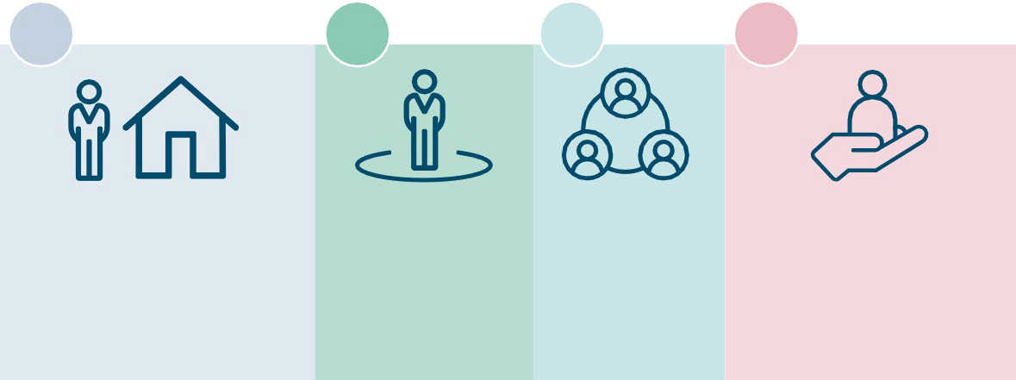

**1**

**2**

**3**

**4**

Enable older people to continue living in their homes or in a home more suited to their needs (Rightsizing)

Live with a senseof

independence

and autonomy

Be and feel

part of their Community

Support the avoidance of early or premature admission to longterm

residential care

Participant Profile

**2,133**



**6,908**

Participants completed assessments

Supports delivered

**1,422**

**3,273**



Live in Urban areas

Home visits carried out

# Housing Conditions & Living

Arrangements

Live in own home with Family member, **11%**

Live with signiﬁcant other **37%**

Reported ‘Other’ Living arrangements, **1%**

Live Alone,

**51%**

Programme Participants own their Home,



**74%**

# Overview of Domain

##### Supports have been provided relating to the four key domains



Housing

## 61%

Housing adaptations including Housing Adaptation Grants (HAGs), Mobility Aid Grants (MAGs) and Housing Aid for

Older People Grant (HOPs). SEAI grants and BER energy assessments were the most common areas of need identification in the assessments under the Housing domain.

Technology

## 16%

Smoke detectors and Carbon Monoxide Alarms accounted for 72% of Home Technology Aids provided to the participants. In relation to Assistive Technology, devices information and access to the Pendant | Personal Alarm was 20%.

Health

## 12%

Social Welfare schemes (27%) and contact information and linkages to an Occupational Therapist (25%) were the predominant Health Supports Provided.

There were

seventeen various Supports related to Health that the Local Support Coordinator assisted the participant with.

Community

## 11%

An Introduction to Local Community Groups was the most common community support, followed by the Befriending Service, with Library Service the third highest support.



*“I recommend it for the simple reason that, you know, people might not know that things like this exist; you know like grants and (….) it’s nice to find out that there are actually bodies out there that are willing to help.”*

# Findings

### Self Efficacy

Greater number of participants feel more optimistic about coping with the demands of life

### Rightsizing **Key**

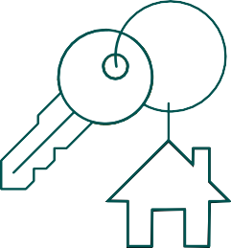**Factors:**

Existence of more Age friendly housing in desired area is very important

### Quality of Life

Participants reported an improved “Sense of fulfilment of their potential” in their Lives

### Social Support

More than half of participants now feel they have Strong levels of Social Support



### Loneliness

7 out of 10 participants self-reported as ‘Not Lonely’

Greatest source of loneliness measured was a *“lack of companionship”*

### Self Reported Health Status

Overall, participants considered themselves slightly healthier



### Functional Ability

4 out of 5 participants reported having greater self-belief in their ability to

respond to difficult situations

# Impacts

#### Prevention

Older Person with no falls and a support of Housing Adaptations implemented

###### Of the 648 participants



**963 participants** indicated housing adaptations were required in their home with **648 indicating they had not experienced a recent fall**.

#### Intervention

**347** have been assisted in making a housing adaptation grant application.

**376** were provided information on housing adaptation grants for consideration and follow-up**.**

Older Person with mobility issues affecting their capacity to use the stairs with the support of stair lift implementation (housing adaptation)

###### Of the 674 participants



**674 participants** stated that they had difficulty in using the stairs all the time.

**322** have been assisted in making a housing adaptation grant application.

**290** were provided information on housing adaptation grants for consideration and follow-up**.**

#### Reaction

Older Person living alone who has a history of falls and a support of entry level telecare with 24-hour emergency response provided

**996 participants** are living alone with 311 experiencing a recent fall



###### Of the 311 participants

**299** indicated they did not have a fall detector.

**164** indicated they did not have a pendant alarm.

**Of the 996 participant 224** have a history of falling

###### Of the 224 participants

**215** indicated they did not have a fall detector.

**116** indicated they did not have a pendant alarm.



**152** were provided fall detector assistive technology supports

# Key Recommendations

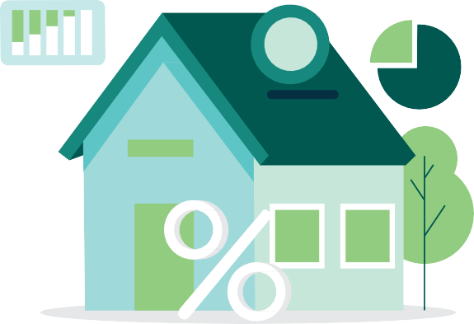

#### National scale up of the Programme



Using a population-based approach, each local authority in the country

(31) will host a local coordinator, with some areas receiving more coordinators based on their population's needs.

#### Introduction of a Regional Management tier aligned to RHAs

Regional managers will be aligned to the Regional Health Areas, to ensure alignment with health and social care services. Partnerships with key stakeholders will also be scaled to ensure service provision across the country.

#### Broaden scope of Programme

It is recommended that the existing framework be expanded to encompass **six key domains** by including:

###### Climate Action/Warmer Homes Financial Awareness

This will offer better support in these critical areas, thereby facilitating more comprehensive reporting and outcomes across all key domains.

€

#### Prioritise participants who have poorer self - reported health & mobility status

**Evaluation**

Those with poorer self-reported health and mobility status, availed of fewer supports than those who

reported no issues on their health & mobility status. This cohort could be prioritised and supported to avail of services and perhaps be given more one to one support to walk them through what is available to them. In addition, they may need more encouragement or information on the benefits available or services to make an informed decision.



This research could explore an in-depth cost-benefit analysis to explore health care utilisation savings to the HSE.

A longer follow-up period could be utilised to examine the full effects of home modifications on participants’ health and wellbeing.

##### By supporting older people to continue living independently and avoiding **premature or untimely** admission to long-term care the programme can potentially produce demonstrable savings of €41.5 million annually



Healthy Age Friendly

Age Friendly Ireland

 