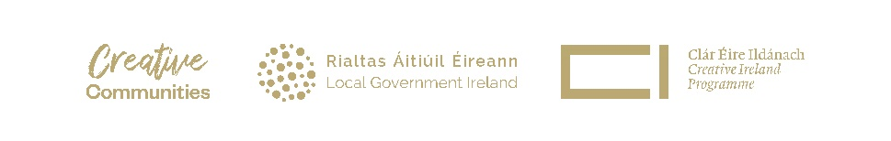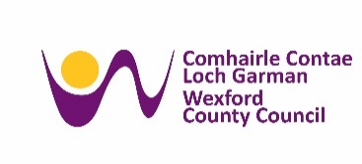

Creative Ireland Wexford

Haumea Ecoversity Bursaries for 2025

Guidelines
Creative Ireland Wexford will provide twelve bursaries each worth €390 for the Haumea Ecoversity course during 2025. Applications for the bursaries are open to creatives (artists of all disciplines, producers, organisers, managers, teachers of the arts and creativity) living and working in County Wexford.

What is Haumea Ecoversity?
Haumea Ecoversity includes:
- online ecoliteracy and values education modules;
- reading groups;
- special talks with invited guests.

It empowers creatives with ecoliteracy and values to guide their creative work for a better world. Learning is self-paced and for all art forms. Haumea Ecoversity offers holistic learning and emphasises wellbeing practices for what can be a confronting, yet ultimately rewarding area.

Membership includes 10 learning modules in eco-literacy training which are supplemented by salon-style group sessions co-facilitated by Cathy Fitzgerald and other eco-literate facilitators for in-depth exploration. Members will also have access to a private vibrant eco-literacy community forum where they can connect, collaborate, or select eco-literacy learning partners.

How is the learning facilitated?
Ecological artist and accredited educator, Cathy Fitzgerald, PhD facilitates Haumea Ecoversity with Californian-based philosopher, mentor and podcaster, Dr Nikos Patedakis.

Every two weeks participants will have access to video lessons and other resources in online modules that can be engaged independently. There will be regular group meetings via Zoom.
Haumea Ecoversity 2025 begins in early January 2025.
Haumea Ecoversity will offer an orientation week, starting 13th January 2025, to allow participants to become familiar with the new Haumea Ecoversity Community platform. The first live group Zoom meeting will take place on Wednesday 15th January at 7pm Irish time and every two weeks on Wednesday evenings during 2025 following a school timetable.
Please Note Haumea Ecoversity will NOT suit experienced ecological art practitioners already be familiar with introductory material. Haumea Ecoversity is also not about making an environmental-themed artwork, or review others’ ecoart work in depth although the learning does support the development of such work. It offers accessible context, knowledge, language, values and resources that enable you to confidently frame, communicate and maintain your creative or education work in an ecological context, that is relevant to your situation and place.

Why learn with Haumea Ecoversity

- Reframe your creative practices within an area of important social power that inspires others to embrace a more beautiful, equitable just and sustainable culture;
- Learn valuable understanding of how to position grant applications for ecologically-orientated creative endeavours;
- Become more informed about developing impactful exhibitions, events, community art programmes, art courses, and insightful cultural leadership for these urgent times;
- Discover insights from leading voices in philosophy and ethics, ecopsychology, environmental science, economics and activism, ecological art practice, and from the world’s wisdom traditions;
- Learn more about nourishing practices for personal, collective and planetary wellbeing.

Webinar:
Join Cathy Fitzgerald from Haumea Ecoversity, online at Wednesday 4 December 2024, 7pm for an overview of the Haumea Ecoversity courses, eligibility and bursary application process. We strongly encourage anyone interested in applying for the Bursary to register for the webinar.
To register for the webinar, please email elizabeth.howard@wexfordcoco.ie

