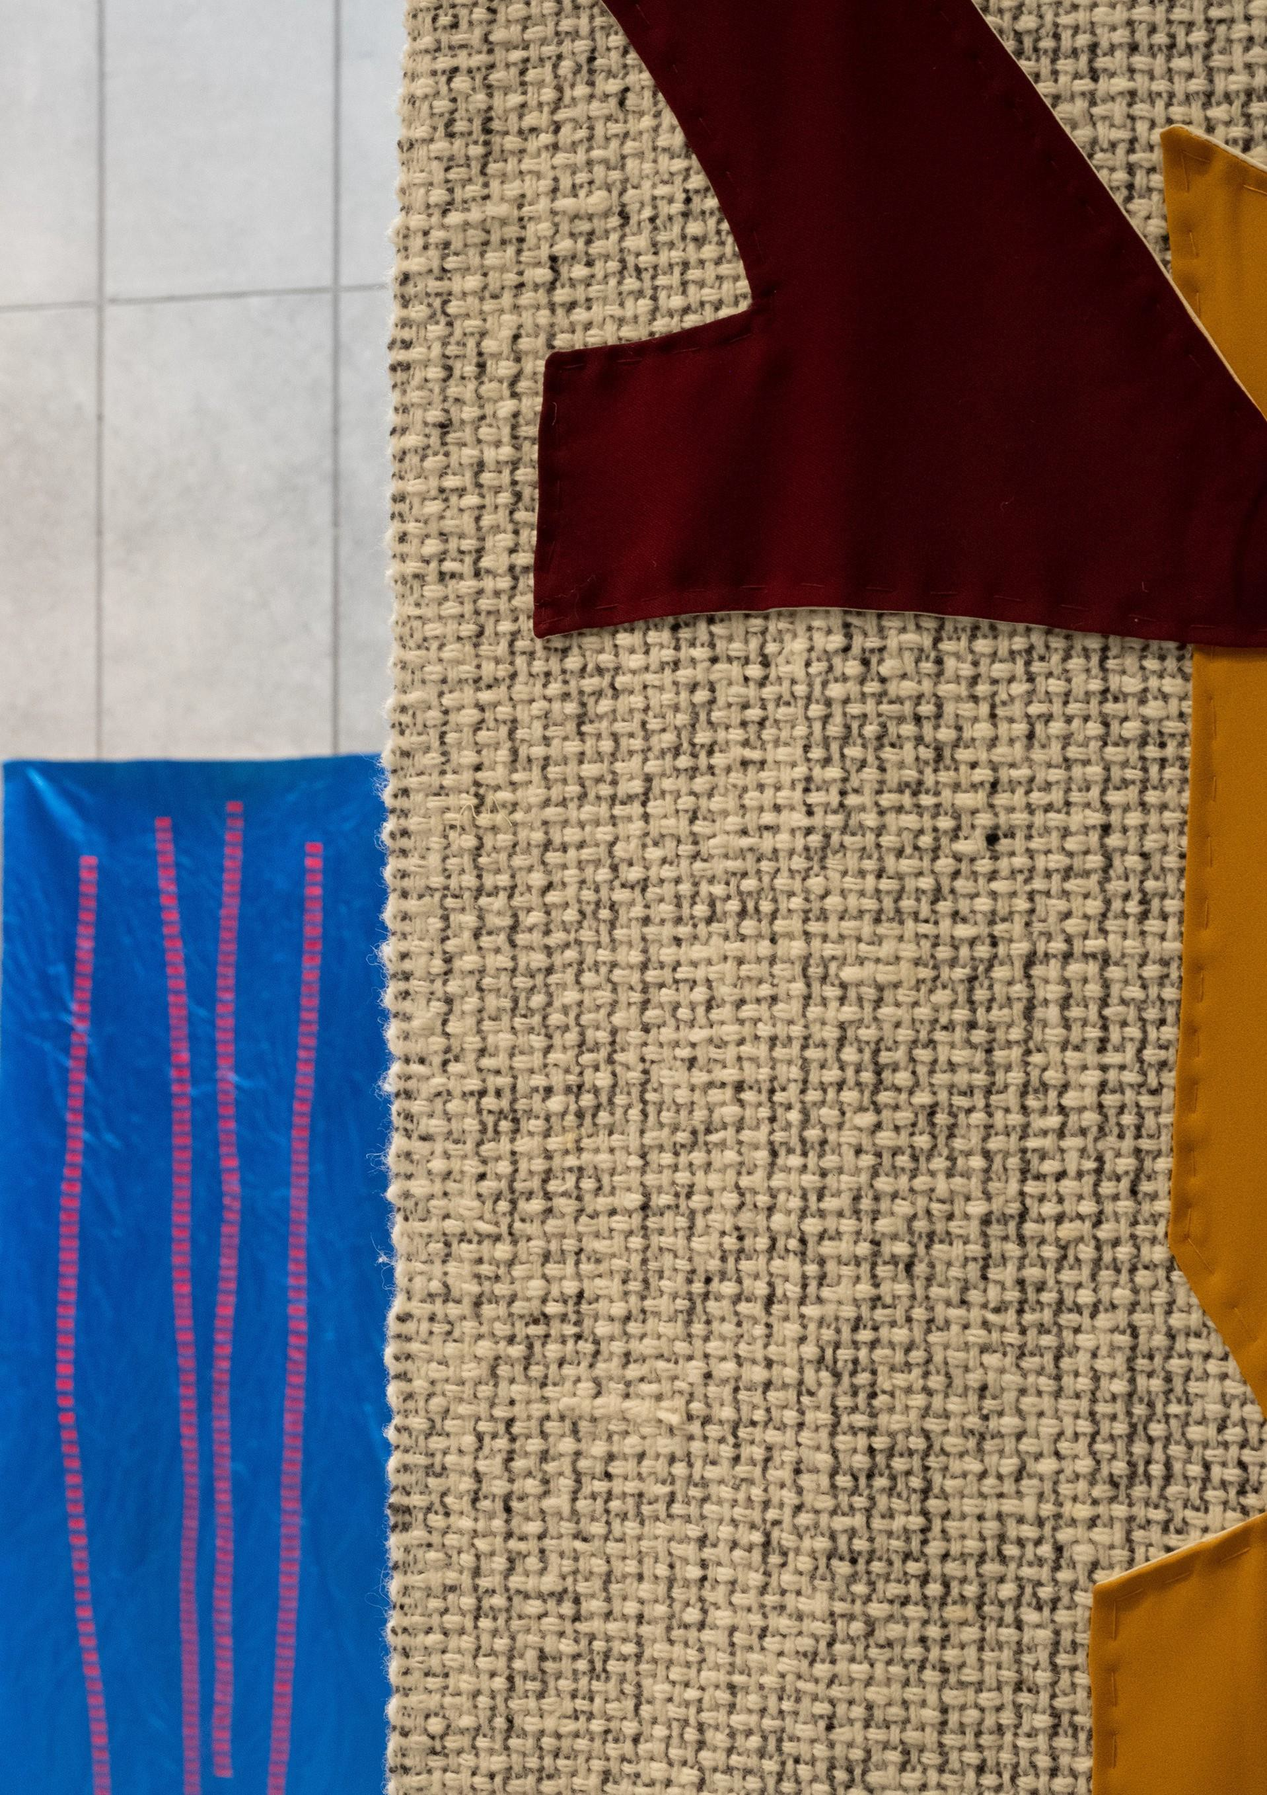

Artist In the Community Programme
Artists’ Panel
2024 – 2025
A panel of thirty professional artists and creatives proficient in enabling meaningful artistic collaboration
START AT $2.250.000

Artists Panel 2024

Name
Michael Benson Vivian Brodie Hayes Luke Cosgrave Jimi Cullen
Sylvia Cullen Caoimhe Dunn Brendan Fahy Fernanda Ferrarie Doreen Fitzmaurice Sheila Forsey Michael Fortune Margaret Galvin Laura Hyland Garrett Keogh Lucia Kickham Aileen Lambert Tony McCleane Fay Andi McGarry
Deirdre Meehan-Buttimer Kate Murphy
John Ó Faoláin Melanie O'Reilly Amy Redmond Jeni Roddy Deirdre Travers Rachel Uí Fhaoláin Mary-Ruth Walsh Josephine Whitmore Elke Williams
START AT $2.250.000
Fadi Zmorrod
Art Form
Film Making Dance Artist Film Music
Music
Literature, Writing
Street theatre, Visual Arts, Theatre Maker Juggler and Circus
Performer, Visual Arts, Puppetry, Stories Textile Arts + mixed media
Literature
Visual Arts, Traditional Arts, Publications Creative Writing, Poetry and Prose Sound art + Music, performance Acting, Writing, Theatre
Dance
Traditional Song, Visual Art, Song-writing Theatre and Film
Visual Art Printmaking Visual Art Visual Art Music
Theatre, Literature + Film Interdisciplinary
Visual Arts
Music – Traditional Song & Visual Art in Community Settings
Visual Art + Writing Textiles
Ceramics
Contemporary Circus

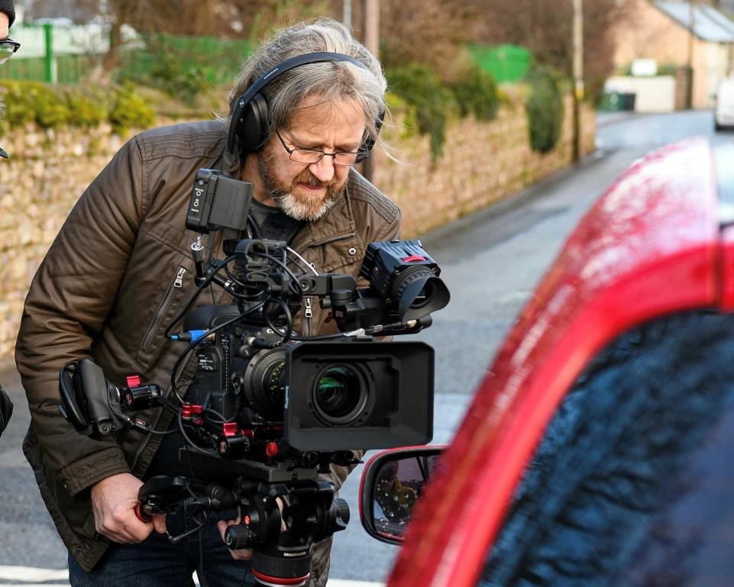
Michael Benson

Contact
E: michaelbensonproductions@yahoo.com
P: 086 8321063
Socials: Michael Benson Productions

Art Form: Film making

Projects and Workshops
Projects offered have at their centre the principle of using visual media to explore/express current and relevant social issues experienced by young people, older people, disability groups and community organisations in contemporary society.

Programmes have at their core a desire to facilitate and encourage healthy emotional expression in an experiential and practical creative environment. This is of particular importance in the lived experience of individuals/groups where other opportunities/outlets for safe emotional expression are either limited or non-existent. Filmmaking has the added advantage of realising a physical end product in the shape of a completed piece of visual work that can be shared with the wider community/society (at a possible Red Carpet Premier Event) creating a sense of completion and success for all participants involved.

“Participants who have a history of in-depth arts involvement show better academic outcomes than those with less arts involvement. They earn better grades and have higher rates of third level enrolment and attainment.” US National Endowment for the Arts, 2012.
Programme design is very much consultative in nature and participant led and can be used by participating groups to promote awareness of their service, highlight a social issue impacting the particular group or indeed simply be a fun dive into the process of making a film.

Programmes can include (but are not limited to) film and pre-production, scripting and casting, using a camera, acting for camera, editing and post production and of course the option for having a formal screening of the finished work to share with friends, family and the wider viewing public.

Background
Michael is multi award winning and hard-working film creative with over thirteen years’ experience across a broad range of creative programme types. He has completed work for, and delivered material to Bord Bia, Bank of Ireland, Coilte, Wexford County Council, Wicklow County Council as well as multiple local and national businesses.
Michael has an honours degree in Social Science (Youth and Community Work) and employs various models of both youth and community work to his work as a filmmaker. In a community context he engages a very participative, inclusive and person centred approach to the film making process and experience for the participant seeking to engage the individual and group in multiple positive experiences that are designed to contribute to their sense of personal achievement and success.
His camera work has featured on RTE and TG4 as well as PBS in the USA. His recent documentary production (2021/2022) “Pat Walsh – The Life and Legacy of an Irish Revolutionary” has received multiple Film Festival awards worldwide (currently 80+) and a number of films he has worked on as Director of Photography and editor such as ‘Slab’, “Indelible”, “Lola”, and “Envy” have all had success in film festivals in various locations around the world.

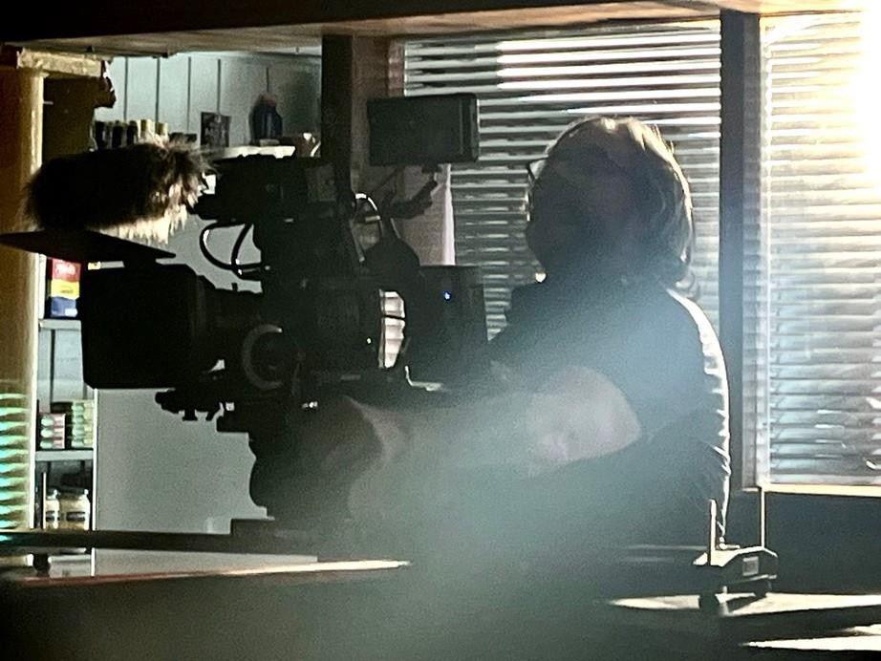

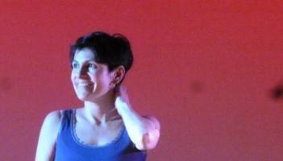
Vivian Brodie Hayes

Contact
E: badgers.hill@gmail.com
P: 0877622312

Art Form:
Dance Artist Filmmaker

Projects and Workshops
I work with movement, dance and video, also using photography, writing, sound, music, and voice. I facilitate groups working together as individuals to create unique projects and am always open to new ideas of how I might work with a group.

Some of my previous projects have been -
Dance Skills sessions - creating a new choreographed piece together to perform, write about, film or photograph.
Shortfilms - learning film making skillsand then making a film together. Theme of interest - such as nature or technology, using film, photography, audio or movement (or a mix), to capture and develop the project.
I am enthusiastic to embolden people to discover or develop their creative voice. I try to be open and receptive and facilitate creativity in a safe, non-judgemental environment.

I have worked with many groups, from young people to over 70’s, from beginners to professionals. I will help the group through application writing, planning, learning together, feeding back to the group/organisers, coordination of performance/presentation and final project evaluation.

Whether it be a performance, film, gathering, printed booklet or audio recordings, I encourage the group to participate on how we want to remember or document our work.

Background
Choreographer and creative educator is the Artistic Director of SpringMoves Dance Festival in County Wexford, was the Arts Council Dance Artist in Residence for County Wexford 2021 & 2022 and works with the Wexford Mental Health Association and the HSE as the Yoga and Movement Specialist (YAMS).

Vivian has been living and working in Ireland for over 20 years. She trained in dance and theatre in San Francisco and worked as a dancer and performance artist in New York for 11 years prior to moving to Ireland. She studied fine arts in Hunter College NY, is a certified, senior yoga teacher, holds a first class honours MA in Contemporary Dance Performance and is a professional member of Dance Ireland. She began by teaching and performing with Manhattan Tap dance theatre, touring New York City schools and now has over 20 years experience as a choreographer and educator.

She makes films and live performed work, which has been shown at the The Lir Theatre, Dance House, Lightmoves festival, Smock Alley Scene and Heard Festival, Maynooth University, Firkin Crane, Wexford Arts Centre, National Opera House and the University of Limerick.

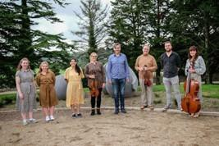
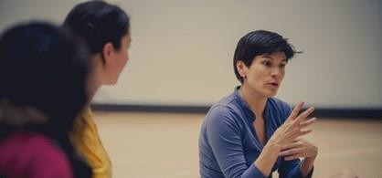

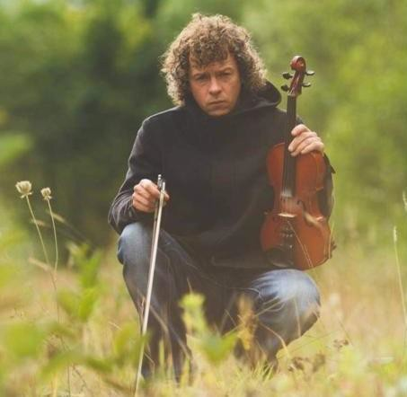
Luke Cosgrave

Contact
T: 0876922558
E: 1lukecosgrave@gmail.com

Art Form:
Music

Area of Specialty:
Song writing, composition, recording, video production and publishing

Projects and Workshops
The aim of the project is to share my experience and knowledge in the art of song writing, composition, recording and publishing in a really relaxed and fun way so as to allow the participants to express themselves through music and art.
This will include mentoring on a variety of instruments including piano, guitar, violin and voice for people of all standards. Whether you’re a complete beginner or you already have experience in music and writing, the project aims to cater for all levels.
The project will also focus strongly on collaboration between participants so as to bring each individual talent together to explore the wide and diverse styles of songwriting and performance and to highlight all the positive things that come from working together.
Songwriting is an art form and like all art there are no rules! Be yourself and let others experience all the Wonderful and quirky things you have to offer. Who
knows… you might end up with a number hit but regardless you have produced something beautiful and unique and something to be very proud of!

Background
I have been a recording artist and composer for over 20 years. I studied Music, Sound and Management in Scoil Stiofán Naofa, Cork and from there I have gone on to record and release multiple works on a national and international level.
I have worked with some of the country’s finest producers and musicians and received airplay on regional, national and international TV and radio. I am continuously writing and recording and performing also as a freelance contemporary violinist with multiple artists and groups.
I am a Co music facilitator with Wexford mental health for the past two years and look forward to working with them for the foreseeable future.

Links to past work: https://youtu.be/o4IGmzpYsL8?si=UannL-criCZ-KF6R

https://youtu.be/VjbgsT6-xPI?si=Itlm1DfpABVst-30

https://youtu.be/a2OSu_U_2HU?si=RzPxAV6H5RErHBfG
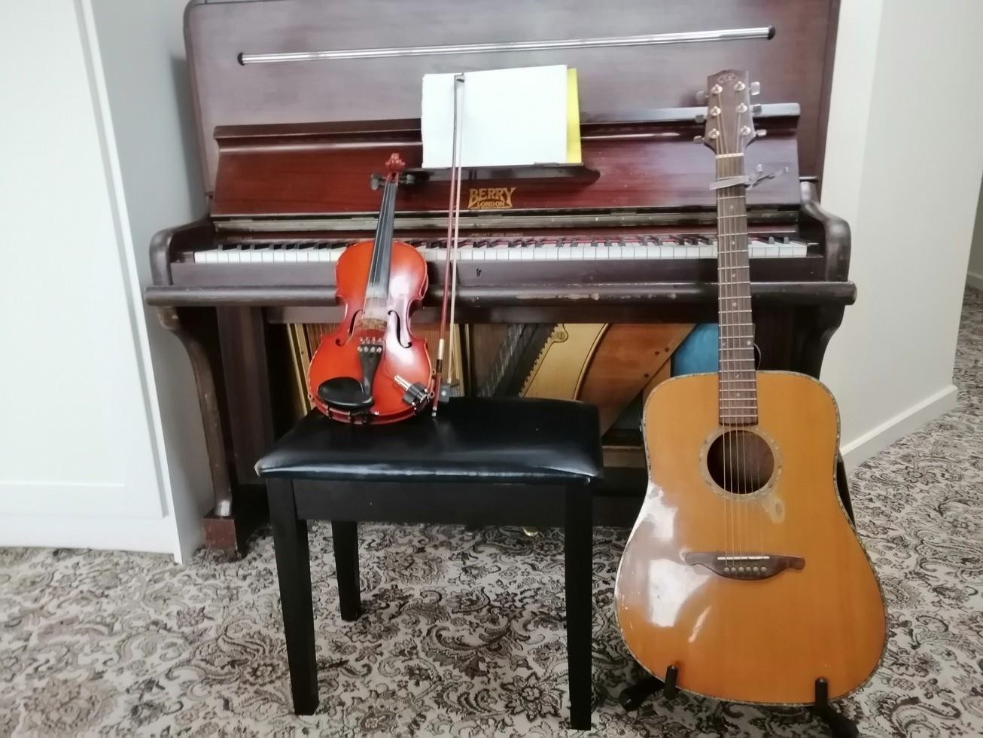

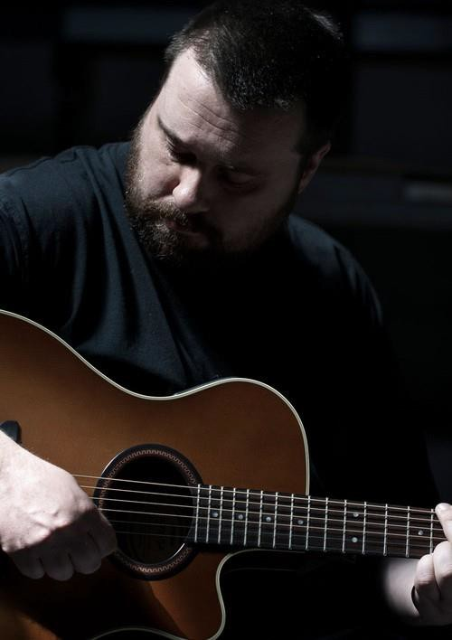
Jimi Cullen

Contact
T: 085-7123525
E: jimicullenmusic@hotmail.com

Art Form:
Music - Musician, Singer-Songwriter, Guitarist

Projects / Workshops
I specialise in creating and facilitating workshops that are developed to engage young people, adults and groups through the medium of music. The aim of my workshops is to collaborate with an organisation, group or community to design and deliver a project that promotes self-expression, personal growth, communication, creativity and participation within the community through the therapeutic values of music.
To date I have delivered music workshops throughout Counties Wexford and Wicklow, I have had the pleasure of working with communities from a wide range of backgrounds, these have included youth groups, mental health service providers, rehabilitation services, therapeutic training initiatives, primary and secondary schools as well as residential care facilities.
Music has the unique power to connect us through a shared experience, workshops such as my own ask participants to explore themselves and express their unique point of view through music. Past participants have engaged in individual and group song writing, learned about performance, singing, instrumentation, creating and running their own long term music programmes and putting on live events.
All workshops are created in collaboration with staff and care providers to meet the specific requirements and requests of those taking part.
If you think your group/school might be interested in working with me, please give me a call or send me and email and we can discuss it in greater detail.

Projects / Workshops
I am a professional musician and music facilitator based in Gorey, Co. Wexford with over two decades experience in the music industry in Ireland and abroad. I have toured widely sharing a stage with many acclaimed bands and artists and have released seven albums. I have extensive knowledge of song writing, music exploration and performance practices as well as industry experience in recording and organising live events.
Music and community work are two things I’m passionate about, I have built a career that allows me to use them in tandem, over the last twenty years
I’ve learned that arts practices can be a vehicle for personal and social change as well as individual and community empowerment.
To help facilitate this growth and empowerment within my own community I’ve undertaken a number of educational opportunities outside of music, these include qualifications in; Youth & Community, Train the Trainer, Intellectual Disabilities Studies.
Through my previous work on previous Creative Communities Panels I have been afforded the opportunity to collaborate with a diverse range of ages, nationalities, genders, economic backgrounds and varied abilities and have seen first hand how exploring the music and the arts enriches the communities involved.

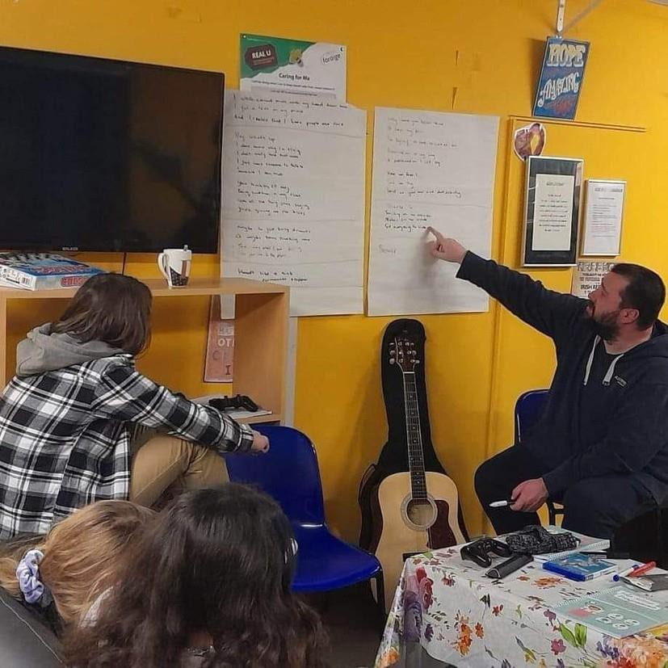

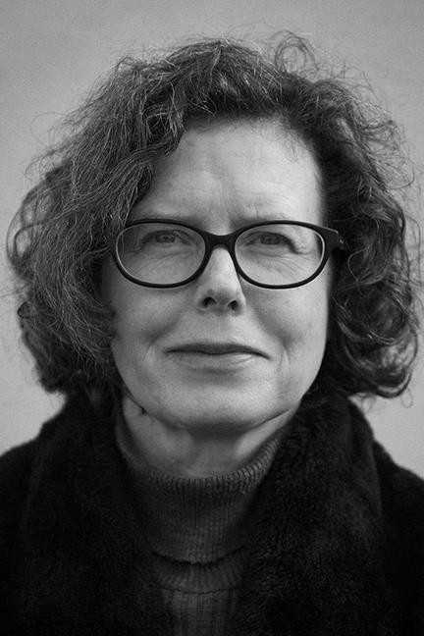
Sylvia Cullen

Contact
T: 086 3920746
E: cullensylvia@outlook.com

Art Form:
Literature, Writer

Projects and Workshops
I enjoy facilitating a variety of approaches to creative expression through writing workshops, in a positive and encouraging atmosphere. Projects can range from process-based work where goals come about organically, to more concentrated work where the objective of a booklet or online publication is established from the outset. I like to take a focused approach: clarifying goals and objectives early on, exploring alternatives in terms of genre and style, ensuring that participants are clear about the options open to them.

As well as being enjoyable, the writing process needs to be creatively challenging. When embarking on any community project, I encourage participants to take ownership of the process, using the opportunity to discover and develop their own voice as writers. In addition to working with groups of adults or children, I also offer intergenerational workshops.

Background
A significant part of my practice has involved facilitating workshops for a wide variety of community groups right across County Wexford and further afield. As a result, I have a lot of experience tailoring specific sessions to meet the needs of individual groups which may vary considerably. For example, my work with Wexford Women’s Refuge involved a process-based approach, focusing on overcoming the fear of writing. Working with Crushin Traveller Women’s Group, storytelling and visualisation were central to the process.

How to Skin a Rabbit for the Gap Arts Festival involved a series of intergenerational workshops, with adults and children working side by side. Most recently, Stories from Sliabh Bhuí was a booklet of creative non-fiction produced by Askamore Writers’ Group. The framework for all of these projects usually involves an intensive series of group workshops, as well as one-to-one sessions with individuals

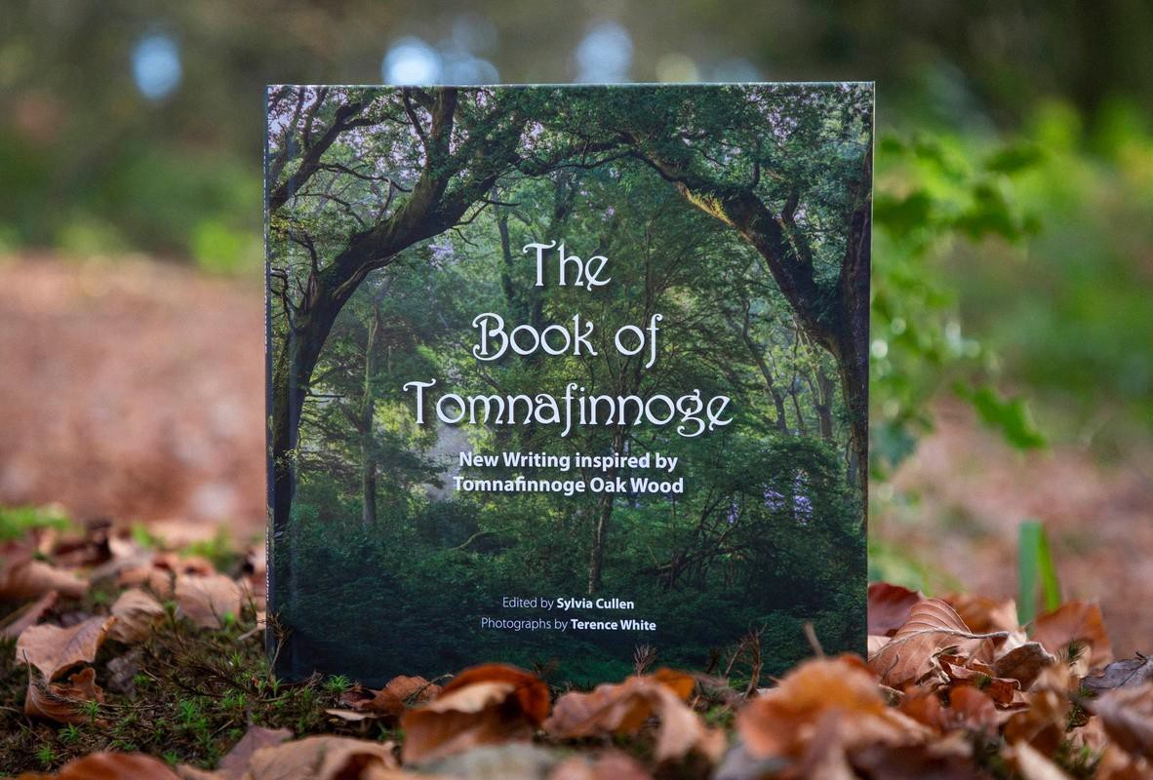
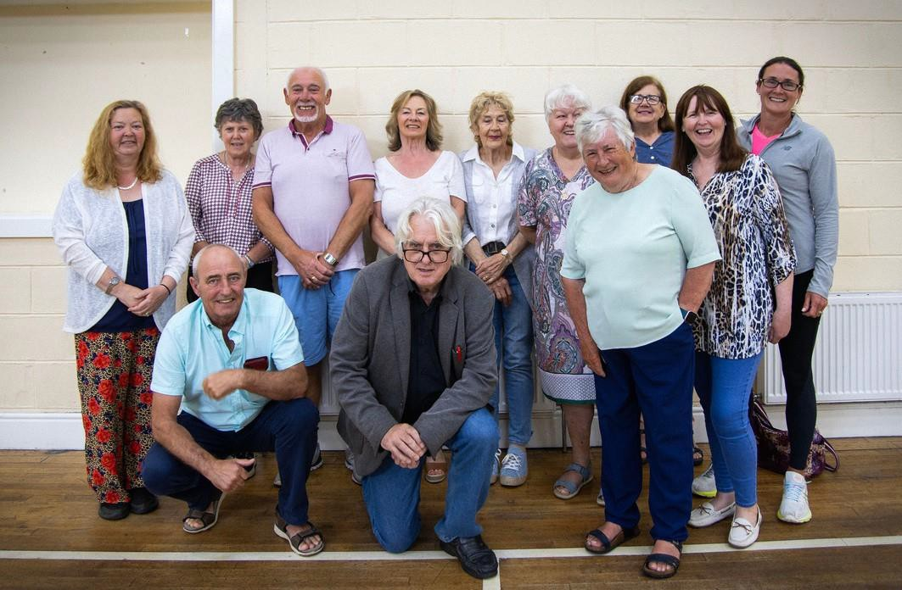

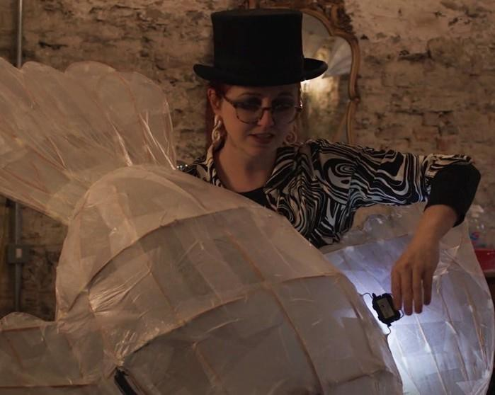
Caoimhe Dunn

Contact
E: dunncaoimhe@gmail.com
P: 087 7549454
W: www.dunncreate.com
Socials: @CaoimheDunnArtist

Art Form:
Street theatre and Spectacle, Visual Arts, Theatre Maker Areas of Specialisation:
large scale props, giant puppetry, willow lantern making, carnival arts, mask-making and performance.

Projects / Workshops
Caoimhe can deliver workshops in a range of skills from large scale work like willow lantern processions and carnival arts parades, to more intimate indoor work creating shadow puppets, exploring light and dark.
All workshops are individually tailored for the group participating and can include a mix of workshops building up to an indoor or outdoor performance, showcase or installation.

Workshops can include the following:
Carnival Arts Workshops
Participants gain skills in large-scale prop and costume construction, and even giant puppet making, for outdoor performance, as well as the practicalities of working together in groups and performing as a team. These workshops can lead towards a site-specific performance, outdoor installation, or parade.

Willow Lantern making Workshop
Participants can take part in a taster workshop, introducing the skills and creating their own unique design bending and shaping the willow – participants will cover the lantern in wet strength tissue and add lights to complete their lantern.
Larger lanterns can be created around a theme – with Shapes of all types achievable to create a fantastic display of light. These workshops can work towards an evening parade or procession or an outdoor installation.
Ideal for adults or groups of different ages to create together

Background
Caoimhe is a Wexford based artist, An IADT graduate of both Fine Art and Model Making, she has been involved for many years in Street Arts & Spectacle, Community and Youth Arts.

During 2023 she created work with community groups including Lismore’s Tower & Tales Festival - Waterford, The National Circus Festival - Tralee, the Festival of Ferns – Wexford, Birr Vintage Week - Offaly, Cloughjordan Circus Club - Tipperary (performing at the Limerick St. Patrick’s Day Parade)

Recent work includes a shadow film created as part of “Lost Songs of Tipperary” a collaboration with Nenagh Arts Centre and Music Generation Tipperary as well as touring her street theatre Show “A Snail’s Tale” nationally.

She has taken part in Creative Communities since 2017 - including projects with the Wexford Arts Centre’s Halloween Púca Parade 2023.

As part of her practice Caoimhe enjoys exploring folk traditions in Ireland. Her work relies on the participation of communities to bring ideas to life. Passing on skills to others has always played a large part in her work.

She is a member of the Irish Street Art, Circus and Spectacle Network and keen to promote interest and engagement in Street Arts & Spectacle.

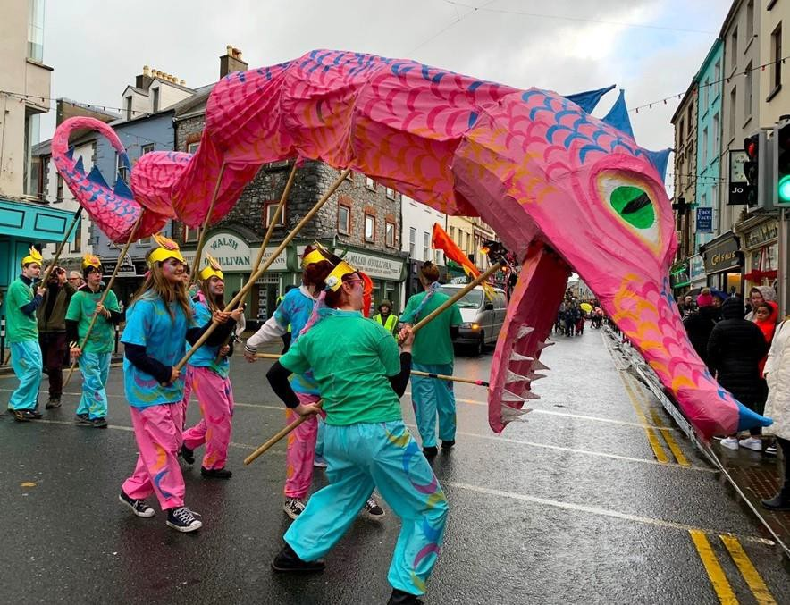
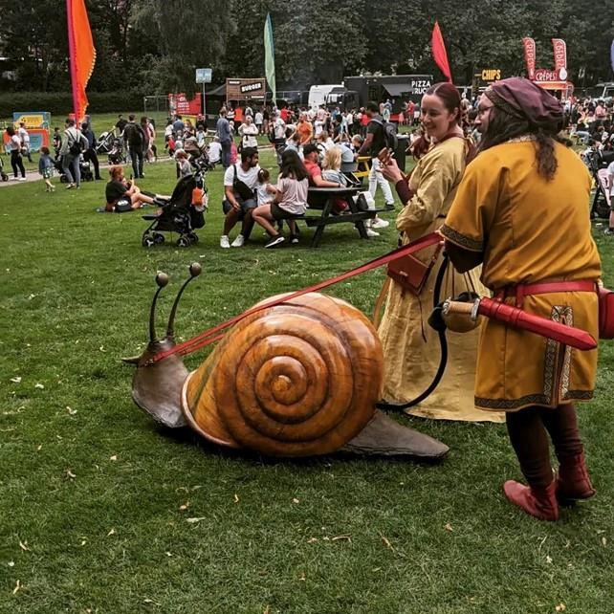

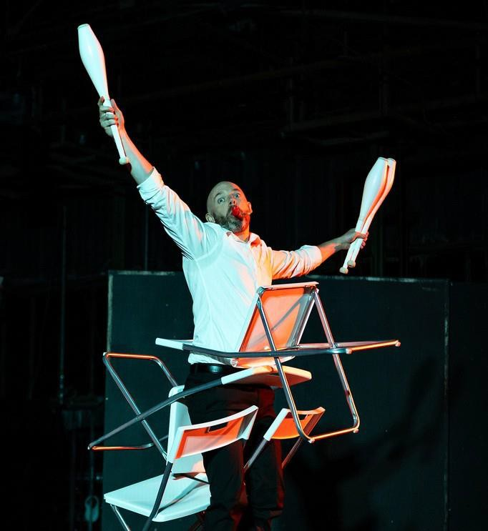
Brendan Fahy

Contact
E: jugglerbrendan@gmail.com W: https://jugglerbrendan.com Socials: @JugglerBrendan

Art Form: juggler and circus artist

Projects / Workshops
I am a teacher and performer of juggling and circus skills for adults and children. My workshops focus on fun, achievable tricks with a variety of different props, to make sure that every student leaves with a feeling of accomplishment and pride. Each class uses multiple different props to develop skills of balance, throwing/catching, and object manipulation. Longer sessions, or multiple sessions, allow for progressing beyond the introductory tricks, to highly visual multi-person passing patterns and even the creation of short performance routines.

Juggling is non-competitive, social, and has an enormous range of proven benefits, both physical and mental, to people of all ages. Circus skills are for everyone – no previous hand-eye coordination needed!

Background
I’ve performed and taught all over Ireland, including the National Circus Festival, Galway Community Circus, Cork Circus Factory, and I’m a former board member of the Dublin Circus Project. I’ve worked in a variety of community contexts such as schools, youth groups, festivals, sports clubs, and social programmes. This work ranges from introductory classes covering a range of circus props, to adult-and-child workshops focusing on partner tricks, to juggling intensives for sports clubs looking to develop hand-eye coordination. I’m registered with the Teacher Artist Partnership (TAP+) programme and ‘BLAST: Arts in Education’ through Wexford Education Support Centre, and I’m a professional member of the Irish Street Arts, Circus & Spectacle Network (ISACS).

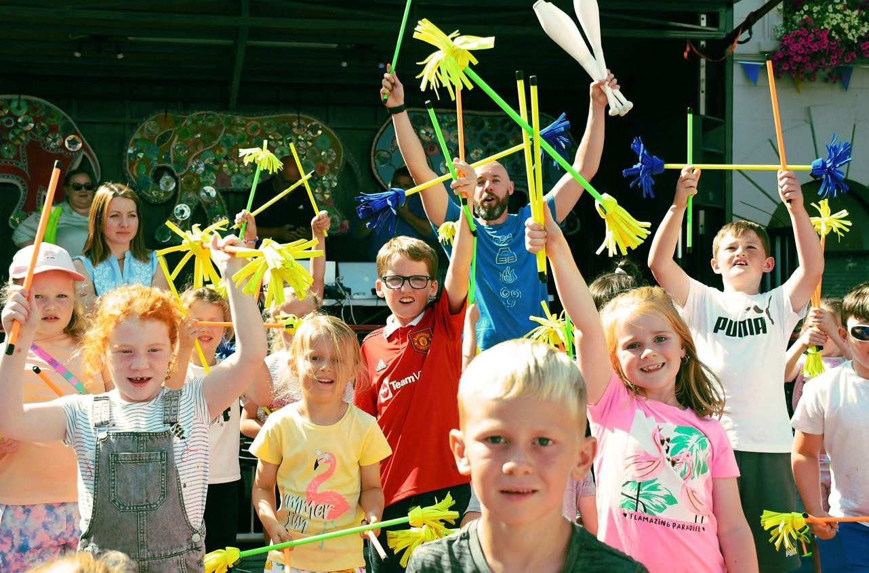

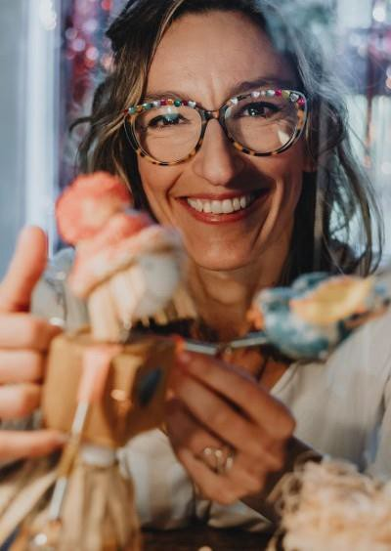
Fernanda Ferrari

Contact
E: bubbleoflightstudio@gmail.com W: www.bubbleoflightstudio.com P: 083 4618188
Socials: @bliss_to_fly

Art Form:
Performer, Visual Artist, Puppeteer, Art facilitator, Storyteller

Projects / Workshops
IIt is well-known that art and creativity have a positive impact on our mental health and general well-being. In my practice, I integrate different artistic languages such as Art & Craft, Storytelling, DIY toys, Visual Arts and Puppets to create enchanting experiences for the audience. My approach in my workshops is to encourage participants to express themselves freely in a relaxed and safe environment. Playfully, I invite children and adults to create simple visual art or craft projects to experiment with art without fear of doing right or wrong. The important is not the result but the joyful process of creativity. Joy is proved to be a tool for healing and creativity is a powerful tool for self and social transformation. My aim with my work is to inspire young audiences to develop a strong feeling of belonging, self-steam, and creative thinking.
A differential in my workshops is that I use my performance background, coming always with a colourful costume, to evolve the participants in a magic environment.
The projects for the workshop could be tailored to meet the needs of the specific community. And facilitated for children aged between 3 to 12 years old, families and adults.

Background
For the last three years, I have been collaborating with the MOTHER TONGUES, a social enterprise working to promote multilingualism and intercultural dialogue in Ireland. With them, I develop projects and facilitate art-based workshops in schools, libraries, and community centres for multilingual children and their families. In 2023 we developed a pilot project to strengthen linguistically responsive pedagogy in Early Years settings in partnership with Early Childhood Ireland called OWL (Our World Language). This project was funded through the TOY SHOW Appel. Also, in a partnership between MOTHER TONGUES and the Glencree Centre for Peace & Reconciliation, funded by the International Protection Integration Fund (IPIF), I facilitated workshops for refugee families in Clondalkin/Dublin.

In 2021 and 2022, I was awarded by the Arts Council with the YPCE Bursary Awards, and by the South Dublin County Council in 2022 with the INDIVIDUAL ARTISTS AWARDS BURSARY. In 2023 I developed an interactive installation mixing puppetry and cutting-edge AR technology supported by the YPCE Arts Council Bursary Awards and The Civic through the Ready, Steady, Show! Commission.

Also, in 2023 I facilitated workshops in schools through the LIVING ARTS PROJECT and “Drawing is a Universal Language” project, both supported by the Wexford County Council/ ARTS OFFICE.

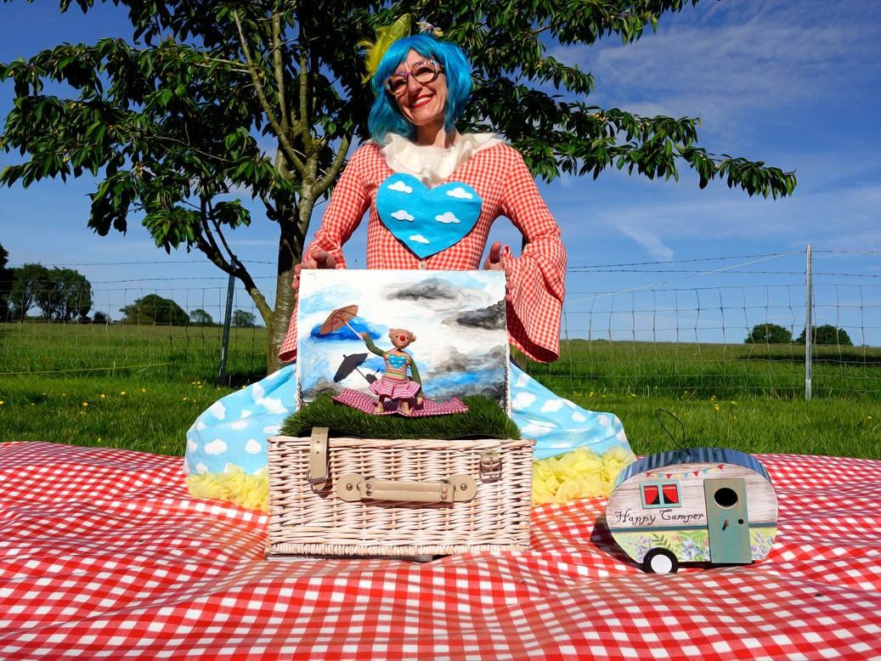

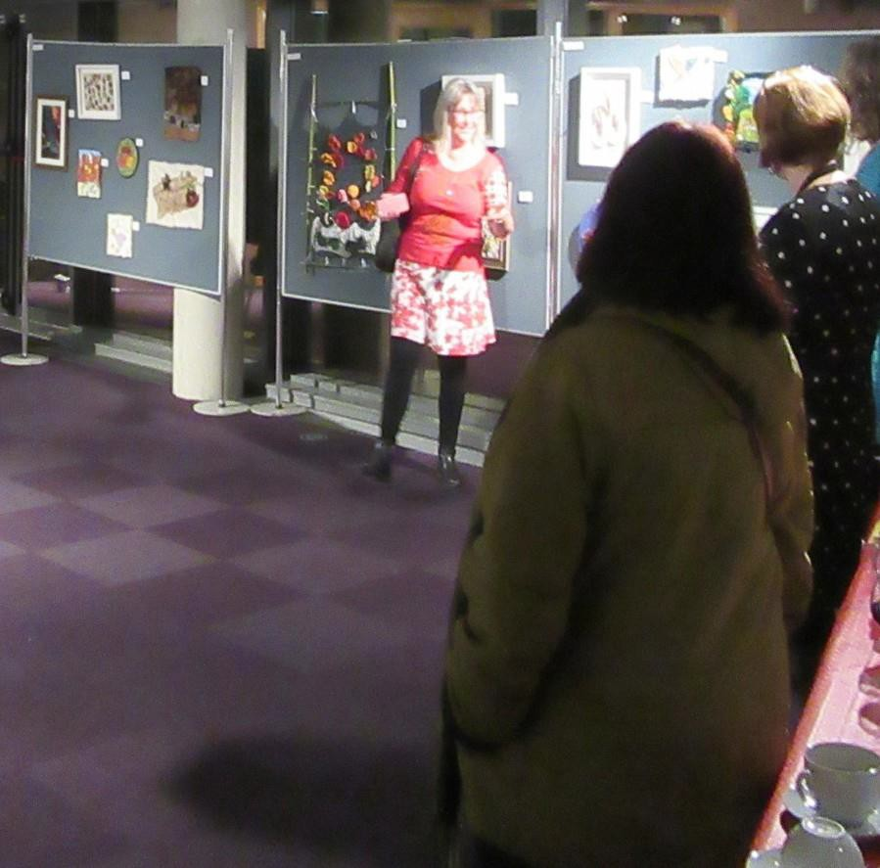
Doreen Fitzmaurice

Contact
T: 0863028743
E: doreenfitz@hotmail.com

Art Form:
Textile Arts + Mixed Media

Projects / Workshops
Participants use traditional textile techniques and skills in innovative ways; and discover new contemporary methods. Investigating current themes we explore textile art as a means of self-expression. I specialize in leading projects using:

Plant foraging and natural dying
Everyday plants, flowers and seeds are gathered to make dye pots.(e.g. onion skins will dye wool yellow). We identify plants which will make dyes to create a variety of sustainable dye pots, these can colour a range of recycled textile fibres and fabrics.

Felt Making
Exploring both wet and needle felting techniques, workshops are flexible enough to accommodate beginners in addition to those who have skills and want to build on them through creative projects. To support Wexford farmers we try to source wool locally.

Tapestry Hand Weaving
Tapestry hand weaving is one of the oldest ways of making cloth. Using a simple wooden frame, warp threads are placed vertically to form a taut lattice structure. After preparing a design – called a cartoon, coloured weft threads, are then horizontally woven in and out of this warp forming patterns to create a strong textile picture. Workshops are personalised for the group participating, projects can include a mix of workshops, techniques and art mediums.

Background
My Wexford based art practice uses a range of mediums, including Weaving, Felting, Embroidery, Batik and Natural/Eco dyeing. After attending Art, Craft & Design courses in Wexford and Grennan Mill, Thomastown, I specialized in Art Textiles at Crawford College of Art, Cork. Degrees that I undertook previously in Education and Nutrition led to extensive experience teaching cooking and nutrition, in addition to craft.
Work I have exhibited in Solo and group shows, explores textural narratives through landscape and figurative compositions; and responds to stories, travel and social injustice. My work with community education art projects investigates art as a process of personal and professional development, in addition to communication and reflection on the social, political and cultural life of a community.
With Creative Ireland funding I ran a community textile art project on the theme of Biodiversity; participants initially gained and shared skills by making individual pieces of work, and then collaborated on a larger piece which was donated to Wexford General Hospital.
Through community projects I have learned that the mutual exchange of ideas, skills and knowledge and a willingness to allow the project to develop through this sharing is what makes working on community-based projects so challenging and rewarding.

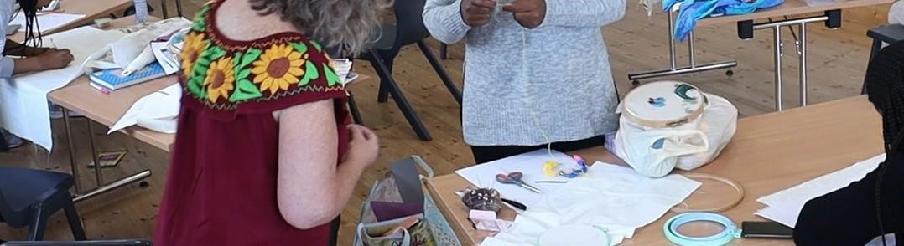

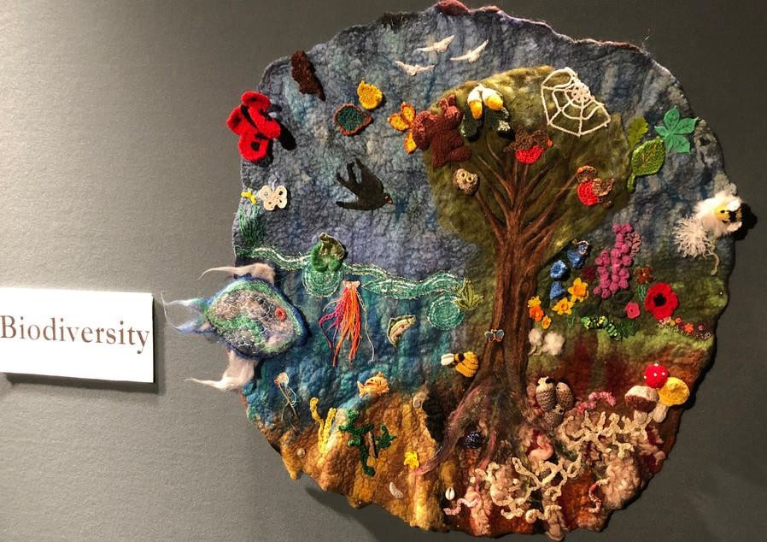

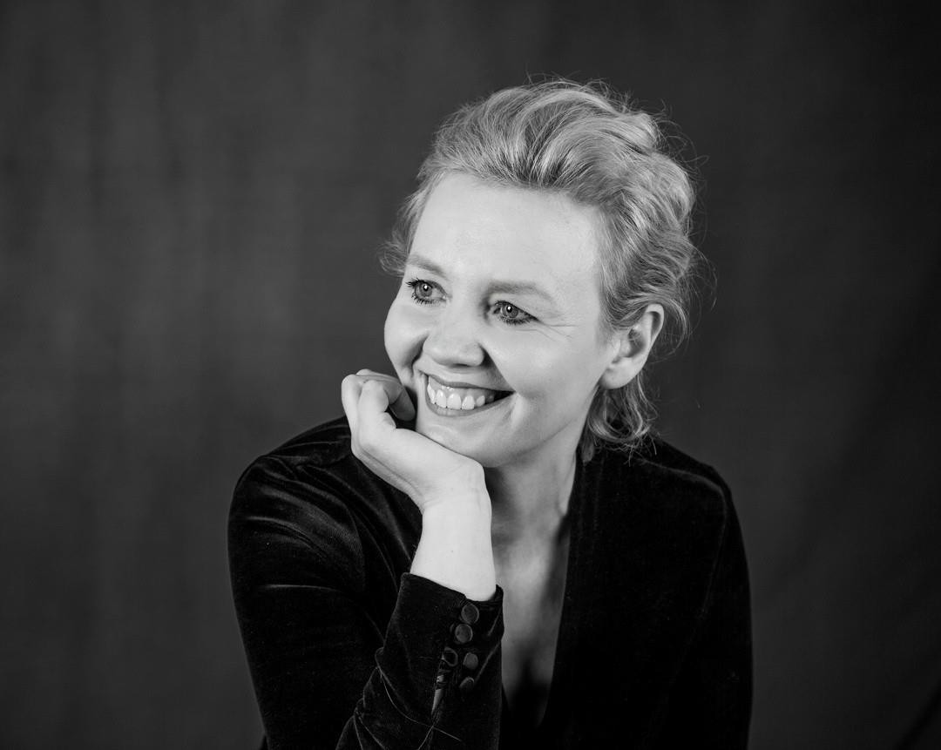
Sheila Forsey

Contact
T: 0876338027
E: sheila.forsey@gmail.com
W: sheilaforsey.com

Art Form:
Literature

Projects and Workshops
Example of what a project could entail. Beyond Boundaries – Narratives of the Unheard.
The creative writing project or series of workshops will aim to give voice to the marginalised voices of society that often find themselves unheard. The project will focus on uncovering the more silent voices and empowering them to creatively express themselves and their unique perspective. Sheila believes that this in turn will lead to a deeper understanding for society and will contribute to a more inclusive narrative.

Workshop/Project overview
Sheila will aim to design a series of workshops that will focus on developing the art of weaving compelling narratives from personal experiences. Taking into consideration the specific needs of the community group the workshops will be tailor made. The focus of the process and outcome will be to offer a platform for participants to express their creativity and empower them to tell their stories in whatever creative way that they wish. The culmination of the project could be a publication of their written works creating a tangible record of their voices.

To conclude – Empowering marginalised community groups through the power of creative writing goes beyond storytelling. It becomes a tool for self – expression, cultural preservation, community building and contributes to a more inclusive and understanding society.

Background
Sheila Forsey is an Irish Times best selling author of historical fiction. She is a graduate from Maynooth in creative writing and has completed a postgraduate in Trinity College where part of her studies were design thinking and critical thinking. She is inspired by the past and is passionate about writing about the forgotten voices. She is an experienced mentor and creative writing tutor. She has a special interest in built heritage and is a specialist with The Heritage Council.

She is the tutor for the creative writing module in Gorey Adult Education and has worked extensively with children, the youth and adults through Wexford Education Support Centre and Waterford and Wexford ETB. She hosts workshops throughout Ireland at literary festivals and in 2024 has been appointed judge for the prestigious Marie Edgeworth short story award.

One of her last projects was overseeing the publication of a book to commemorate a school that was sixty years old. It was written by the children of the school and inspired by all the history associated with the school. Sheila believes the strength of any socially engaged project is in listening to all voices and in the power of collaborative work.

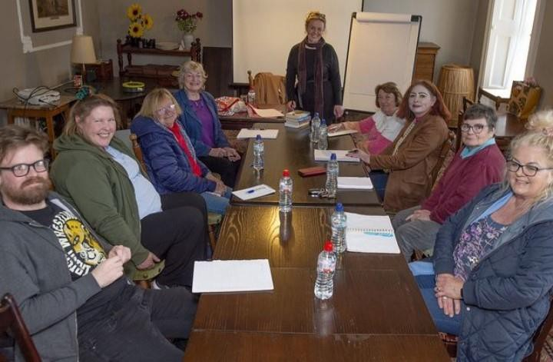

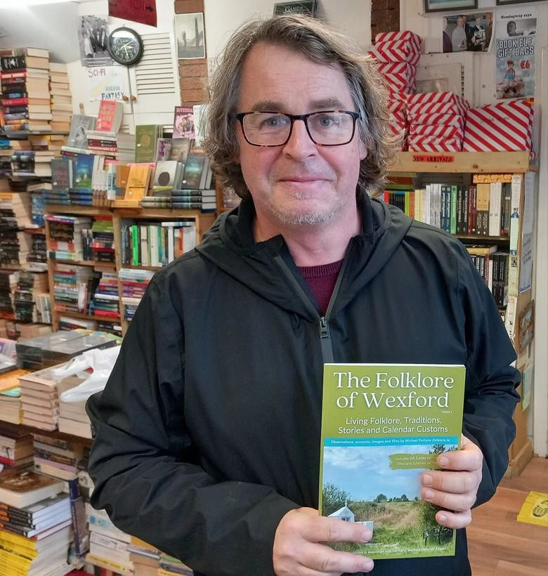
Michael Fortune

Contact
W: www.folklore.ie
Socials: www.facebook.com/folklore.ie
P: 087 6470247
E: folklore.ie@gmail.com

Art Form:
Visual Art (Photography and Film)
Traditional Arts (Folklore, Storytelling and Song) Publications (Digital and Physical)

Projects and Workshops
I have a strong socially-engaged arts practice where I collaborate and communicate with communities and groups in a variety of ways. I have produced films, books, archives, exhibitions, talks, seminars and digital maps
with communities on this scheme over the years and the end result or the form of engagement depends on the group and what they do and how we can collaborate.
Workshops depend on the group I am working with
and they could be with a group of Traveller women in a room Bunclody collecting folklore or with a group of traditional singers by a pier in St. Helens recording songs.

A project could take the form of a folklore collection of film.
I could help revive old customs or create a new one in an area.
Create a documentary about a local story or a new body of songs about a place. I could bring people walking through fields to look at what’s around them.
I could produce a publication of old dressers and vernacular furniture.
I could create an exhibition of photographs of historic and folkloric sites. I could produce a digital map of the local area.
I could explore objects and hidden treasures within our homes. The list is endless.

I love genuine collaboration with people and producing work that is honest, meaningful and valued by participants and myself.

Background
I have cut many furrows with my work for almost twenty years, and my practice has widened the conversations regarding the intersection of traditional and contemporary cultures in Ireland and the general appreciation
and understanding of culture in all its manifestations, especially in the area of folklore, the ordinary and the everyday. Working predominantly in film and photography, much of my practice revolves around the collection of material
– material, which I generate out of the relationships, and experiences I have developed with the people he encounters. I have produced an extensive portfolio of collaborative project work with people of all ages and abilities,
both rural and urban throughout the county.

My work connects with many audiences and on many levels, and I am as comfortable presenting work in a village hall in Cassagh as I am at an international film festival or gallery in Mexico. In recent years much of my
work is presented on social media platforms while I contribute articles and papers for various local, national and international journals/newspapers as well as RTÉ Radio and television. I run a page called folklore.ie on Facebook
which acts as an open studio to my practice and it currently reaches about 1 million people every 4 weeks. I like people and enjoy working with people and this is evident in the work I produce.

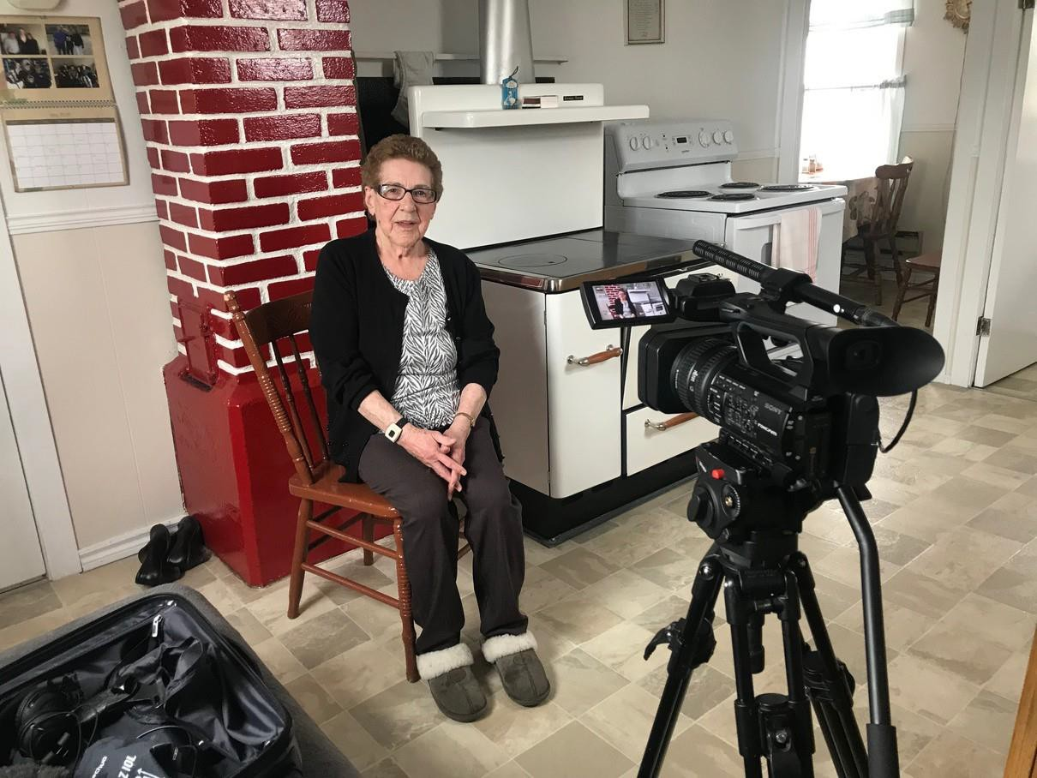

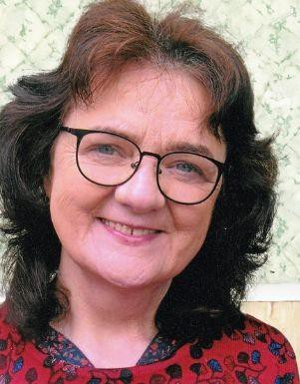
Margaret Galvin

Contact
E: galvinmargaret88@gmail.com
P: 053 9121924/087 3545014

Art Form:
Creative Writing, Poetry and Prose.

Projects and Workshops
I am interested in facilitating creative writing workshops for community groups with a social care, well-being or health remit. I am especially interested in working with people who are new to writing. I welcome the opportunity to assist participants to explore their own stories and consider the people, places and events that have shaped them. Such socially engaged work carries an important element of personal validation. Through engaging in this participatory arts practice, people who might never have considered expressing themselves in writing, find their voice. Person-centred work of this type, especially with groups that have been traditionally ‘hard to reach,’ can promote awareness, wellness and support and communicate a meaningful and shared sense of self. Workshops can have a general or specific focus depending on the needs of the participants. A general workshop might centre on ‘Writing for Self-identity and Understanding’ or ‘A Consideration of the People, Places and Events that Shape Us’. A more specific focus might involve writing for reminiscence purposes or for dealing with bereavement or distress.
Workshops can also have project focus in addition to the process element. Participants work might be displayed, for instance, or a reading organised. A small booklet or broadsheet might be produced.

Background
I hold a BA in Social Care and an MA in Child, Youth and Family Studies. I have been writing for many decades and published six collections of poetry, most recently, Our House, Delirious published in June 2023 by Revival Press, Limerick. My prose essays are frequently broadcast on RTE 1, Sunday Miscellany. I have also featured on RTE 1, A Word in Edgeways.

I have worked with Ard Aoibhinn Services, Wexford since 2018, facilitating a group of persons with intellectual disability to bring out a calendar of their creative writing on three occasions. In April/May 2023 I was a facilitating artist for the Festival in a Van project, working in eldercare in Grantstown Priory and Saint John’s Enniscorthy on a project called ‘Songlines’. Under Festival in a Van, I also facilitated a workshop for HSE Social Workers in Tullamore on introducing writing for clients with enduring mental health difficulties.
I have led a group of people availing of the services of a Social Prescriber to bring out a booklet of their creative writing in Clonmel Family Resource Centre in 2023. I have also received funding from The Irish Hospice Foundation to facilitate a day long workshop to assist those who support the bereaved to introduce therapeutic writing into the outreach.

A Sample of Writing Undertaken by Persons with ID, at a Writing Workshop JANUARY WEATHER
Snow, rain
falling, drenching, freezing.
I’d love to be by the fire, warm.

Hot Chocolate marshmallow sweet steaming, boiling, roasting in my cup.
Delicious! (Lesely) Winter Remedy
Warm jackets keep out Icy cold on Numb days.
Time to
Eat big roast dinners and
Relax on the sofa or in your bed! (Lesley, Eleanor, Michael)

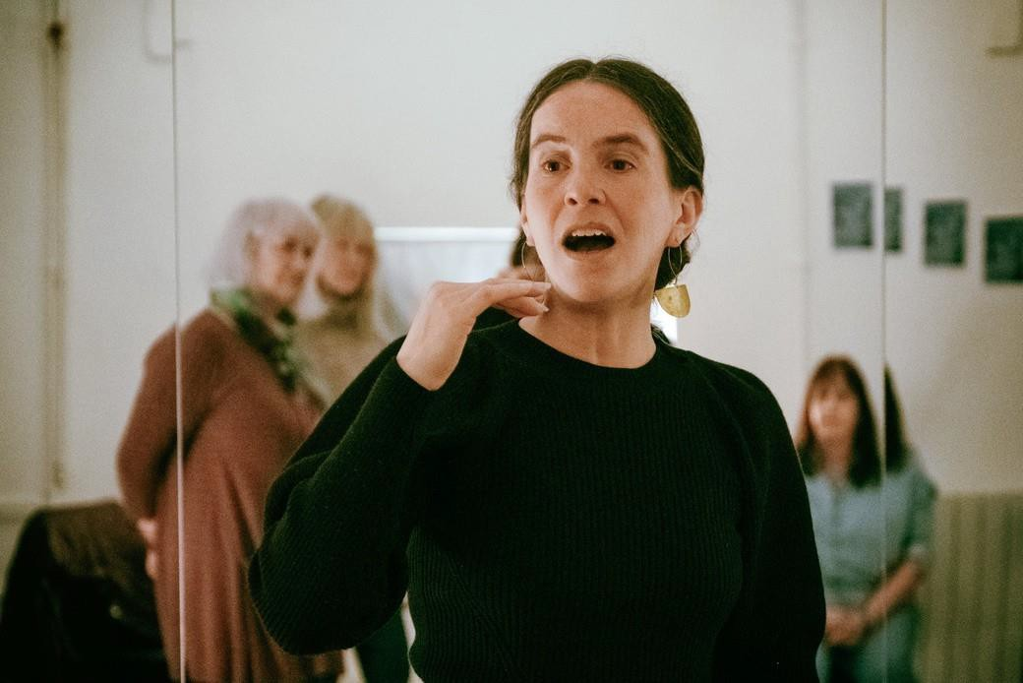
Laura Hyland

Contact
E: hylandla@gmail.com

Art Form:
sound art & music, multidisciplinary performance

Projects and Workshops
I can work with music or sound-oriented groups of any level, from beginner to experienced. I have an unusual approach to music-making & sound-art facilitation, which is not reliant on conventional music education at all, therefore, I welcome people who either have never played music or experimented with sound before, to those who are adept at a given instrument, but who would like to approach music-making and/or sound art from a different perspective. Improvisation is a key part of my approach. I'm particularly interested in groups who have a deep interest in the arts across the board, and who want to channel this interest and explore it creatively through sound.

Background
I'm an artist, composer & musician. I began my artistic career as a singer-songwriter with a zeal for experimentation in my teens, and gradually expanded my practice over the years to embrace the more experimental end of music and sound art. Recent works include a commission for Crash Ensemble (Ireland's foremost contemporary classical group; crashensemble.com), founding/directing experimental choir, Wildsong Ensemble (wildsongensemble.org) designing a permanent public sound art sculpture for the Irish National heritage park, my avant-folk band, Clang Sayne (clangsayne.com), and selected artist for Improvised Music Company's 30th anniversary program '30/30' ( improvisedmusic.ie/listen-discover/30-30 ).

Working within community settings has been a core element of my practice since I became interested in 'free' improvisation while Iiving in London in the early 00s. In addition to performing professionally with fellow players from the international improvised music community, I've facilitated various community- oriented music & sound art projects in Cuba, London, Denmark and Ireland.

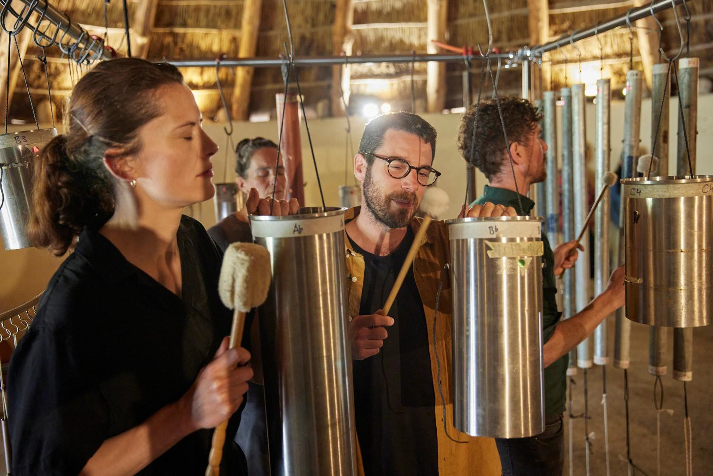

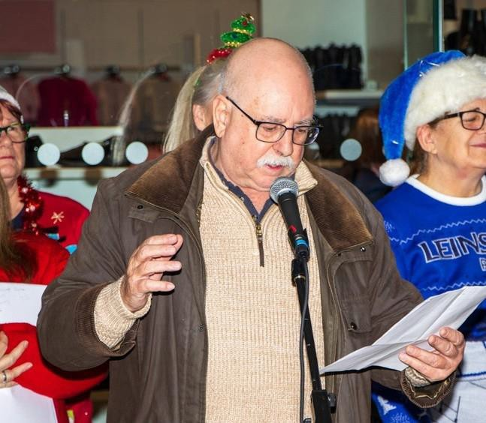
Garrett Keogh

Contact
E: gaarcy@gmail.com

Art Form:
actor, writer, theatre-maker, woekshop facilitator, festival director.

Projects / Workshops
Whether for pleasure, study, or performance, whether you want to write, act, direct, or simply enhance your enjoyment of going to the theatre, I can offer an actor/writer/director’s insight into plays and playwriting.
Tailoring a series of in-person or online participative workshops suitable to your group of adults/young adults, I can concentrate on your choice of play or plays, writers, genres, or on specific aspects of theatre.
In a system developed over many years of participative practice, and based on the professional rehearsal process, I offer practical hands-on approach. This is designed to break down the barriers between the reader and the text, to lift the words off the page, and to explore the wonderful illusion that audience, readers, performers and characters freely enter into.
Also, as co-founder and director of the Gap Arts Festival since 2011, I can advise and help in developing and funding artists, projects, and community festivals.

Background
Having at the Abbey Theatre I performed in theatres and halls all over Ireland. I’ve played on Broadway, the West End, the Hellfire Club (up a chimney), on Dollymount Strand (in a barrel), and in Seán McDermott Street (in a coffin).
My writing was recognised by a Stewart Parker Award, an Oireachtas Duais Script Teilifíse, and a play I directed won an Edinburgh Fringe First. As well as the www.gapartsfestival.com, I have overseen the festival’s workshops, in poetry, puppetry, film making, playwriting and photography.
Culture Night 2023, I produced From Ballythomas to Memphis and Back, an illustrated presentation with live music reliving one man’s journey to the cradle of the Blues.
December 2023, as part of Creative Ireland/Wexford Arts, I devised the X-GAP Project, a collaboration between community writers, singers, performers and professional artists.
2021, with Hollyfort Writers Group, a series of online workshops featuring women playwrights.
2020, supported by the Arts Council, a series of workshops for adults online, exploring Synge’s short play, In the Shadow of the Glen: the language, the isolation, the rain, the sheep… And the dilemma of a young woman stuck in an abusive marriage with an old man.

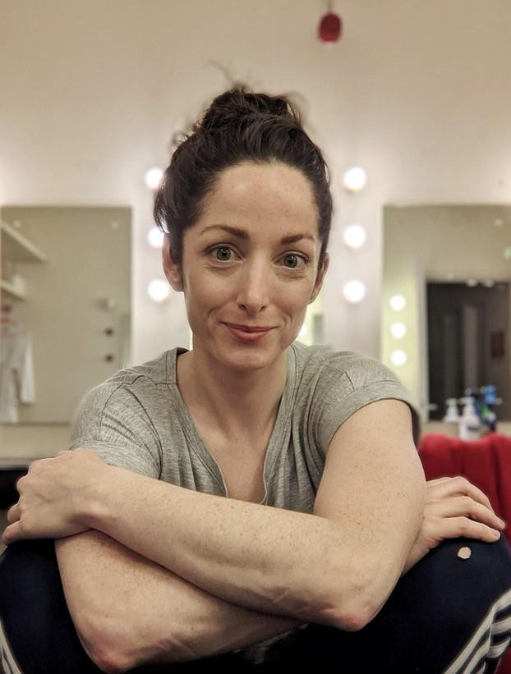
Lucia Kickham

Contact
T: 086-0632640
E: luciakickham@gmail.com
W: www.luciakickham.com
Socials: @luciakickhamdanceartist

Art Form:
Dance Artist

Projects and Workshops
As a dancer I am passionate about serious play; how we can explore complex topics through movement and play. In my work I aim to facilitate a space where everyone can be involved, from the shyest child to the wildest extrovert, with movement and content tailored to the needs of the specific group. We can build energy or find relaxation. I can provide a wide range of options for community group workshops, leading a single event, a series of classes or co-facilitating sessions with another art-form to bring movement into the room as another language.

I’m interested in working with community groups to develop important skills in confidence, coordination, trust, body-awareness, and collaboration. The goal could be to create an event, a dance performance or ultimately to bring people together to dance in a welcoming workshop setting. I have been producing my own choreographic dance works for stage since 2015 and have a wealth of experience in project planning and implementation. I would be very happy to discuss project proposals and formats for all kinds of community collaborations. Your imagination is the limit!
As a dance performance teacher and mentor, I have gained a wide range of experience across different age groups and teaching environments. Primary school: Dance workshops exploring themes related to professional dance performances which the children had seen;
-2013 Rabble tour and outreach with Underhand Dance Company/Macrobert Arts Centre Scotland with a work about inclusion and anti-bullying,
-2014+2018 Flora Fauna Project outreach initiative between four schools in Ballymun supported by Dublin City Council Children's Art in Libraries Scheme with work about biodiversity and climate action.
Secondary school: Series of workshops creating a dance with the Transition Year students sharing ways to make a dance piece together and build confidence with performance
-2022 Project Arts Centre Dance in Schools Residency at Stanhope Girls School Stoneybatter Dublin Youth Dance:
-2019-2022 Mentor on NoiseMoves EMERGENCE programme funded by South Dublin County Council. This is a series of monthly workshops and meetings with young people (16-25 years) across an 8 month time frame, guiding them in making their own dance pieces and performing them on stage.

-2022+2023 Step Up Dance Project, a national training opportunity for early career dancers. While this is a professional context, in this role I offer support relating to a number of areas of development applicable to community and professional groups alike: building confidence, body awareness, communication, connecting with others, dealing with stressful situations and mental fitness for performance.
Adults:
-2022 Workshops at D-Light Studio Dublin with Flora Fauna Project community group, working on warm up, creative sessions and relaxation. This session was a highlight of the week for many of these women with feedback received that it was the one time they had for themselves away from care responsibilities.

Background
Lucia Kickham is a Wexford based dance artist. Trained in the Netherlands she has worked with many professional dance companies and artists including Liz Roche Company, Company Philip Connaughton, Junk Ensemble, Maria Nilsson Waller, Laura Murphy, TRASH(NL) and Oonagh Kearney.

Training intensively with David Zambrano in Flying Low and Passing Through techniques, Lucia has developed her interest in group dynamics within improvisation, composition and teaching environments. Lucia is a guest tutor at IWAMD at University of Limerick and regularly leads workshops at dance centres across Ireland.

In recent years she has been a recipient of awards from Dance Ireland, Dance Limerick, Tipperary Dance, Grand Studio Brussels, Tanztendenz Munich and the Arts Council of Ireland, including the Next Generation and Commission Awards.
Lucia has been expanding her practice in both professional performance and community contexts with a specific focus on care and sustainability. She is excited to work further in this area locally in Co.Wexford as a parent artist.

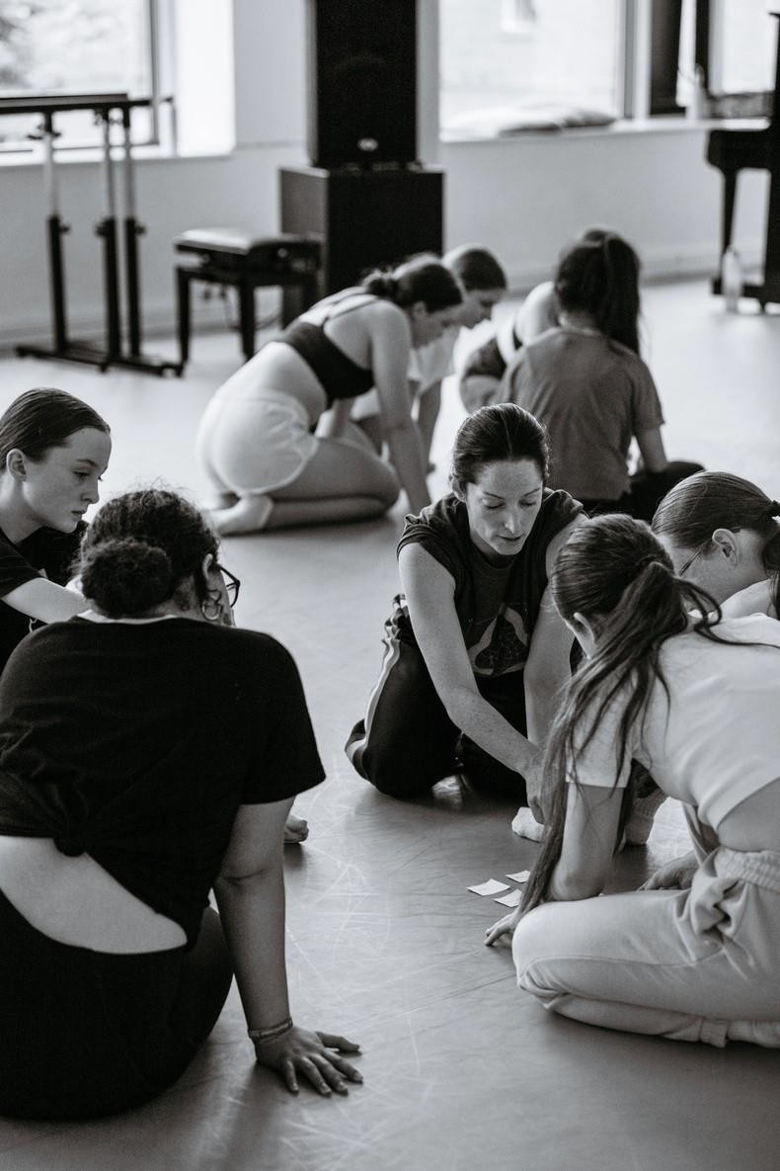
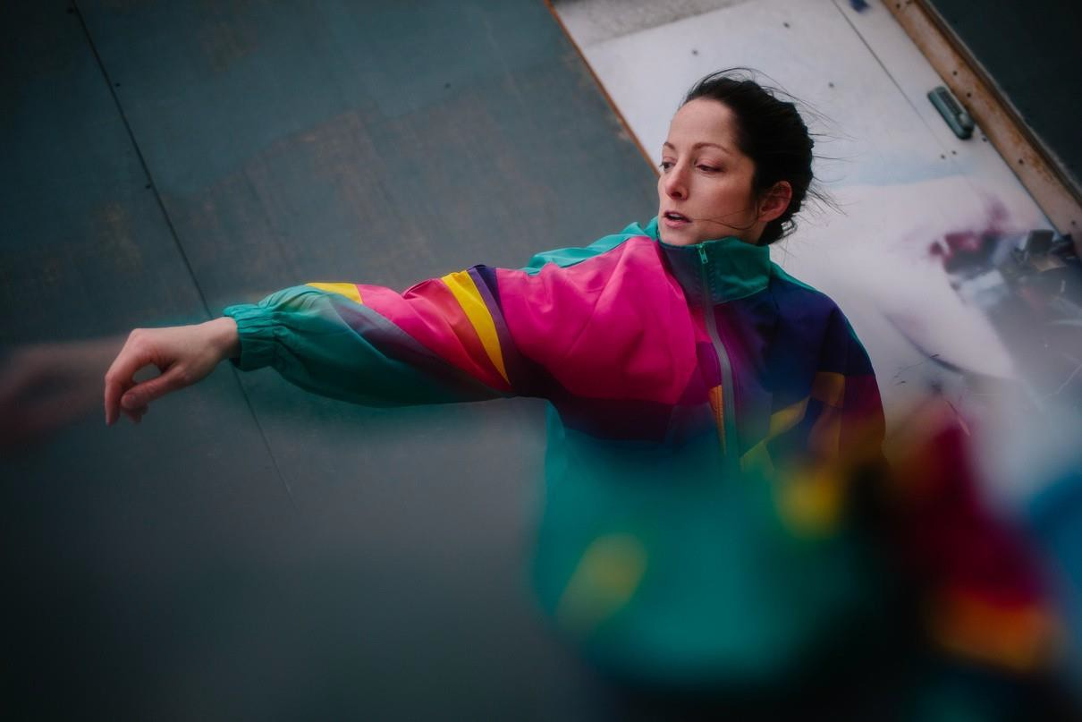

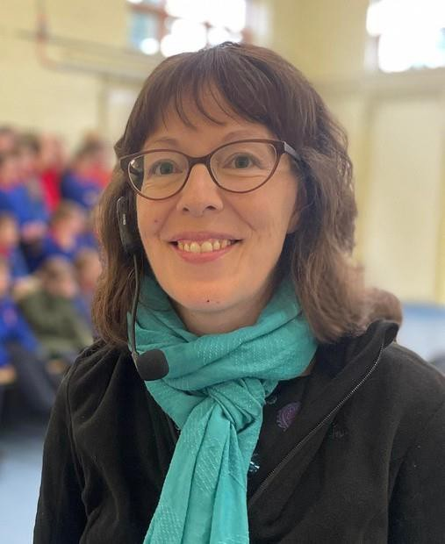
Aileen Lambert

Contact
T: 087-7552593
E: aileenlambert@gmail.com

Art-form
Music–Traditional song, visual art, video, song- writing.

Background
Projects may involve researching and collecting local songs, learning songs and recording participants performance of songs, researching songs on a particular theme, working towards a themed performance. There have been songs written about almost any topic – sport, love, war, journeys, animals – is there is great potential to link a traditional song project with any group or individual’s particular interest.

There is a great emphasis on enjoyment, building confidence, facilitating everyone’s participation and finding something that will interest everyone. Even is a person is not particularly interested in traditional singing as such, you can be sure to engage them in a lively action song, a comic song or a song about their favourite hobby, or hometown etc.
Visual Art Practice: Projects may also be supplemented with the use of photography and video and audio recordings of participant’s performances.

Parting note! I am thoroughly committed to the promotion of traditional song and continue to find ways to enable communities to connect with this part of our heritage. My wide range of skills and experience, (which includes performance art, video work, photography, undertaking public art commissions), and most of all my way of working with people places me in a perfect position to devise new projects with creative communities in county Wexford in 2024.

Background
Aileen is a traditional singer, researcher, song-writer, composer and educator. Her background in visual arts brings experience of working in a participatory arts context to the field of traditional arts. Over the past twenty years she has established her creative approach to traditional song projects from collecting and interpreting songs to song-writing and composing new airs. She is passionate about sharing her love of songs and singing and her enthusiasm is infectious.

An experienced music educator she delivers workshops and undertakes projects with all ages and abilities. For the past fifteen years she has been a specialist with the Heritage in schools scheme and delivers workshops in traditional song to Primary Schools across the southeast. She regularly performs alongside her three daughters who feature in many online song workshops with her. Her publication The Frog and the Mouse – Traditional Irish Songs for Children was launched in November 2021 and demonstrates her commitment to preserving and promoting our rich song heritage to younger generations.

At the core of her work in community contexts is an emphasis on encouraging others to sing and expand their repertoire. Her approach to engaging and involving others in her traditional song practice results in a most meaningful experience for both participants and audiences alike.

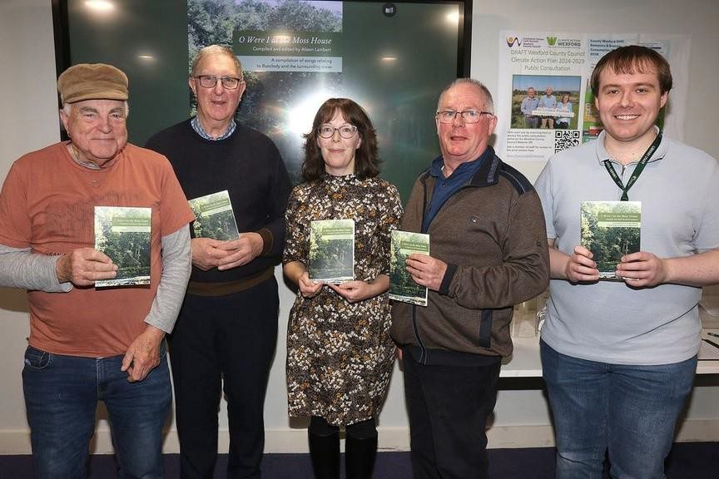

Aileen’s Creative Community Project 2023

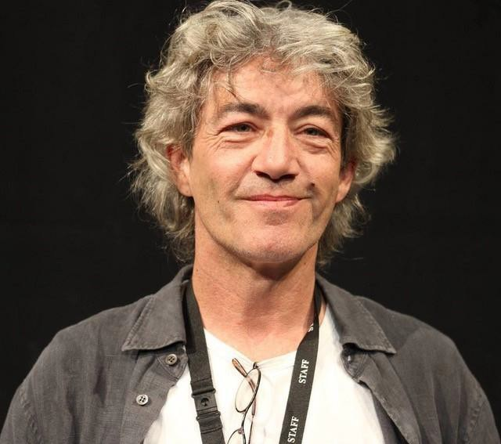
Tony McCleane-Fay

Contact
T: 0876404187
E: tonnymccleanefay@gmail.com

Art Form:
Theatre & film; Specialising in
Devising & creating new work in collaboration with the group Acting & Production Tutor

Projects and Workshops
Working with a community, children, teenagers, or adults on creating a new piece of theatre or film about issues that interest them or a new piece of fiction just based on a story we create together. The project can happen over a period of time, e.g. an evening or two a week, or at weekends or perhaps a full immersive week.

Participants do not need to have any prior experience of the art forms. Past projects under the Creative Communities initiative included a week-long project where participants (a group of young teenagers in Raheen) created and wrote a short film about a haunting; a project over a number of weekends in Kilmuckridge where we created a substantial theatre piece about the local community; a six-month long drama project where we staged a version of ‘Hamlet’ and another devised piece about the participant’s lives in Enniscorthy.

Theatre and Film work encourages creativity, self-confidence, and self-expression. The group will be able to develop or further enhance many skills such as acting, technical & production, writing and above all enjoy the camaraderie of working together to produce something new that they have created.

Background
Tony obtained a post-graduate degree in Performance Studies from Middlesex University in 1996 and an MA in Drama & Theatre Studies from UCC in 2004. He has been directing stage productions for approx. thirty years both in Ireland and the U.K.

He was Technical Director of the Institute of Contemporary Arts, Director of the Barnet Drama Centre, and Manager of the Man in The Moon Theatre; all in London during the 1980’s and ‘90’s. He was Stage Production Officer with Aberdeen District Council in Scotland, covering all the Council’s venues and Assistant Director of St. Stephen’s Theatre in Cardiff, Artistic Director of Cork’s Granary Theatre and taught on UCC’s under-graduate theatre programme and ran the Gaiety School of Acting Cork division. He is currently a Creative Associate on the Arts Council’s Creative Schools Programme, working with schools in the delivery of Arts through Education and is an Engagement Coordinator with the Dublin Culture Company.

He has continued to be Artistic Director of Bare Cheek Productions and County Wexford Youth Theatre since 1998. Tony has recently become more involved in film and TV, directing a series of TV shorts for the Arts Council (CSTV), some short films and two features and is directing another feature later this year in Wexford.

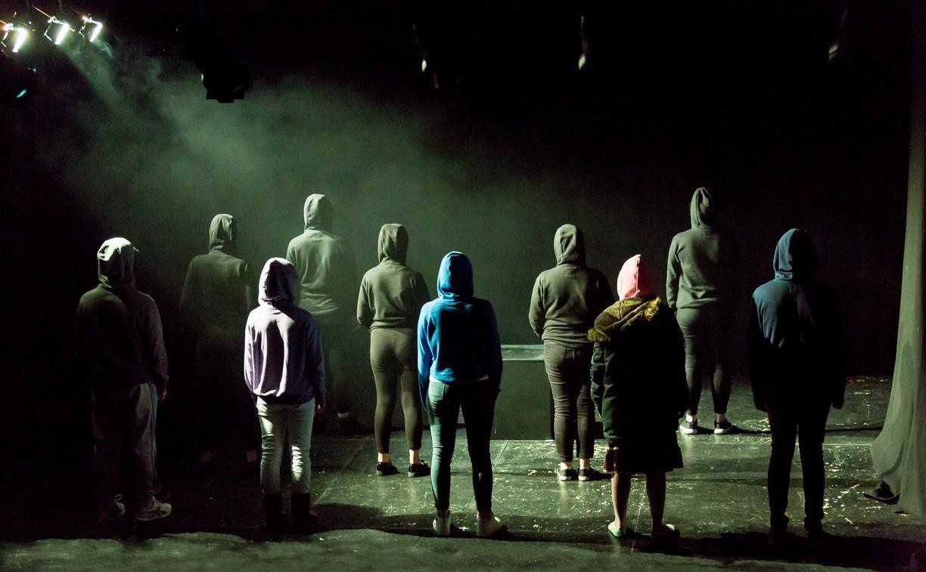

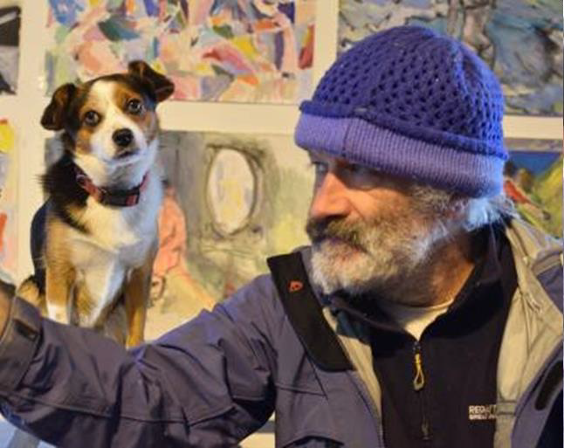
Andi McGarry

Contact:
E: sunmoonandstarspress@hotmail.com

Art-form: Visual Art

Projects/Workshops
Artist Led Collaborative Projects/Boat Projects/ Artists' Books Projects/Visual art workshops /Exhibitions /Gallery based activities /Music Making Project/ Collaborative film making projects/ multi-disciplinary collaborative projects

Background
I am an experienced artist and maker with an extensive background in participatory arts. I graduated with an MA in Social Practice and Creative Environment from Limerick School of Arts and Design. The nature of my visual arts practice has enabled me to interact and collaborate with many communities. I can start any project from the ground up.
My varied experiences have enabled me to form new collaborations and develop partnerships with a wide range of individuals, groups, agencies and fellow artists. I have a good sense of humor, and this often comes in quite handy as an effective tool for breaking down barriers and putting people at ease.

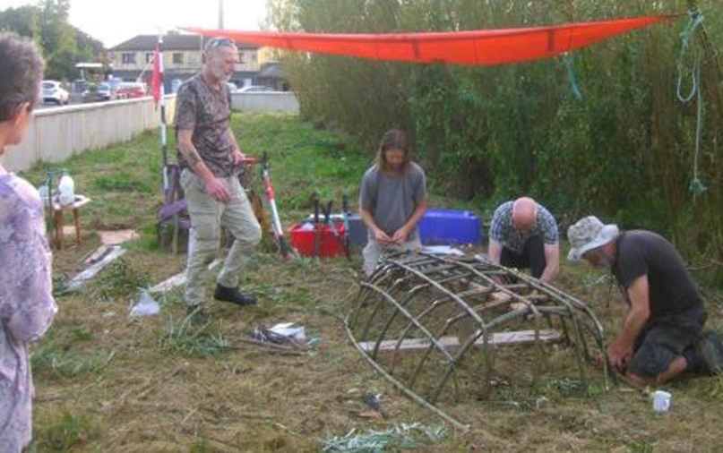

Paddle your own Canal 2023

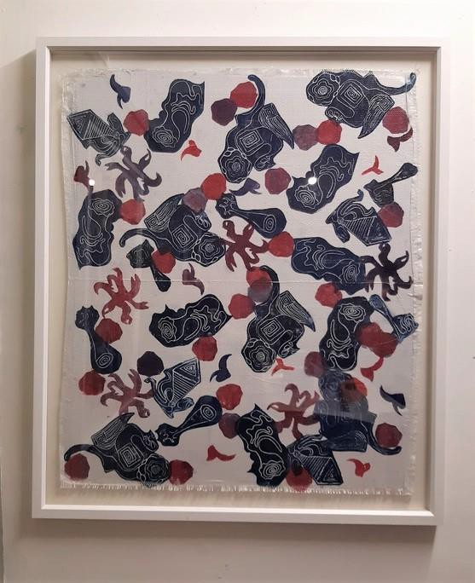
Deidre Meehan Buttimer

Contact
E: deemeehanbuttimer@gmail.com
P: 086 8275494

Art Form:
Print / Mark Making with Inks and everyday objects

Projects / Workshops
Text / language forms a big part of my practice, across a range of media e.g. print / mark making, voice recording, journals, drawing, painting, photography, video.
·My main workshop media is print / mark making in a creative, fun, mindful manner:
Working with inks and everyday objects, to narrate stories
Creating individual pieces, using a selection of methods and a range of print surfaces Print / Mark making collaborative pieces
I have considerable experience in participatory collaborative / socially engaged work, which is a large part of my successful art practice, including Creative Communities Projects:
2019: ‘Coercive Control’ Project, with Wexford Women’s Refuge, which became an exhibition in Creative Hub “THIS IS WHAT IT IS” .It was a 6 month collaborative, developmental, text and object based project, empowering participants to use personal experiences to describe Coercive Control. 2022: Windmill Therapeutic project, looking at what it is like to be an adult with intellectual disabilities, which we expanded to an exhibition “HOME GATHERING OF FRIENDS”
2023: SI Wexford (Soroptimists) project, looking at ‘Orange the World’ and “16 Days of Activism Against Gender Based Violence”, which we expanded to an exhibition “HEED” in Wexford County Hall, Carriglawn.

Background
I live and work in Wexford. My art practice, which is experimental in nature and driven by a positive, intuitive, and curious approach, comprises:
- studio based work in my printmakers’ hub, Creative Hub Wexford Town
- collaborative / community residencies, projects and workshop facilitation.
I’m influenced by how we live our lives in interaction with our everyday surroundings/objects. Humanist studies show we leave our marks there and tell our stories, vs. documentation. I gather found, gifted, source materials, take photographs, drawings, rubbings, and collect anecdotes and texts. My practice has a strong photographic/drawing element, using inks, mixed media. I use a mixture of non-standard surfaces to draw, print on / ‘stitch into’ and collage, e.g. linen effect paper, and fine art surfaces, e.g. Fabriano / Canson paper, for intricate fine ink drawings. My current body of work is created through automatic drawing / subconscious mark making.
My work emanates from “collaborative story telling “ using everyday objects, the more personal the better, giving people (including myself) a voice and the right to have our stories told, listened to, and understood. I love solo work, but also need the interaction and energy from working through creative processes with others. My interpersonal skills have been crucial in achieving successful collaborations with community groups.

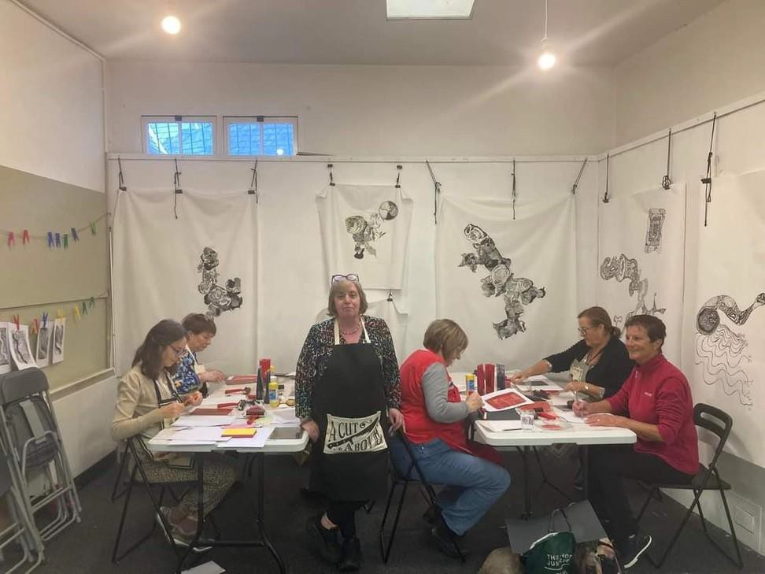

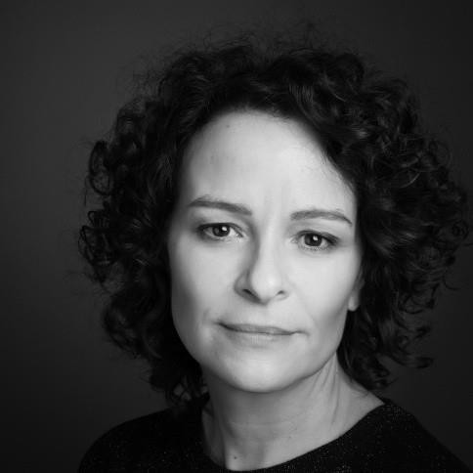
Kate Murphy

Contact
T: 086-3552203
E: katemurphyemail@gmail.com

Art Form:
Visual Art – painting, drawing, crafts, sculpture, street-theatre, mural, mixed media

Projects and Workshops
My approach to art-making centres on fun, humour, experimentation and 'thinking outside the box'. I like to try to new ways of working which may be outside the usual.
For newcomers to artmaking, my approach is to build confidence by making small steps, with an emphasis on finding the core of the group's interests, drawing out each participant's own visual language and art-making skills.

In the past, I have assisted groups with the following art practices: painting, drawing, sculpture, street-theatre props and costume, mural design, puppetry, paper crafts, mixed media installation, construction, clay-modelling as well as in the areas of basic art theory, art appreciation and history.

An important part of making art is viewing the work of others and I would happily facilitate groups to visit exhibitions in Wexford or further afield.

Background
I graduated from the National College of Art & Design in 2000 with an honour’s degree in Fine Art.
I have worked as a professional visual artist since 2001, with a number of solo exhibitions in galleries in Dublin and Wexford and have participated group exhibitions nationally and internationally. Most recently I exhibited my work at Claremorris Gallery, Co. Mayo and will show my work again in March 2024 at the Molesworth Gallery in Dublin. My paintings have been purchased by the Office of Public Works, Bank of Ireland, Wexford County Council, Wicklow County Council and by private collectors.

For the past 12 years I have worked in various collaborative/educational contexts with a wide range of participants, including Men’s Sheds, Women’s groups, at-risk children, mental health groups, school groups and adults with disabilities. I worked for seven years on Wexford Arts Centre’s Insight Education Programme for children and have also delivered a wide range of adult projects through Wexford County Council Arts Office, Creative Schools and other funding bodies.

I have undertaken Azure training to work effectively with older people and those living with dementia and have completed TAP (Teacher-Artist-Partnership) training on working with school teachers. I have Tusla and HSE safety certificates. I am currently working in St. Aidan's Parish School under the Living Arts Project, an artist-in-schools residency (Wexford Arts Centre and Wexford CoCo) and am looking forward to a number of forthcoming projects with Wexford Mental Health Services, Wexford General Hospital and Waterford Healing Arts Trust

I have also worked in the area of arts administration and am experienced in writing applications.

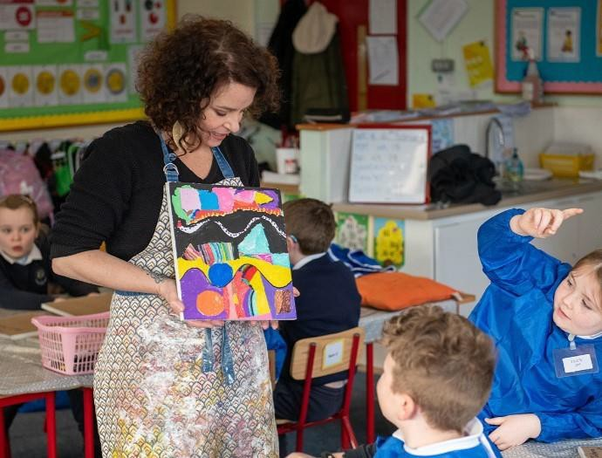

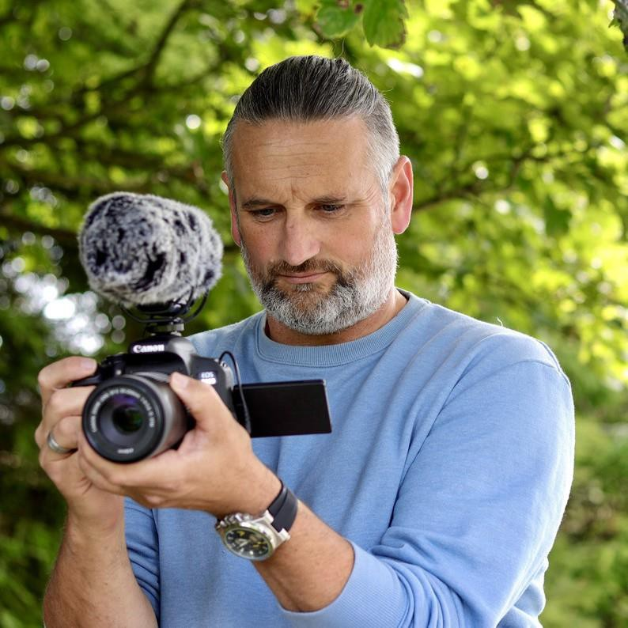
John Ó Faoláin

Contact
P: 0877045961
E: traditionalarchivechannel@gmail.com

Art Form:
Visual Art - Film, Photography, Digital

Projects / Workshops
I have extensive experience working with a wide range of groups and enjoy engaging in projects connecting peopleto their place.My work primarily involves documentation through photography and film, culminating in performance or screening events. Over the years, I've creatively engaged with community groups across Ireland, guiding them in exploring and deepening their understanding of local history, folklore, customs, and traditions specific to their region.
Currently serving as a Creative Associate with Arts Council Ireland, I collaborate with schools nationwide to develop tailoredarts programs. Additionally, I contribute as a part-time tutor at Gorey School of Art, focusing on film and photography courses. My commitment extends to delivering digital skills programs to various community groups, primary and secondary school students in collaboration with local authorities and county libraries. Our collective efforts result in documenting and archiving projects through the newly acquired photography and filming skills, with project outcomes reinvested in the respective communities.
I am eager to further contribute to community projects centred around history, heritage, culture, archive, traditional music, and song. Whether creating documentaries, films, or publications, I can offer educational programmes centred aroundfilmmaking which would include developing skills in directing, scripting, location, shooting, audio and editing etc. These workshops can be adapted to suit all ages and abilities.

Background
As a photographer, filmmaker, digital storyteller, cultureand heritage researcher, educator, and community artist, my diverse skill set is rooted in extensive practice. Operating the Traditional Archive Channel online, I focus on film and photography, emphasising the collection, archiving, and sharing of cultural and heritage materials, superstitions, and folklore derived from community interactions.
My involvement in socially engaged art projects spans participation, collaboration, conversations, and immersive experiences with diverse communities and individuals. Notable projects includethe Arts CouncilTraditional Arts BursaryAward, where I explored the concept of the Aisling through song, art, and film. Additionally, I secured funding from Wicklow County Councilfor an Oral History & Heritage projectwith Carnew HeritageClub, recording members from the South Wicklow and North Wexford communities. I was also recently commissioned by North Wexford Traditional Singing Circle as part of a Creative Wexford project to create an film archive of traditional singers for their website.

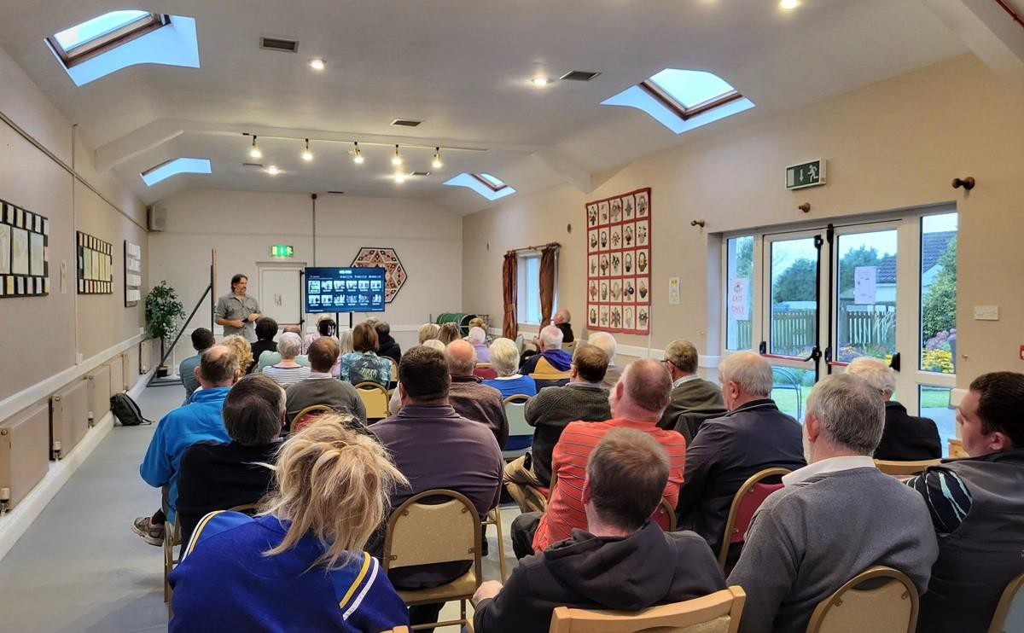

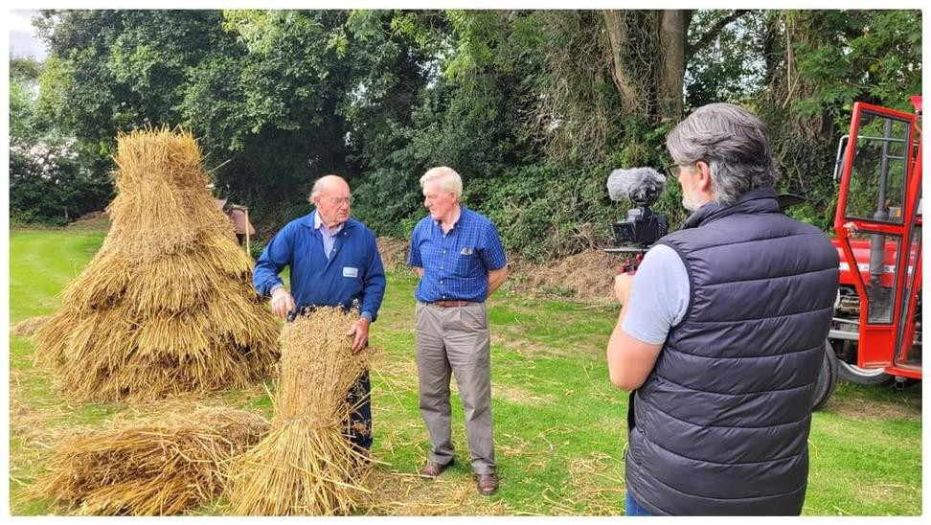

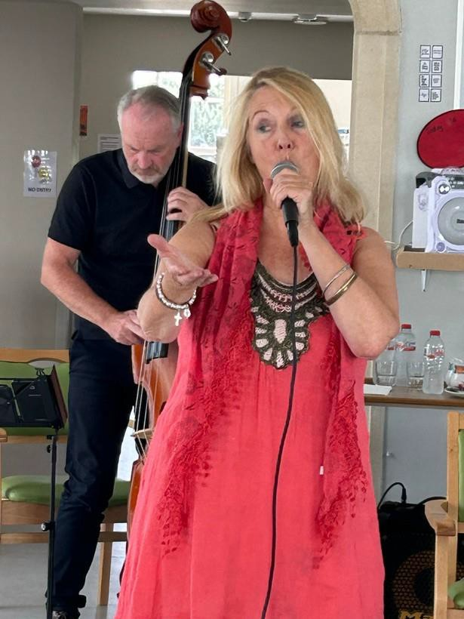
Melanie O’Reilly

Contact
E: moreilly.newschool.ie@gmail.com
P: 087 335 6153

Art Form:
Music

Projects and Workshops
As an accomplished performing artist with a passion for creativity, with a strong understanding of communication, connection and collaboration and with much experience of music artistic performance collaboration in community projects, I can provide projects to help others express their own creativity through music and specifically singing with Swing Jazz, which is rhythmic, accessible, fun and positive. This would be with 2 other musicians working with me. I can provide these themes in community collaboration projects in Nursing Homes and Senior Day Centres, and afternoon sessions for Seniors in in community and/or Arts venues . These can be in a series of sessions or workshops and are always collaborative and participatory for the attendees. Also I can provide these swing jazz projects specially tailored for Youth (teenagers) in community or Arts venues. I can also provide a series of participatory Swing jazz workshops to help participants to discover their own uniqueness, joy, wellbeing and social engagement through swing jazz singing participation. I can also collaborate with other artists of other forms in these projects and workshops if needed.

Background
Born and brought up in Dublin, worked in Scotland, & the USA, and returned to live in Ireland 5 years ago.I am now based in Wexford. I have performed throughout France, Britain, Ireland, Norway, and USA;represented Ireland at the Schoenburg Hall Los Angeles , at Edinburgh Fringe Festival and at European Heritage Festival
,Normandy 2019. In Wexford - Jazz Artist in Residence at Wexford Arts Centre, developed Jazz Appreciation and Education Outreach series, represented Wexford for National Culture Night; performed my Swing Jazz series in many festivals. Artist- in-Residence in Normandy -a new music-dance performance piece of my own Celtic jazz. Music radio host, previously with RTE Radio 1 and now with jazz station KCSM.org

In 2023, Creative Ireland Award for Music & Spoken word in Nursing Homes with my jazz trio and poet Stephen James Smyth Swing Jazz Afternoon workshop with Seniors for Bealtaine Festival 2023, National Opera House Wexford.
In 2022, Creative Community Award -Swing into Afternoon music for seniors with writer Michele Dooley Mahon at Wexford Arts Centre. Award - Ferns Heritage Wexford -Commission to compose song-cycle with my project Allabair
Trio and Ferns community choir for Ancient Connections Festival 2022 and 2023.

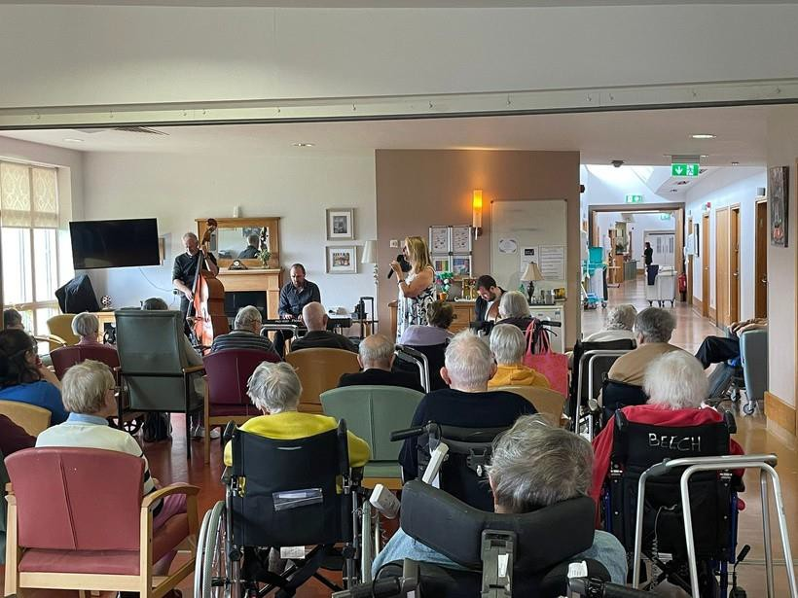
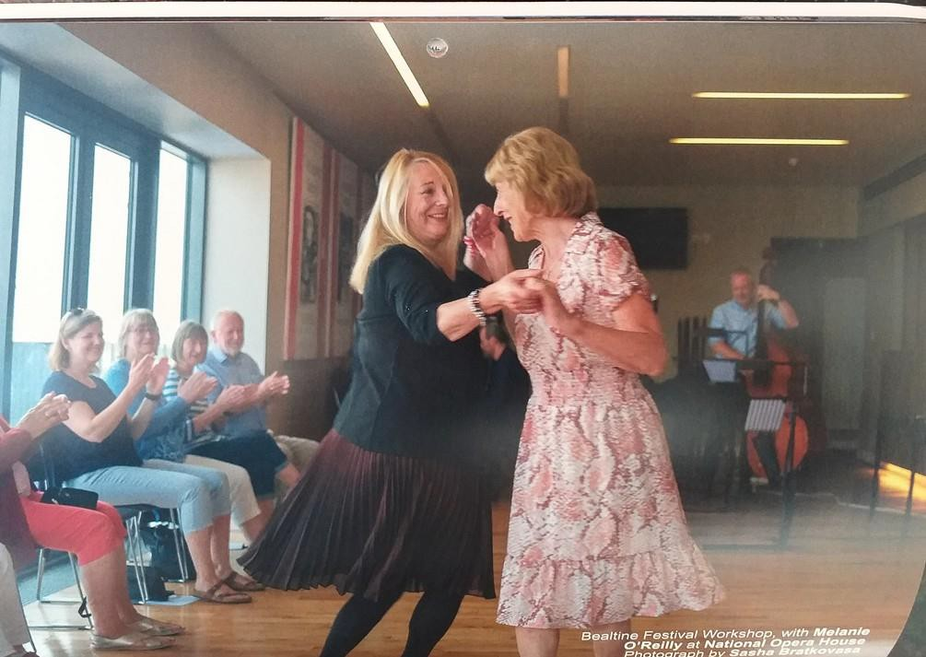

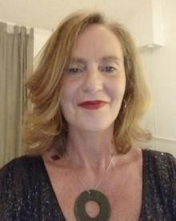
Amy Redmond

Contact
T: 087-374 4926
E: amyqpredmond@gmail.com
W: www.actthemaggot.com

Art-form:
Multi-disciplinary Artist: Theatre, Literature, Film.

Projects/Workshops
I’m based in Gorey, Co. Wexford and I am interested in developing socially engaged artistic collaborations with other artists; filmmakers, photographers, musicians, audio and visual artists on durational projects with communities of interest and place through open-ended exploratory workshops to co-create art such as audio or fine art exhibitions, publications, performance pieces, films or podcasts. My current preoccupations are: 1. Media disinformation & critical skills for discerning new media. 2. Working with women to develop confidence and creativity. 3. Migrant, Housing, Climate crises & engagement on these issues. 4. Isolation and how we can harness creativity and artistic output as a means of social connection.
Methodology
I create a playful environment using various artistic tools as well as discussion, field trips, cultural visits, inviting visiting artists and meditation/mindfulness to open/close sessions. I have designed dozens of courses for Act The Maggot, CD ETB, People’s College and DCU Recovery College. Below is a sample of the types of workshops I design and facilitate for beginners, intermediate and advanced.

Literature: Poetry, Flash Fiction, Short Fiction, Playwrighting, Scriptwriting.
·Theatre: Devising and writing a new play with a group
·Audio/Film: Making a radio or film documentary or podcast with a group.
·Theatre/Film: Acting: improvisation, voice work, character development
·Theatre/Film: Acting: Commedia Del Arte, Shakespeare
·Theatre/Film: Acting: Directing monologues, scene study for showcases
·Theatre: Directing a stage play

Background
I trained and worked as a professional actor in New York, where I played the lead role in Eclipsed at The Irish Repertory Theatre and trained in Shakespeare with voice coach, Patsy Rodenburg. Later, I did an MA in Journalism at DCU and enjoyed a career working for RTE, The Irish Times and The Irish Independent. In 2008, I returned to my first love, theatre and retrained in drama facilitation and mindfulness for groups. In 2009, I set up Act The Maggot which I ran for 12 years, delivering workshops to adults as well as working as Artist in the Community for Gateway Mental Health Association, DePaul Ireland, Coolmine, DCU and Gorey Youthneeds.
My writing is published in The Irish Times, RTE Sunday Miscellany, Wexford Bohemian and Books Ireland Magazine. My screenplay was shortlisted for RTE Filmbase Short Shots in 2016. I was one of three playwrights selected nationally by Scripts Ireland to attend their June 2023 workshop with playwright, Eugene O’Brien. I received Arts Council funding in September 2023 to develop my play, The Midas Touch with former Abbey Theatre dramaturg, poet Jessica Traynor. I was selected for the November 2023 Climate Lyricism poetry workshops with the Gallery Press. My poetry was commended in Headstuff National Poetry Competition, 2018. I have performed my poetry at Ranelagh Arts Centre and the Irish Writer’s Centre, Dublin.

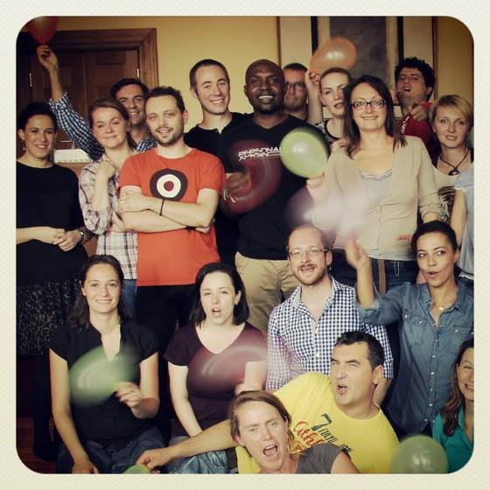
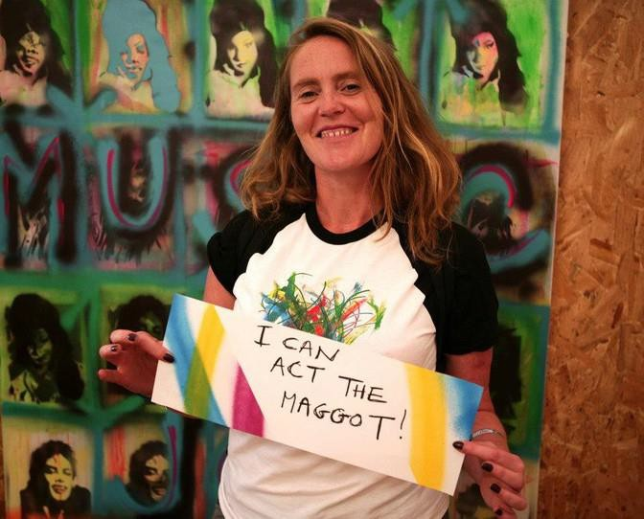

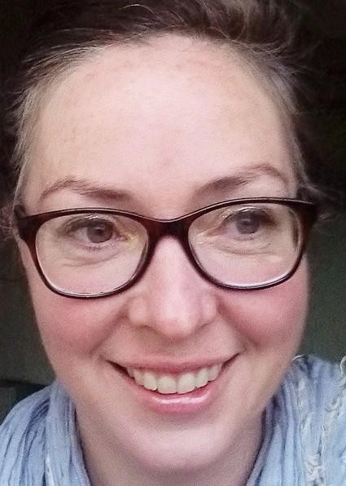
Jeni Roddy

Contact T:+353892309753
E: jeniroddy@gmail.com

Art Form:
Interdisciplinary Artist

Projects / Workshops
I am a facilitator with experience working with a range of groups: children, teenagers and adults in contexts including galleries, classrooms and community settings and as an artist in residence. I have led and contributed to numerous public art projects and longer term programmes working in a wide variety of mediums. I can provide workshops that include public participation from topics of sustainability through to textiles. I like to create connections between people to help to ease social isolation. I often refer to my background in theatre and work with participants to create stories and build worlds. The mediums that we use are dependent on the drive that the project takes as it develops, I follow the creative impulses of the participants to encourage ownership of the resultant work. The finished work could be an installation, a book or a performed event.

Background
I am an established visual artist and costume designer. I worked for 20 years producing live content through the mediums of theatre, film, live event and performance art. I work with textiles, nature and the body and look at how these intersect.I am interested in the question of value; how we value ourselves, each other and the material world that we are in. Through creating together I help to develop connections between participants and to evolve micro- communities. I use whatever mode of creation suits the project as it develops; talking, story-making, drawing, stitching and playing.

I am interested in giving participants tools to be confident in producing and speaking about art. I do this through visual thinking strategies encouraging the development of visual art literacy in participants. My work is socially engaged and concerned with our connectedness to both the natural and the socially constructed world. I am concerned with how we can live responsibly and responsively in our localities and globally, being mindful and creative in our daily lives.

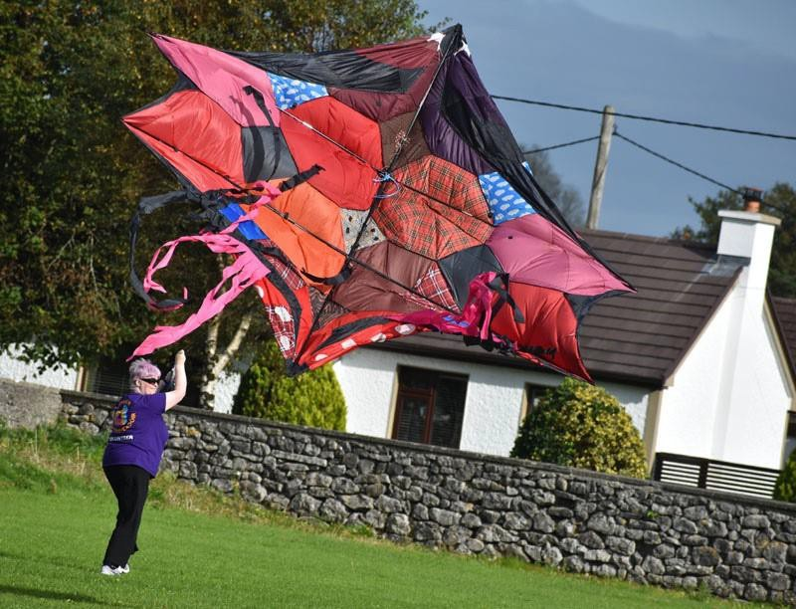

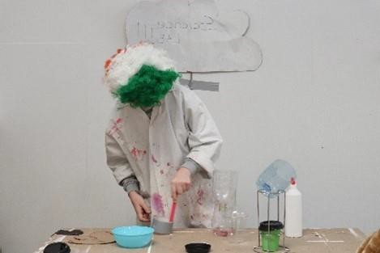
Deidre Travers + Sonya Weston

Contact
P: 0877874826, 0833919544
E: sonyaweston8@gmail.com deirdre.travers@gmail.com

Art Form:
Visual Arts

Projects / Workshops
Both Artists believe that creating art provides a sense of accomplishment and boosts self esteem in all age groups. It also promotes wellbeing, creates a space for social connection, facilitates discussions and helps process emotions.
In our workshops we work with a variety of mediums and methods. It’s all experimentation, sometimes obscure. We encourage you to think outside the box but to also enjoy the process. All projects and workshops are structured to suit the ability and interests of all participants.
Past projects have included analogue photography and digital photography, image transfer techniques, stop motion film, set design, text-based work, collage, performance, public murals and printing techniques, and book making.

Background
Both visual artists have graduated from Wexford School of Art and Design with a B.A Hons in fine art in 2018/2019. Their art practice includes printing, sculpture, photography, film and performance. We have both participated as assistant artist on the living arts programme in primary schools and have worked collaboratively on several projects and workshops. Both from private and public organisations such as the collective Sensory Group, The Loretto Secondary school, Wexford Mental Health association, Windmill Therapeutic Unit and Wexford Arts Centre and CAMHS both in Wexford and Enniscorthy.

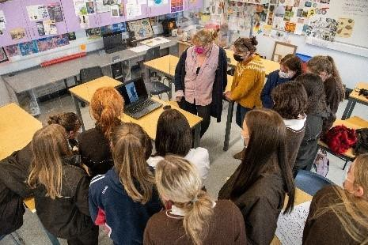

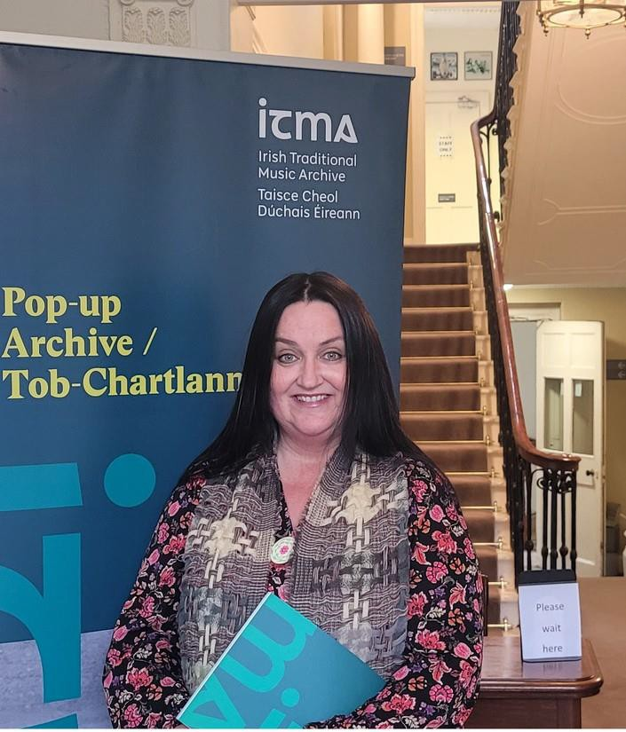
Rachel Uí Fhaoláin

Contact
T: 087 2988473
E: ceolmochroi@gmail.com

Art Form:
Music – Traditional Song & Visual Art in Community Settings

Projects and Workshops
I specialise in delivering local and national traditional song workshops, and have extensive experience in research, composition and collection projects. I have led and developed numerous projects in a community context in Wexford, Ireland and beyond, while also tutoring groups, choirs, and individuals, both in person and online.
People, place, song, language, and folklore are at the core of my work. I aim to develop and enhance intergenerational conversations through song, composing new songs in the traditional style, storytelling, poetry and the Irish language. I am increasingly exploring multicultural traditions and language to better understand and connect our cultural similarities in a meaningful way. Traditions and heritage are universal.

I work with communities to document and archive these projects through photography, film, publications, radio production etc. and the projects have resulted in performance and screening events where the material is recirculated back into the community.

I’ll bring the biscuits! Let’s start a conversation and develop the project from there. My extensive range of skills and experiences, my passion for bringing us all together to connect with our local heritage and our places, coupled with your group’s interests, makes us the perfect team, so let’s work together on a unique project with Creative Communities in Wexford!

Background
I am a traditional singer, folklore collector, researcher and educator with an extensive repertoire of songs from Wexford and beyond, in English and Irish. My practice, through Ceol Mo Chroí, is rooted in devising, delivering and presenting traditional song & heritage programmes for children, young people and adults, and the facilitation of song research, composition & collection projects in a community context. I am a founding member of the North Wexford Traditional Singing Circle.

I am a specialist on the Heritage-in-Schools Scheme with the Heritage Council, delivering traditional song & folklore workshops to Primary Schools, in Wexford & Ireland. Some of my most recent achievements include receiving the prestigious award - Young People, Children, and Education Bursary (YPCE) from the Arts Council to continue my research in the Irish Traditional Music Archive (ITMA).

Communities which I have worked with include, nursing homes (The Nursing Home Project supported by Creative Ireland & Galway County Council), the travelling community in Wexford (supported by the Heritage Council & FDYS County Wexford), active retirement groups, storytelling/poetry groups, North Wexford Traditional Singing Circle (‘In the Singing of Songs’ supported by Creative Ireland & Creative Communities Wexford – see photo below), and Ancient Connections (supported by Wexford County Council & Pembrokeshire County Council). I am also the founding director of the new intergenerational 'Songs of the Wexford Coast Community Choir' at The National 1798 Rebellion Centre & Enniscorthy Castle.

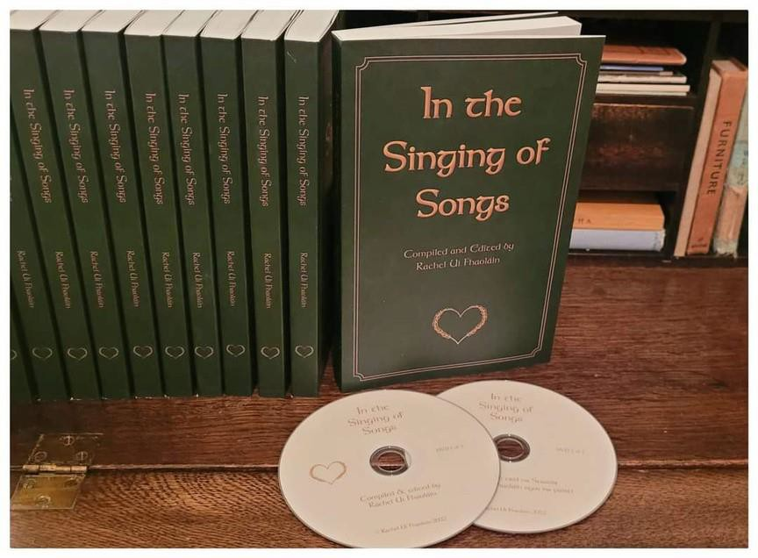

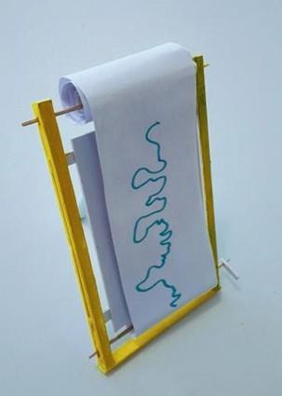
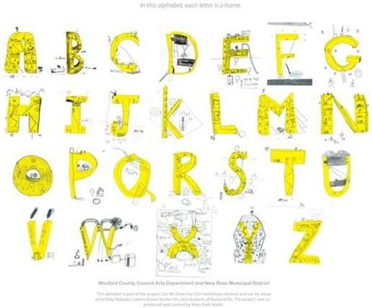

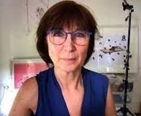
Mary-Ruth Walsh

Contact
P: 353878242343
E: maryruthodw@gmail.com

Art Form:
Visual art and writing: Drawing, painting and film making relating to architecture and landscape.

Projects and Workshops
The workshops I do are specific to each group. Occasionally I may bring in anotherexpert to the workshop.
For example the community project I designed, titled ‘Can we Draw you Out?’ for New Ross Primary School BunscoilRís engaged the children’s curiosityon architecture and their town, through the medium of drawing. This way they brought their attention to the very fabric of our surroundings that is often taken for granted. I created a treasure hunt of everyday but iconic features of their town, which we saw on a classroom slide projection. Then, with drawing boards and pencils tucked under our arms we went on an expedition into town to find these images. We found these and a lot more. Artist Elida Maiques joined this project and suggested the children create ‘alphabet-houses’, these in turn were transferred into an alphabet. This created a new online font keeping the children’s unique lettering intact. See images below titled No:1 ‘Can we Draw you Out?’ see No 2 Butler Gallery National Drawing Day – Drawing Machines! – A workshop and No 3 ATMOSPHERES workshop in Scoil San Clar, Manorhamilton, Leitrim.

Background
My art practice started with an interest in architecture, how it was built, why build the way we do and who is the building for? From exploringthe architecture of humans I’m now exploring the architecture of insects and animals. All the threads of my practices have ecological and sustainability interest and awareness.
Recently I joined Sanctuary in Nature and Heritage* and have found my tribe!

Outline of Approach: Sanctuary in Nature and Heritage (SiN&H), Ireland, run by Paddy Woodworthand Muhammad Achour is an initiative that aims to provide a place of sanctuary throughIrish wildlife, landscapes, and built heritage for people new to Ireland and local people. This is a perfect fit for my interest in a small woods near where I live, locally known as Bluebell Wood. There is a wealth of material in the woods and in New Ross & Wexford for exploration, engagement and extending my art practice.
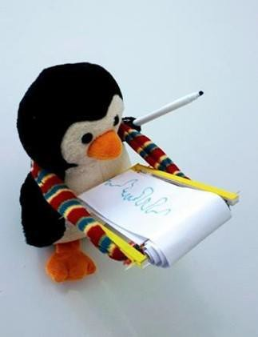
Materials are my particular interest, from refined materials used in contemporary architecture to naturalmaterials under our feet,to explore where they come from,how they are formed or processed. Through this engagement, I will create a meaningful collaboration by co-designing and facilitating art projects with communities in Co Wexford.

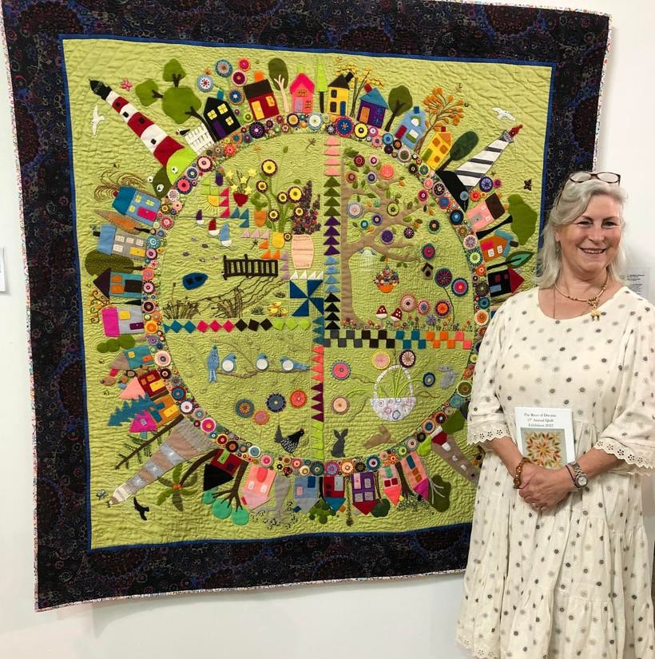
Josephine Whitmore

Contact
E: josephinewhitmore10@gmail.com

Art Form:
textiles, machine and hand sewing, knitting, crochet, embroidery

Projects and Workshops
I am available to facilitate groups to develop their skill sets while working with textiles. This may include a series of workshops on learning or improving machine stitching, hand sewing skills, patchwork and quilting, sustainable projects e.g. upcycling clothes. Other crafts to consider are embroidery, knitting, crochet, sashiko or slow stitching. These workshops can be tailored to individual projects over a given number of weeks with predetermined goals.
Or, a group may have identified a subject matter and wish to collaborate socially in an art practice which enables them to communicate that vision to the general public. Then using folk methodologies in textiles they participate in creating a one-off art piece.This involves working in an inclusive and holistic environment, collaborating on artistic and creative ideas, empowering participants to express themselves through textile art, which is often an undervalued area. They may consider including the textile supplies of their ancestors, which can be both sustainable and evocative in producing an art piece of an area, an image or a combination of agreed ideas to “tell a story in stitch”. I am open to working with any group while giving artistic direction throughout the planned project.

Background
I am a native of Wexford town. I have sewn since childhood and am passionate about textiles. My skills include machine and hand sewing, knitting, crochet, embroidery. I have many qualifications and am particularly interested in ‘telling a story in stitch’ by drawing on folk methodologies in textiles.

I am involved with many community groups including Access 2000, Women’s Collective Ireland (Wexford), Southend Family Resource Centre, New Ross Women’s Shed and Wexford Arts Centre.I have led several projects to completion working with women, collaborating on artistic ideas and skill sharing which encourages women to express themselves creatively through sustainable textile art.
Upcycling Clothes Project
This 20-week programme involved working with women utilising pre-owned clothes, which were upcycled in different garments. They also collaborated on bigger projects such as turning a beanbag cover into a raincoat and upcycling a wedding dress.
Ukrainian Women’s Quilt
This 20-week programme with Ukrainian women used knitting and crochet to allow them create their own unique quilt. This quilt was exhibited by the Wexford Mental Health Association during the Wexford Opera Festival.
Biodiversity Project
1n 2019 I participated in a group who created a felted art piece that is now exhibited at Wexford General Hospital.

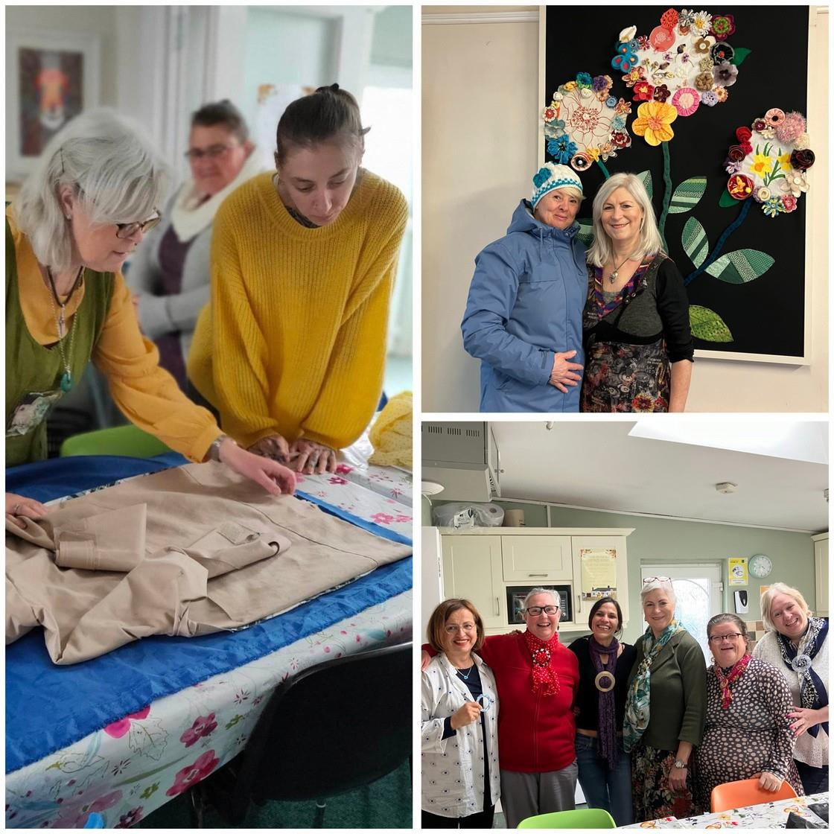

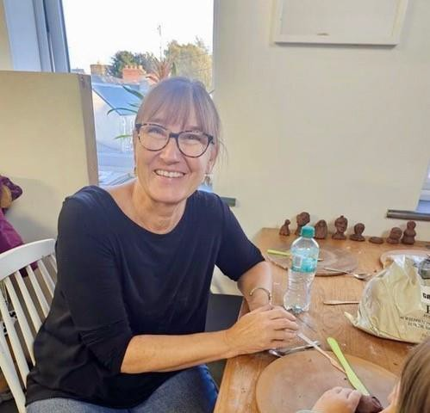
Elke Williams

Contact
E: e.williams.artist@gmail.com
P: 085 818 6426

Art Form:
Visual Artist specialising in Ceramics

Projects / Workshops
I am experienced in most ceramic techniques including indoor and outdoor mosaic work and can offer introductory courses for groups of all ages and sizes. Because of the hands-on nature of clay work I will bring an assistant for large
groups.

Courses can be held on one day, over a weekend or as regular evening classes. Times can be adapted to suit the participants.

A planning conversation will be held to develop a course together with the participants and cater to their needs.

Possible course types:
Play with clay: 4 hours including break. Introduction to ceramic techniques course will encompass hand building techniques such as pinch pot forming, coil building and slab forming.
Participants will experience all techniques and can then choose to focus on one style to create a piece of work.

Wild Clay weekend: Connect with your local Wexford history!
Outdoor workshop with Wild clay that is collected at the beach or dug from the ground and then. cleaned and finally used to create small vessels or sculptural work.

Tell a story with clay: 2hours+. Build small scale sculptures either based on a story or develop a story to link them together. Introduction to Wheel throwing: 1 hour. For small groups if ceramic wheels are available.

Background
My approach to working with communities is rooted in inclusivity, trying to create spaces that welcome people from all walks of life, embracing their unique perspectives and cultural backgrounds. This ensures that the collaborative process is enriched by a variety of voices, resulting in a more meaningful and representative artistic outcome.
I have been fortunate to have facilitated community-driven projects, where the creative process is shaped by the interests and needs of all the community members. By attempting to actively involve everyone in decision-making and idea generation, individuals are empowered and may feel sense of ownership over the artistic journey and their product.
I hold a BA International in Fine Art Glass and Ceramics from NCAD. This is backed up by over 25 years of experience in living and working with adults from all over the world in inclusive communities. In previous courses, I have successfully
collaborated with diverse groups, ranging from the inclusive adult communities of Camphill Communities of Ireland and cultural organizations, such as Gorey Art Collective, where I have run summer workshop programmes for adults and children and joined in hosting their annual culture night event, to more focused local community projects such as ’Invitation to a conversation’ by the SOWN initiative in Ballyfad.

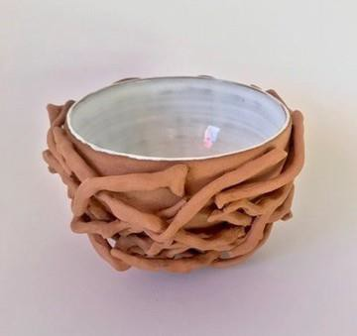
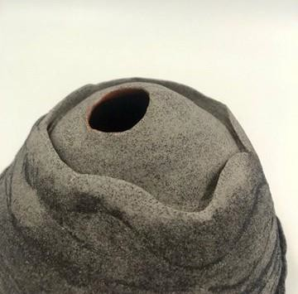

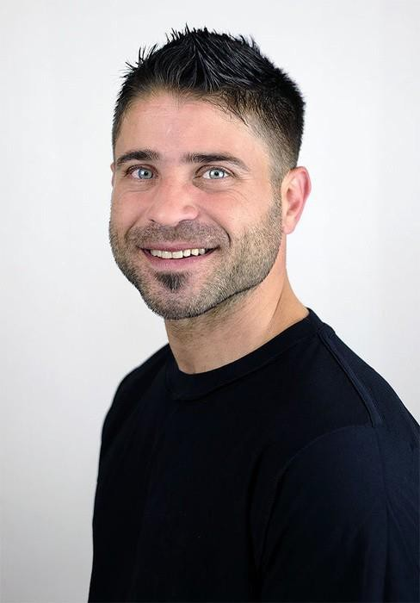
Fadi Zmorrod

Contact
E: Doulabcircusanddance@gmail.com
P: 085 262 3926

Art Form:
Contemporary Circus
Speciality: Chinesepole, acrobatics, Chair balance and social circus

Projects / Workshops
Workshops that I can provide include juggling, functional juggling (for those with additional needs), manipulation, balance, acrobatics, acroporte, group/DUO acrobatics, social circus workshops using different families of circus disciplines such as stilt walking, unicycling, diablo, flowersticks, poi, etc. to work on various skills/concepts e.g. coordination, eye contact, equality and respect within a group, group responsibility, individual responsibility, cooperation and more.

Background
I arrived to Ireland 2 years ago, and moved to Wexford within the last year. Before that, I co-founded a school called the Palestinian Circus School, and then trained in Italy at Cirko Vertigo. Following this, I spent years touting around the world, performing and giving workshops. In Ireland I have had the pleasure of working with many different communities, with a focus on refugee communities living in Direct Provision centres, the travelling community and the neurodivergent community. I also have experience working with torture survivors, child prisoners, and people with severe additional needs of various kinds.

