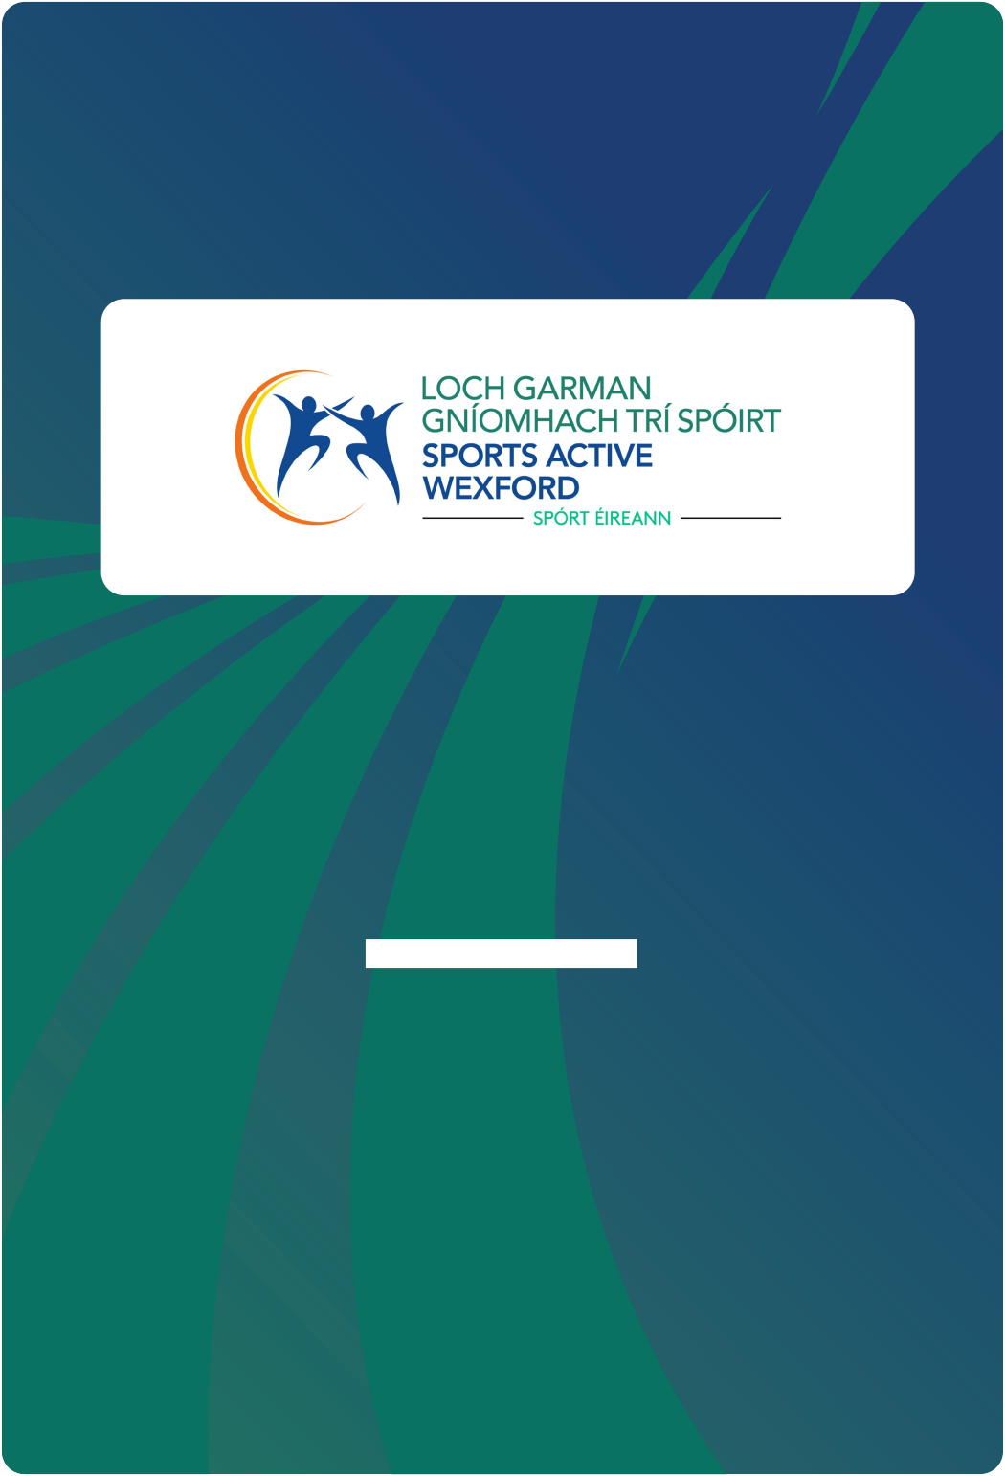
Annual Report

2023

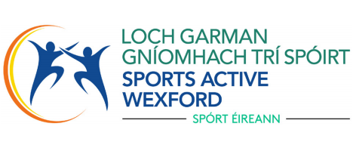
Welcome to our Annual Report for 2023
The report can only include a snapshot of the team’s work to support our
partners in meeting their aspirations for sport and physical activity.
Through signifcant funding from Sport Ireland (core funding, dormant accounts),
HSE, Dept of Health and Wexford County Council, we have helped support
investment of £641,322 in community organisations providing sports, physical
activity, and much more.
The cost of living has dominated conversations across all sectors, and we have
been actively involved in these locally and nationally, seeking to identify ways
organisations supporting those in need can continue to provide opportunities to
be active.
Through a new national relationship, we have also started working on a pilot
project with the Department of Health and HSE to support those with chronic
health issues through the Physical Activity for Health programme. We frmly
believe that physical activity signifcantly prevents many health conditions
individuals face, supports recovery, and improves overall health and well-being.
To provide a focus for ourselves and clarity for our partners this year, we have
prioritised the development of our own Innovation Project, the Nature Walk app,
in partnership with the Walton Institute and set up the New Ross Community
Activity Hub.
While we retain a strong focus on our role in delivering on national and local
priorities, we continue to look for new ways to develop our relationships with
our key stakeholders and communities to promote physical activity for all and
deliver on our critical strategic themes. We look forward to 2024 in developing
new relationships and extending our portfolio to include new staff resources to
engage with specifc disadvantaged groups. We look forward to developing the
new strategic plan and supporting the Local Sports Plan.
We would like to thank the Sports Active Wexford steering committee for their
outstanding commitment to continuing our development. At this point, I would
like to acknowledge the work and commitment of Margaret McDermott, a
founding member of the local Sports Partnership in Wexford, who sadly passed
away in 2023.
We want to thank our highly motivated staff for their continued commitment and
innovation in Physical activity and health.

Sports Active Wexford
Annual Report 2023

2

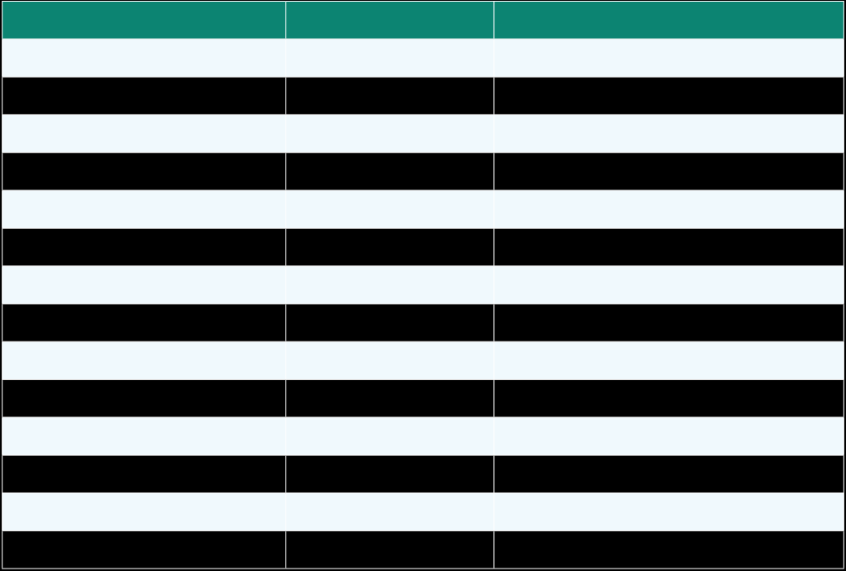
Who Are We
We are building sustainable collaboration to empower communities, Enable
Inclusion, and Support sports opportunities in our key communities.
Reducing inequalities in access to physical activity amongst those who
experience the greatest disadvantage.
Using insight and refective learning in everything we and others do, adopting a
‘what works’ mindset to ensure we are responding to the needs of our County.
Our Steering Committee
The Steering Committee) of Sports active Wexford comprises of representatives
of those agencies regarded as key infuencers in local sports participation and
development including the Local Authority and Community groups in the County.
The Steering Committee represents the views of relevant local agencies and
groups with its priorities decided in consultation with its constituent members.
The Steering Committee also sets strategic priorities for the work of the Sports
Partnership.
Sports Active Wexford is compliant with the Governance code for Sport as a
Type B organisation.

NamePositionRepresentation

Cllr Garry Laffan
Mr Trevor Jacob
Mr Colin Gibbon
Ms Marie Louise Byrne
Ms Breda Banville
Ms Paula Lowney
Dymphna O’Connor
Dr Cíara Losty
Helen Ambrose
Hayley Rochford
Michael O'Brien
Mark Rogers
Maria Gore
ChairpersonWexford County Council
Vice ChairpersonDisability
MemberUrban Adventure Hub WWETB
MemberWexford Local Development
MemberICA
MemberHSE Health and Wellbeing
MemberSEO Wexford County Council
MemberSouth-East Technological University
MemberWexford Mental Health Services
MemberYouth Services (FDYS)
MemberWaterford and Wexford ETB
MemberWexford PPN
MemberWexford PPN

Sports Active Wexford
Annual Report 2023

3

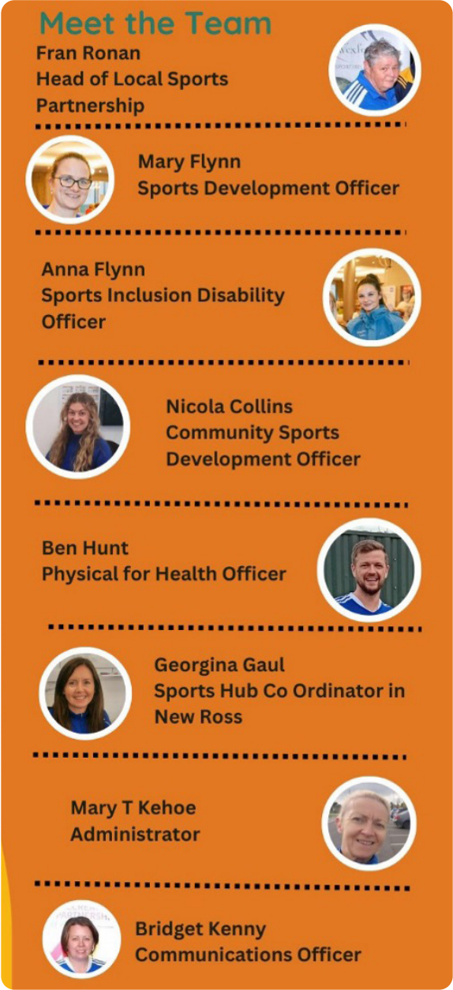
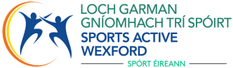
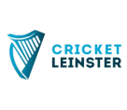
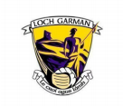

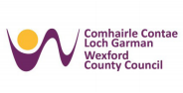
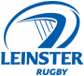
Our Staff

Sports Active Wexford, works
alongside its 16 Community
and sporting interagency
partnerships (which includes
Wexford County Councils
partnership with Wexford
GAA, Leinster rugby, FAI and
Leinster Cricket).

Sports Active Wexford
Annual Report 2023

4

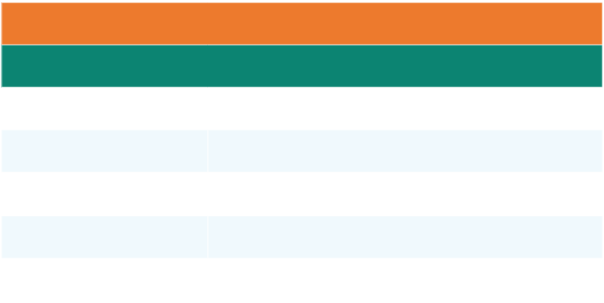



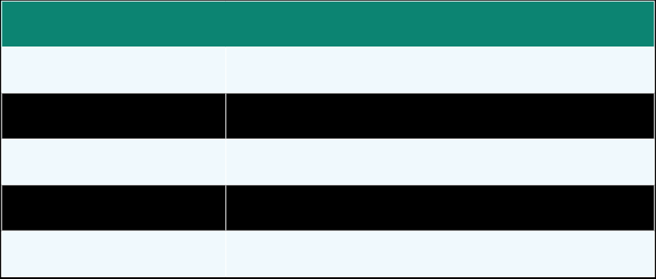
Core Funding for Local Sports
Partnership Operations
€348,922.00Sport Ireland Core Grant

€7,500.00Additional Funding

Grants Awarded To Sports Active Wexford
Dormant Accounts Funding 2023
€51,500.002022 Community Sports Hub (New Ross)
€12,300.00Her Moves – Get Girls Active
€6,000.00Youth Leadership
€15,000.00Volunteer Supports
€30,000.00Innovation Project – Nature Walk App

HSE Grant
€7,650.00

Disability and Men’s specifc programmes

Additional Direct Grants
€60,833.00Physical Activity for Health offcer
€1000.00Age and Opportunity
€950.00Traveller Pride
€2000.00Her Outdoors Campaign
€29,000.00Wexford County Council Grants

Total Funding Awarded to Sports Active Wexford
€589,574.75

Sports Active Wexford
Annual Report 2023

5


Areas of Expenditure

AREAS OF EXPENDITUREAMOUNT €

SALARIES AND EXPENSES
(STAFF & SUMMER STUDENTS)
GENERAL PAYMENTS
BRANDING
CODE OF ETHICS
PALS
COACHING COURSE
WALKING COURSE
CHILDRENS OFFICER
FEE PAY COSTS
FUN IN THE SUN (LSP)
DISABILITY (LSP)
WOMEN IN SPORT
OPERATION TRANSFORMATION
PHYSICAL ACTIVITY PROMO SCHEME
SCHOOLS PROGRAMME
WORKPLACE ACTIVITIES
HSE FUNDING
SPORTING CHAMPIONS GRANT
COVID-19 CLUB GRANTS - LSP
BOARD EXPENSES
COMMUNICATIONS - LSP
MARARTHON KIDS (LSP)
€326,144.68
€2,433.95
€28,812.41
€2,710.44
€440.00
€95.00
€490.67
€900.00
€764.01
€8,674.27
€1,511.38
€595.00
€637.50
€31,585.43
€3,582.50
€467.50
€10,044.69
€10,450.00
€1,500.00
€2,767.50
€274.54
€8,940.00

HER OUTDOORS€1,869.45
TRAINING & EDUCATION€5,953.00
PHYSICAL ACTIVITY FOR HEALTH€1,500.00
TRAVELLER PRIDE€660.00
CREATIVE IRELAND€749.42
AGE & OPPORTUNITY€765.00

TOTAL
€455,318.34

Sports Active Wexford
Annual Report 2023

6

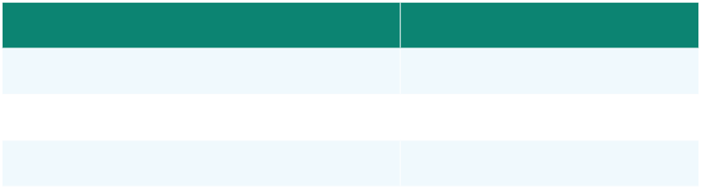
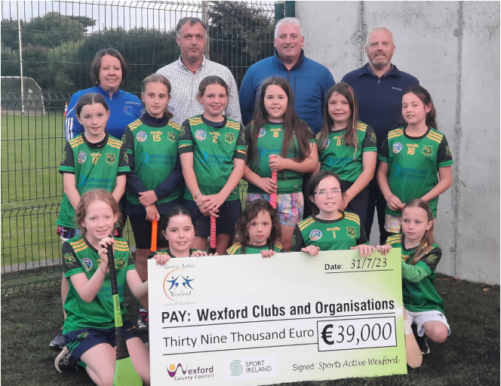
Dormant AccountsExpenditure

DORMANT A/C'S GRANT
VOLUNTEER SUPPORT
SPORTS LEADERSHIP
€74,560.00
€3,450.00
€826.17

The end of year balance stated above includes signifcant grant funding received
in late 2023, but to be spent and actioned in 2024. This also includes funding
ringfenced for Sport Ireland projects still to be actioned and a limited number
of reserves that are in place to ensure continuation of services. Sports Active
Wexford fnancial policies and procedures are fully in line with those of Wexford
County Council.

Grants Given To Clubs
& Community Groups

Physical Activity Promotion Scheme€31,585.43
65 clubs and community groups were awarded funding.
Covid Grant€1,500
Volunteer Training Support€3,450

Sports Active Wexford
Annual Report 2023

7


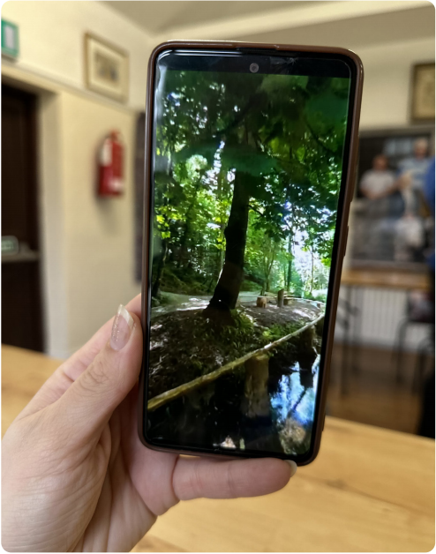
Social Media Interaction

Social Media PlatformPostsFollowers

Twitter
Instagram
Facebook

Newsletter
325 Tweets1,753
252 Posts1,332
525 Posts5,702

A digital newsletter is developed monthly.
Number of digital newsletter views:1,523 in 2023

Launch of new
Phone App

Sports Active Wexford
Annual Report 2023

8

Advocacy
Irish Sports Monitor – a county specifc report on the County Wexford
respondents that took part in the 2022 ISM survey has been received from Sport
Ireland.

Awards & Nomination
OLAMA Awards – Best Mental Health Initiative category for Equine
Therapy Programme

OStrong and Steady programme was shortlisted for the ‘Active and Healthy
Ageing Award’.

OVolunteer in Sport Awards – LSP network now main sponsor of this initiative.
With Denis Cadogan from Horeswood GAA winning the Wexford Award.

OActive Schools Week – worked with schools around activities and signposting.
OOpportunities for this national initiative.
OLGBTQI+ Inclusion in Sport – recognized training delivered to staff.
OAge Friendly Alliance – Coordinator invited to sit on this multi-agency group that
works to support initiatives for older adults.
OHealthy Wexford Committee Coordinator invited to sit on this multi-agency group.
OEvent Equipment – continuing to loan out generic equipment, to clubs and groups
to use at local events and open days etc.

Sports Active Wexford
Annual Report 2023

9

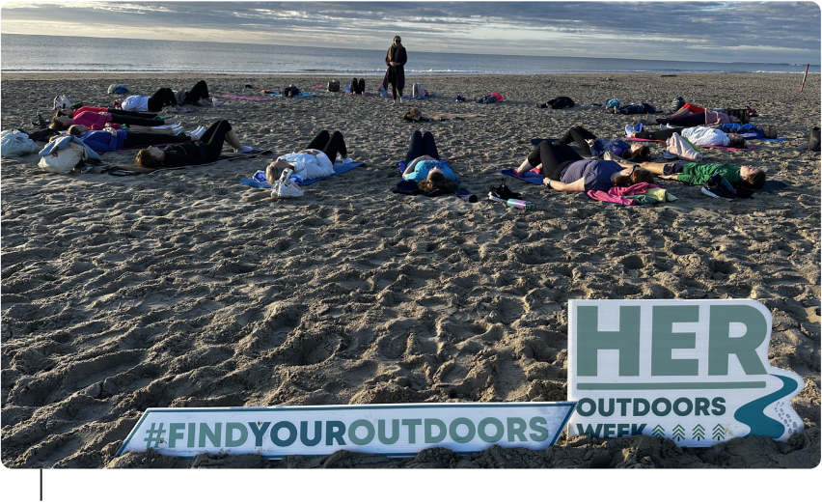
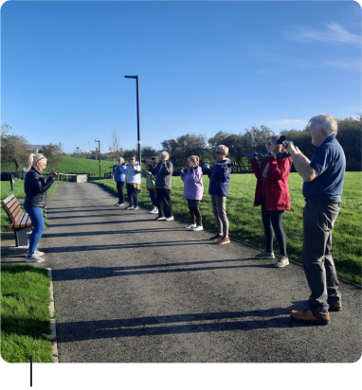
Participants

66,995
Adults, youths, and people with a disability

45% of these were female.

No of programmes

801

Programme Examples

Activators in Min Ryan Park

Women’s ftness & Self Defence, Men’s sheds, Ukrainian children activity
programmes, Social Soccer with Rosslare Accommodation Centre, return of
Fun in the Sun children’s camps, Schools Programmes, Disability programmes,
Schools Swimming Support, Walking Rugby, Leadership programmes
Volunteers support and training programme. Activator Pole Walking, Couch
to 3K/5K, Active Fellas Soccer Programme, Marathon Kids, ASD Kids Cycling
Camp, Ragtree Equine Assisted Programme.

Campaigns
“Her Outdoors” Week, European Week of Sport, Positive Ageing Week, Women
in Sport Week, Bike week.

Beach Yoga, “Her Outdoors”.

Sports Active Wexford
Annual Report 2023

10

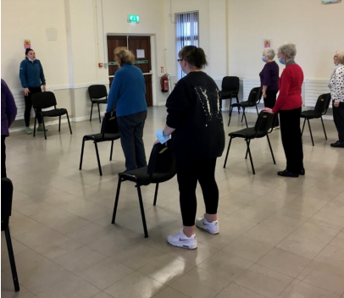
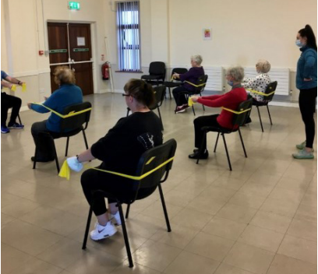
Case Study
STRONG & STEADY PROGRAMME

Overview
This Strong and Steady Programme is aimed at vulnerable older adults who
have a fear of falling, and as a result let this fear affect them in their day-to-
day activities. This is especially evident if the person has fallen previously. The
Strong and Steady programme aims to increase access to structured exercise
programmes for older people which is evidenced to reduce falls.
Aims
OProvide safe, effective/evidence-based exercise programme that are enjoyable.
OProvide graded transitions between primary care and community leisure settings.
OBuild on the functional gains achieved through physiotherapy and occupational
therapy.

Implementation
This free programme is held at Coolcotts Community Centre, Wexford and Astro
Active, Enniscorthy. These venues were chosen because both facilities are
suitable for older adults, wheelchair accessible, accessible toilets, they are warm,
private and have convenient parking. It is a 20-week programme which initially
consists of 6-weeks led by the physiotherapist and 14 weeks led by an exercise
professional in Sports Active Wexford for one hour weekly. There are 6 to 8
participants maximum with 2 staff members. This ensures the each participant gets
suffcient supervision. Ages anywhere from 65 years to 95 years. (not exclusive to
these ages). Advertising is done solely by the Physiotherapists and referral to the
programme is gained through WEXICOP. On the fnal day, Sports Active Wexford
provided tea and coffee, and some refreshments for all the participants.
The programme is funded by Age and Opportunity, Healthy Wexford and
Slaintecare.

Sports Active Wexford
Annual Report 2023

11

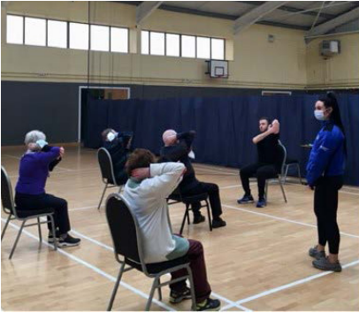
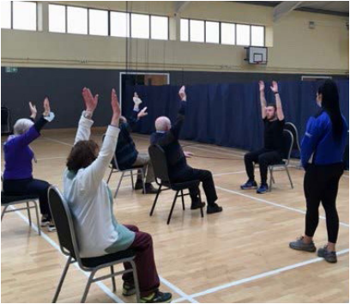

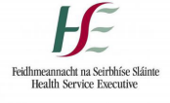
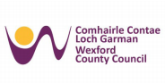
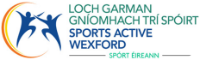

Outcomes
The programme will continue in September 2023 in Wexford Town as there is
signifcant demand. The programme aims to reach all towns in Wexford.
Participants got the opportunity to engage in exercise and increase their
confdence. Some have stated they have started walking and one lady has joined
a yoga class.
Our aims were defnitely achieved!

Feedback
“Enjoyed the company and instructors”
“Has started walking more”
“Made me more conscious of doing more exercise”
“Increase in muscle strength”
“It was lovely all the women were lovely – aways felt comfortable”

Sports Active Wexford
Annual Report 2023

12

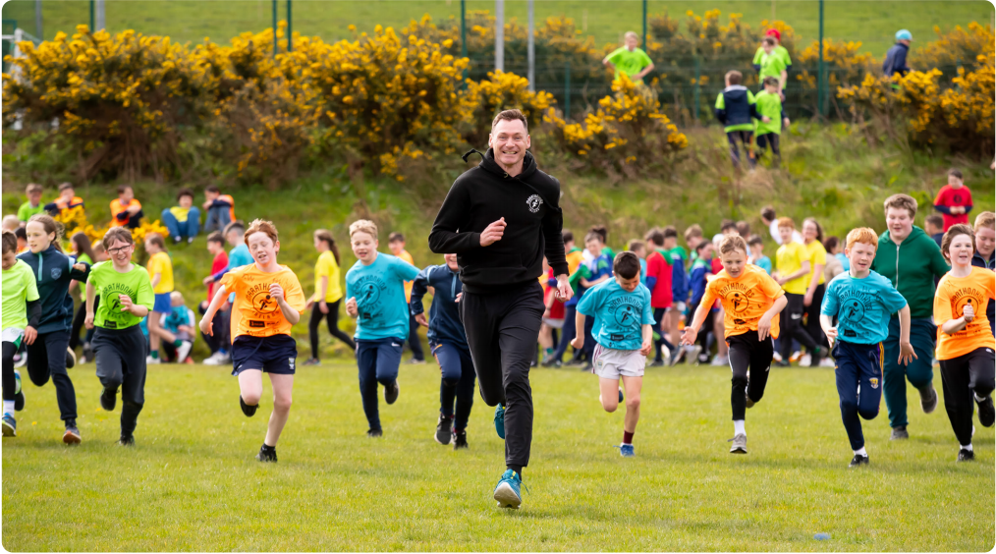
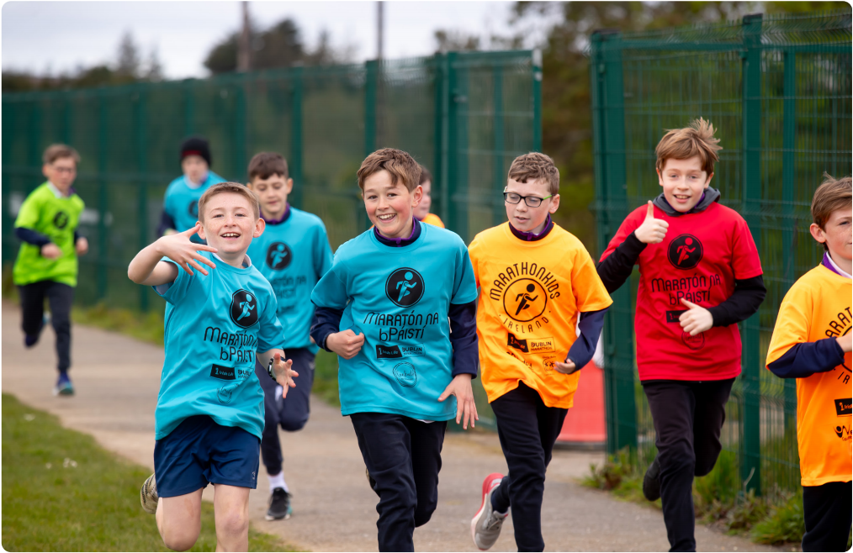
Marathon Kids Programme
with David Gillick

Sports Active Wexford
Annual Report 2023

13

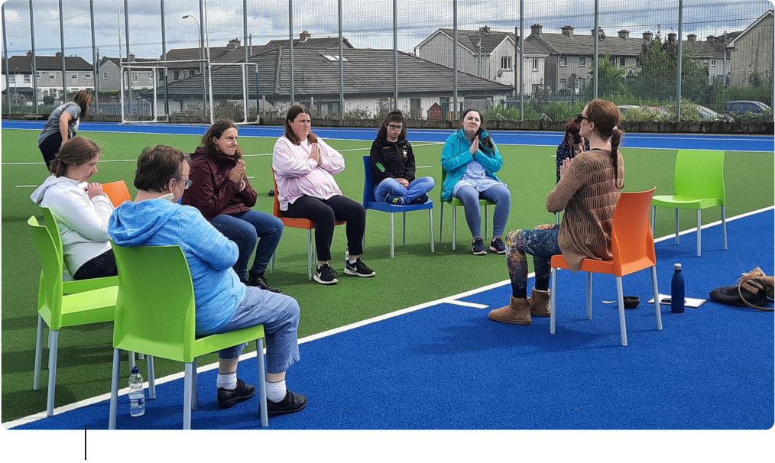
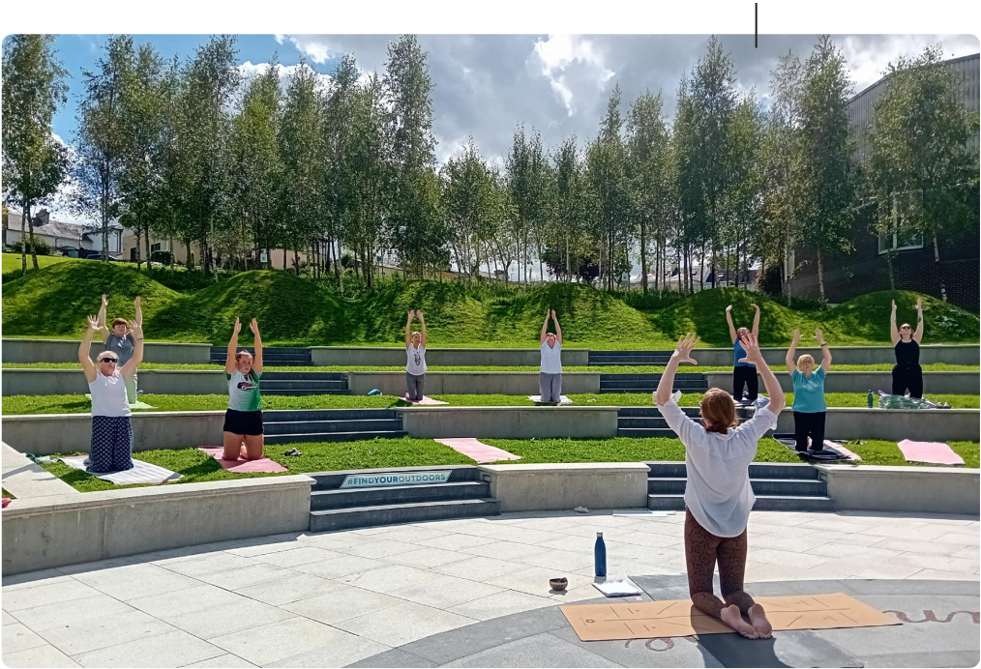
Inclusive Day
Chair Yoga

Garden Yoga
New Ross Library

Sports Active Wexford
Annual Report 2023

14

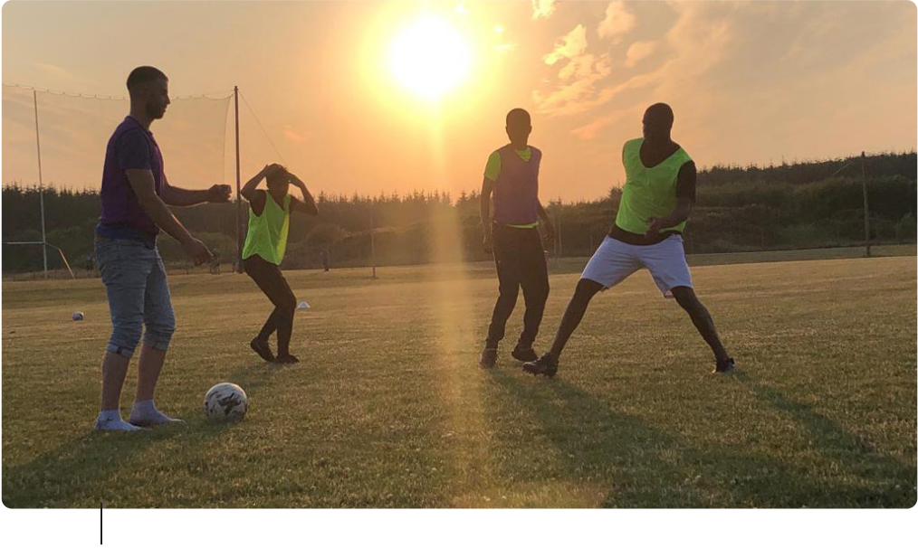
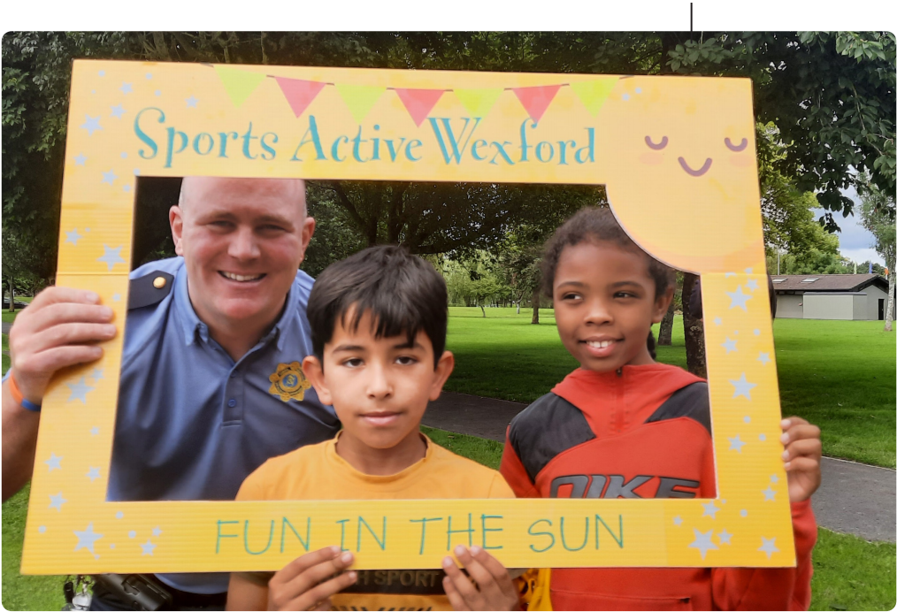
Social Soccer

Fun In The Sun

Sports Active Wexford
Annual Report 2023

15

