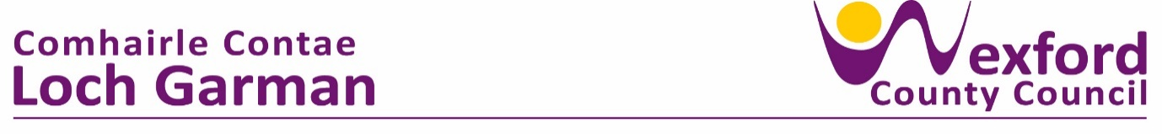

**Press Release 7 February 2024**

**Women for Election – Training Programme Launched**

Wexford County Council and Women for Election hosted an introductory session on Wednesday 31st January 2024 in the Council Chamber, Wexford County Council, to launch a training programme to support women who are interested in running for election in 2024 or in future elections.

Over twenty-five attendees enjoyed a programme of speakers which included Councillor Maura Bell who is Chairperson of the Women’s Coalition and Councillor Kathleen Codd Nolan who shared her experience of being a female councillor for the past twenty years.

Wexford County Council Archivist Gráinne Doran gave a talk on Ellen ‘Nell’ Ryan who was the first female councillor elected to Wexford County Council in June 1928.  Nell had also been a member of Wexford Board of Guardians (and chairman of same in 1920) in addition to her active participation in the revolutionary struggle 1916-23.

Brian Sheehan, CEO of Women for Election stated "We all know of extraordinary women who are the lifeblood of communities and community organisations across Wexford county. This programme will encourage and support many of these women to bring their community knowledge, experience, and skills to where decisions about their communities are made - Wexford County Council.”

An armchair chat with Councillor Kathleen Codd Nolan was very interesting and lead to a conversation on what to expect from the role and sound advice to those starting out on their political life journey.

The views of sitting female councillors who are members of the Women’s Coalition were sought and they shared their experiences with potential candidates on the role of an elected representative.

The training programme launched at the event aims to inspire and encourage women to stand in the upcoming Local Elections in June 2024, or in the future and is part of a national programme to achieve gender balance in politics. It also is aimed at the team behind the candidate as there are many ways to support female candidates.

"Wexford, like many parts of the country, is a long way from having women's voices equally represented in the County Council. With just 6 women of the 34 Councillors in Wexford, there is a distance yet to go. There is a one-in-five-year chance in the coming local elections in June to begin to redress this imbalance. This programme from Wexford County Council aims to inspire and equip women who might be interested in local politics to consider standing in the elections,” Brian Sheehan explained.

"The launch event showed a huge appetite among women in Wexford to serve their communities by entering local politics and also showcased the great work being done, cross-party, by the Women's Coalition on the Council.  This next election cycle carries a great opportunity for the voters of Wexford to reshape their local council, and to make significant inroads in addressing the imbalance on the council, where just 18% of the councillors (6 of 34) are women,” Brian added.

The attendees at the event welcomed the opportunity to learn more about the training programme being facilitated through Women for Election.

Further information on the training programme is available from wwww.womenforelection.ie and at wwww.wexfordcoco.ie.

Ends