PRESS RELEASE 6th November 2023

School Roadshow to encourage more young women into politics and bring diversity to council chambers.

Wexford Women’s Coalition which brings together the female Wexford County Council members is committed to ensuring that female members are supported in the Local Government System. The Coalition has joined forces with See Her Elected, the award-winning Government funded project which aims to encourage women from rural areas to engage in local politics.
Together they visit secondary schools in County Wexford in a bid to encourage more young women to see politics as a possible career path. The Schools’ Roadshow is part of a political education series which hopes to encourage diversity in county council chambers in rural areas throughout the country.
The Wexford Women’s Coalition and See Her Elected will visit Coláiste Átha in Kilmuckridge, Loreto College, Wexford and Selskar College, Wexford this month (8th and 9th November). Schools will benefit from a See Her Elected presentation while members of the Wexford Women’s Coalition will share their lived experiences of the day-to-day life of being a county councillor.
This brings the number of schools visited in 2023 to six with plans to continue the initiative in 2024.
Chairperson of the Wexford Women’s Coalition Cllr. Maura Bell said, “It is so important that our political and civic structures are representative of the communities that they support and work for.”
The Coalition Members are very aware that only 26% of councillors in Ireland are women and there is a major difficulty with an under representation of women in local politics in rural Ireland. For example, there are only six women out of 34 councillors on Wexford County Council: 4 out of 32 in Waterford and only 2 out of 18 in Carlow. In almost one hundred years there have only been 15 women elected to Wexford County Council (since 1925).
Communications Manager with See Her Elected, Mairead O’ Shea said: “We want to see more diversity in our rural county council chambers. As it stands, there are very few women councillors and virtually no representation of minority communities. Our aim is to increase the numbers of women in local politics in rural counties where anything from 78% to 95% of the elected local authority councillors are men. We need our chambers to be more reflective of society and we need to see more women in politics in order to have more balanced decision making.
“As part of our political education series, we do a presentation for students from senior classes to encourage them to critically engage with See Her Elected’s work and the outcomes from having Council Chambers that do not reflect what the communities they represent look like. See Her Elected’s aim is to engage with students to increase their awareness and understanding of gender inequality in politics as well as encouraging them to get their names on the Register of Electors. Some schools have Politics & Society as a subject but even if schools don’t have these subjects, it’s a fantastic opportunity to get students thinking about why the current status quo needs to change.”
“Many 5th and 6th year students will be able to vote in the next Local Elections in 2024 so they are the ideal age group to address and the feedback and positive engagement from students has been fantastic. We have lots of information to share and some great videos and each presentation is tailored to the specific county,” said Mairead.
See Her Elected is a joint initiative between Longford Women’s Link and 50/50 North West. The project is funded by the Department of Housing, Local Government and Heritage.
The Women’s Coalition hope to reach as many secondary schools as possible around the county amongst other initiatives to encourage women to enter politics and in doing so help bring about change.

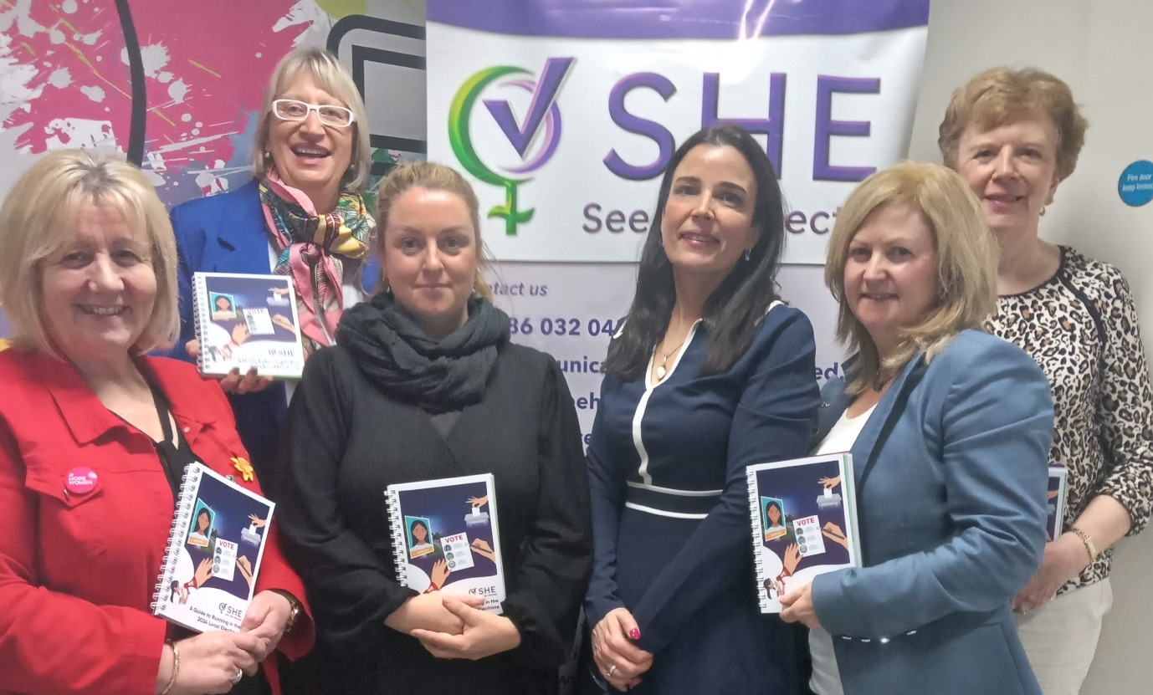
L-R Councillor Mary Farrell, Councillor Maura Bell, Councillor Bridin Murphy, Mairead O’Shea of See Her Elected, Councillor Barbara-Anne Murphy and Councillor Kathleen Codd Nolan

ENDS

