PRESS RELEASE 31 July 2023
Taghmon Camross Parish Community Car launch
A new Community Car for the parish of Taghmon Camross was officially launched by Cathaoirleach of Rosslare Municipal District, Cllr. Jim Moore on Wednesday 26th July 2023 at the Taghmon Action Group building, Taghmon. Speaking at the launch, Cllr. Moore welcomed the initiative saying “'this is a fantastic pioneering local development driven by the community with the support of commercial sponsorship and several agencies. The wonderful volunteers are reaching out across the area and providing a unique service by their commitment to their local community. Well done agus comhgairdeas go léir”.
Also in attendance at the launch were Councillors Jim Codd and Leonard Kelly, a number of council officials including Annette O’Neill (Director of Rosslare Municipal District), Nóirín Cummins (Rosslare District Manager), Claude Clancy (Community Development), Annette Dupuy (Healthy Wexford) and Ann Marie Laffan (Sláintecare Healthy Communities Programme) as well as Enda Newport from main sponsors, Bolands of Wexford Town. Despite the poor weather many members of the local community turned out in force to hear about the pilot project and find out more about how it will operate.
The organisers of the initiative, Ann Marie Laffan (Sláintecare Healthy Communities Programme), Mary B O’Leary (Wexford Local Link), Emily O’Rourke (Wexford Local Development) and John Waters (Taghmon Action Group) spoke at the event and answered questions from those present including many of those attending from Taghmon Day Care Centre. The project which is open to people living in the parish of Taghmon Camross will get underway shortly and it is aimed primarily at people who no longer are able to drive or those who have no access to transport in their homes.
Explaining how this works Ann Marie Laffan said “people can use this car to get to medical appointments but also it is hoped that it will help to alleviate social isolation and loneliness by allowing people to get to social events such as sporting events like GAA matches, mass, bingo or just to visit friends or relations. Also, younger members of the community could use it to get to training courses, work, or job interviews”. Thanking all the volunteers who will run the service, she added that the availability of the car is determined by the availability of volunteers and additional volunteer drivers are still required for the programme. If you are interested in volunteering, please email annmarie.laffan@wexfordcoco.ie or contact Taghmon Action Group.
Mary B O’Leary from Wexford Local Link noted that the community car will not compete with public transport but rather will compliment it and link passengers in with ongoing bus services such as into Wexford Town or to Waterford for hospital appointments which has been an issue identified particularly by older people. Wexford Local Link currently operates up to 6 return journeys from Taghmon to Wexford Town with plans to enhance this service soon. On top of that they also operate a door-to-door service in the parish with options available several days of the week. For more information on this people can contact Wexford local Link at 053-9011828. Mary B added that “We in Wexford Local Link are delighted to be involved in projects or initiatives like this that enhance access to public transport for local people”.
John Waters from Taghmon Action Group (TAG) thanked all those involved in making this project happen and in particular to Bolands of Wexford Town for supplying the 161 Ford Focus car which was parked outside the front door of the TAG building for the launch. It is hoped the car which is branded and very visible will be regularly spotted around the parish.
The project received 100% funding from the Department of Health’s Sláintecare Healthy Communities Programme which is managed locally by Wexford County Council. It is hoped that people can start making bookings from mid-August onwards with the car on the road from the first week in September. Bookings can be made via a phone number which will be advertised shortly.

ENDS
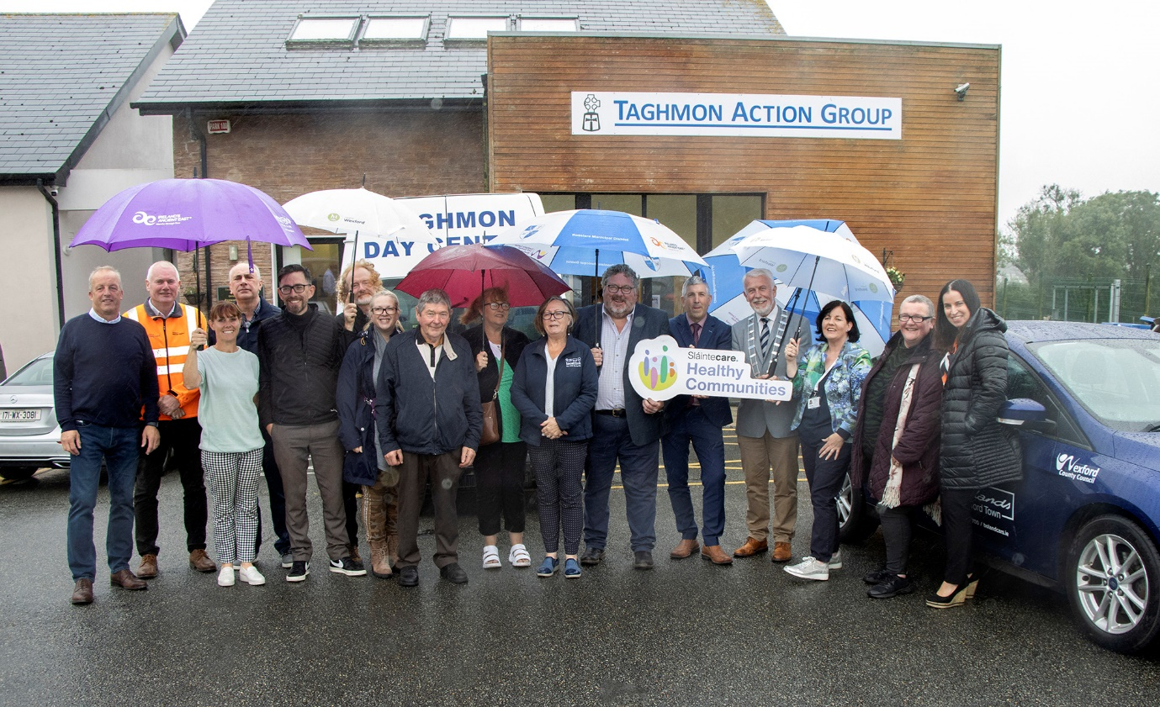

Photograph below : Enda Newport, Bolands Wexford and Cllr. Jim Moore,
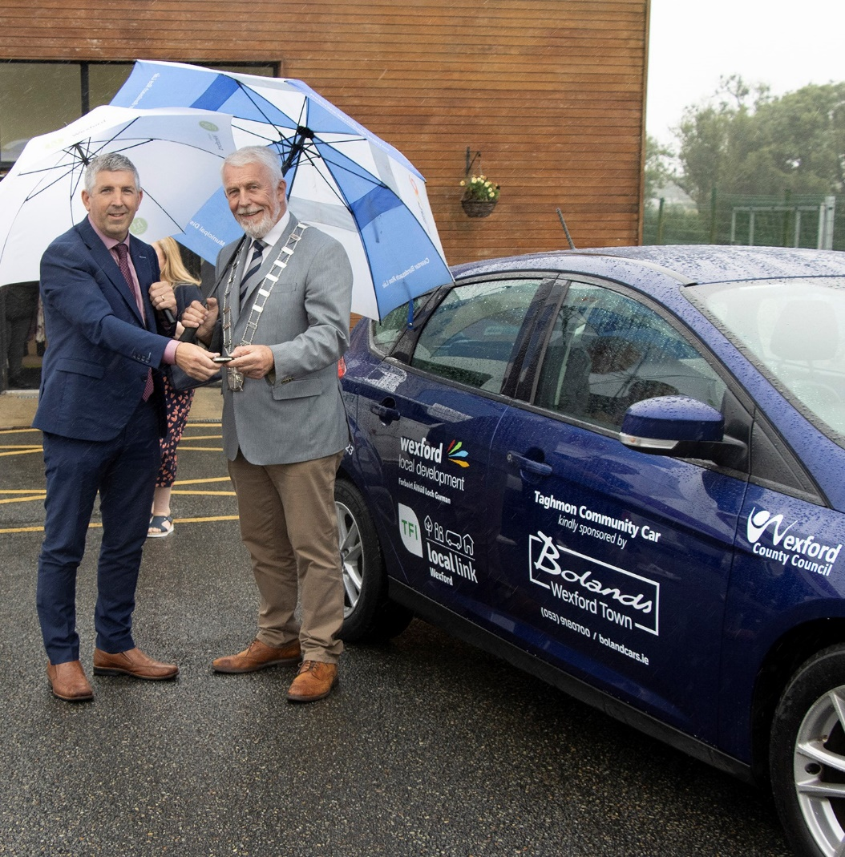
Cathaoirleach Rosslare Municipal District

