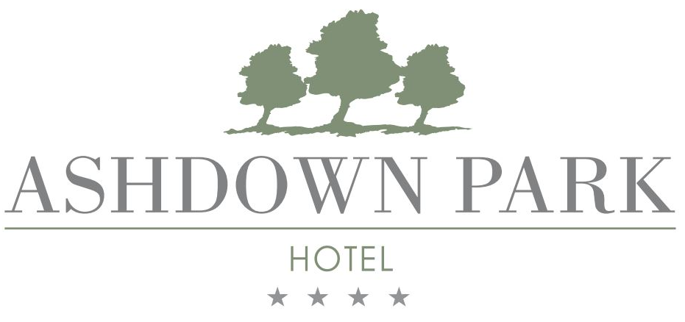
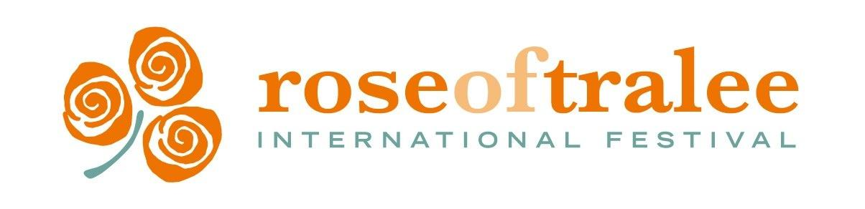

PRESS RELEASE 29th September 2023

Over half a million RTÉ viewers tune into thrilling footage of Wexford Rose Tour 2023

The Rose of Tralee International Festival and this year’s 32 Irish and International Roses were welcomed to County Wexford this August for a thrilling and adventurous 3 days in the sunny southeast. After meeting for the very first time in the Model County, the 2023 Roses were left stunned by the warm welcome on every stop of the tour.

Wexford County Council was delighted to be one of main sponsors of the Wexford Rose tour. The welcome and support that was shown by the official hospitality partner Ashdown Park Hotel Gorey and from the local tourism businesses involved, and the people of Wexford, are an ode to the success of the Wexford Rose Tour 2023. Wexford County Council would like to extend a very special thank you to the county as a whole for hosting the tour.
Cllr. John Fleming, Cathaoirleach of Wexford County Council said ‘The brand partnership between Wexford County Council, Ashdown Park Hotel, Gorey, and the Rose of Tralee International Festival opens doors and offers unique opportunities for the sunny southeast in a modern, fun and exciting way by supporting and promoting the Wexford Rose Tour, especially with its return. It goes to show the fun last year’s Rose Tour was and how we can keep building on that with the abundance of adventure, fun, ancient history, friendly faces and excellence in tourism and hospitality this county has.’

New Zealand Rose, Kelsi Wallace compared Wexford to her homeland in New Zealand as ‘home away from home’ with landscapes so similar and the people so friendly. While Texas Rose, Eden Kasprak, reminisced on the fun she had dancing at the Wexford Rose Tour Gala Dinner hosted by the Ashdown Park Hotel - the official hospitality partner of the tour which hosted the Roses and set a standard for top-class hospitality. The 32 Roses and all of the guests invited to the highly anticipated Gala Dinner on the second night of the tour had all the stops pulled out for them with a delicious Taste Wexford menu featuring local food and drink producers across the 5-course dinner, incredible entertainment by James Sexton and excellent service throughout the night.
County Wexford was a confirmed firm favourite on the Rose tour of Ireland in which the Wexford-leg of the tour was mentioned overall 9 times on the two TV selection nights on RTÉ One on the 21st and 22nd August in which over half a million viewers tuned in. As one of the most heavily featured counties on the highlight reel of the Rose tour of Ireland, the video footage captured all of the adventurous, fun and thrilling activities including special moments and Wexford memories highlighted across Wexford’s most iconic locations.
Visit Wexford, the county’s official destination brand, saw double amounts of traffic and an increase in engagement across both the website and social media channels during the Wexford Rose Tour and festival’s broadcast on RTÉ One. With downloadable itineraries available to download, a pre-tour letter-style blog from 2023 Wexford Rose Brónagh Hogan and a memories campaign from the Wexford Rose Tour in 2022, the social media covered a momentous build up to the 2023 tour.
Follow @VisitWexford on social media and go to VisitWexford.ie to catch up on all of the #WexfordRoseTour2023 content throughout the tour as well as everything else happening around the county this month.
ENDS

