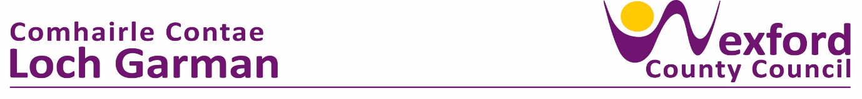

**PRESS RELEASE 29 April 2024**

**Sing Along with Pete and Aileen! Free Music & Song Sessions for month of May 2024 - Bealtaine Festival 2024**

Partnering this year with the National Opera House, Templeshannon Community Centre, Enniscorthy and Southend Family Resource Centre, Maudlintown; Wexford County Council’s Arts Office is delighted to announce free Songs from the Past music and song sessions followed by tea, coffee and cake.

These sessions will run in May, to coincide with Age and Opportunity’s annual Bealtaine Festival which celebrates the arts and creativity as we age.

Bealtaine is a well-established festival organised by Age & Opportunity, the national development organisation that aims to provide the best possible quality of life for us all as we age.

Supported by the Arts Office at Wexford County Council, the events for Bealtaine 2024 taking place across three venues and are facilitated by singer Aileen McCamley and actor Pete McCamley.

All these events only require interest and enthusiasm – no prior experience or expertise is necessary!

**Date, times and how to book:**

**Thursday 16th May**

Templeshannon Community Centre, Enniscorthy

10:30am - 12pm

To Book Phone: 053 92 37 511

Or email: tccctempleshannon@hotmail.com

**Monday 27th May**

Saint Marys GAA Hall, Wexford Town

10am - 12pm

To Book Phone: 053 9126027

**Thursday 30th May**

National Opera House

Either 11am or 1.30pm

To Book Phone: +353 53 912 2144

Or Visit: www.nationaloperahouse.ie

Come and join us!

For full Bealtaine National Programme for 2024 go to <https://bealtaine.ie/events-2/>

ENDS

