PRESS RELEASE 24th November 2023

Staff & Stakeholders get Virtual Dementia Experience at County Hall.

On Monday 20th November Wexford County Council welcomed the ‘Virtual Dementia Tour Bus’ to County Hall. The Mobile Virtual Dementia Tour allows people to experience the lived reality people with dementia can go through on a daily basis, allowing participants to gain an insight into what it is like for those who are living with dementia.

Speaking after the training Ann Marie Laffan from the Community Section at Wexford County Council said: “Participants found the training quite overwhelming, thought provoking and a great way to develop an understanding of what people living with dementia might experience.’ She continued ‘Our aim in delivering this training was to enable participants to gain a greater understanding and to consider the lived reality of dementia in design and delivery of our services and how we interact with people”.

The initiative was supported by Healthy Wexford, at Wexford County Council. Annette Dupuy, Healthy County Co-Ordinator said, ‘In our vision for a Healthy Wexford we are working to support the wellbeing of all of our citizens and enabling this type of dementia awareness training with staff and stakeholders is a further step to delivering on this vision’.

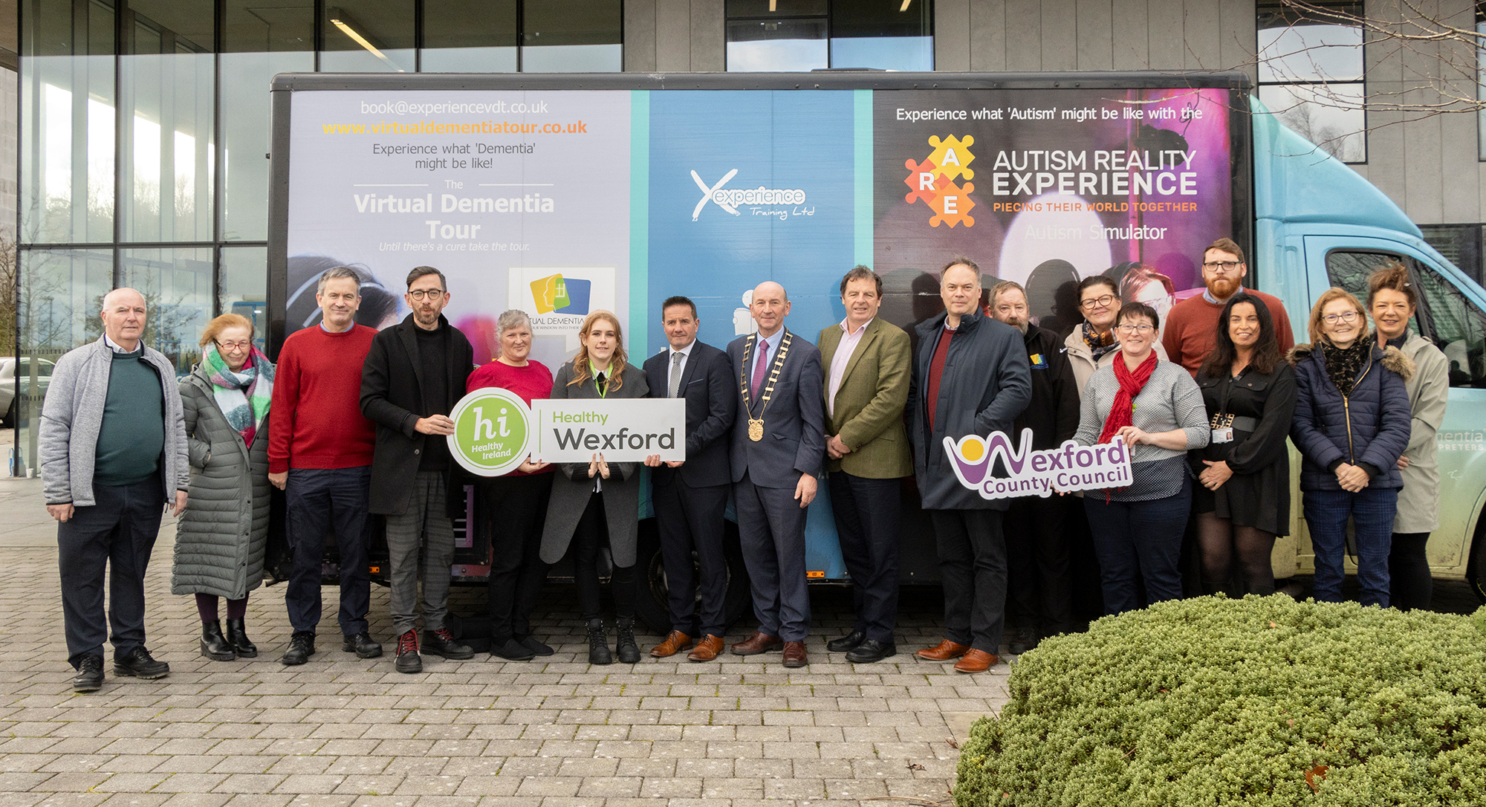

John Fleming, Cathaoirleach of Wexford County Council who took part in the training said “This is one of the most powerful things I have experienced, and I would encourage everyone to take the opportunity to experience this training to fully understand exactly what is like for someone living with dementia. This training will assist those who attended to understand the needs of those living with dementia better as well as to communicate better with them which is important for us as a local authority.

Alongside the Dementia Bus, the Alzheimer Society of Ireland’s Mobile Information Service attended County Hall, offering both staff and those visiting County Hall the opportunity to pop in and gather some information on local resources and supports available.

This training follows on from a series of initiatives that Wexford County Council has delivered over recent years to make the organisation more dementia friendly. These included their involvement in the setting up of the Wexford Dementia Alliance, a multi-agency group that aims to improve the health and wellbeing for people living with dementia and their families and carers in Wexford as well as the production of a dementia information leaflet and directory of services with information on key services and supports available locally.

Other agencies that attended the training included An Garda Siochana, HSE, WWETB and Wexford Local Development.

ENDS

Note to Editor:
There are 64,142 people currently living with dementia in Ireland. With age being the leading risk factor for dementia, this number is expected to rise alongside population ageing to 150,131 by 2045. People living with dementia will require care and support across different care settings. This can also be true for their care partners. These figures are based on Central Statistical Office Census data 2016 and were generated by HealthAtlas, HSE.

