PRESS RELEASE 24th November 2023

South East Businesses Embrace Sustainability Message at Local Enterprise Office Conference
On Thursday 16th November over 60 business leaders gathered in the Wexford County Council for the "Making Sustainability Happen: Funding Pathways and Success Stories" conference. The objective of the conference was to create awareness of sustainability supports via the Local Enterprise office and partner agencies and to encourage the business community in the South East to urgently integrate sustainability as a KPI for their business. Renowned Irish biologist, environmental consultant and radio and television presenter Éanna Ní Lamhna was master of ceremonies and moderated 2 panel discussions on this topical and important subject. Attendees were delighted to hear firsthand from successful businesses owners Simon Lynch, Wicklow Wolf Brewery, Catherine Murphy Brady, Brady’s Coffee, and Michael Griffin, Griffin Group how they have implemented changes in their businesses to improve their sustainability credentials. Michael Griffin detailed how the Griffin group have successfully incorporated solar panels as a key measure to reduce energy consumption, the benefits of renewable energy was reiterated by Simon Lynch who also outlined how Wicklow Wolf have focused on local sourcing of their ingredients while Catherine Brady spoke about the positive impact of the Local Enterprise Office Green for Business support on her Coffee roasting business. With the help of a LEO appointed environmental consultant they have identified and implemented practical steps to reduce their carbon footprint by reducing their packaging usage amongst other measures. Information on the various supports available was outlined at the event by speakers Ankush Shirsath from Enterprise Ireland, Amanda Timbrell from the High-Performance Building Alliance, Breege Cosgrave Head of Enterprise and Economic Development Wexford County Council, Onyedikachi Onwusor of the South East Energy Agency and Michael Crowley of Microfinance Ireland. Engagement from attendees was high during the Q&A and networking sessions which afforded companies the opportunity to meet with LEO staff and Green Consultants who are available via the LEO to help business to apply for the Green for Business support and the €5000 Energy Efficiency Grant. Further information on both supports is available by contacting the Local Enterprise office on 053 9196020 or by checking out the relevant page on the website www.localenterprise.ie/green

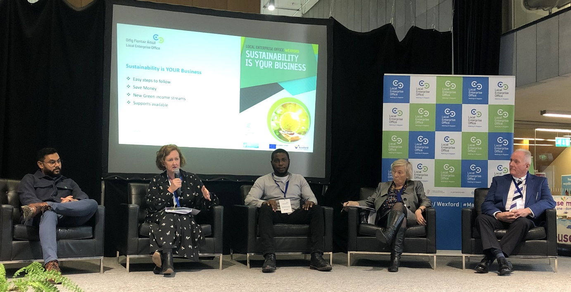

L to R: Ankush Shirsath (Enterprise Ireland), Breege Cosgrave (Head of Enterprise and Economic Development), Onyedikachi Onwusor (South East Energy Agency), Eanna Ni Lamhna (MC) , Michael Crowley( Microfinance Ireland)
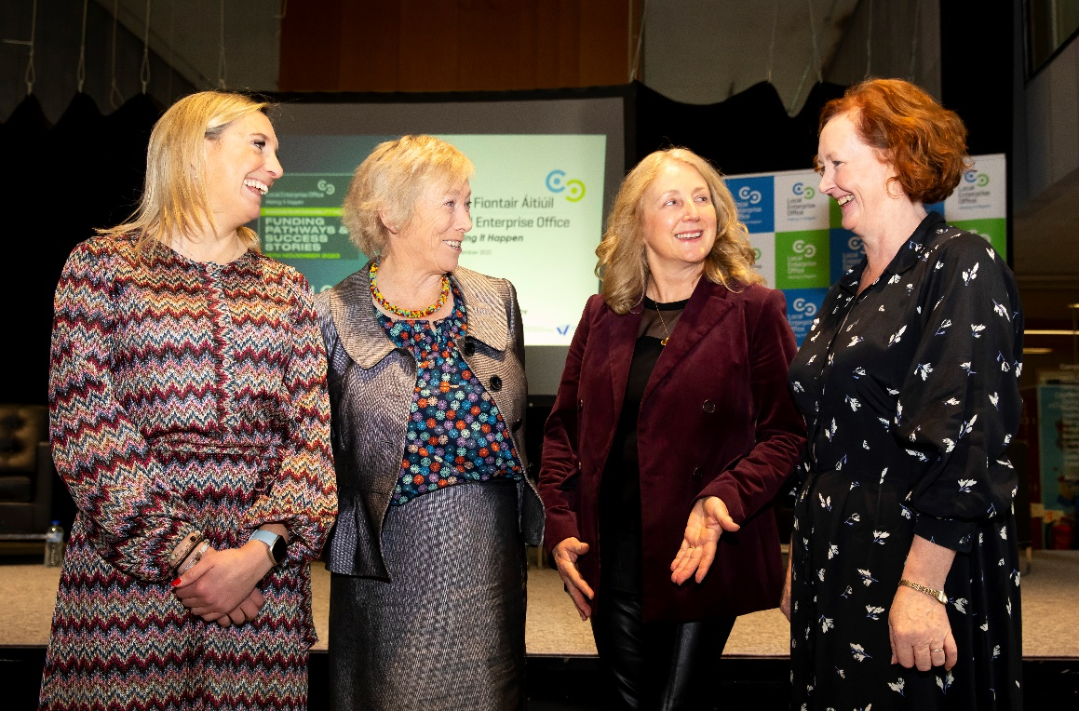
L to R: Amanda Timbrell (CEO of the High Performance Building Alliance and Green Cluster coordinator for the South East), Eanna Ni Lamhna (MC), Marie Doyle Henry (Astrum Consulting), Breege Cosgrave (Head of Enterprise and Economic Development)

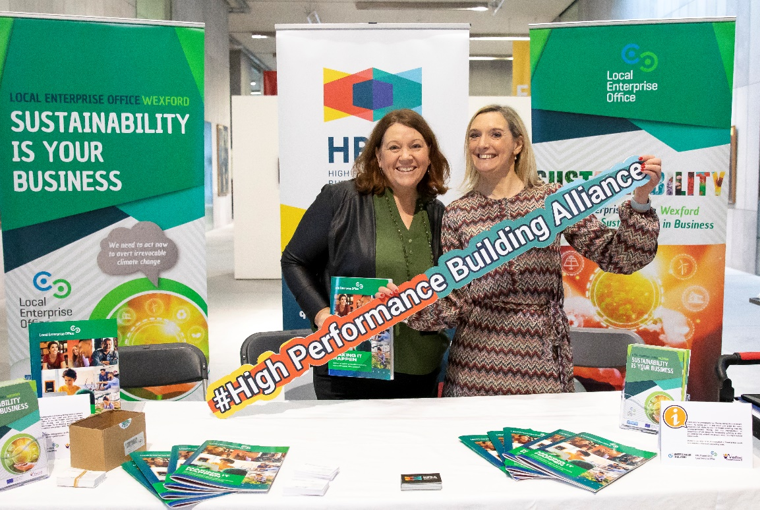
L to R: Carmel Moran (Business Adviser), Amanda Timbrell (CEO of the High Performance Building Alliance and Green Cluster co-ordinator for the South East)

ENDS

For further information:
Local Enterprise Office
Wexford County Council,
Carricklawn,
Wexford Y35 WY93

Contact: 053 9196020
Email: annette.rowsome@wexfordcoco.ie

