PRESS RELEASE 23 August 2023

WEXFORD BUSINESS GETS CHANCE TO EXHIBIT AT PLOUGHING 2023

One of Wexford’s best small businesses will get a chance to exhibit their business to almost 300,000 people at the National Ploughing Championships next month as part of the Local Enterprise Village.

Founded by Niamh Hogan, Holos Skincare, supported by Local Enterprise Office, Wexford is a luxurious and ethical skincare brand handmade in County Wexford. The Skincare range is produced using natural botanical ingredients and scientifically proven plant actives with sustainable practices at the core of all that the company’s activities. The company were recently acknowledged for their eco consciousness and sustainability credentials at the Global Green Beauty Awards 2023 where three of their products won gold medals and a fourth product was highly commended.

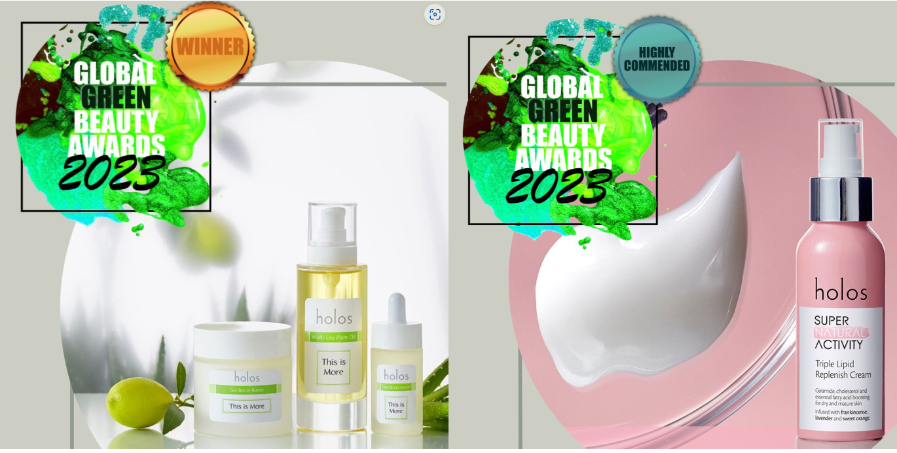

The initiative of the Local Enterprise Offices (LEOs) will see over 30 small businesses from across the country take a stand in the Local Enterprise Village in the heart of the Ploughing Championships, opening their businesses up to almost 300,000 prospective customers across the 3 days of the event.

The initiative of the Local Enterprise Offices was launched by Minister of State for Business, Employment and Retail, Neale Richmond T.D. and will be open as part of the Ploughing Championships taking place in Ratheniska, County Laois from the 19th to 21st September this year.

Breege Cosgrave, Head of Enterprise and Economic Development in Wexford County Council said “The National Ploughing Championship is one of the biggest occasions on the Irish calendar and there are very few events that draw a crowd as large as this over 3 days. For our small businesses this is a huge opportunity to engage with thousands of prospective customers every day and this could have a significant impact on their business. We have been working with them across the summer on their products, marketing and merchandising for the event so they can maximise this amazing opportunity. There’s something for everyone in the Local Enterprise Village.”

Some of the clients involved this year cover areas such a kids clothing & games, agtech products, luxury bathing and skincare products, artisan food and drink producers, sustainable clothing and beauty products and range of innovative products from Ireland’s best small businesses. Year on year the Local Enterprise Village proves to be one of the most popular destinations for visitors to the Ploughing Championships.

Neale Richmond, Minister of State for Business, Employment and Retail, said; “The Local Enterprise Village is a fantastic initiative from the Local Enterprise Offices. For these small businesses, many only in their early years, to get a chance to have a stand at the Ploughing Championships is a significant milestone for them. The opportunity to meet with thousands of people at the Local Enterprise Village, which is one of the popular stands at the Ploughing is going to be great boost to their business. I’m looking forward to getting down to the Village myself next month and meeting them all in person and sampling all the great products and services on show.”

NPA President James Sutton said “It is marvelous to see that so many diverse and impressive businesses will be partaking in this year’s ‘Local Enterprise Village’ at the National Ploughing Championships taking place in Ratheniska, Co Laois from September 19th to 21st. This is a wonderful opportunity for these small businesses to showcase their products & wares to the large number of visitors that Ploughing attracts.”

The Local Enterprise Village is just one of a number of initiatives that the Local Enterprise Offices run, to foster entrepreneurship across the country. Others include Local Enterprise Week, the National Enterprise Awards, the Student Enterprise Programme, National Women’s Enterprise Day and Local Enterprise Showcase. The Local Enterprise Offices in local authorities are funded by the Government of Ireland through Enterprise Ireland.
Established in 2014, the Local Enterprise Offices are the essential resource for any entrepreneur looking to start a business or any small business that is looking for support or advice to help them grow. Since their inception eight years ago, the Local Enterprise Offices have helped create over 25,000 jobs across the country. The LEOs work with thousands of client companies across Ireland in a diverse range of sectors offering mentoring, training, expert advice and financial supports to small businesses. For more information see www.LocalEnterprise.ie

LOCAL ENTERPRISE VILLAGE CLIENTS @ NATIONAL PLOUGHING CHAMPIONSHIPS 2023

- LEO Carlow – Cullen Nurseries - Growers and Suppliers of a large range of Native trees and hedging plants. www.CullenNurseries.ie

- LEO Donegal – O’Reilly Sports - Supply customised clothing, to teams, schools and businesses throughout Ireland. www.oreillysofficial.com

- LEO Fingal – Milk Bath - Innovative luxury bathing. Handcrafted with indigenous, sustainably sourced Irish ingredients, Irish grass-fed cow’s milk, organic Irish oats, Epsom salts and pure essential oils. www.MilkBath.ie

- LEO Kilkenny – Bó Bar Soap - Udderly delightful natural soap. Lovingly handmade using whole milk from our award winning, grass fed, family run dairy farm in South Kilkenny where happy cows = happy milk. www.bobarsoap.ie

- LEO Carlow – Jo Browne – Hand-made Natural and organic skincare and Body care using Bamboo Packaging and ingredients from the Bamboo Tree. www.JoBrowne.com

- LEO Longford – Mark Cadam - The business comprises two enterprises the first a civil engineering business which is involved in transport, road repairs, haulage of aggregate supplies and waste collection and secondly an animal bedding business which trades as Acadami Bedding providing high quality bedding to the various sectors within the agri-sector mainly the equine industry. www.markcadam.ie

- LEO Louth – Esker Fields - Esker Fields is a range of natural skincare products. All the products are handmade using natural ingredients and pure essential in Co. Louth on the family dairy farm. www.EskerFields.ie

- LEO Dun Laoghaire-Rathdown – JR Games - Children’s licensed sports jigsaws. www.JRGames.ie

- LEO Wicklow – Sussed - Production and packaging of branded/own brand Oil’s and Dressings for sale in retailers and food service. www.Sussed.ie

- LEO South Dublin – Born Again Bites - Born Again Peanut and Dark Chocolate Soft Snack Bites made with Brewer’s Spent Grain, promoting circular food economy. Honest, handcrafted, accidentally vegan. High in fibre, 100% plant based protein, no nasties and full of flavour. www.well-spent-grain.com

- LEO Westmeath – Klaaskickz - Colour-coded football boots to help children learn football through colours and become more confident. www.klaaskickz.com

- LEO Cavan – Moran’s Megajam - We produce quirky jams, chutneys, relishes, pesto and sauces using the best of local & Irish ingredients where possible & giving our customers “a little imagination in every jar”. www.MoransMegajam.ie

- LEO Clare – Moher Cottage - Moher Cottage is a family owned and run business beside the Cliffs of Moher in Co.Clare. Situated on their own farm in what was previously our cowshed and pigsty, now a design led destination store selling their own gifts and supporting local Irish businesses, selling their beautiful Irish products. www.MoherCottage.com

- LEO Cork City – Badly Made Books - Notebooks, cards and prints made from recycled paper. www.BadlyMadeBooks.com

- LEO Dublin City – Wacky Clothing – Wacky clothing for kids using fun and vibrant colours. www.WackyClothing.ie

- LEO Galway – Galway Fairytales - Galway Fairytales is a publisher and author of educational irish storytelling books for children, aged 5 -12 years. They all focus on children’s wellbeing and social issues, such as bullying, friendship and kindness, teamwork, coping with anxiety, family break up and much more. www.GalwayFairytales.com

- LEO Kildare – GoodBrew - GoodBrew is a Kildare based beverage manufacturer making functional, plant-based cold brew coffee drinks fortified with Vitamin D & B12 for an extra nutritional boost. www.GoodBrew.ie

- LEO Laois – Bowfield Farm - Bowfield Farm is a vertical hydroponic farm based in Co. Laois that grows a large variety of microgreens and edible flowers. www.bowfieldfarm.ie

- LEO Leitrim – Pathfinders Custom Conversions - We create bespoke van conversions for the B2B and B2C markets. A customer will take an empty van to us and we will then design a van to their specification. www.PathfindersCamperConversions.com

- LEO Limerick – This Is You - This is You Ltd specialises in providing quality gifts for homeowners and families. www.ThisIsYou.ie

- LEO Mayo – Thinstone Ireland - Stonemasonry and wholesalers of stone cladding. www.ThinstoneIreland.ie

- LEO Meath – Irish Compost Turners - Bespoke Irish made compost turners.

- LEO Monaghan – Glaslough Chocolate - Handmade Chocolate Manufacturing Business. www.GlasloughChocolate.net

- LEO Offaly – Glass Innovations - Decorators of Glass Containers for the Drinks, Home Fragrance and Body Products Market. www.GlassInnovationsLtd.ie

- LEO Roscommon – deDANÚ Wellness - deDANÚ Manufactures and researches plant-based skincare and wellness products using locally sourced ingredients. www.dedanu.ie

- LEO Sligo – SUIP Manufacturing - Manufacturers of farm and household sprayers booms and garden equipment. www.SUIPCo.ie

- LEO South Cork – Hanna’s Bees - Beekeeping and producing sustainable honey and beeswax products. www.HannasBees.ie

- LEO Tipperary – GoLo Rugby Tackle Pads - Golo Tackle Pads are a hands-free tackle pad that encourages accurate and safe tackling in Rugby. www.GoLoRugby.com

- LEO Waterford – Polly & Andy - Sustainable super soft seamless bamboo socks. www.PollyAndAndy.com

- LEO Wexford – Holos Skincare - Handmade luxurious and ethical skincare that nourishes skin health though whole plant ingredients and scientifically proven botanical extracts. Products include facial cleansers/serums/oils/creams and treatments. www.Holos.ie

ENDS

For further information:

Local Enterprise Office Wexford
Tel: 0539196020
Email: info@leo.wexfordcoco.ie

