PRESS RELEASE 22nd December 2023

Enniscorthy Municipal District Christmas Window Display Winner Announced

Enniscorthy Municipal District in conjunction with Enniscorthy & District Chamber are delighted with the beautiful Christmas Window displays throughout the district this Christmas.
Out of the 27 businesses who entered the ‘most imaginative Christmas window display’ competition in both Enniscorthy and Bunclody, the esteemed judges Mr Michael Dunbar and Mrs Annette Wall Dunbar chose the Heavenly Café as the overall winner.
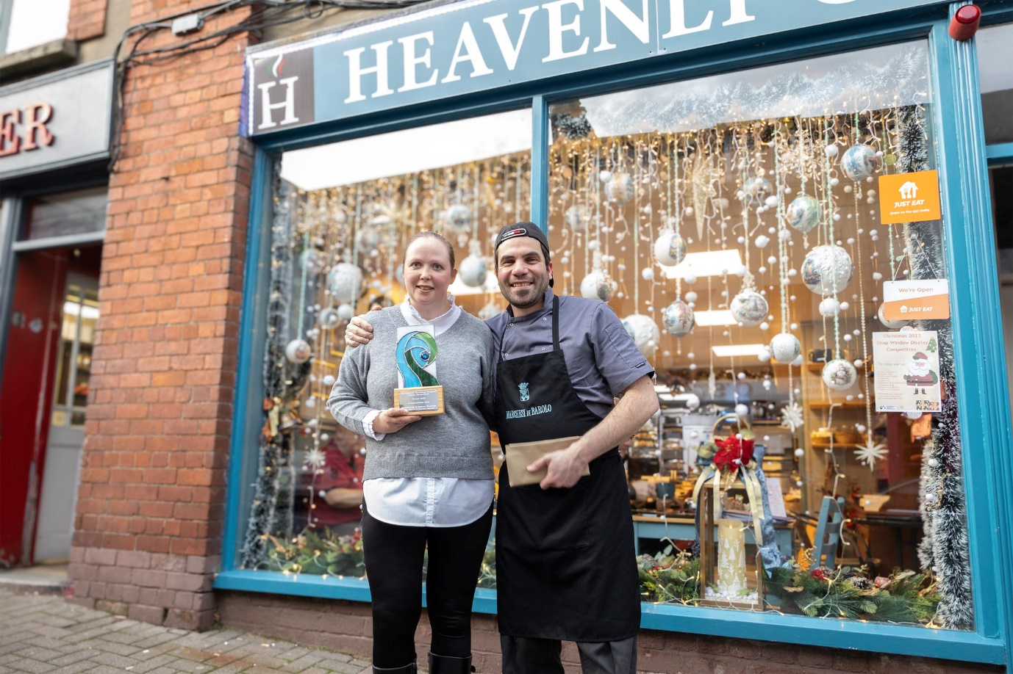

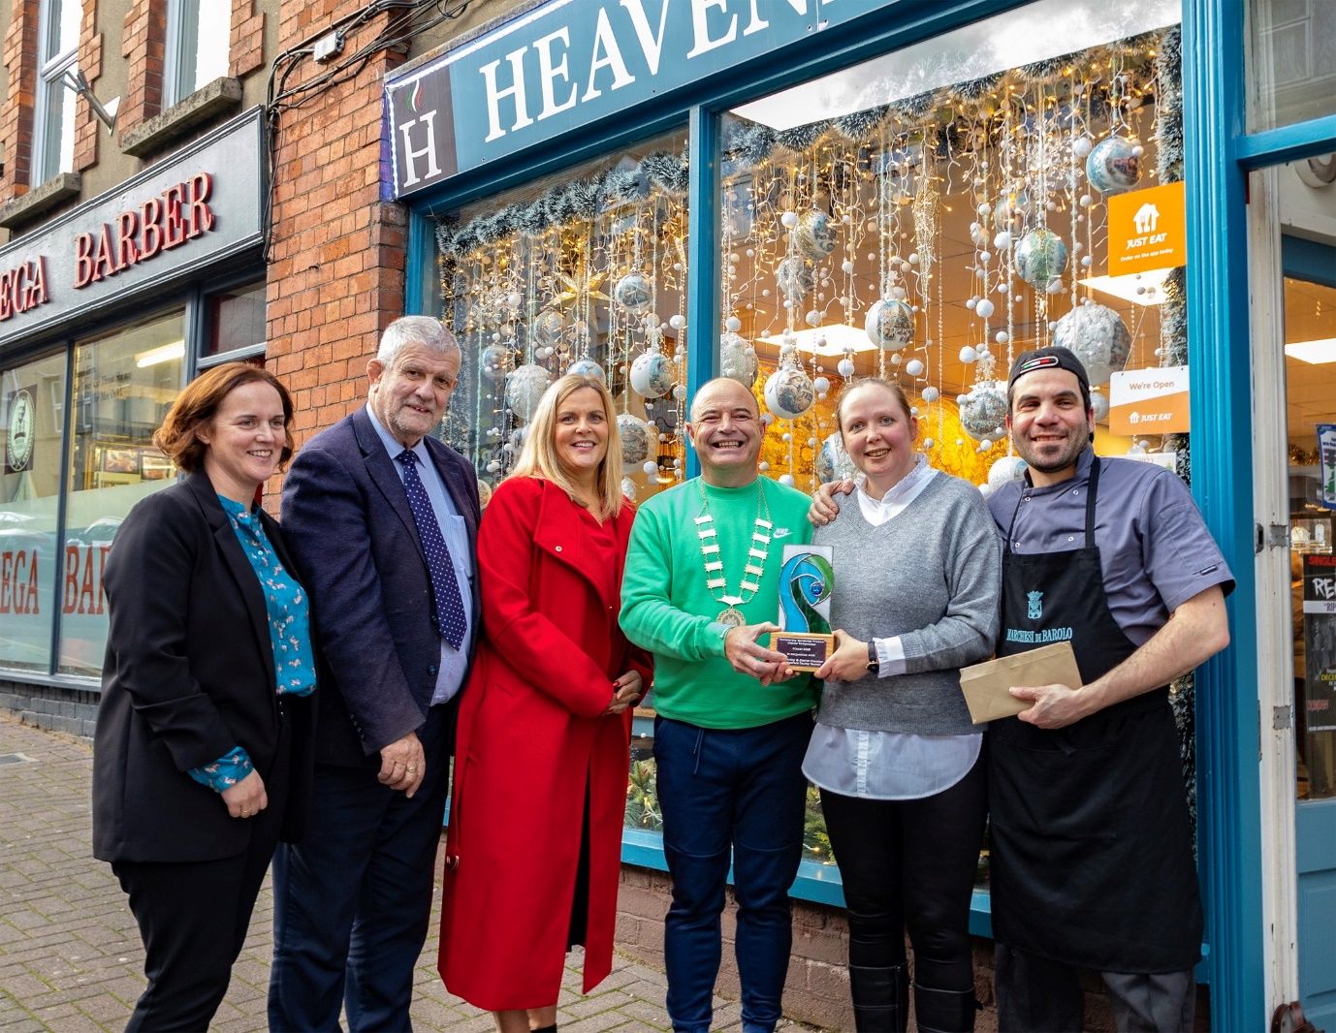

The standard for the competition was very high, and the following were highly commended by the judges:
Bernie’s Florist, Ryland Rd, Bunclody
D’arcy Blinds, Dunnes Carpark
Evolv Healthcare, Castle Hill
Jimmy Gahan of Enniscorthy & District Chamber said ‘I am delighted with the success of this inaugural competition as it highlighted the many attractions shopkeepers in Enniscorthy and Bunclody have to offer at Christmas. I hope that Enniscorthy Municipal District Council will continue to sponsor the event in the future and I wish to thank the Council for their generosity this year and the many other people associated with the competition’.
The Cathaoirleach of Enniscorthy Municipal District Cllr John O’Rourke presented Anastasija Liadova, owner of Heavenly Café, with a trophy that was handmade by award winning glass artist Biana Divito and €500 worth of Enniscorthy & District Chamber vouchers sponsored by Enniscorthy Municipal District and said ‘ I am delighted to see so many businesses getting involved in the competition and I wish to congratulate the Heavenly Café on their magical Christmas window display.’
Businesses in Enniscorthy were also offered to attend a “Creating Christmas Magic Webinar’ delivered by James Burke, James Burke & Associates and Lisa McCarthy who have years of experience in this area.
Kate Hore, Visual Merchandiser who specialises in all areas of visual merchandising including window design and implementation, store layout, customer experience and training workshops also worked directly with a number of retailers in the town.
Thank you to all the businesses that entered the competition and to everyone that decorated their windows to help create a magical atmosphere in our towns throughout the district for Christmas!
Ends

