PRESS RELEASE 22 December 2023

County Council Rewards Christmas Creativity …
Wexford County Council, in conjunction with South East Radio, has announced the winners of the 2023 Christmas Decoration Competition. The school year ended on a festive note with Cllr. John Fleming, An Cathaoirleach presenting the awards at a special ceremony in County Hall on Thursday 21st of December.
Councillor John Fleming, said “The Christmas decoration competition for schools has been an annual tradition in Wexford since 2004. Each year the decorations get more innovative and creative and show how items that normally end up as waste can be given new life through reuse. Those who have participated in this Competition have shown us all how to reduce waste by making unusual Christmas Decorations from everyday household waste materials. The decorations displayed today show great imagination and are an inspiration to us all.”
Hundreds of children around the county participated in the Christmas Decoration Competition which was open to all primary and secondary school children.
Cliona Connolly, Environment Education Officer with Wexford County Council stated that “The aim of the competition is to encourage children to make creative Christmas decorations with waste materials, fostering the ethos of reuse wherever possible. Schools around the county were invited to make a Christmas decoration out of waste materials. Numerous schools throughout Wexford participated in the competition and one entry per category from each school was put forward to the County Final. Among this years’ submissions were nutcrackers, Christmas owls, Christmas trees, penguins, snownmen, angels, Christmas village scenes, wreaths, Rudolf, and lots of tree decorations.”
All 171 decorations received were displayed in County Hall and received great praise. The People’s Choice award proved to be a great success again this year where members of the public voted for their favourite decoration on display. Annie Mcguire, Kilymshall National School secured this award with her decoration ‘Reindeer Head’.
A group category proved to be a huge success again this year as it encourages children to work together to make amazing decorations from as young as junior infants.
The overall primary school winner was created by Niamh O’ Connor, St Fintan’s National School, Taghmon. Niamh made the winning decoration entitled ‘The White Angel’ by simply using a soap bottle, a foil tray, old ping pong ball and milk cartons.
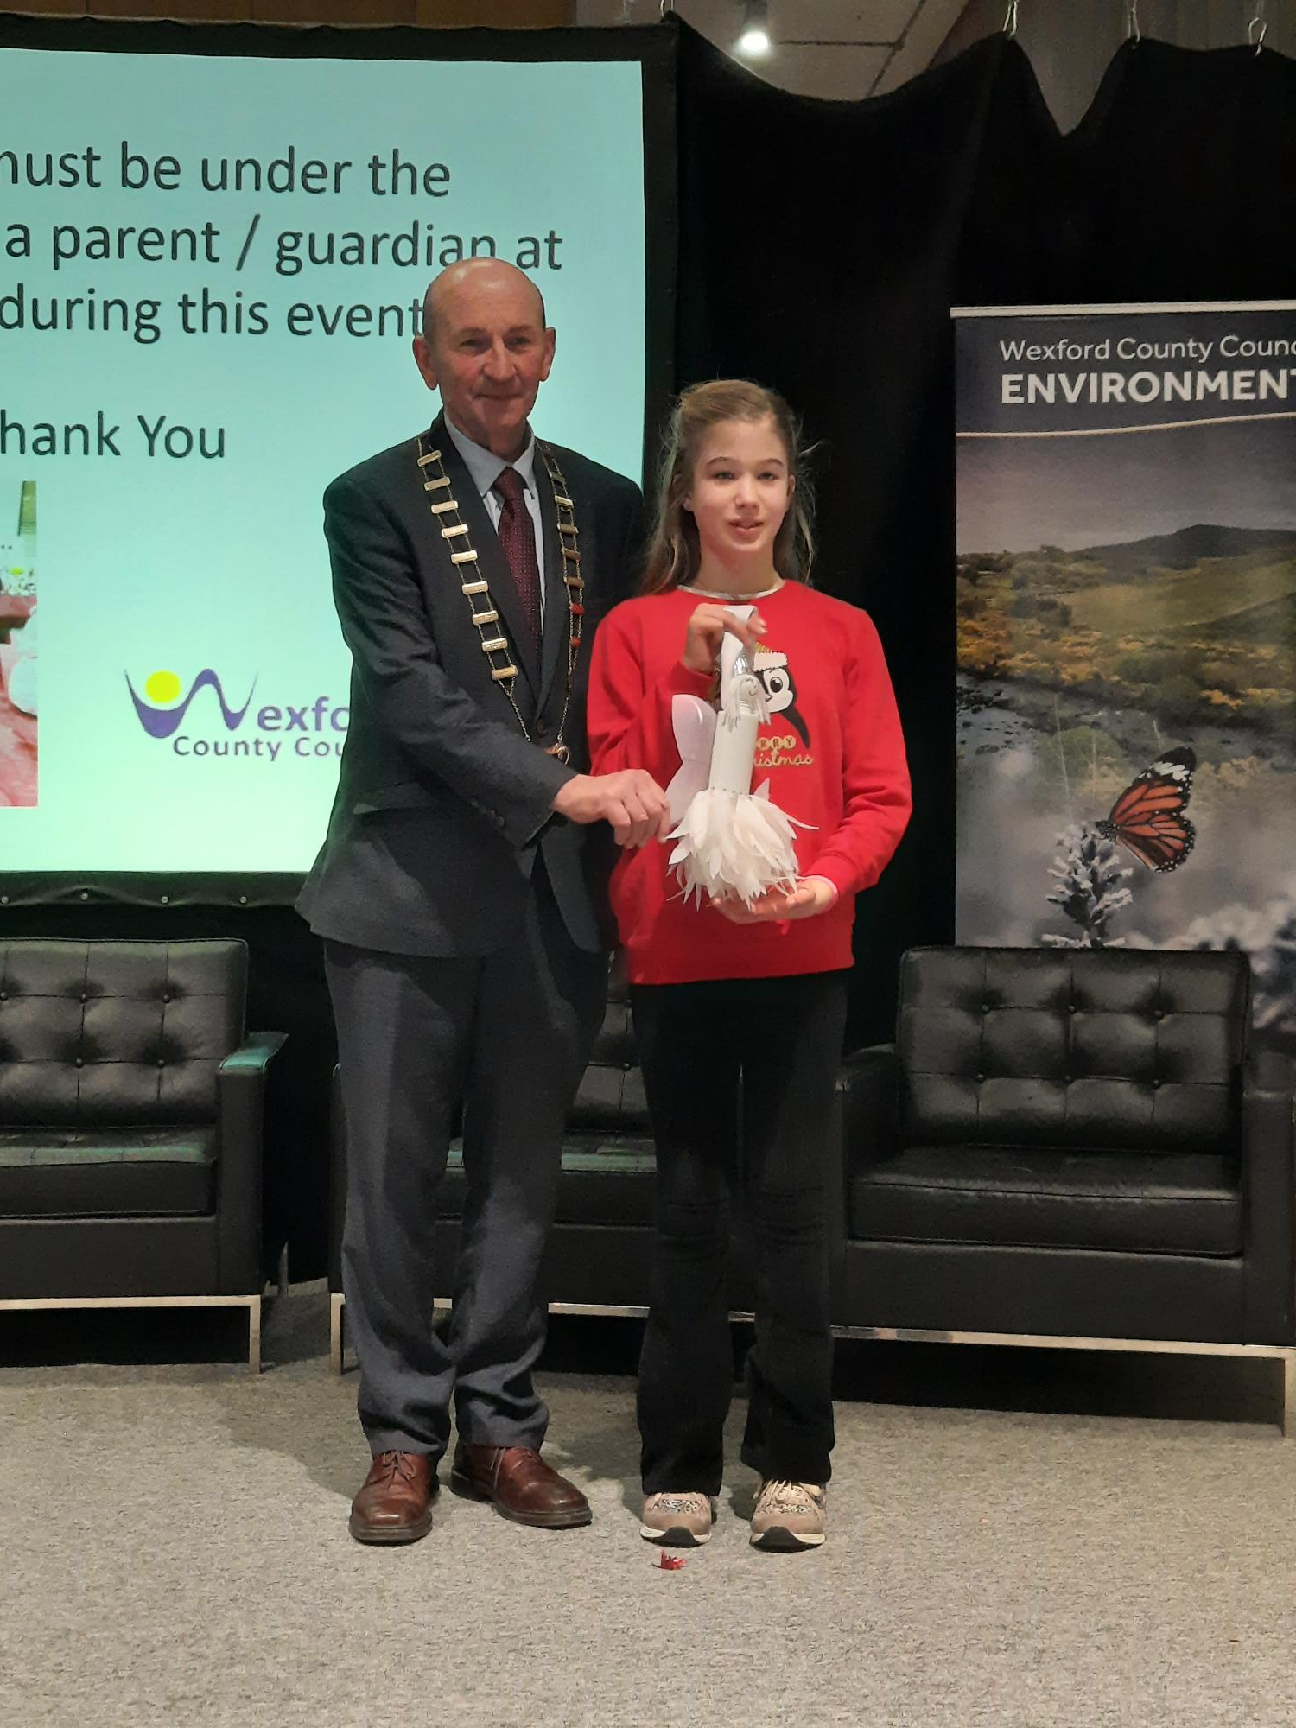
An Cathaoirleach Cllr. John Fleming & Overall Primary School Winner Niamh O’ Connor St Fintan’s National School, Taghmon
The Overall Runner Up was an entry entitled ‘Christmas is Magic’ by Shona Larkin, 1st class, Mercy School, John’s Road, Wexford.
An Cathaoirleach Cllr. John Fleming & Overall runner Up Shona Larkin, Mercy School, John’s Rd, Wexford

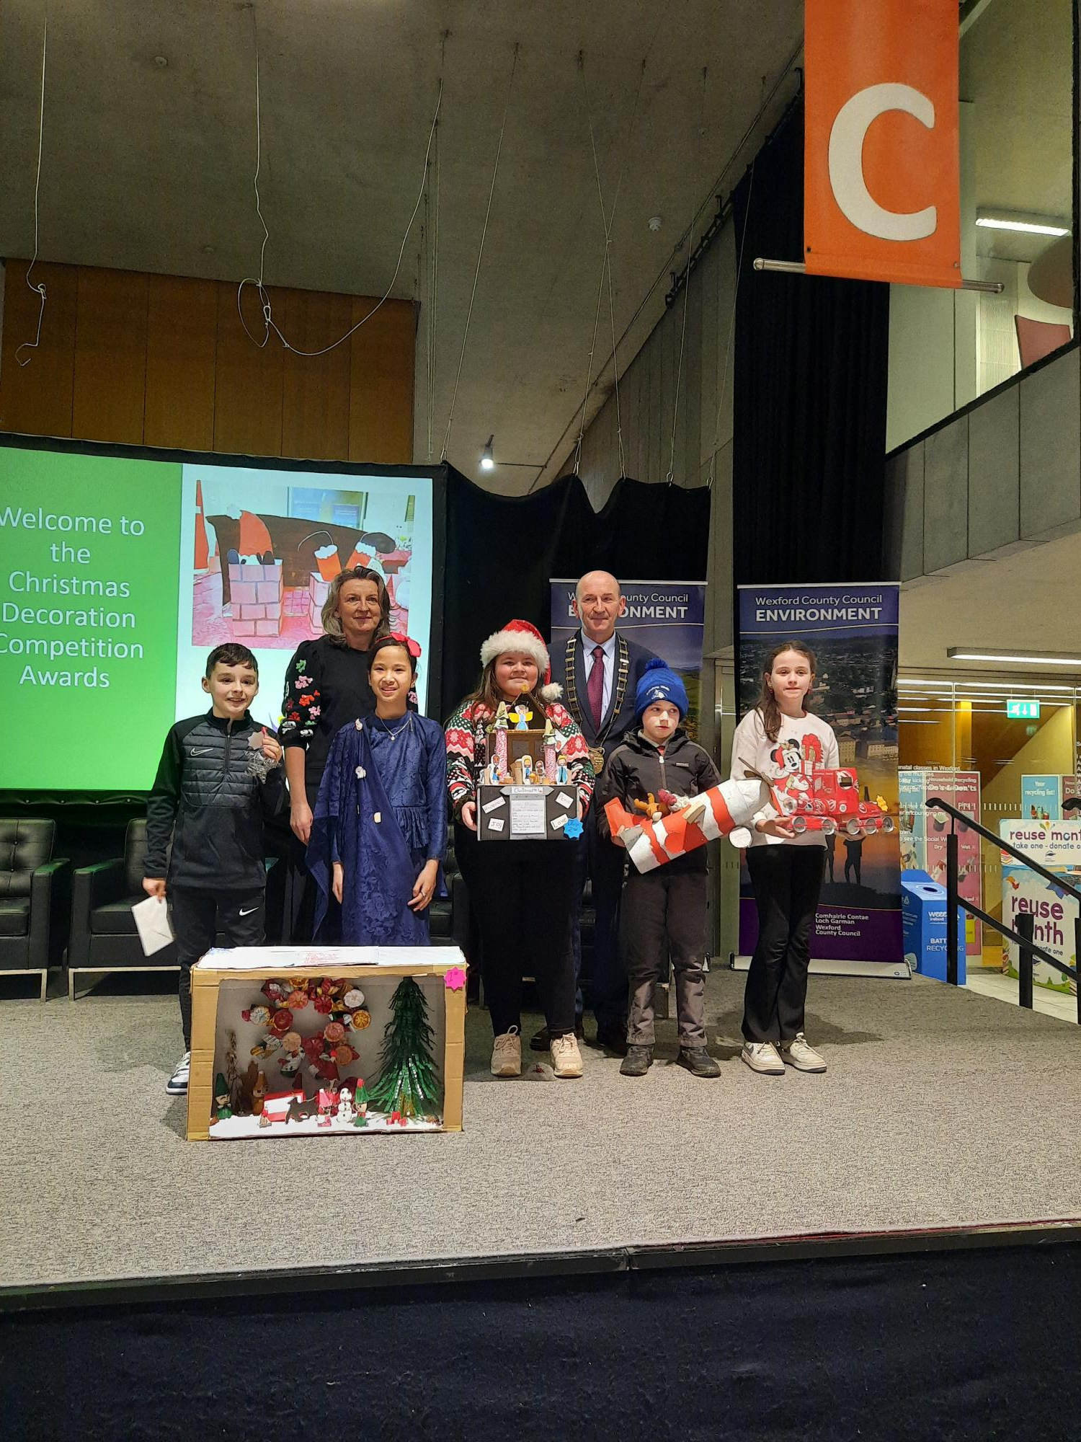
Front Row (LtoR): Freddie Hammel, Screen National Screen, Adel Ahmad Muhammad, Mercy School, John’s Rd, Wexford, Hannah Rae, Kilrane National School, Stephen Rea, Kilmyshal National School, Sarah Goddard, St Garvan’s National School, Caroreigh
Back from left Cliona Connolly Environment Section and An Cathaoirleach Cllr. John Fleming

Other winning decorations included ‘Mr. Cool Christmas’ by Luke Murphy, Junior Infants, Ballyduff National School; ‘Snownmen & Snowflakes’ by Ava Lewis, Senior Infants, St Mary’s National School, Enniscorthy; ‘Angel’ by Mia Wall, 1st Class, Scoil Naomh Bríde, Blackwater; ‘Snowflake’ by Orrin Murphy, 2nd Class, Danescastle National School; ‘Santa’s Sleigh 2023’ by Roxie Copeland, 3rd class, Gorey Central School; ‘Hannah’s Christmas Wish’ by Hannah Rea, 4th Class, Kilrane National School: ‘The Gingerbread House’ by Karina Tokarska, 5th class, Scoil Mhuire Rosslare; ‘Human Sized Nutcracker’ by Ethan O’ Byrne 6th class, Scoil Mhuire Barntown. ‘Santa’s Sleigh’ by Tommy O’ Leary & Martel Saluveer, St Peter’s College Wexford. Primary school group categories winners included ‘Santa Got Stuck in the Chimney’ by Millie Franks, Sophie Doyle, Tara Hegarty & Millie Franks, Mercy School, John’s Rd., Wexford; ‘Christmas Village’ by pupils of Our Lady of Fatima School Wexford.

Congratulations to all who participated.
ENDS

