PRESS RELEASE 22 May 2024
Wexford’s ‘Not Around Us’ Extends Further With Businesses Encouraged To Become Supporters
Healthy Wexford has announced further extension of the ‘Not Around Us’ initiative as businesses and tourism venues can show their affiliation to the initiative and pledge their support by extending the ask to their patrons not to smoke or vape around young people at their premises.
Healthy Wexford lead the campaign for Not Around Us in Wexford, in partnership and collaboration with Wexford Comhairle Na nÓg, HSE, Wexford CYPSC, WWETB, Wexford County Council, Wexford LCDC, FDYS, Sports Active Wexford, Wexford GAA, Leinster Rugby, & Wexford FAI. Chair of Wexford’s Healthy County Committee Cllr John Hegarty explained ‘‘Not Around Us commenced in Wexford in 2021 and since then we have worked with clubs and groups to spread the ‘Not Around Us’ ask of making their spaces smoke and vape free spaces for children and young people. Extending to supporting events in 2023 saw the campaign progress and today with the opportunity for businesses to deem themselves supporters shows the momentum and support for the initiative which is heavily driven by the young people of Wexford Comhairle Na nÓg’.
Speaking of the extension to business Healthy County Coordinator Annette Dupuy said ‘The extension to business is a natural progression as we work to protect children and young people from second hand smoke exposure and to de-normalise smoking and vaping for children and young people. Ultimately, we want ‘Not Around Us’ to be the norm in Wexford and today’s extension is a further step in that direction’
To date the campaign has over 80 supporting locations including sporting facilities, youth spaces, community centres, schools, playgrounds, libraries and beaches. It is hoped that the opportunity for businesses to show their support for the campaign will extend this further and make outdoor smoke and vape free spaces for children and young people the norm in Wexford.
Businesses can sign up online and will be provided with outdoor signage and window stickers indicating their support of the campaign. Imagery will also be available for businesses to highlight their support via their websites and social media. For further information about Wexford’s ‘Not Around Us’ and for businesses to sign up see https://www.bit.ly/NotAroundUs

ENDS

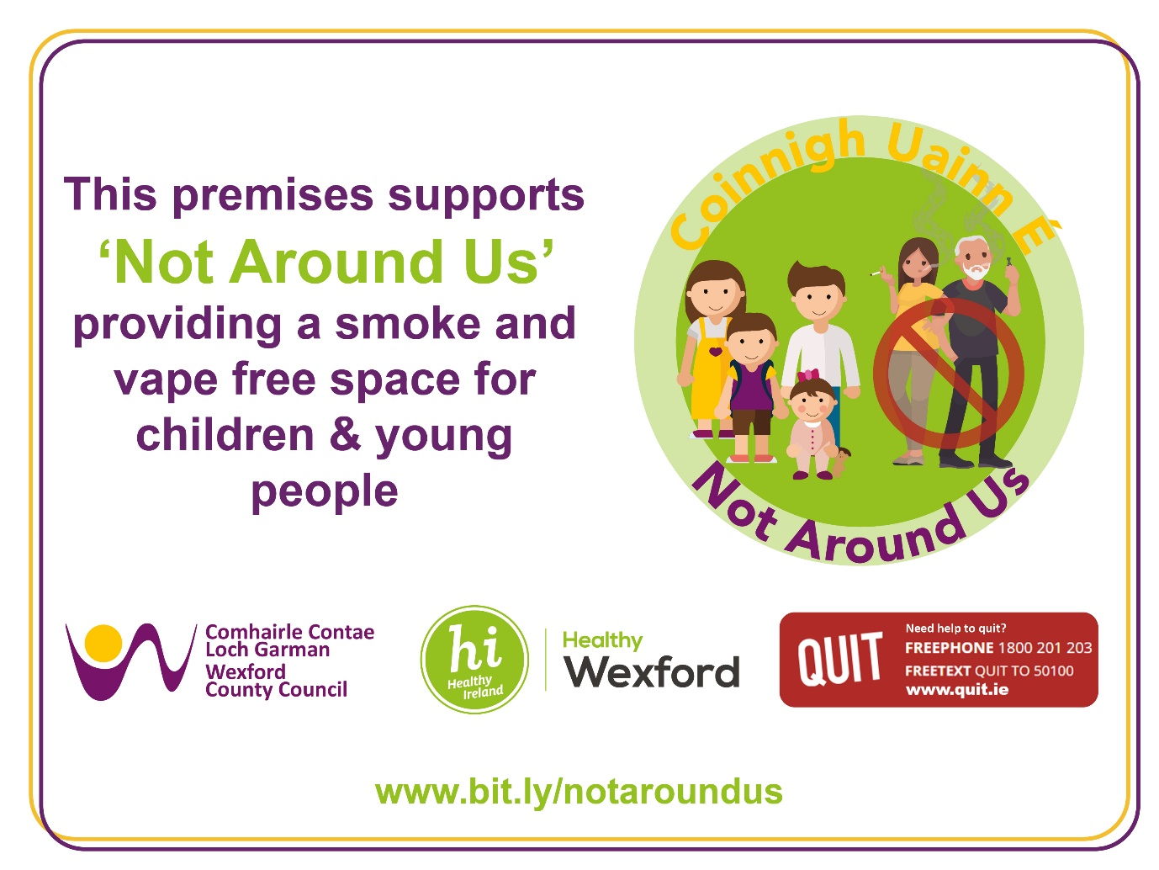

Notes to Editor:
About Not Around Us
Wexford’s ‘Not Around Us’ initiative is an invitation from young people to consider your activity in spaces where there are children and young people, in order to provide smoke/vape free environments for our young people and to help de-normalise smoking and vaping for the next generation. Not Around Us is another step Towards a Tobacco Free Wexford.
The purpose of ‘Not Around Us’ in Wexford is fourfold:
- Helping to protect children and young people from second-hand smoke exposure
- Contributing to the de-normalisation of smoking for children and young people
- Raising awareness and support amongst all stakeholders in the county on tobacco/vape free Ireland and everyone playing a part in supporting it
- Signposting to HSE Quit services
For more, including copies of campaign signage see https://www.bit.ly/NotAroundUs

Media queries to: Helen Frayne, Communications Officer at helen.frayne@wexfordcoco.ie.

