PRESS RELEASE 22 May 2024

Wexford County Council sign Service Level Agreements with Sporting Organisations

Last Monday (20th May) saw the signing of the three separate Service Level Agreements between Wexford County Council and major sporting organisations: the FAI, Leinster Rugby and Wexford GAA.

The Agreements, through collaboration with these organisations, will strengthen the Council’s commitment to support social inclusion and a Healthy Wexford where each person can enjoy physical and mental health and wellbeing to their full potential.

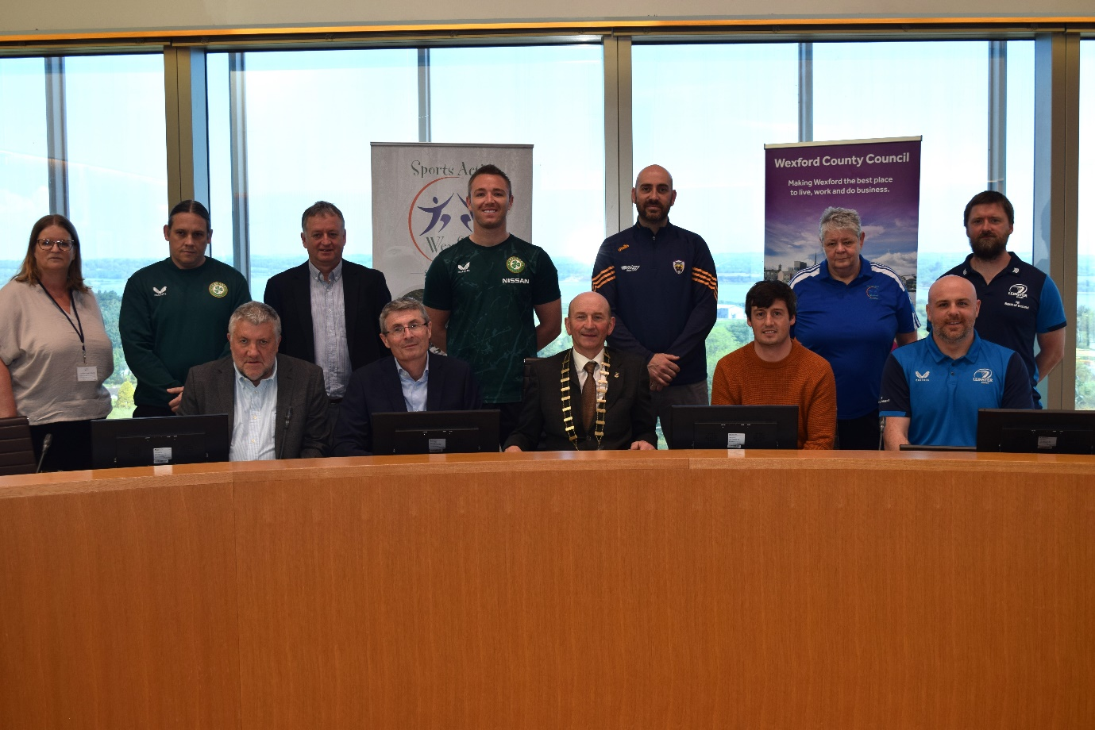
Image 1: (seated L-R) Paul Cooke (FAI President), Eddie Taaffe (Chief Executive Wexford Co Co.) , Cllr. John Fleming ( Cathaoirleach, Wexford Co Co.), Conor Day (Wexford GAA Operations Manager),Corey Carty (Leinster Rugby Community Rugby Officer)
Standing (L-R) Dymphna O’Connor ( S.E.O Community, WCC) Brendan Corish (FAI Development Officer),Michael Looby (FAI Regional Manager),Dean Broaders (FAI Development Officer),Ray Harris ( Wexford GAA Games Development Manager)
Fran Ronan ( Sports Co -Ordinator, Sports Active),Mick Bolger (Leinster Rugby Women’s Development Officer)

Speaking at the signing, Wexford Co. Council’s Chief Executive, Eddie Taaffe said: “As Chief Executive of Wexford Co. Council I am delighted to endorse these three Service Level Agreements between Wexford Co. Council and Leinster Rugby, Wexford GAA and the FAI. Sport and physical activity have a demonstrable impact on improving wellness and social inclusion for people and communities in County Wexford and the Council stands firmly beside these agencies in their ongoing endeavours to strengthen their presence and social outcomes in the county at grass roots as well as high performance levels. I am delighted to co-sign these service level agreements which provide a level of funding to each agency as part of mutually agreed programmes.”

Cathaoirleach of Wexford County Council, Cllr. John Fleming added “I am delighted to see the collaboration of Wexford County Council and these 3 important organisations, Wexford GAA, Leinster Rugby and FAI continue . This agreement plays an important role in the lives of so many Wexford people, both adults and children”

Corey Carthy, Community Rugby Officer with Leinster Rugby expressed his delight “ in continuing the fantastic working relationship with Wexford County Council and Sports Active Wexford. From New Ross to Gorey and everywhere in between we look forward to working with Wexford County Council, Sports Active Wexford and the people of Wexford to promote the opportunity to participate and enjoy sport”.

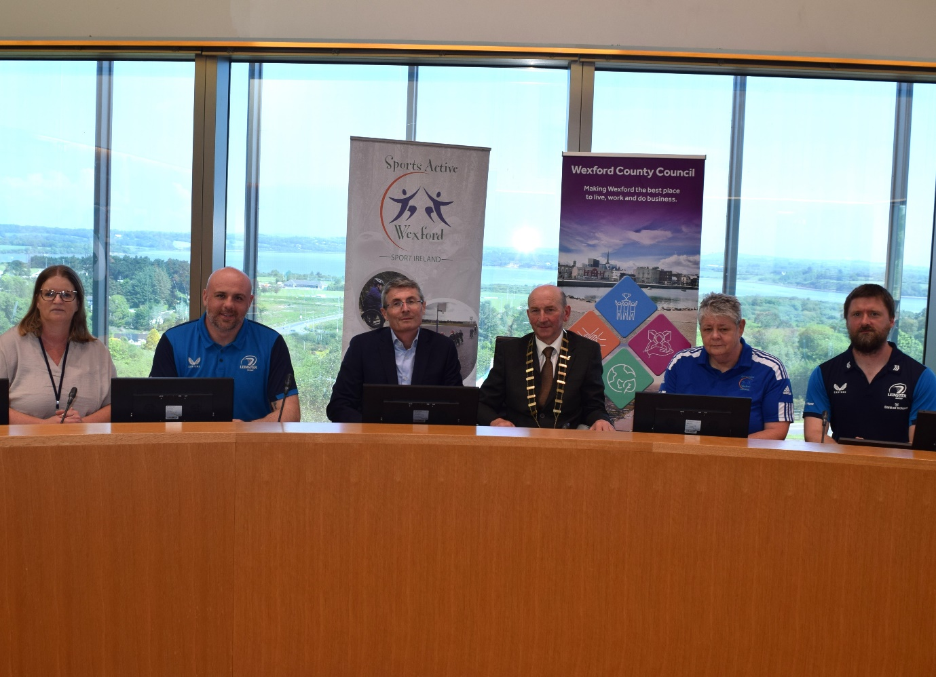
Image 2: (L-R) Dymphna O’Connor ( S.E.O Community, WCC), Corey Carty (Leinster Rugby Community Rugby Officer), Eddie Taaffe (Chief Executive Wexford Co Co.) , Cllr. John Fleming ( Cathaoirleach, Wexford Co Co.), Fran Ronan(Sports Co Ordinator , Sports Active),
Mick Bolger (Leinster Rugby Women’s Development Officer)

Ger McDermott, Grassroots Director of the Football Association of Ireland said “We are delighted to continue our longstanding partnership with Wexford County Council.
The funding and support provided through this partnership allow us to further develop our clubs and volunteers who offer participation opportunities to those who are marginalised in society through our Football For All and Social Inclusion initiatives.

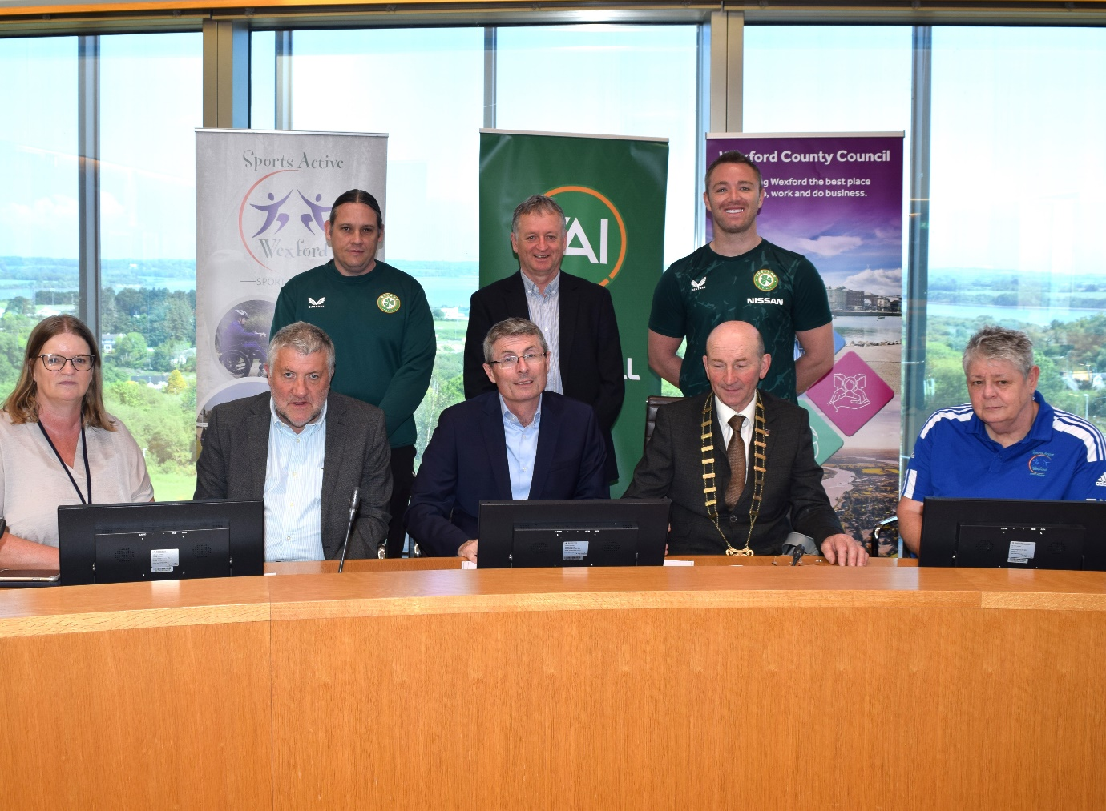
Image 3:(L-R) Dymphna O’Connor ( S.E.O Community, WCC) Paul Cooke (FAI President), Eddie Taaffe (Chief Executive Wexford Co Co.) , Cllr. John Fleming ( Cathaoirleach, Wexford Co Co.),Fran Ronan(Sports Co Ordinator , Sports Active)
Standing (L-R):Brendan Corish (FAI Development Officer),Michael Looby (FAI Regional Manager),Dean Broaders ( FAI Development Officer)

Conor Day, Operations Manager with Wexford GAA added:
“Our partnership with Wexford County Council has allowed for development and upskilling of both players and coaches throughout County Wexford over the past number of years. In the past five years, player participation from the u6 to u12 grades, has increased by 44%. This shows our underage players are enjoying our National Games more than ever and also pays tribute to the high standard of coaching being provided to them.”

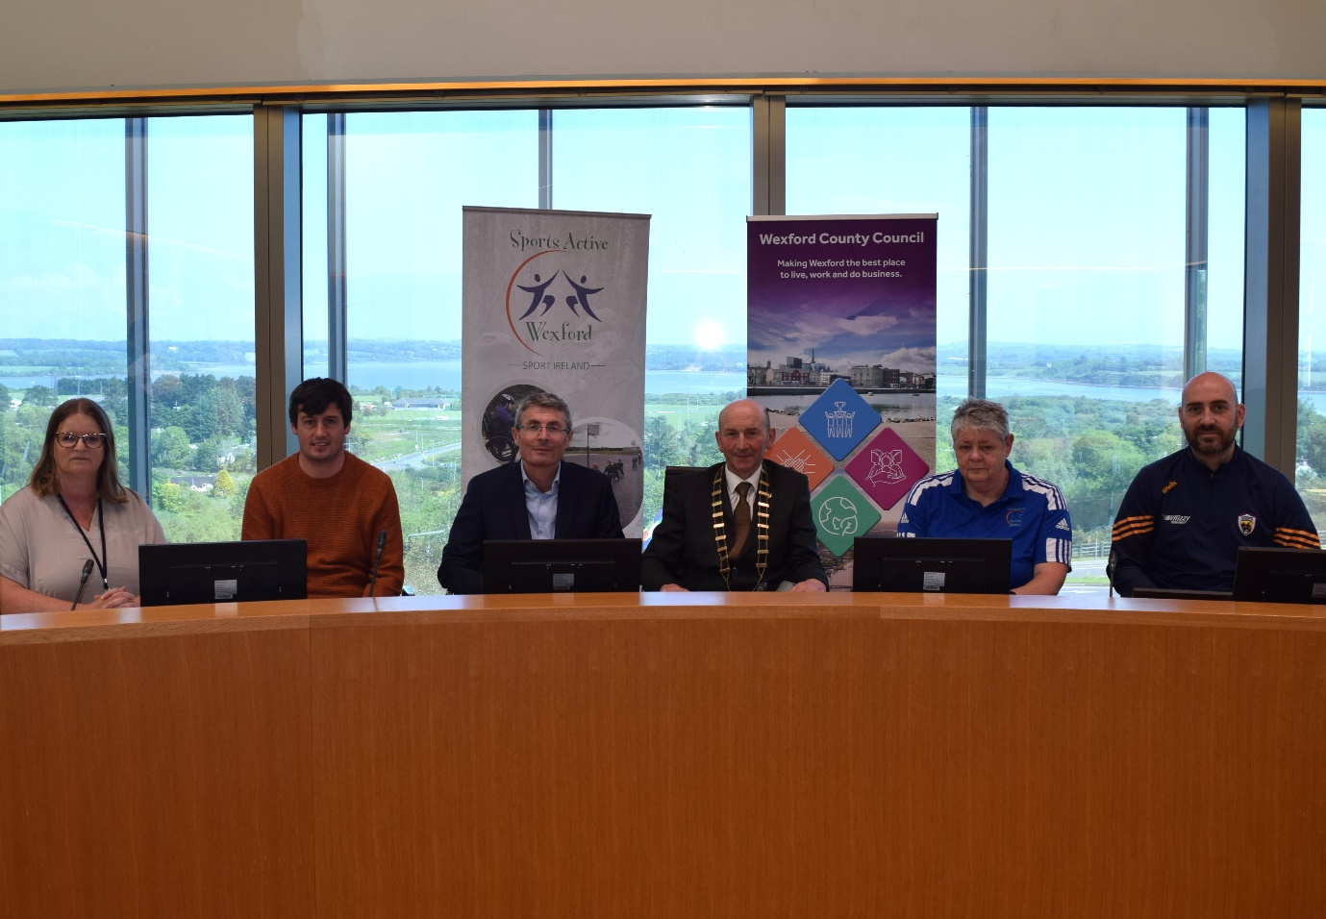
Image 4:(L-R) Dymphna O’Connor ( S.E.O Community, WCC), Conor Day (Wexford GAA Operations Manager), Eddie Taaffe (Chief Executive Wexford Co Co.) , Cllr. John Fleming ( Cathaoirleach, Wexford Co Co.), Fran Ronan(Sports Co Ordinator , Sports Active), Ray Harris, Wexford GAA Games Development Manager

ENDS

