PRESS RELEASE 22nd January 2024

WEXFORD’S SULLY & JUNO ANNOUNCED WINNERS OF BEST NEWCOMER FOR BUSINESS OF CRAFT AWARDS AT SHOWCASE 2024

A craft and design business from Wexford has won Best Newcomer of the Business of Craft Awards as part of Local Enterprise Showcase at Showcase 2024 which took place in the RDS on Monday 22 January 2024.
Sully & Juno, supported by Local Enterprise Office Wexford, won Best Newcomer category for the inaugural Business of Craft Awards.
Sully & Juno: Pioneering Sensory-Inclusive Clothing in Ireland sole designer and manufacturer of sensory-friendly clothing, Sully & Juno, presents a vibrant collection catering to the unique needs of the wearer. From beautiful, tag-free designs to soft organic fabrics, the range includes varied fits from snug to baggy and loose necks for headphone comfort.
Originally catering to smaller children, Sully & Juno now offers sizes from newborn to 5XL, reflecting their commitment to meeting customer needs. Each garment includes a sensory profile for informed purchasing.
Available online through a dedicated website with individual garment "sensory profiles," or in person at events, Sully & Juno stands out for embracing "everyday Irish" on their garments, offering personalization options in both Irish and English. 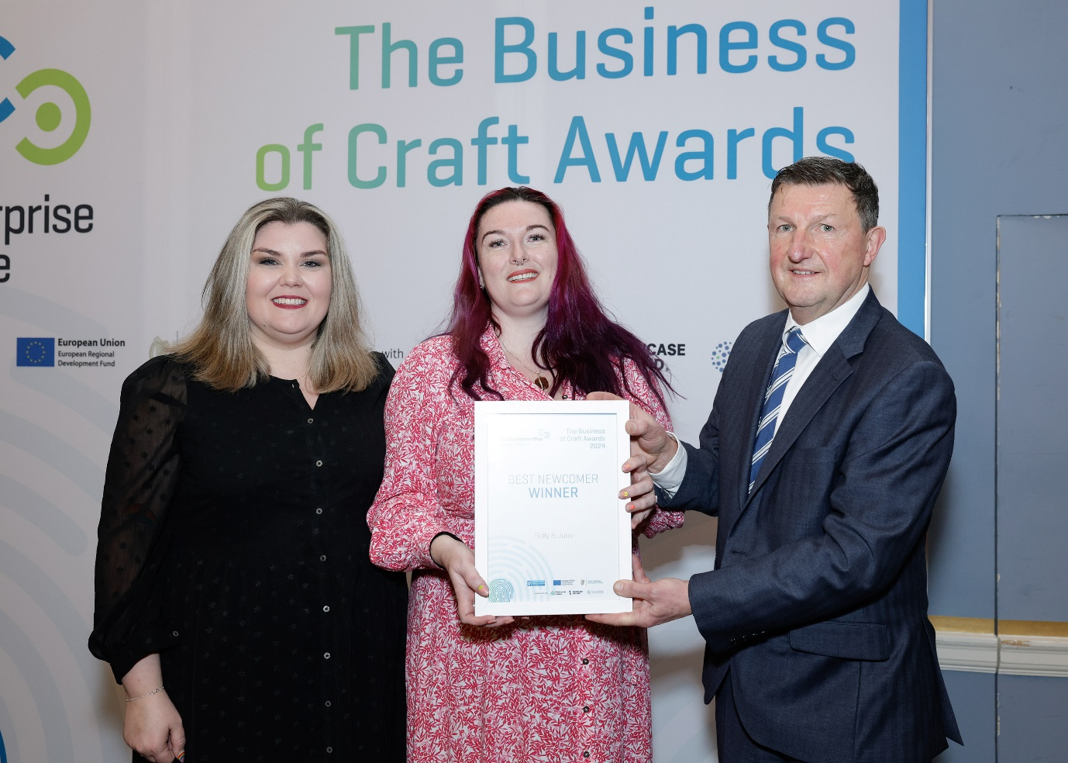 Sully & Juno: Nina Shelton and Gillian Duggan White pictured with Tom Rooney - Head of Enterprise at South Dubin Local Enterprise Office.

Breege Cosgrave Head of Enterprise and Economic Development “commends Sully & Juno, an innovative craft and design business from Wexford, for their groundbreaking work in developing sensory-inclusive clothing. The Best Newcomer award at the Business of Craft Awards recognises their dedication to meeting diverse customer needs and embracing 'everyday Irish' with personalised, comfortable style. Congratulations to Sully & Juno, a true pioneer in the industry!

The addition of the Business of Craft Awards to this year’s Local Enterprise Showcase at Showcase 2024 is a significant boost for the companies. It helps to highlight some of the best-in-class businesses from the design and craft sector across the country and we are doing that in front of key buyers both nationally and internationally.

On the whole Showcase 2024 is a huge event for our 3 Local Enterprise Office supported companies Sully & Juno, WeirdWatercolours and Jumbleink taking part. They get the chance to meet with buyers from all over the world and it’s three days that could change their business forever. We’ve been working closely with them all to ensure they can maximise their participation so there is a lot of excitement ahead of the event this year.”

Cllr. John Fleming, An Cathaoirleach, Wexford County Council, extends congratulations to Sully & Juno for securing the Best Newcomer title at the Business of Craft Awards during Local Enterprise Showcase at Showcase 2024. Their success not only highlights Wexford's craftsmanship but also underscores the invaluable support provided by Local Enterprise Office Wexford. As we kick off the new year, Sully & Juno's achievement exemplifies the impact of local support structures in fostering innovative businesses. Their pioneering work in sensory-inclusive clothing sets a remarkable standard. Well done, Sully & Juno, and a salute to the commitment of Local Enterprise Office Wexford”!

The Local Enterprise Office (LEO) awards were open to all the LEO clients who are exhibiting at the event as part of the Local Enterprise Showcase. This is the first year of the awards that celebrate the business behind the amazing craft and design products that are behind created across the country.

Nina Shelton and Gillian Duggan White from Sully & Juno “we are truly delighted to be honored with the Best Newcomer award at the Business of Craft Awards during Showcase 2024. Taking part in this prestigious event has been a rewarding experience, showcasing the significance of craft businesses in our community. We extend our heartfelt gratitude to Local Enterprise Office Wexford for their unwavering support; this achievement wouldn't have been possible without their guidance and encouragement. Recognising and celebrating the importance of craft businesses is at the core of our mission, and we are thrilled to contribute to this narrative. Thank you, Showcase 2024, and a special thank you to Local Enterprise Office Wexford for being our steadfast partners in this journey."

Mary Blanchfield, Head Operations, Design & Crafts Council Ireland (DCCI) commented: “Congratulations to all the winners of the very first Business of Craft Awards. These awards are a great way to celebrate the business models of craftspeople across the country. Showcase 2024 promises to highlight the very best of Irish talent and creativity. At DCCI, we are delighted to have the opportunity to provide a dynamic platform for businesses to connect and collaborate with both domestic and international buyers. We look forward to working closely with the Local Enterprise Offices to welcome all the exhibitors and to build on the success of last year’s show.”

Showcase 2024, which is a pinnacle event in the global design and crafts calendar, will open its doors to thousands of buyers from across the world, including Ireland, the UK, USA, mainland Europe, Asia and Africa, generating millions of euros of sales orders during the show. Showcase is presented on behalf of Design & Crafts Council Ireland, with support from Enterprise Ireland in promoting the trade show internationally through their network of offices overseas, and the Local Enterprise Offices nationwide.

Local Enterprise Showcase is one of several enterprise initiatives run by the Local Enterprise Offices across the year to foster entrepreneurship and help small businesses to start and grow. Other events include Local Enterprise Week, National Women’s Enterprise Day, the National Enterprise Awards, the Student Enterprise Programme and the Local Enterprise Village as part of the National Ploughing Championships. For more information on the Local Enterprise Offices and the supports they can provide, please visit LocalEnterprise.ie
Ends

