PRESS RELEASE 21 March 2024
ArtLinks 2024 Bursary Awards Announced
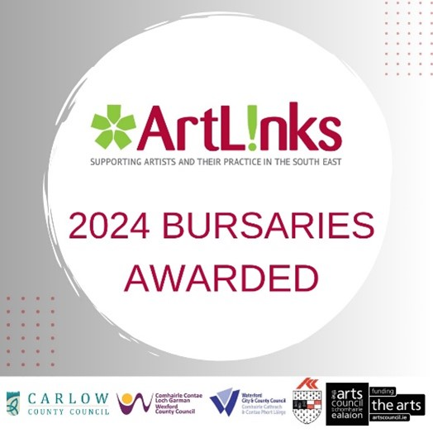
ArtLinks is a partnership of the four Local Authority Arts Offices in Wexford, Carlow, Kilkenny and Waterford, supported by the Arts Council/An Chomhairle Ealaíon. The bursaries for emerging and professional artists provide professional development opportunities and supports for artists who are resident in the four counties.
The recipients of the €30,000 bursaries from the Arts Office, Wexford County Council are:

Bernadette Doolin - Visual Art; Josephine Whitmore - Visual Art/Textile; Mayumi Nakabayashi - Visual Art; Cillian Byrne – Music; Caroline Busher – Literature; Ciana Fitzgerald - Visual Arts; Vivian Brody Hayes – Dance; Aileen Lambert - Traditional Arts; Brendan Fahy - Circus; Deborah Reidy - Visual Arts; Alec Moore - Visual Arts; Keli-Ann Masterson – Opera; Mirona Mara - Visual Arts; Serena Caulfield - Visual Arts.
In thanking all the ArtLinks members who submitted applications, Liz Burns, Arts Officer, Wexford County Council said: ‘I am pleased that the Local Authority could support so many artists in the development of their arts practices and careers. The competition in Wexford was very high in 2024 with 46 applicants in total. Out of an increased fund of €30,000 the assessment panel awarded 14 Bursaries in total to Wexford based artists across art forms of Visual arts, Literature, Music, Drama, Film and Street Arts’.
For all ArtLinks enquiries please contact artlinks.ie@gmail.com
Follow @Artlinks.ie on Facebook and Instagram for more information and updates.
ENDS
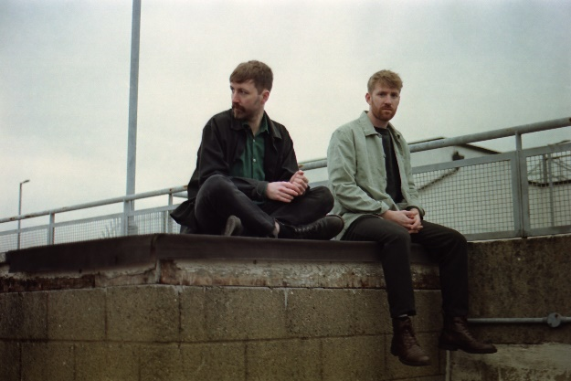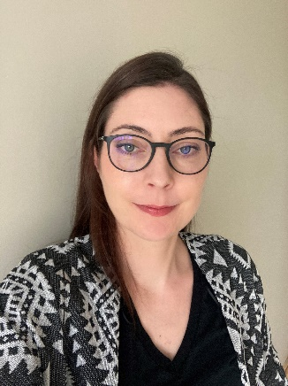
Basciville (Music) Deborah Reidy (Visual Art)

