PRESS RELEASE 20 May 2024

Excitement Builds as Wexford Gears Up for Fringe Fleadh 2024: A Prelude to the Fleadh Cheoil in August

The countdown to the highly anticipated Fleadh Cheoil na hEireann in Wexford Town has officially begun, and the excitement is palpable across the county as the official Fleadh Cheoil Loch Garman and Fringe Fleadh Events were launched last Thursday (16th May) in Gorey’s Civic Offices.
Hosted by Cllr. Pip Breen, Cathaoirleach of the Gorey & Kilmuckridge Municipal District, the event marked the beginning of a series of celebrations leading up to the Fleadh Cheoil na hÉireann in August ‘This will be a wonderful event and is a forerunner of what’s to come in August. This is the County Fleadh and Fringe Fleadh being launched here tonight. We are honoured to have his excellency the Japanese Ambassador here. The importance of the Celtic Culture to Ireland and the world is just as important today as it will be in the future. Wexford Town will be a wonderful venue for the Fleadh’

Chief Executive of Wexford County Council, Eddie Taaffe said ‘Fleadh Cheoil na hÉireann is going to be a huge event not only in Wexford Town but also in Gorey , Enniscorthy, New Ross and Rosslare Districts I’m delighted to see Gorey taking a leading role in leading out in what it can offer in terms of music and accommodation. Fantastic event here this evening.’

Gorey CCE and international uilleann piper, Mark Redmond officially opened the Fleadh Cheoil Loch Garman, captivating the audience with a stunning performance on the Uilleann Pipes that received a huge round of applause from the attendees

Director of Services Liz Hore shared her excitement about the upcoming events, stating, " I am delighted to be here tonight for the official launch of The Fringe Fleadh 2024. We know that Wexford has a rich tapestry of music from every corner of the county down as far as Bannow and right up to Gorey and we are delighted to see this programme being launched where there is an exciting range of events for everyone young and old , and all types of musicians, so please review the brochure and get out and about and see the programme , This is a fantastic build up to the Fleadh coming to Wexford in August but there is an exciting programme right over the summer months for everyone”

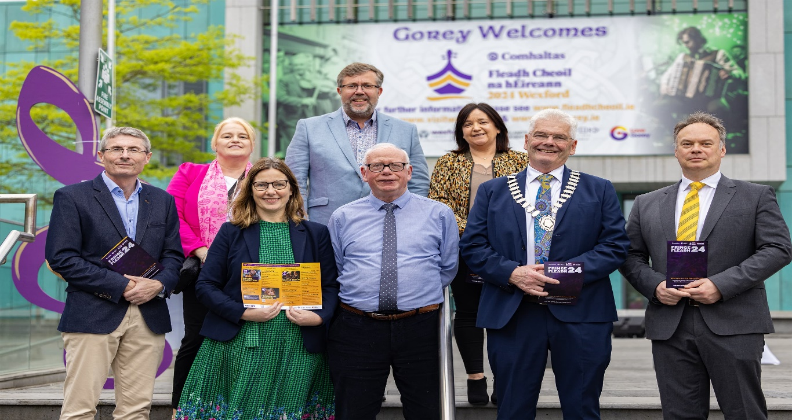
Image 1: Front Row ( L to R) Eddie Taaffe ( Chief Executive, Wexford Co Co), Liz Hore ( Director of Service, Wexford Co Co), Michael Murphy (Chairperson Wexford CCE Co Board), Cllr. Pip Breen Cathaoirleach Gorey/Kilmuckridge Municipal District), Philip Knight ( Gorey/Kilmuckridge District Manager)
Back Row( L to R): Barbara Walsh ( Chairperson Craobh Loch Garman CCÉ), Joe Sinnott (CCÉ Gorey Ballygarrett ), Paula Carroll (Chairperson CCE Gorey Ballygarrett)

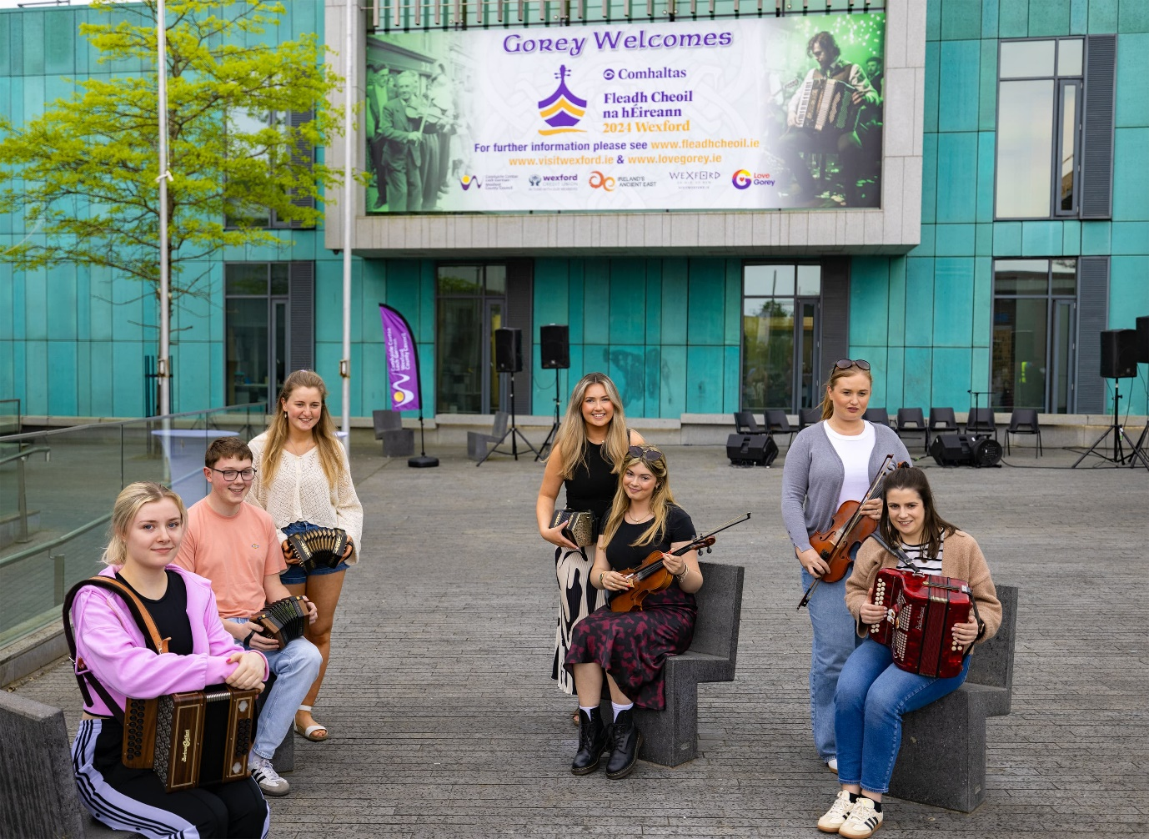
Image 2: Members of Gorey Ballygarrett CCE (Alex Farrell, Tadhg Byrne, Ciara Kinsella, Laura Sinnott, Leah O’Mahony, Aideen Byrne, Susie Griffith)

The Fringe Fleadh will feature an array of exciting events, including:
Traditional Irish Music Sessions: Local pubs across Wexford will host live music sessions, offering an authentic taste of Ireland’s musical heritage.
Dance Workshops: Learn traditional Irish dance steps from expert instructors in a fun and welcoming environment.
Art Exhibitions: Explore the artistic talents of local artists at various galleries and community centres.
Storytelling Sessions: Immerse yourself in the rich oral traditions of Ireland with captivating storytelling sessions for all ages.
For more details on the schedule of events, please visit www.visitwexford.ie/fringefleadh.
The launch event concluded with a sense of anticipation and excitement as Wexford prepares to host these remarkable cultural festivities. The Fringe Fleadh and Fleadh Cheoil Loch Garman promise to be a celebration of music, dance, and community spirit that will leave a lasting impact on all who attend.

ENDS

Media Contact:
Amanda Whitmore,
Rocket Science Media
visitwexford@rocketsciencemedia.ie
087 4419140

