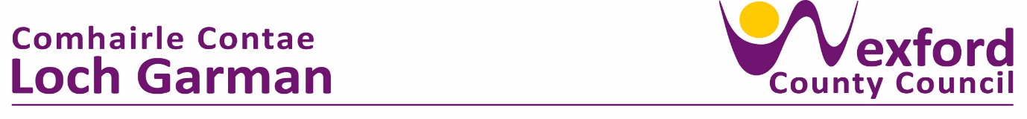

PRESS RELEASE 20th Oct 2023

**National Women’s Enterprise Day Wexford 2023**

**On Thurs 19th October** over 130 female entrepreneurs, women in business and female-led businesses from all over County Wexford gathered in Newbay House Hotel Wexford to celebrate **National Women’s Enterprise Day 2023.**

A much anticipated event each year, National Women’s Enterprise Day is in it’s 16th year and is growing in popularity and importance each year, going from strength to strength and attracting both speakers and participants from all business sectors, both Irish and international.

Wexford town-native **Theresa Grant OBE** led the line up of homegrown and international speakers on the day. Theresa shared her story of delivering high-value outcomes for communities and local governments across the UK. Generating a positive organisational culture through leadership and teamwork has led her to be recognised with an OBE from the Queen for her work in 2021. Sharing how she has worked for major sporting events including the Commonwealth Games and the Sydney Olympics, as well as for government bodies, Prime Ministers and parliamentarians made for a compelling and inspirational morning.

Pauline Dunne of Killowen Farm, was this year’s **National Women’s Enterprise Day Ambassador for Wexford** also spoke at the event.An NWED Ambassador is a business who has come through Local Enterprise Office services and have proven themselves to be **an inspirational ambassador, leader and mentor for other female-led businesses and entrepreneurs.** Pauline’s story of growing a small family dairy farm to a major producer of both yogurt and cream cheese, who produce 4000 jars of their signature yogurts *per hour* gave inspiration and encouragement to businesses of all sizes in the room.

**Deborah Brock of Nua Fertility** explained how her business came from personal experience and how both people and science have played such a crucial role in her business journey. Speaking about taking the leap from employment to entrepreneurship, Deborah highlighted the value of knowing that others have done it and thrived – it is very empowering and reassuring to know that you are not alone when you decide to follow your business dream.

Paying tribute to female entrepreneurs and business-women everywhere, **Breege Cosgrave, Head of Enterprise at LEO Wexford**, who this year is the joint National Chair for NWED, described last Thursday’s event as a celebration of female entrepreneurship, leadership and empowerment by women who are both innovation and strategic in their thinking. “Women are intuitively innovative, adaptable and forward thinking – these are the skills that we need to harness now to secure a strong economy where female entrepreneurship is allowed to flourish. Businesses are facing growing energy costs, a shortage of labour and skills, climate change and increasingly uncertain global security and women are well equipped to deal with these challenges.”

National Women’s Enterprise Day Panel of Speakers

(L to R)

NWED 2023 MC Maryrose Lyons of Brightspark Consulting

Liz Hore, Director of Services at Wexford County Council

Theresa Grant OBE, Keynote Speaker

Pauline Dunne Killowen Farm, Wexford NWED Ambassador 2023

Deborah Brock of Nua Fertility, Speaker and Panellist

Councillor Lisa McDonald

Breege Cosgrave Head of Enterprise at Local Enterprise Office Wexford

Pauline Dunne Killowen Farm & President of The Wexford Food Family, NWED Wexford Ambassador 2023 for Local Enterprise Office Wexford

Wexford native Theresa Grant OBE speaking at National Women’s Enterprise Day 2023 in Wexford’s Newbay House Hotel, with MC for the day Maryrose Lyons of Brightspark Consulting.

Breege Cosgrave, Head of Enterprise and Economic Development at Wexford County Council at National Women’s Enterprise Day in Newbay House.

ENDS

For information please contact:

[laura.lyons@wexfordcoco.ie](mailto:laura.lyons@wexfordcoco.ie)

Tel: 053 9196027