PRESS RELEASE 18th January 2024

Enniscorthy Technology Park planted as part of The 100 Million Tree Project.

On 12th January, Enniscorthy Technology Park, was planted with 2500 native trees as part of ‘The 100 Million Trees Project’. The project which was launched in late 2022 in Co. Wexford is a national community-driven initiative developed by brothers, Richard and David Mulcahy. The project’s aim is to plant 100 million native Irish trees throughout the next decade to reverse the environmental damage caused by the reduction of forests worldwide.

The project’s ambitious aim will be achieved through densely planting between 1,000 and 2,500 native Irish trees at a time across small areas of land using ‘the Miyawaki method’. Named after Japanese Botanist, Professor Akira Miyawaki, who developed the technique in the 1970s. By using this method, the trees grow considerably faster, denser, are more biodiverse, and most importantly create a very rapid carbon sink and provide excellent areas of biodiversity.

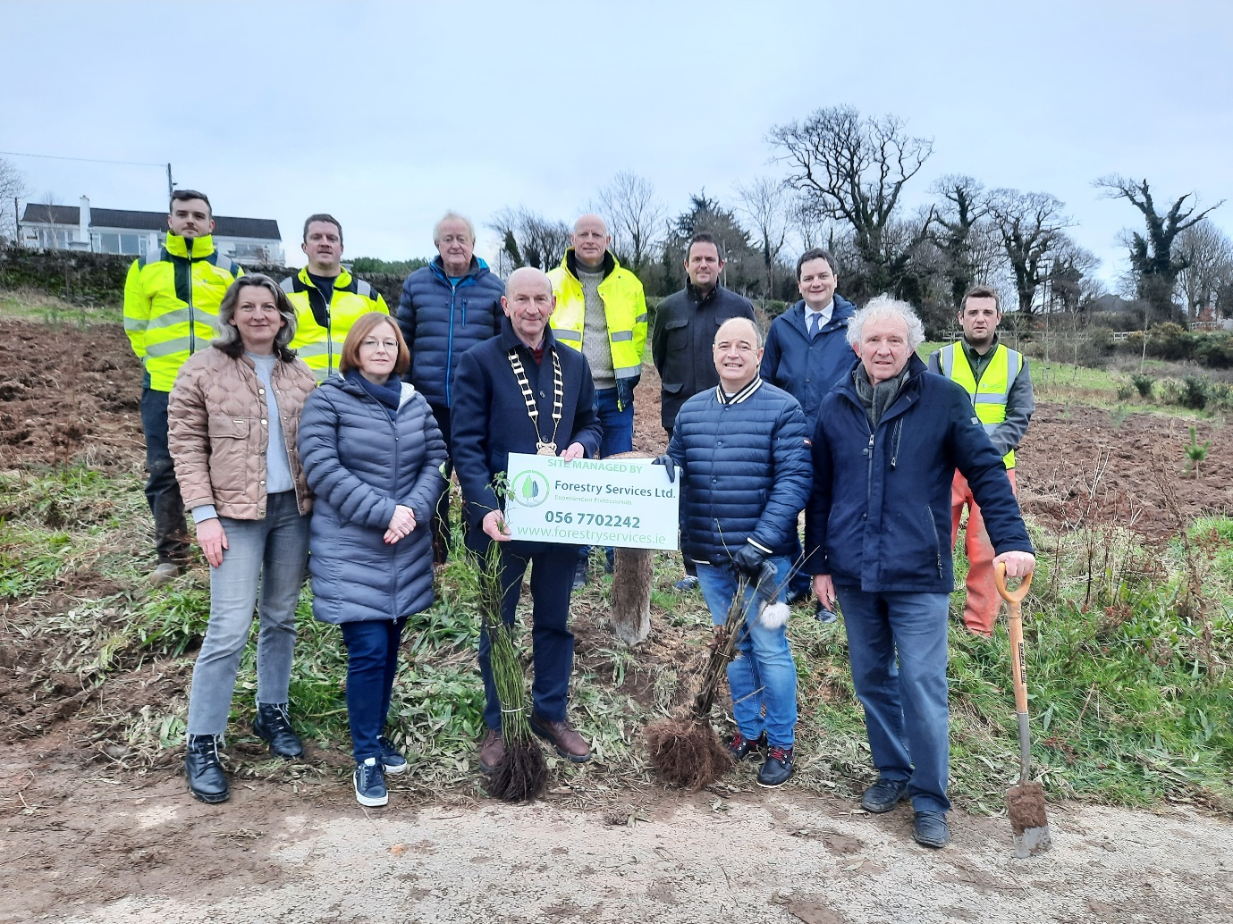

Councillor John Fleming, Cathaoirleach Wexford County Council, Councillor John O’ Rourke, Cathaoirleach Enniscorthy Municipal District, Councillor Aidan Browne and Councillor Cathal Byrne were all in attendance. Enniscorthy Tidy Towns and Sustainable Enniscorthy were represented by local volunteer Billy Murphy. Richard Mulchay and representatives from Forestry Services were also in attendance.

Cathaoirleach of Wexford County Council, Councillor John Fleming welcomed all and said, ‘it was great to see another site in Co Wexford planted with native trees as part of the 100 million trees project and thanked Richard and David Mulcahy for choosing County Wexford to launch their project’.

Cathaoirleach of Enniscorthy Municipal District, Councillor John O’ Rourke thanked the many local volunteers for their commitment and dedication in keeping Enniscorthy beautiful and stated that this project will provide so many benefits to the local community and for biodiversity’.

Richard Mulcahy said, “We were absolutely thrilled to meet our launch objective of planting 20,000 trees in year 1 but by this April, we aim to have 200,000 to 250,000 new young native tree varieties planted in the ground at over 75 different sites around the country”.

Notes to Editors:
- For further information on The 100 Million Trees Project, check out the website here www.100milliontreesproject.ie or email the project at info@100milliontreesproject.ie.

