PRESS RELEASE 16th November 2023

Red Carpet for Green Communities

On Monday 13th November the Wexford County Council Annual Environment Awards were held at the Ferrycarrig Hotel and proved to be a tremendous celebration of the environment and voluntary effort.

Over 250 children, community groups, volunteers, resident groups and individuals turned up on the night to see their wonderful efforts acknowledged by Wexford County Council.

On a night which clearly the elected members also enjoyed, given the presence of so many county councillors from all parts of the county, there were presentations and awards to 11 schools, 63 community groups and 2 individuals.

Councillor John Fleming, Cathaoirleach of Wexford County Council, warmly welcomed and congratulated all the participants and went on to recognise the commitment and dedication of all committees and individuals who make such a real difference at a local level. He stated ‘It is heartening to see groups of local volunteers showing such spirit and endeavour and, in the process inspiring others in their community to follow their example. The unselfish effort and the generosity displayed by you as volunteers really is making a difference to communities. Your dedication is an inspiration to communities everywhere and illustrates the real benefits of pulling together for the greater good of the place we call home.’

Carolyne Godkin, Director of Services said ‘I’m struck not only by the level of commitment you make on a voluntary basis but also the quality and diversity of work being carried out and indeed the creativity and innovation we see form you as dedicated local volunteers. It is the hours you spend in your communities that enhances our County, helps Keep Wexford Beautiful and ensures that we continue to be known as The Model County.’

There were many notable highlights. Tomhaggard Clean Coasts Group were presented with a plaque for winning the Community Group Snap Into Action competition. Hollyfort Development Group, The Gap Tidy Towns & Heritage Group, and Askamore Community Council / Tidy Towns were also presented with awards for their participation in the North Wexford 2K.

A ‘Sort Of ‘ Environment Quiz kept all guessing at the beginning of the night and prizes to the first 6 correct answers drawn were presented. Winners drawn were Catherine Redmond, Aleksandra Perek, John Woodbyrne Clodagh Roche, Fionn Quirke and Grace McCormack.

The overall winners of the Keep Wexford Beautiful Competition were Blackwater Tidy Towns, Master of Ceremonies for the night, Alan McGuire, stated as he announced this award that ‘It’s not surprising that Blackwater Village is the Overall Winner in the Keep Wexford Beautiful Awards 2023, having already won Gold in the National Tidy Towns competition.
A warm welcome is extended to all, with colourful planting augmenting the charm of this seaside village. Blackwater Tidy Towns Group has been working hard since the 1950s to show how Blackwater is a beautiful place to live in, to work in, and to visit. An ecologist was commissioned to produce a biodiversity action plan. This plan is now being implemented through a variety of exciting projects, including cataloguing rare plant species and a ‘Grow With Us’ project which involves young students growing their own acorn or chestnut trees which will be presented to them for planting out in their final year at school. As the river flows gently under the ancient bridge it leads to the Millrace wildlife area, where informative signage offers a variety of walkway options to suit both the casual and seasoned rambler.
It’s worth pausing as you stroll along the Millrace walk to observe the Swift nest-boxes high up on the gable end of an old stone mill. And this is just one example of the many fine buildings in the area. Barn Owl boxes have also been installed in an effort to help this endangered species. Additional perennial planting has taken place in the green spaces and 80% of this came from seeds saved from the previous year.
The sense of pride, belonging and a shared desire to present a thriving, colourful and environmentally-aware village is very evident in the achievements of Blackwater Tidy Towns Group.’

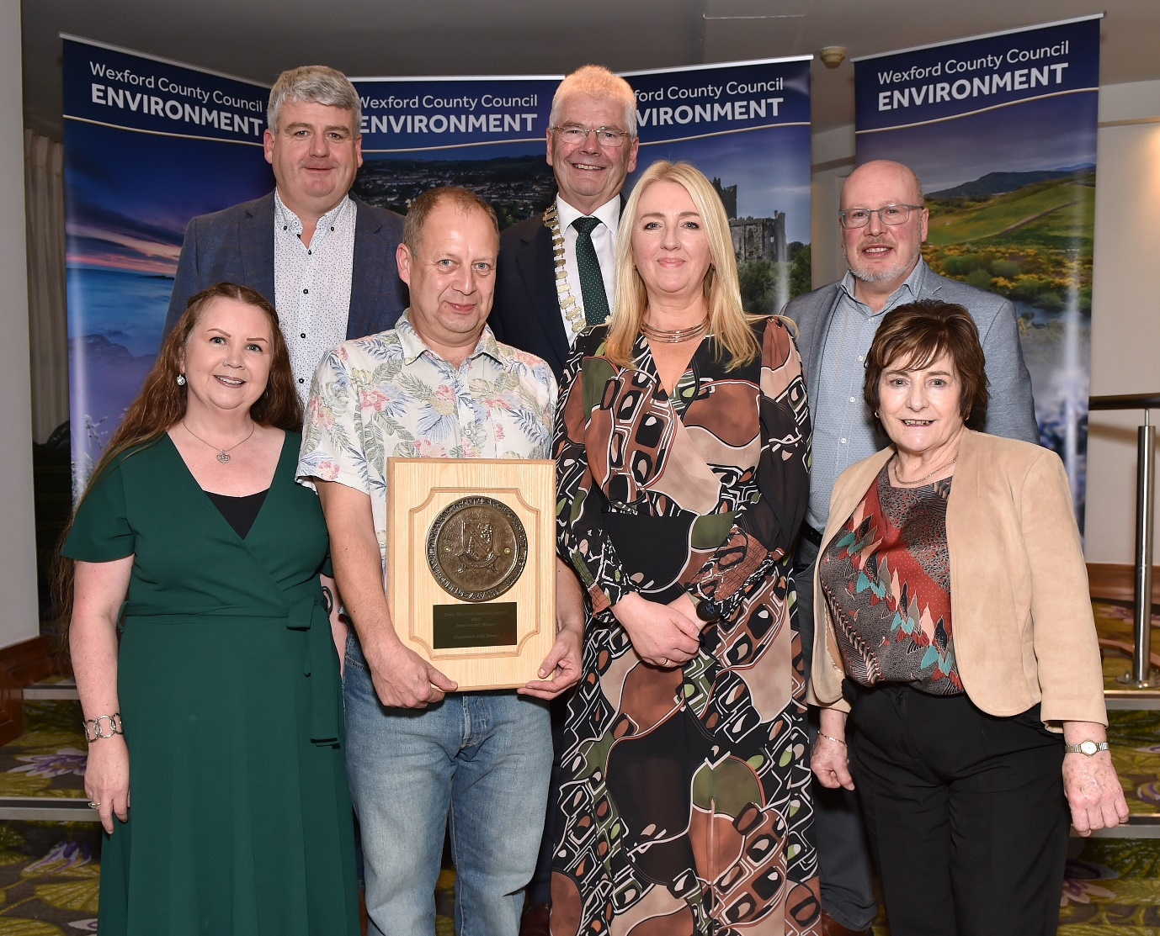
Image (Credit: Jim Campbell) : Members of Blackwater Tidy Towns Committee , overall winners of the Keep Wexford Beautiful Competition with Cllr. Oliver Walsh; Cllr. Pip Breen (Cathaoirleach of Gorey Kilmuckridge Municipal District); Cllr Fionntán Ó Súilleabháin and Sheila Lacey, Wexford Co Co.

The schools were well represented with eleven schools receiving presentations from Councillor John Fleming, Cathaoirleach of Wexford County Council. Coláiste Bríde, Enniscorthy, New Ross Educate Together National School and St Edan’s National School, Ferns were all recognised for receiving their first green flag and presented with a nest box sponsored by The Wexford Naturalists’ Field Club.

Coláiste an Atha, Kilmuckridge, Gorey Community School, Loreto Secondary School Wexford, Ramsgrange Community School and Selskar College were awarded certificates for their participation in the Rubbish Film Festival Programme.

Mercy School Wexford was awarded a Plaque as the overall primary school winner in the Christmas Decoration Competition 2022 in conjunction with South-East Radio for their group entry entitled ‘The Christmas Tree’. The entry was created by students Tomás Meyler, Fionn Quirke and Blake Thomas.

Ramsgrange Community School was recognised for their achievements on the National stage having won the WEEE Ireland schools battery recycling national competition in the medium secondary school category, collecting more batteries for recycling than any other school in the country in that category. A grand total of the equivalent of 82,200 AA batteries were collected for recycling by the school.

Certificates were presented to Conan Kelly, Wexford Educate Together National School who was the Overall Primary School Winner in the Environment Artwork Competition and Mikolaj Perek Coláiste an Atha, Kilmuckridge who was the overall secondary school winner of the Environment Artwork Competition.

Kilmyshall National School were also awarded a Plaque for being Wexford’s Cleanest School.

An Award for Outstanding Individual Contribution to Wexford’s Environment was presented to Catherine Redmond and Mary Cogley both worthy winners.

The whole event was wonderfully organised, expertly presented by Master of Ceremonies, Alan McGuire and enjoyed by everybody. The feeling leaving the Ferrycarrig Hotel was certainly one of satisfaction for work well done and roll on next year. The environment is in very good hands.

ENDS

NOTES TO EDITOR:

Environment Awards 2023 : Full List of Award Winners

GREEN SCHOOLS

Coláiste Bríde, Enniscorthy
New Ross Educate Together National School, New Ross
St Edan’s National School, Ferns
ANNUAL ENVIRONMENT ARTWORK COMPETITION

Overall Primary School Winner – Conan Kelly, Wexford Educate Together National School

Overall Secondary School Winner – Mikolaj Perek, Coláiste an Átha, Kilmuckridge

CHRISTMAS DECORATION COMPETITION
in conjunction with South East Radio

Overall Primary School Winner – Mercy School, Wexford

Rubbish Film Festival

Coláiste an Átha, Kilmuckridge
Gorey Community School
Loreto Secondary School, Wexford
Ramsgrange Community School
Selskar College, Wexford
School Battery Champion

Ramsgrange Community School

WEXFORD’S CLEANEST SCHOOL

Kilmyshall National School

SNAP INTO ACTION COMPETITION
Community Group Winner – Tomhaggard Clean Coasts Group

KEEP WEXFORD BEAUTIFUL COMPETITION

Overall Winner Blackwater Tidy Towns

Best Environmentally Aware and Presented Housing Estate
1st | Westwinds Residents Association, Kilrane
Joint 2nd | Carraig Dubh Residents Association. Blackwater
Joint 2nd | Watch House Village Residents Group, Clonegal
3rd | Hazelwood Residents Association, Gorey
Highly Commended | Bridgemeadow Residents Association
Highly Commended | Ounavarra Park Residents Association, Ballycanew
Best Environmentally Aware and Presented Town/Village
1st | Kilanerin Tidy Towns
2nd | Gorey Tidy Towns
Joint 3rd | Kiltealy Tidy Towns
Joint 3rd | Bunclody Tidy Towns
Highly Commended | Ballyduff Development Group

Best Community Environment Initiative

1st Enniscorthy Community Allotments
2nd Monageer Parish Grotto Group
3rd Rosslare Harbour Kilrane Environment Group
Highly Commended Clonard Area Development Association, Wexford

Best Heritage Preservation & Conservation Project
1st Duncormick Area Action CLG
Joint 2nd Gorey Tidy Towns
Joint 2nd Kilmuckridge Tidy Towns
Joint 3rd Tomhaggard Pastoral Council
Joint 3rd Ferns Tidy Towns
Highly Commended Killanne Development Group
Highly Commended BallymurnTidy Towns

Best Community Coastal Management Initiative
1st Tomhaggard Clean Coasts Group
2nd Courtown Community Council
3rd Rosslare Harbour Kilrane Environment Group
Best New Entry
1st St Brendan’s Residents Association, Rosslare Harbour
2nd Community Of Oulart Women's Society
3rd Wexford Bat Group
Highly Commended Talbot Greenfingers, Wexford
Highly Commended Ballindaggin Development Group / Ballindaggin Tidy Towns

Best Community Project To Improve Accessibility to Infrastructure

1st Kiltealy Tidy Towns

Best Community Project to Improve Accessibility in Gardens / Parks

1st Taghmon Action Group
2nd Monageer Parish Grotto Group
3rd Gorey Tidy Towns
Highly Commended Foulksmills Tidy Towns

Best Community Project That Tackles And Reduces the Impact Of Climate Change

1st Sustainable Enniscorthy
2nd Ferns Tidy Towns

Best Community Biodiversity Project

1st Monageer Parish Grotto Group
2nd Enniscorthy Tidy Towns
Joint 3rd Bridgetown Community Development
Joint 3rd Kiltealy Tidy Towns
HC Clonegal Tidy Village Association

Best Community Waste Prevention/Re-Use Project

1st Tomhaggard Clean Coasts Group
2nd Foulksmills Tidy Towns
3rd Carrig on Bannow Tidy Towns
Highly commended Boolavogue Tidy Towns

North Wexford 2K Clean
1st Hollyfort Development Group
2nd The Gap Tidy Towns & Heritage Group
3rd Askamore Community Council/Tidy Towns

Outstanding Individual Contribution to Wexford’s Environment
Mary Cogley, Catherine Redmond

