PRESS RELEASE 16 May 2024
‘Affordability and the chance to own a home at the heart of national and local housing policy’.
The Governments ‘Housing for All Programme’ aims to increase the delivery of different forms of housing to meet different needs - with a number of measures aimed at people who are currently unable to meet their housing needs but who, with help, could purchase their own home.
New delivery and support streams for Affordable Housing have been introduced under the programme including, Local Authority Affordable Purchase Schemes with financial support being provided via the Governments ‘Affordable Housing Fund’.
To support the county Wexford housing programme, Wexford County Council recently hosted a ‘A Breakfast Briefing on Affordable Housing Delivery’ in the Ferrycarrig Hotel, with invited speakers presenting an overview of the national schemes and funding streams.
The event included members of the Wexford County Council, officials from Planning and Housing Delivery Teams, Construction Industry Federation Members, Housing Building Finance Ireland and property professionals from across the county.

Opening the event, Cathaoirleach of Wexford County Council, Cllr. John Fleming noted ‘Affordability and the chance to own a home is a key element of our housing policy. Wexford County Council is actively working on developing an affordable housing programme over the coming years, - today’s event will hopefully highlight some of the opportunities available to deliver our shared housing ambitions ’.
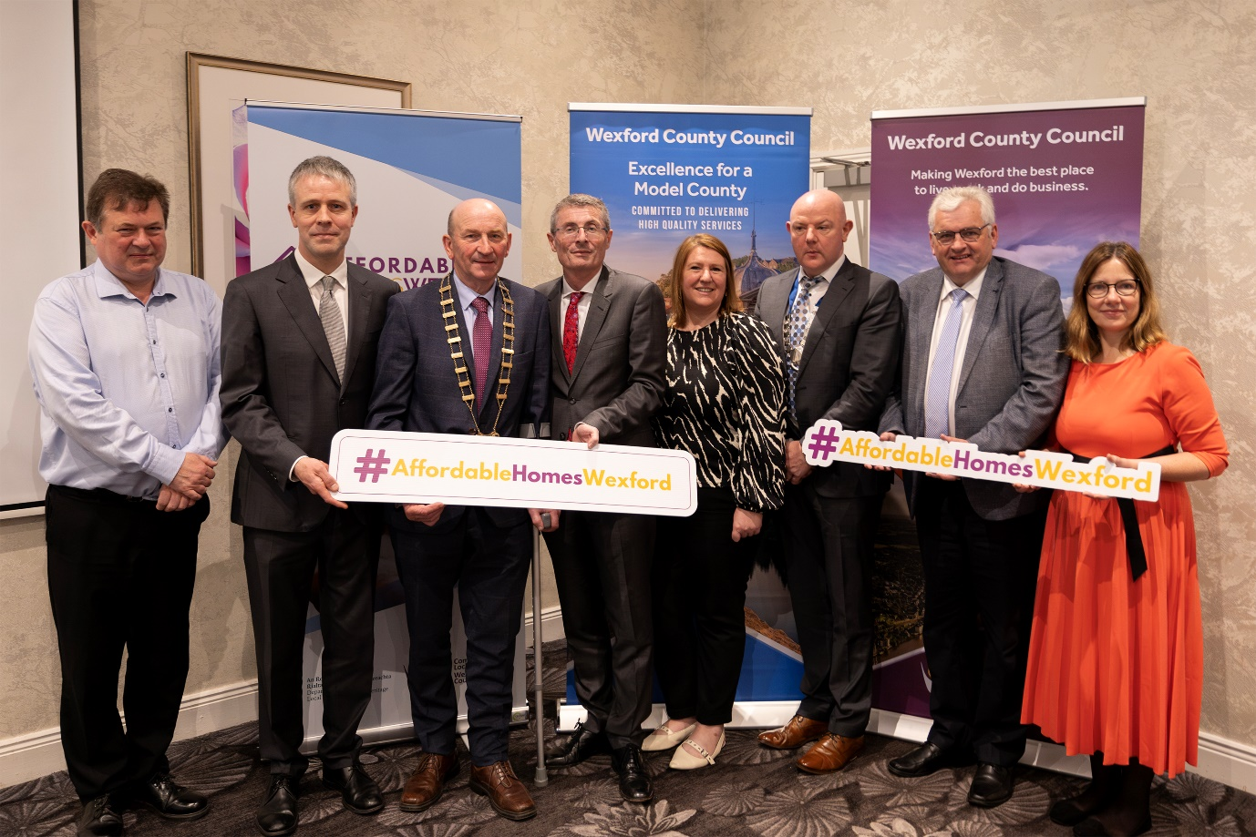
( L to R) Diarmuid Houston ( Senior Planner, WCC),David O’Doherty (HBFI), Cllr. John Fleming (Cathaoirleach of WCC) , Eddie Taaffe ( Chief Executive WCC) , Carolyne Godkin ( Director of Service , Housing), Leonard Daly (CIF Southeast Chairman), Cllr . Joe Sullivan (Chair of Housing & Community SPC), Liz Hore (D.O.S Planning)

Speaking at the seminar, CIF Southeast Branch Chairman Leonard Daly welcomed their members and commended Wexford County Council for arranging the briefing. Noting the available housing programmes in place to support the delivery of affordable homes,’ A critical factor in the increase in housing commencements was the ability of housebuilders to commence with confidence. This is why the Local Authority Affordable Purchase, Help 2 Buy and First Home Schemes are all so important’.
Presenting on the day, Chief Executive, Eddie Taaffe provided a detailed outline of the governments funding programme and housing delivery models, noting the housing collaborative opportunities between the local authority and construction sector confirming ‘We want to develop enduring partnerships to make delivery as simple as possible’.
Director of Services for Housing delivery, Carolyne Godkin outlined details of the County Wexford Affordable Homes Programme, with plans to deliver a pilot Affordable Housing scheme in Ramsfort Park, Gorey Co. Wexford and future projects currently in development, including the ‘St. Walerans’ Masterplan – which hopes to deliver over 170 units in this mixed housing scheme.
While also providing details for future plans to expand the housing delivery pipeline she said ‘Today was an opportunity to directly engage with the sector. In the coming weeks Wexford County Council will actively engage the market seeking expressions of interest for the provision of housing developments by developers and building contractors for delivery of affordable housing across County Wexford’.
ENDS

