PRESS RELEASE 13th December 2023
Wexford County Council Host Age Friendly Recognition and Achievement Awards Ceremony.
Councillor John Fleming, Cathaoirleach of Wexford County Council extended a warm welcome to over 250 people from across Ireland to the Model County for this year’s National Age Friendly Recognition and Achievement Awards ceremony on Thursday, 30th November, in Clayton Whites Hotel.

The awards recognise and reward, groups and individuals who have put significant time and effort into ensuring projects become a reality to make a difference to the lives of the older generation.
Mr. Tom Enright, Chief Executive of Wexford County Council, extended a particularly warm welcome to Minister Mary Butler, Minister for Mental Health and Older People. In addressing the attendees, he said “Wexford County Council is delighted to be hosting these National Awards which recognise the contribution that is made across the country to enhance the lives of older people. I wish to congratulate these groups for their hard work, enthusiasm and determination and the immense contribution they have made to enriching the lives of older people in their counties. Regardless of the results tonight, you should all take great pride in what you have accomplished and the positive impact your work will have on the lives of older people”.

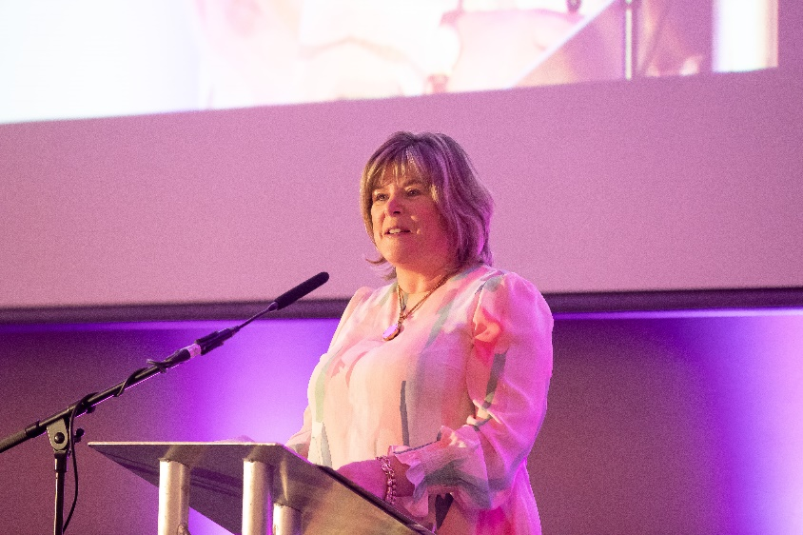
Minister Mary Butler, Minister for Mental Health and Older People
(Image: Browne’s Photography)

Chief Executive of Meath County Council and host of the National Age Friendly Ireland shared service, Fiona Lawless said “The prestigious National Age Friendly Recognition Award is an annual ceremony that celebrates innovation, collaboration and implementation of objectives, programmes, projects and initiatives that are responsive to the needs of our ageing population. I am particularly pleased that year on year, the national workplan translates national policy objectives into local outputs that produce demonstrable outcomes and have meaningful impact on the lives of older people and wider society in Ireland.
I would like to take this opportunity to sincerely thank my colleague Chief Executive, Tom Enright and his team in Wexford County Council, for hosting this year’s Awards Ceremony. I would also like to convey my gratitude to our Sponsors and Judging Panel for their continued commitment and support in celebrating all the wonderful achievements that we see showcased this year from across the country.”

This was the seventh annual awards ceremony for Age Friendly Ireland since 2014.
The event was presented by Age Friendly Ireland, a shared service function of Local Government in Meath County Council and was hosted by Wexford County Council.

Wexford County Council has been an Age Friendly County since 2013 and have made significant progress in embedding an age friendly approach to their work.

Wexford projects were nominated and shortlisted in two categories this year. The first was in the “Age Friendly Environment Award” category. “Playful spaces for all” is a collaboration with the local community of Our Lady’s Island in conjunction with Wexford County Council’s “Age Friendly”, “Access”, “Healthy Wexford” and “Active Travel” sections to enhance the playfulness of the area across the generations to ensure age friendly and intergenerational opportunities through development of playful spaces that can be used simultaneously by all ages and abilities.
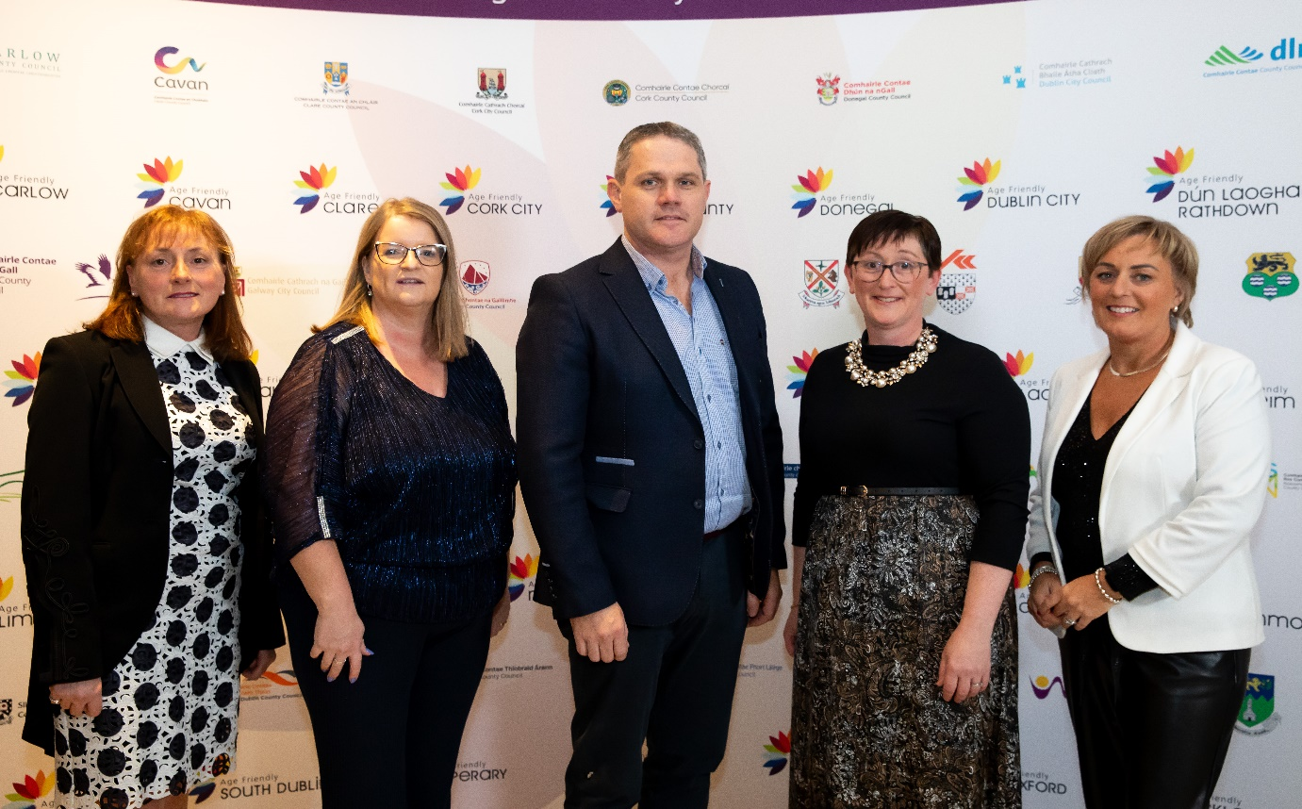
(L to R) Caroline Horan (Access Officer Wexford County Council), Dymphna O'Connor (S.E.O. Community Section), Cllr Ger Carty (Chairman Our Lady’s Island Community Development Committee) Annette Dupuy (Healthy County Coordinator) Lorraine Burke, Our Lady’s Island Community Development Committee) (Image: Browne’s Photography)

In the Age Friendly “Active and Healthy Ageing Award” category, Sports Active Wexford’s “Strong and Steady” project which is a structured evidence-based exercise program for the older generation was also shortlisted. This program is aimed at vulnerable older adults who have a fear of falling and as a result let this fear affect them in their day-to-day activities. It is a collaboration with between the Physiotherapist team in Wexford Integrated Care Team for Older People and Sports Active Wexford
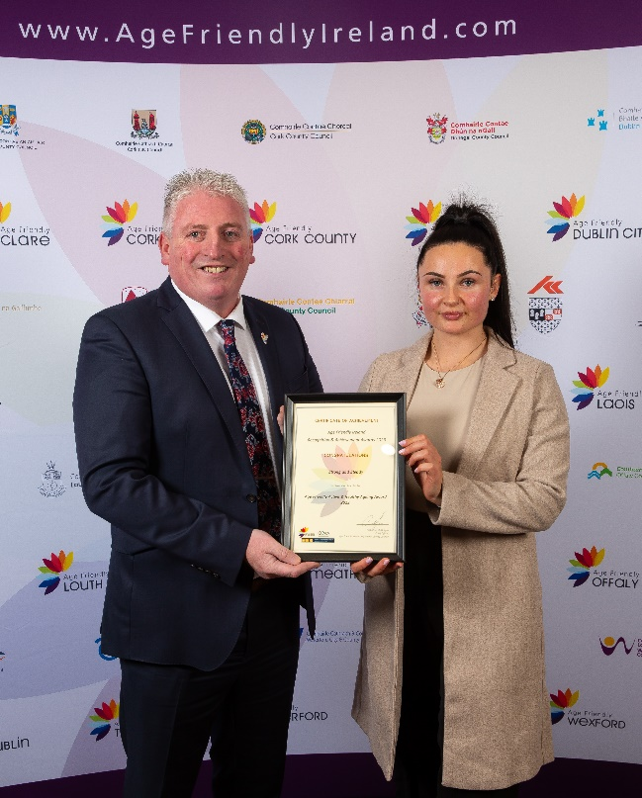
Cllr Garry Laffan (Chair of Sports Active Wexford), Anna Flynn (Sports Active Inclusion Disability Officer) (Image: Browne’s Photography)
This year eight categories of awards, aligning to the themes of the World Health Organisation’s global framework for Age Friendly Cities and Communities, were presented to age friendly projects in recognition for their innovative and creative approach to making Ireland a great place in which to grow old.

ENDS

Notes to Editor:

The winners in each category were:

1. Age Friendly Transport Award

Ireland’s First Age Friendly Train Station, MacDonagh Station in Kilkenny.

2. Age Friendly Active & Healthy Aging Award

Healthy Islands, County Galway offshore islands

3. Age Friendly Business Innovation Award

Specsavers, Age Friendly Business, Newbridge

4. Age Friendly Safety & Security Award

An Garda Síochána, Older Persons’ Wellbeing Event, Cavan and Monaghan

5. Age Friendly Communication Award

Information Screens, Dublin City Council Central Area

6. Age Friendly Environment Award

“Access for All”, Age Friendly Recycling Initiative, Carlow

7. Age Friendly Community Innovation Award

“Sweeter the Tune”, Leitrim

8. Age Friendly Housing Award

Cornamona Court, Ballyfermot, Dublin

Judges Special Recognition Award

Beech Hill College, Monaghan - Beech Hill College Intergenerational Project- TY Students broadcasting news for local nursing homes and Colaiste Na Sceilge – Cahersiveen - Intergenerational Connection: Youth Action Addressing - IT Poverty among older people in South Kerry were jointly awarded this special recognition award.

