PRESS RELEASE 14th December 2023

Sod turned on 18-unit social housing scheme at Tagoat, Co. Wexford.

Cathaoirleach of Rosslare Municipal District, Cllr. Jim Moore today officially turned the sod to commence a new development of 18 social houses at Grahormack, Tagoat in the presence of his fellow elected members of Rosslare Municipal District, Wexford County Council officials and representatives from the appointed contractors.
The scheme which is funded by the Department of Housing, Local Government and Heritage under ‘Housing for All’ the national housing plan, will help to address the demand for social housing in the area. It will comprise of modern and energy efficient homes designed to meet the needs of individuals and families. The development consists of 2 Nr 2 bedroom single storey houses, 6 Nr 2 bedroom duplex apartment units, 2 Nr 1 bedroom Duplex apartment units, 1 Nr 2 Storey 4 bedroom house & 7 Nr 2 storey 3 bedroom houses.
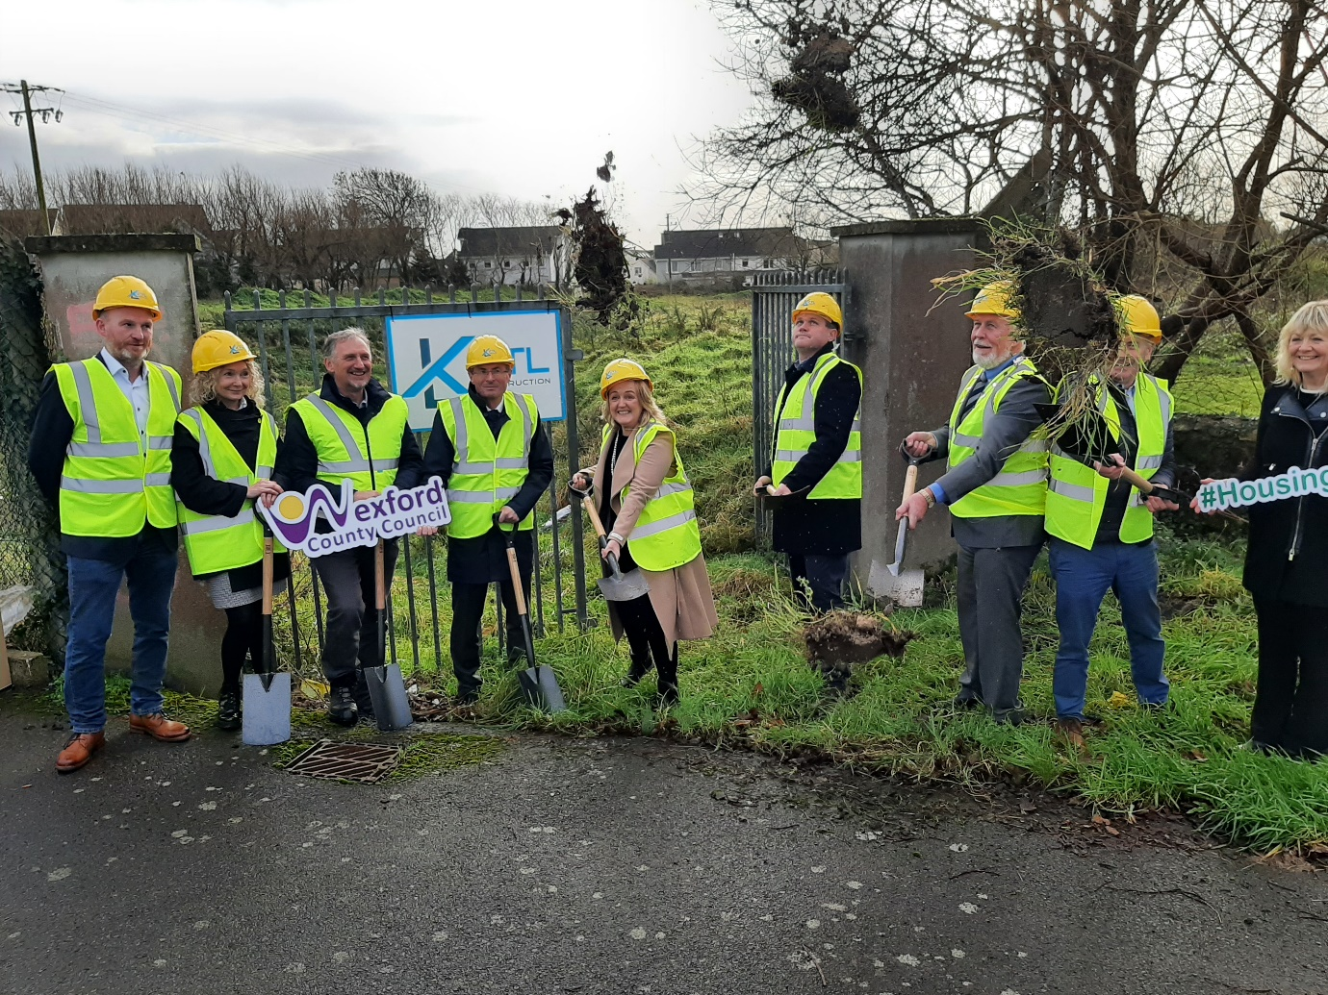
(L to R) Kevin Thorpe (KTL Construction), Lynda Lacey( Acting Head of Finance & ICT and Director of Service for Rosslare Municipal District), Shay Howell ( Senior Architect , WCC), Eddie Taaffe( Director of Service , Capital Development ) Cllr. Lisa Mc Donald, Cllr. Ger Carthy, Cllr. Jim Moore (Cathaoirleach of Rosslare Municipal District), Cllr Frank Staples, Nóirín Cummins (District Manager)

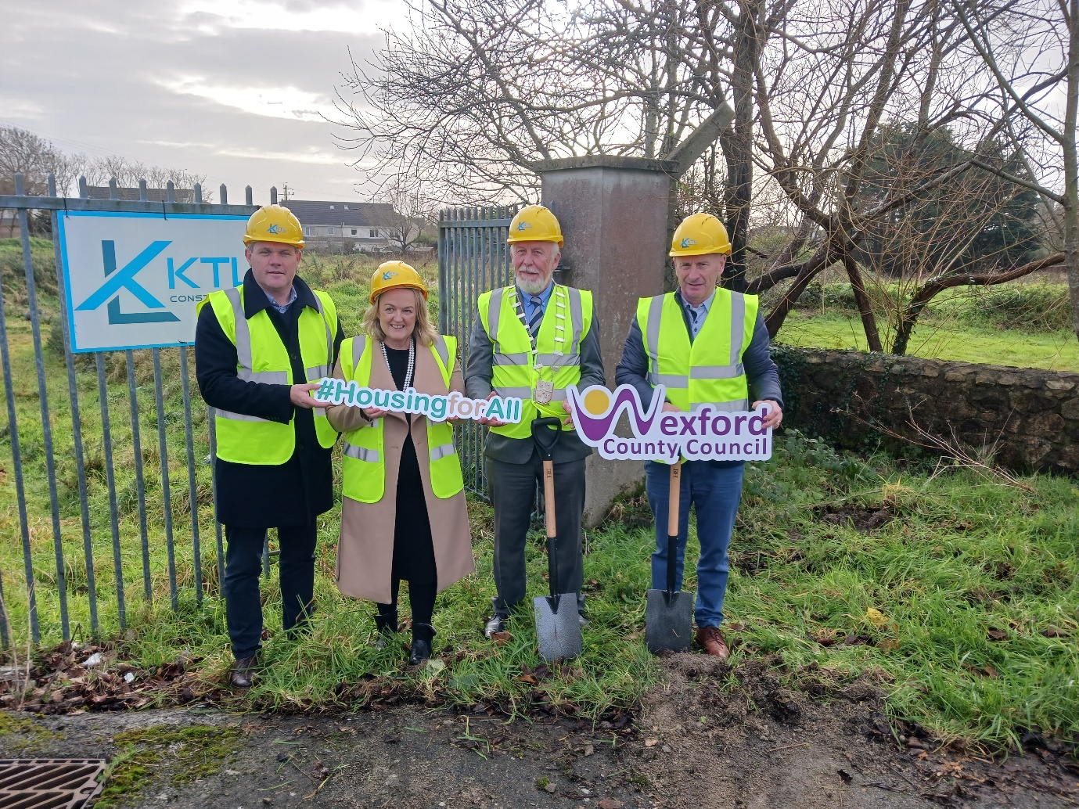
(L to R): Cllr. Ger Carthy, Cllr. Lisa Mc Donald, Cllr. Jim Moore (Cathaoirleach of Rosslare Municipal District), Cllr Frank Staples
Speaking at the ceremony, Cllr. Moore said “I am delighted to be turning the sod on the Tobar Cormaic, Tagoat, housing development today. This new social housing development of 18 units is much welcomed by the Councillors from the Municipal District of Rosslare and the people living in our uniquely rural District. The continued delivery of Social Housing units is of critical importance to the sustainability of our rural communities.”

Eddie Taaffe, Director of Services for Capital Development said “This scheme in Tagoat represents the latest project in Wexford County Councils programme of social housing construction. Together with our partners in the Approved Housing Bodies, over 400 new dwellings have been delivered since the start of 2022 and a further 700 will be completed by 2026. The Housing Construction team is working hard to develop more projects and increase the amount of social housing construction delivered by the Council and we hope to exceed our targets set under the Governments Housing for All plan.
Kevin Thorpe Ltd (KTL Construction), Newtown, Enniscorthy, Co. Wexford have been appointed by Wexford County Council for the construction works, with the development expected to be completed and occupied by early 2025.
ENDS

