Press Release 14 May 2024

High Performance Building Alliance (HPBA) launches new website.

An event to launch the new High Performance Building Alliance (HPBA) website was hosted by Wexford County Council at County Hall on Thurs 9th May. Guests included Minister James Browne, Cathaoirleach of Wexford County Council, Cllr. John Fleming, elected members and HPBA board members.
The website was designed by Clearsoft, a local web designer firm, based in Gorey. The website aims to bridge the gap between academia and industry, providing a one stop shop for all stakeholders in the built environment to access information on training, events and cutting edge research. We recognise that there is a huge amount of information available, and endeavour to pull this together to ensure our users can access the information they require. The new website is easy to navigate on desktop and mobile devices and content is regularly updated. Each month a relevant course will be featured to highlight the features and benefits of engaging in regular upskilling. There are links to interesting content and research, hosted by our partners and stakeholders. To find out more, please visit www.hpba.ie.
In Autumn 2024, our flagship innovation centre located in Enniscorthy, Co. Wexford will open its doors. The centre will be called the “HPBA Green Hub” and is funded by Wexford County Council and Enterprise Ireland. This space will provide opportunities for SMEs to connect with fellow innovators and develop new products and solutions for addressing climate change within the built environment. The Green Hub is unique as it has been designed and will be fitted out using circular economy principles, design for disassembly. The space will also serve as a demonstrator for new products and services within a sustainable built environment.
Cllr. Garry Laffan, Chairman of the High Performance Building Alliance Board said “We have been successful in securing funding from the Department of Housing, Local Government and Heritage and Enterprise Ireland, enabling us to continue in our mission to tackle climate change through the built environment.
We are delighted to officially launch our new website today, which will help companies to access the support they need to enable them to contribute to the delivery of high performance buildings.
Our new website is just the start! We are on the road to achieving the sustainable fit out of a new enterprise and innovation centre, The Green Hub, which is scheduled to complete later this year. This hub is the first of its kind in Ireland, as the architect is using the circular economy principle of design for disassembly. This reduces waste and the carbon footprint of the space. The space will also be a demonstrator for new products and materials, which will benefit the sustainable built environment.”
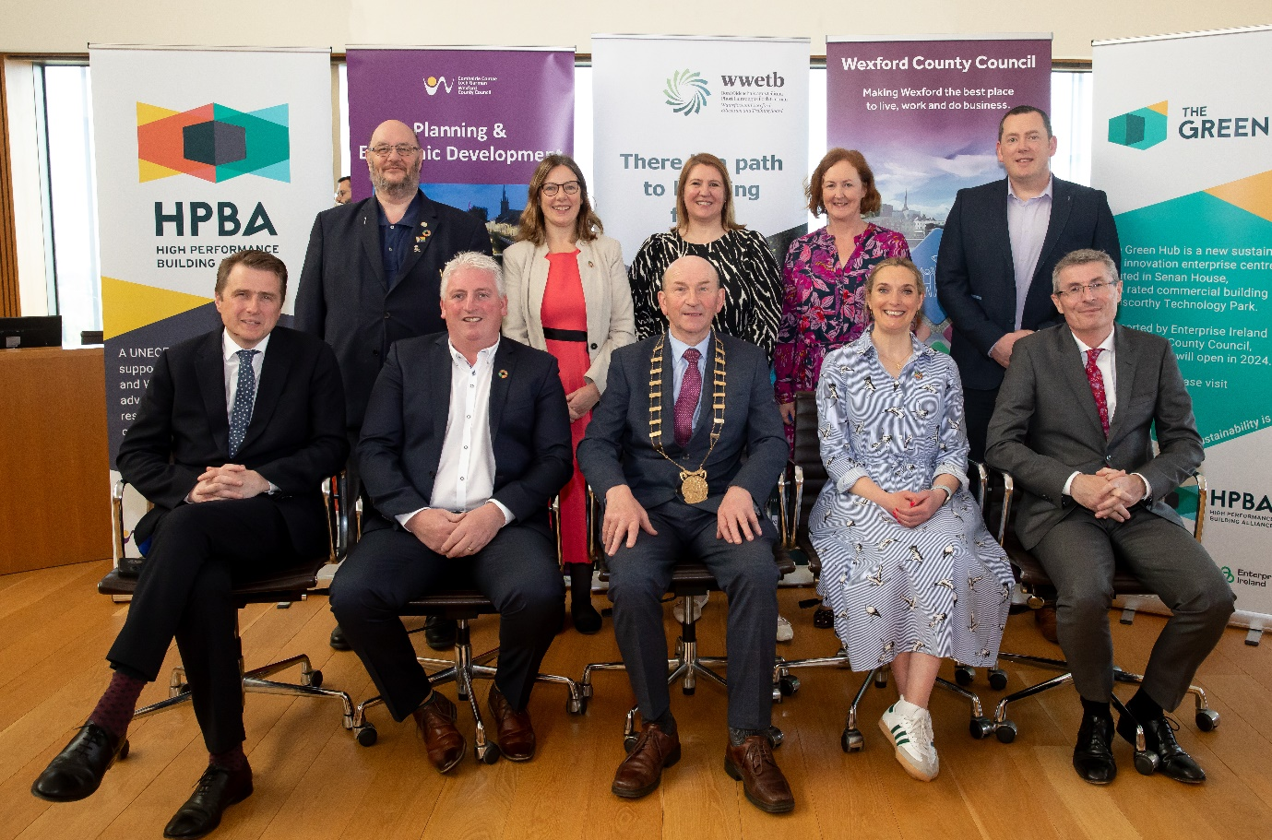
Cathaoirleach of Wexford County Council, Cllr. John Fleming said “I am delighted to support the High Performance Building Alliance today as they officially launch their new website. As Cllr Laffan said, Wexford County Council have been involved in the HPBA, since its initiation.
It is wonderful to see such progress being made and the new website is an important resource for the industry, as companies have had to navigate a raft of initiatives and training, so there is a need for a one stop shop.
Wexford County Council are supporting the HPBA to fit out their new green innovation and enterprise centre, and the fact that they are taking a circular approach to the fit out is testament to their authenticity as a leader in championing high performance buildings.
I wish the HPBA every success in their future and look forward to the next event.”
Representing Waterford and Wexford Education and Training Board, one of the founders of the HPBA, was Innovation Manager, Mr. Michael O’ Brien. Michael took guests though the chronology of the development High Performance Building Alliance and the impact it has made to date in upskilling the workforce in NZEB and Retrofit courses, with over 3200 people trained since inception. Michael said “WWETB is delighted to be part of such a fantastic project and wish HPBA all the best on the launch of its new website”.

ENDS

Notes to Editor:
Background: The High Performance Building Alliance (HPBA) is an Irish Government and UN approved Centre of Excellence, dedicated to addressing climate change through industry informed research and upskilling, to optimise the sustainability of the built environment.
Our mission is to advance the United Nations' Sustainable Development Goals, the Framework for Energy Efficiency Guidelines, the Paris Climate Accord, and Ireland's Climate Action Plan. We are dedicated to leading and championing high-performance buildings and nearly zero-energy buildings, both new and retrofit, while increasing knowledge, capacity, and demand for low-carbon emission buildings. HPBA fosters innovation, promotes sustainable solutions, and collaborates to create environmentally, economically, and socially vibrant communities.
HPBA was established by Wexford County Council in collaboration with Waterford and Wexford Education and Training Board with a goal of addressing skills gaps of the building industry in their ability to respond to the demand for A rated houses. Wexford became the first county in Ireland to have all their new build local authority homes rated as NZEB. WWETB developed the NZEB specifications, followed by relevant training programmes and began delivery from the first NZEB pilot training centre in Ireland. This centre is located in Enniscorthy, Co. Wexford and has since been replicated, with the training rolled out nationally to five other regional centres designated by government policy. In 2021 HPBA joined the UNECE High Performance Buildings Initiative (HPBI) and represents Ireland at global level as one of nine Centre’s of Excellence.

For Further Information please contact:
Amanda.stewart@hpba.ie
Phone 0871232211.
www.hpba.ie

Image: Brownes Photography, New Ross

