PRESS RELEASE 13th November

New Calendar launched by Community Team at Wexford County Council

Today the Community Team at Wexford County Council launched its first Community Calendar for 2024. The team, which includes work under the brands of Wexford LCDC, Healthy Wexford, Sláintecare Healthy Communities, Wexford Age Friendly and Sports Active Wexford gathered for a photo to mark the occasion, and to present the first calendar to Cathaoirleach of Wexford County Council, Cllr John Fleming.

Staff of the Community Team, with Caroylne Godkin, Director of Service and Dymphna O’ Connor, Senior Executive Officer
Speaking about the calendar Cllr Fleming said, ‘Whether you are interested in arts and culture, sports and recreation, education and training, or community development and support you will find something in the calendar that suits your needs and interests.’
Carolyne Godkin, Director of Services with responsibility for Community said ‘We are proud to share this, our first calendar, that showcases some of our work and celebrates our Wexford communities’ while Dymphna O’Connor, Head of Community said ‘Our calendar is more than just a collection of dates and events, it is a reflection of our passion, dedication, and diversity as we serve the people of Wexford in various ways.’

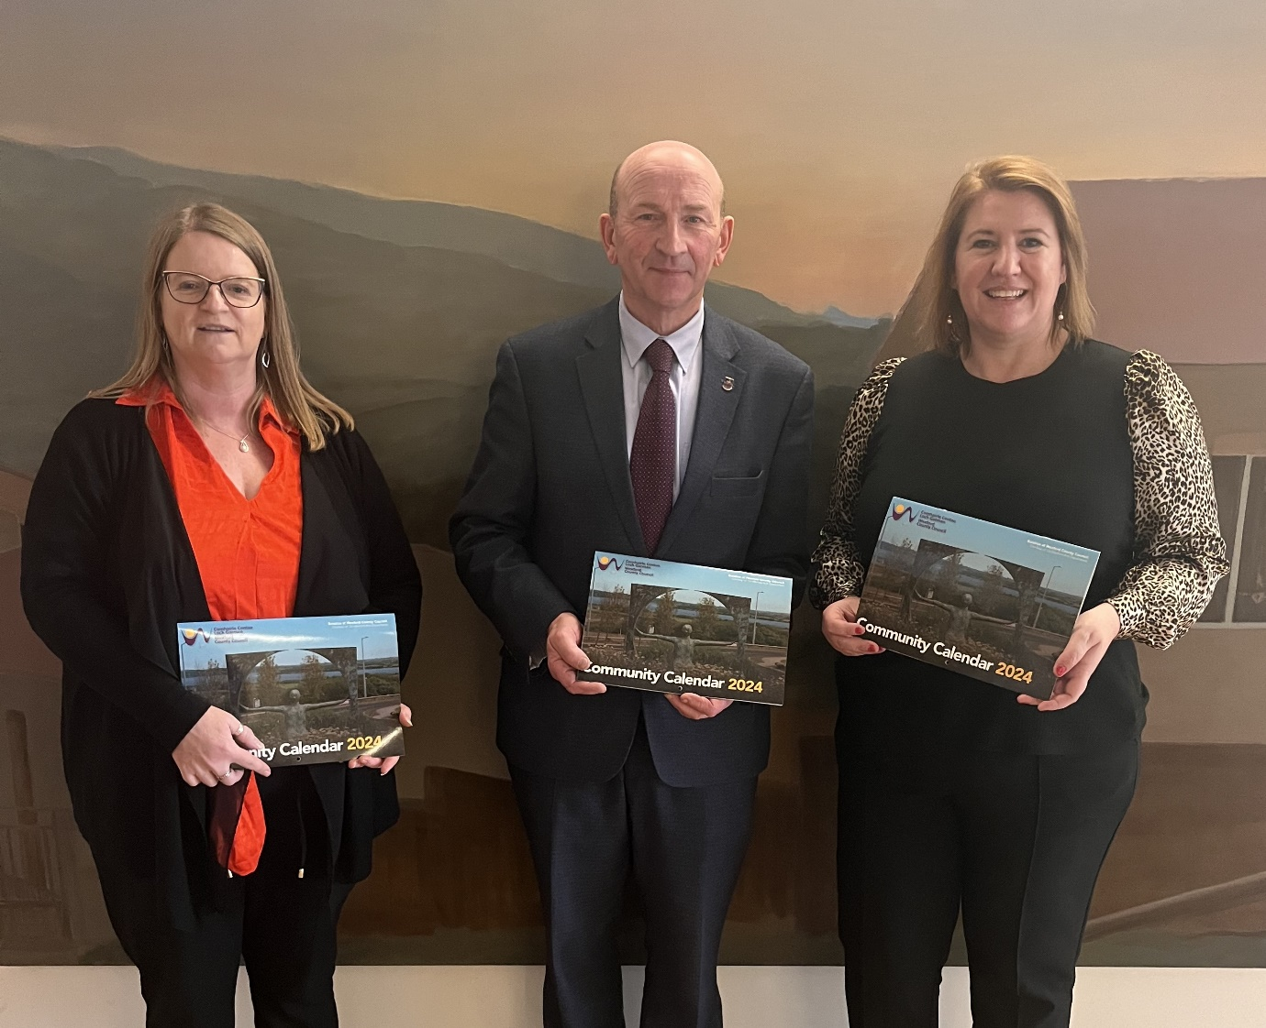
Dymphna O’ Connor, Senior Executive Officer, Community, Cathaoirleach of Wexford County Council, Cllr. John Fleming, Caroylne Godkin, Director of Service
The calendar includes local photos and includes key messages and dates each month which the team hope will act as a further support to communities and citizens across County Wexford.
Calendars will shortly be available for free across County Wexford at local Municipal District Offices, at County Hall and through our Wexford Public Libraries. The Community Team will also be distributing in the course of their work over the next few weeks.

ENDS

