PRESS RELEASE 13 May 2024
WEXFORD COUNTY COUNCIL WELCOMES APPOINTMENT OF EDDIE TAAFFE AS NEW CHIEF EXECUTIVE
At a special meeting held today (Monday 13th May) the elected members of Wexford County Council approved the appointment of Mr. Eddie Taaffe as Chief Executive of Wexford County Council.
Mr. Taaffe, who’s appointment follows a recruitment process conducted by the Public Appointments Service, has held the position of Interim Chief Executive since February this year, following the retirement of his predecessor Mr. Tom Enright.
Cathaoirleach of Wexford County Council, Cllr. John Fleming said: ‘I wish to extend our congratulations to Eddie. A Wexford man at heart with Wexford blood in his veins. He is taking up the role at a good time with the start of a new term. I wish him well in the role’
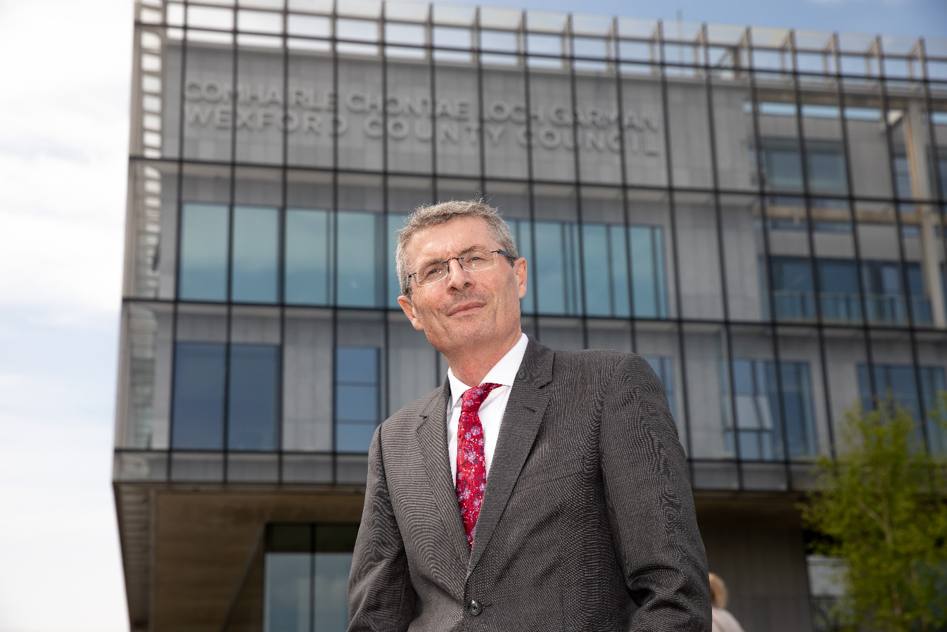
Eddie Taaffe first joined Wexford County Council in 1997 as an Assistant Engineer in the Environment Section. Since then, he has held various Engineering posts such as Senior Resident Engineer on Courtown Main Drainage Scheme, Senior Engineer in the Roads Section and Borough Engineer with Wexford Borough Council. He has also held the post of Director of Service since 2011 with responsibility for various council sections such as Water Services, Environment, Emergency Services, Corporate Services, Human Resources and Capital Development. He has also spent time working as Director of Planning and Transportation with South Dublin County Council. More recently, between 2020 and 2023, Eddie was seconded to the Local Government Management Agency where he led the Housing Delivery Co-ordination Office. Eddie has a degree in Civil Engineering and in Public Management.
Commenting on his appointment Mr. Taaffe said ‘ I am honoured and privileged to be formally appointed as Chief Executive of Wexford County Council, particularly as this is my home County. I look forward to continuing to work with the elected members and staff, striving to make Wexford the best place to work, live and do business for all our citizens. My key priority will be the delivery of the Council’s Economic, Social and Community Development Programme to attract and maximise economic investment, create greater employment opportunities for our citizens. The continued delivery of social and affordable housing is also a key priority for the Council and I look forward to working with all stakeholders to achieve these objectives.’

ENDS

