PRESS RELEASE 11th December 2023

Safe Route to School Scheme officially opened at Adamstown Primary School

An event in the village of Adamstown on the 7th December was held to mark completion of construction works as part of the Safe Routes to School Scheme.

Cllr. Anthony Connick Cathaoirleach, New Ross Municipal District officially opened the scheme, which was attended by local representatives, Cllr. John Fleming, Cllr. Bridin Murphy, Cllr. Pat Barden, Rev. Robert Nolan and representatives of the Safe Routes to School Section of An Taisce.

Cllr. Connick said that the project ‘has been a great improvement to the village as a whole’ and he thanked and congratulated all involved.

School principal Mrs. Claire Kickham said that "It was an absolute pleasure to work collaboratively with representatives from An Taisce, the National Transport Authority and of course Wexford County Council. From start to finish the whole process took about 18 months. We were guided through every step and consider ourselves very lucky and grateful to have buy-in from the local community. I would specifically like to thank the trustees of St. Abban's Hall for their support in the implementation of this initiative”.

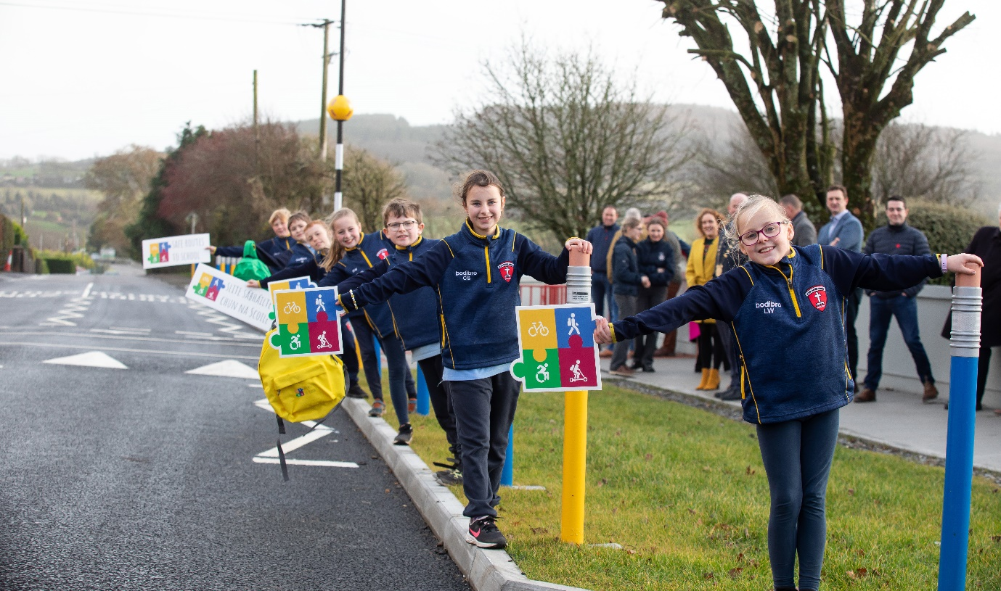
Students from Adamstown National School (credit: Mary Browne, Brownes Photography)
The children also have a lot to say about the aesthetics of the new arrangement. They love the giant pencil bollards. One child said, "I love how the top reflects the lights of the cars at night." Another child remarked that "The school looks so colourful and friendly now."

John Nolan, Principal of Coláiste Abbáin Secondary School also offered his support for the scheme saying that the scheme is of huge benefit to the students of Coláiste Abbáin.

The Safe Routes to School Scheme is a national programme to improve safety at school gates, increase walking and cycling and alleviate congestion in front of schools. The Adamstown scheme includes distinctive street furniture and crossing points to emphasise school location. The design also includes new footpaths and pedestrian crossings to facilitate the safe movement of pedestrians to school, shop, housing estates and church. Re-surfacing and drainage upgrades were also carried out at the main village junction.

Works were completed by contractor Paddy McGee (Wexford) Ltd. The project was designed and managed by the Active Travel Dept. in Wexford County Council

ENDS

