PRESS RELEASE 11th December 2023

Enniscorthy Municipal District Christmas Market Officially Launched

The Enniscorthy Municipal District Christmas Market was officially launched on Friday 8th December in the Market Square in Enniscorthy. The market was stocked with a variety of local arts and crafts, festive treats hot food and lots more.
Speaking at the launch the Cathaoirleach Cllr. John O’ Rourke said that ‘Enniscorthy Municipal District is delighted to be bringing this new market to Enniscorthy this Christmas along with free family entertainment. It is hoped that the market will increase the footfall in the town and encourage people to shop locally’.
The impressive ‘Juggler Brendan’ gave two live performances on the day.
Free family entertainment over the weekend was provided by Giggles the Clown and Craft Central.
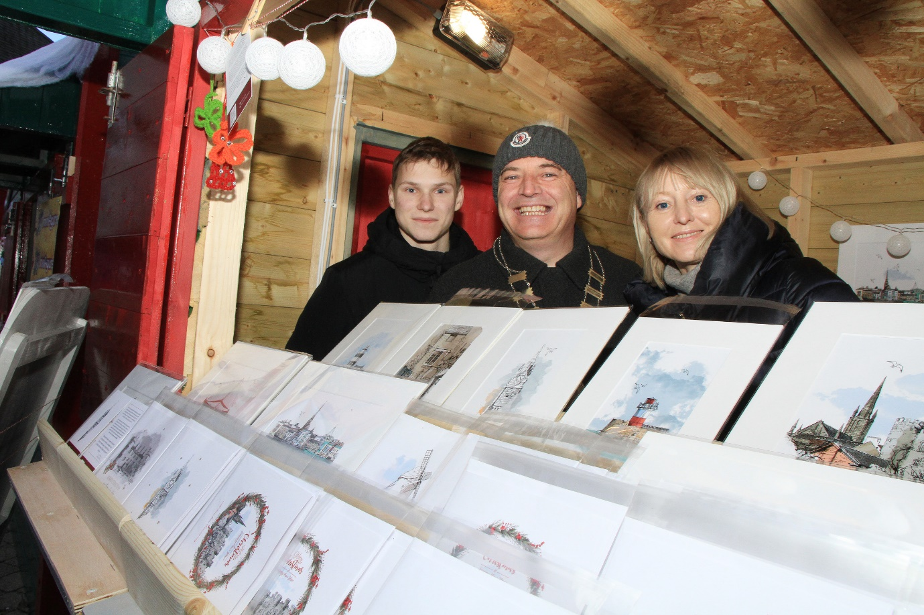
L to R : Natalia Somers, , Cllr John O’ Rourke(Cathaoirleach of Enniscorthy Municipal District) and Lucy Somers of Sisters Ink stand. (credit: Pat O’ Connor)

The market will run over next weekend also on the 15th, 16th and 17th December from 12.00pm to 6.30pm. You will have a chance to see the hilarious Giggles the Clown again next Saturday 16th December from 1.00pm to 3.00pm and there will be free children’s face painting from 1.00pm-3.00pm on Sunday.
Free Christmas Parking is available in public car park only from 11.00am on Saturday 16th December and Monday 18th to Saturday 23rd December inclusive.
Join the festive cheer in your town and remember to Shop Local this Christmas.

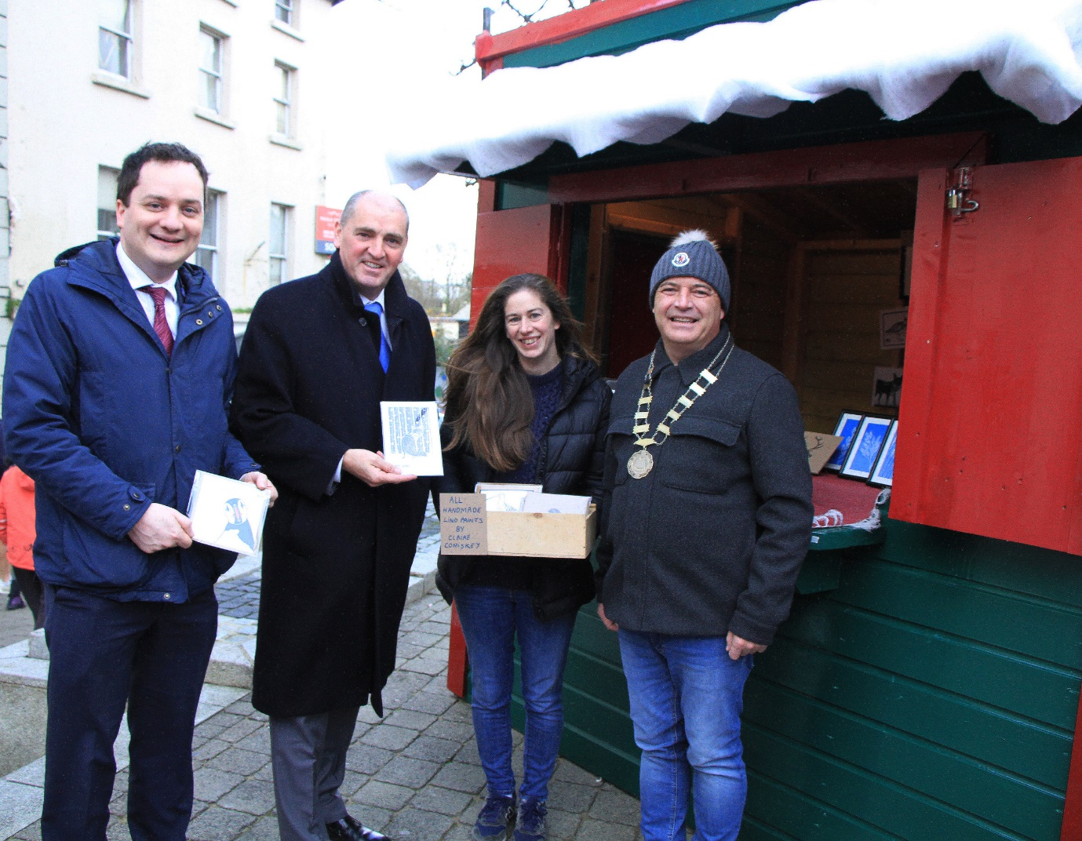
L to R: Cllr Cathal Byrne, Minster Paul Kehoe, Claire Comiskey, Le Mo Lamh andCllr John O’ Rourke (Cathaoirleach of Enniscorthy Municipal District) (credit: Pat O’Connor)

ENDS

