PRESS RELEASE 10 July 2023
Gum Litter Taskforce Roadshow takes to Wexford to tackle gum disposal.
The Gum Litter Taskforce (GLT) took to the streets of Wexford Town on Friday last (7th July) as a part of its Summer Roadshow. The interactive Roadshow works with local authorities and communities across the country to carry out fun and engaging education and awareness initiatives that demonstrate the proper means of gum disposal and raise awareness of the environmental and fiscal impacts of gum litter. Now in its sixteenth year, the campaign is a collaboration between Food Drink Ireland, the Department of Environment, Climate and Communications, the chewing gum industry, and local authorities.

Research published recently to coincide with the National Launch of the 2023 GLT Campaign revealed that 87% of people now report proper gum disposal, versus 49% when the campaign began in 2007– an increase of 77.5%, demonstrating the positive impact the campaign has had on attitudes towards gum litter. Peer pressure was found to be the key contributor to this shift in attitudes, followed by knowledge of the €150 fine.
However, work remains to be done to further reduce this figure, as still only 46% of people can claim to have never dropped gum on the ground, demonstrating the continued importance of the awareness and behavioural change campaign.
Welcoming the Roadshow to Wexford Town, Councillor John Fleming, Cathaoirleach of Wexford County Council said: "We are delighted to welcome back the Gum Litter Taskforce to Wexford. The Roadshow is a fantastic way to demonstrate to people the sustainable impacts of responsibly disposing of gum litter and changing their disposal behaviours.’
Councillor John Hegarty, Mayor of Wexford stated ‘This GLT campaign has seen a visible reduction of gum litter on our streets since it first began, the Roadshow is an important reminder to the whole community that we must continue to reduce our litter and protect our local environment."
Speaking at the launch of this year’s Roadshow, Minister Ossian Smyth welcomed the latest research and the return of the GLT campaign for the second year of its fifth cycle: “The Department of the Environment, Climate and Communications is proud to play a part in this important initiative. Each cycle of the campaign has delivered demonstrable progress in reducing gum litter on our streets, showing the impact that cross-collaborative initiatives such as this one can have. I look forward to continuing with our good work with industry and local authorities to build on the continued success of the GLT campaign to ultimately eradicate gum litter.”
Gum Litter Taskforce Project Manager, Jonathan McDade of Food Drink Ireland, also welcomed the return of the campaign, and praised its success to date: “We are delighted to have launched the 2023 Gum Litter Taskforce campaign with the support of the Minister Ossian Smyth and the Department of Environment, Climate and Communications. Each year of the campaign has delivered significant improvements, and we look forward to continuing our education and local authority engagements nationwide over the coming months. We remain committed to making gum litter on the streets of Ireland a problem of the past.”

Corporate Affairs Specialist at Mars Ireland, Anne Sheeran, also welcomed the announcement: “Mars Ireland has been a proud partner of the Gum Litter Taskforce for the past 16 years. We are delighted to have kicked off the 2023 campaign with the support of the Department of Environment, Climate and Communications. We look forward to engaging with local authorities and students across the country to highlight positive environmental messages around proper gum disposal.”

ENDS

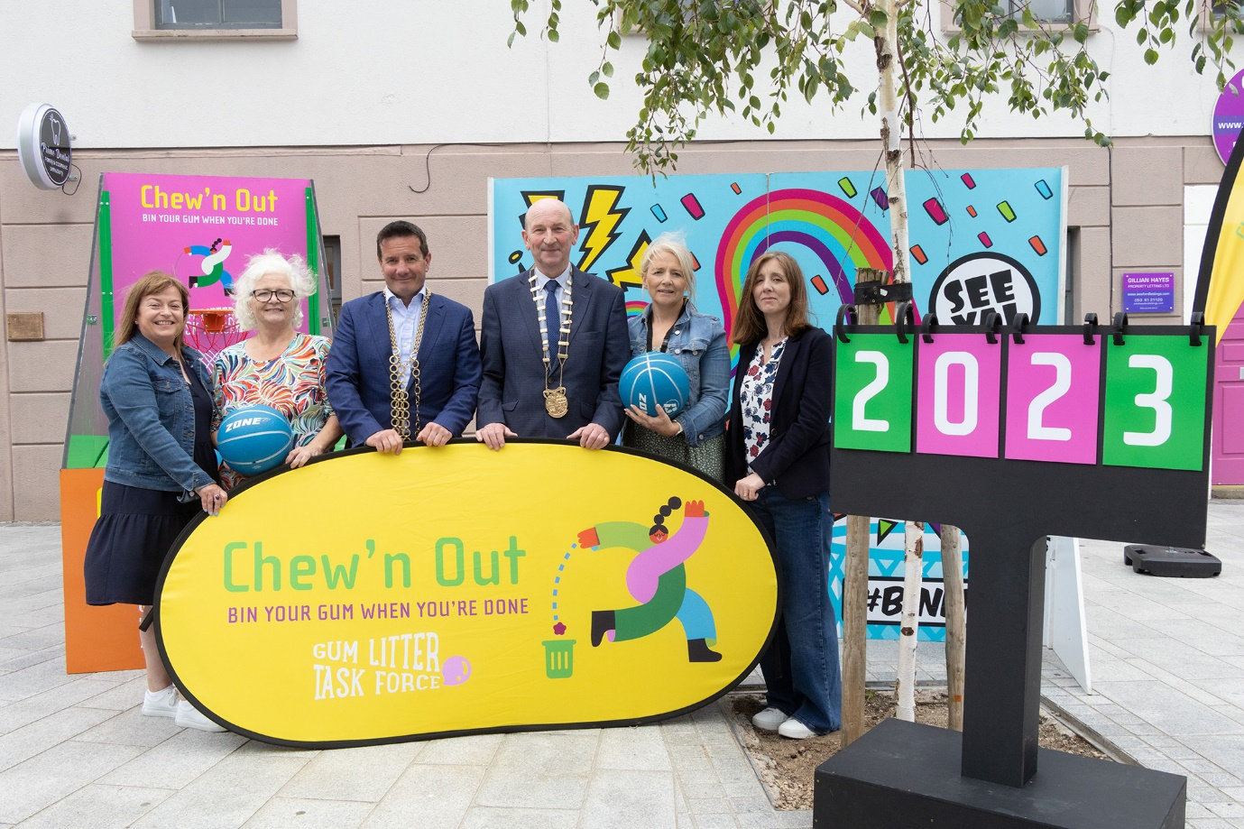

From left to right: Siobhan Kehoe, Wexford Borough District; Phil Murphy, Wexford Tidy Towns; Mayor of Wexford, Cllr John Hegarty; Cathaoirleach of Wexford County Council, Cllr John Fleming, Caroline Sinnott, WCC & Jill Latimer ,WCC
(Photographs: Ger Hore)
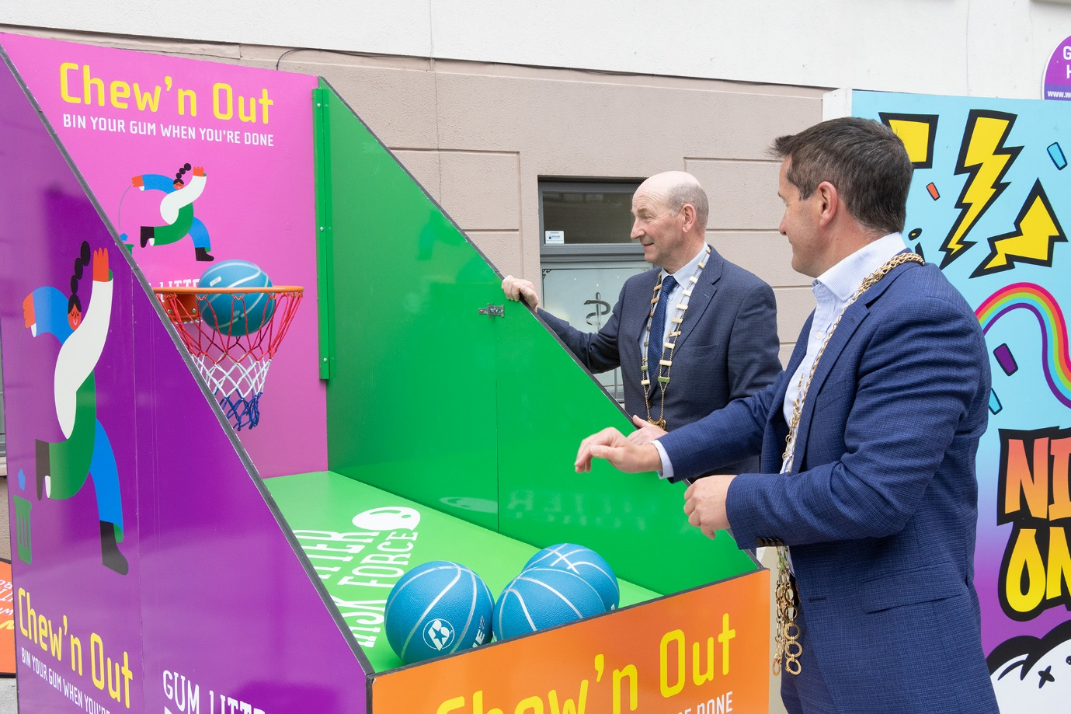

For media queries contact:
- Drury: GLT@drury.ie
- Rachel Kilbane, Drury: rachel.kilbane@drury.ie | 083 339 8587
- Deirdre Sheahan, Drury: Deirdre.sheahan@drury.ie | 085 744 2242

For more information: https://www.gumlittertaskforce.ie/
Or follow: @GumLitterTF (Twitter) | @gumlittertaskforce (Instagram/TikTok)

Notes to the Editor:
Initiated in 2007, the Gum Litter Taskforce is a collaboration between Food Drink Ireland, the Department of Environment, Climate and Communications, the chewing gum industry, and local authorities to achieve a long-term sustainable solution to the irresponsible disposal of chewing gum litter, through education and awareness campaigns that encourage behavioural change.

The national Gum Litter Taskforce Roadshow will commence on the week of June 1st, travelling to local authorities in Dublin, before visiting local authorities across all four provinces over the course of the Summer months. To date the campaign has engaged with over 30 local authorities across the country to promote community-led action on gum litter by hosting awareness initiatives and localised launch events and providing engagement and educational materials.

In September, the Gum Litter Taskforce’s Bin It! education programme will travel across the country and deliver 60 performances a year to primary and secondary schools nationwide, with the ambition to visit 180 schools by 2025. This is in addition to useful lesson plan material that has been made available to almost 730 schools across Ireland.
Mars Ireland will continue to support environmental education programmes Neat Streets, Green Schools and the National Spring Clean. The National Spring Clean experienced a bumper year with the most participants on record and this sponsorship will support the delivery of the programme and the 5,600 spring cleans annually going forward. The sponsorship of Green Schools will support the delivery of the programme to more than 3,700 schools across the country.

