PRESS RELEASE 9 May 2024

Wexford County Council host successful "Rubbish Film Festival" for Transition Year Students.

The Rubbish Film Festival is renowned for showcasing compelling stories and innovative filmmaking that highlights global and local environmental issues. The festival, which challenged students to create a one-minute short film on an environmental theme such as, climate action, reducing waste, and sustainability, was funded by the Environment Section of Wexford Council and was facilitated by Createschool.

The festival received a great response from the 6 participating secondary schools, with transition year students showing their creativity and innovation in producing short films that were both educational and entertaining.

Mayor of the Borough District of Wexford, Councillor John Hegarty presented trophies to Selskar College, Wexford. Students from Selskar College were awarded Best Runner Up Film and Best Poster for their short film entitled ‘The Act’.

Cllr. Hegarty congratulated all the students involved. He said ‘the students used film to develop and express their views on a range of climate action and sustainability topics, and in doing so showed great skill and creativity. The films not only entertain but inspire action for a more sustainable planet.’

Councillor Pip Breen, Cathaoirleach Gorey Kilmuckridge Municipal District presented the trophy for Best Film to students of Gorey Community School for their film entitled ‘In The Eyes Of Innocence’ Councillor Pip Breen stated that the festival received a great response from schools, with students showing their creativity and innovation in producing short films that were both educational and entertaining. He said ‘It was inspiring to see students deliver their message and raise awareness of environment issues amongst their peers’.

The Best Film and Best Poster will now go forward to represent Wexford at the National Awards in Co Meath on May 10th.

Cliona Connolly, Environment Awareness Officer said ‘The 'Rubbish Film Festival' is a fantastic initiative that demonstrates the creativity and enthusiasm of young people in Wexford, and we congratulate all those involved in making it such a success’. ‘We are delighted to fund the Festival as part of our environment education programme, furthering our commitment to environmental education, stewardship and sustainable living.

As part of the programme, transition year students in participating schools received a 2-day workshop in their school facilitated by Create School, which was fully funded by the Environment Section of Wexford County Council.

For more information about the Rubbish film Festival. Please view www.rubbishfilmfestival.com

ENDS
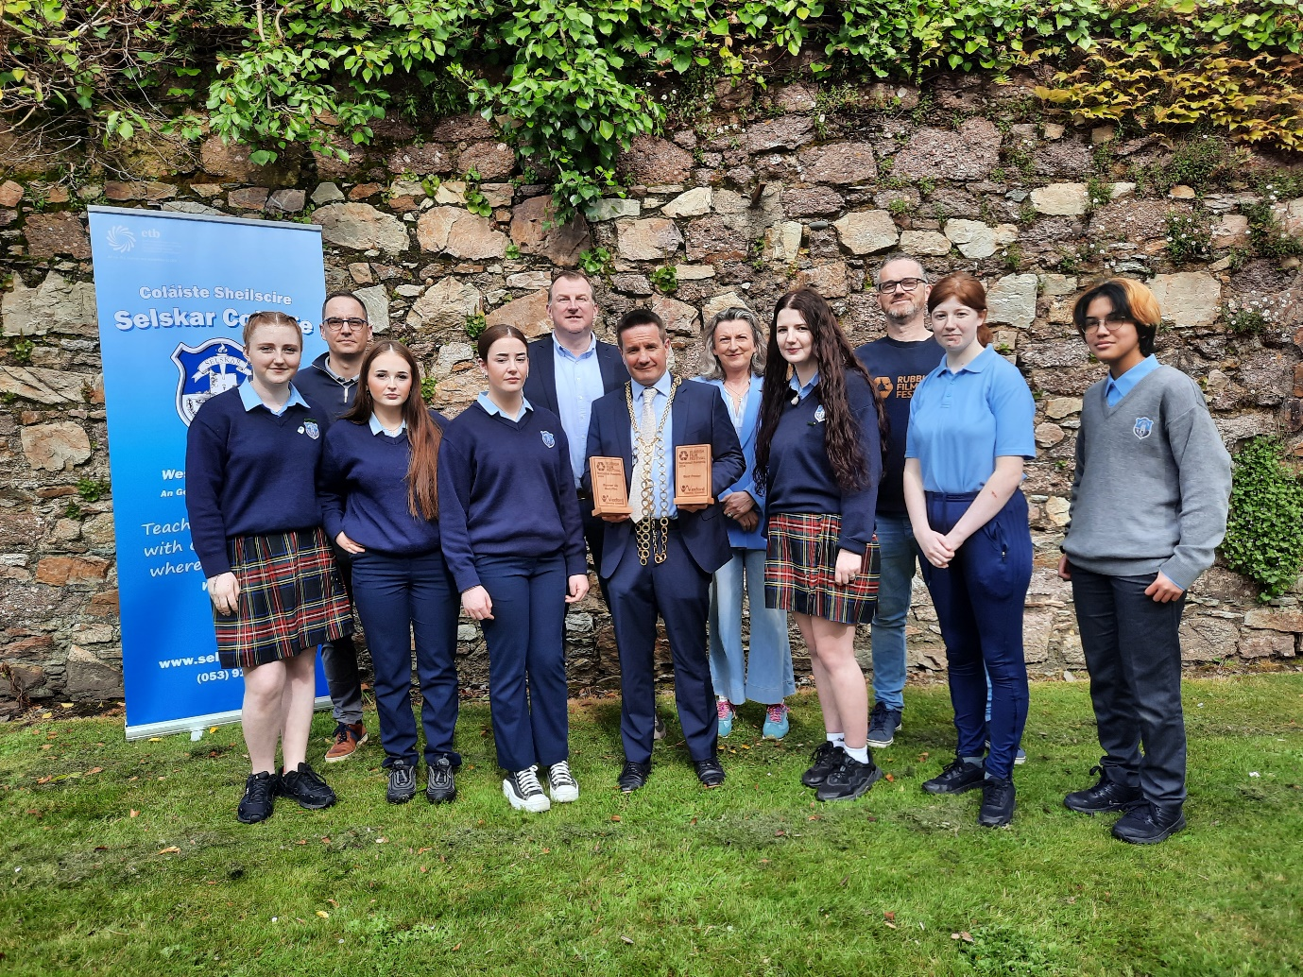
Presentation of trophies to Selskar College – Best Runner Up Film and Best Poster for ‘The Act’
Front row (L to R): Ellie Furlong, Chloe Kelly, Leah Mulholland, Councillor John Hegarty, Mayor Borough District of Wexford, Jodie Delaney Cashe, Aoife Davis, Damien Hogg
Back row (L to R):Kevin Barry, Selskar College, John Connolly, Acting Principal Selskar College, Cliona Connolly, Environment Section and Justin Cullen Createschool

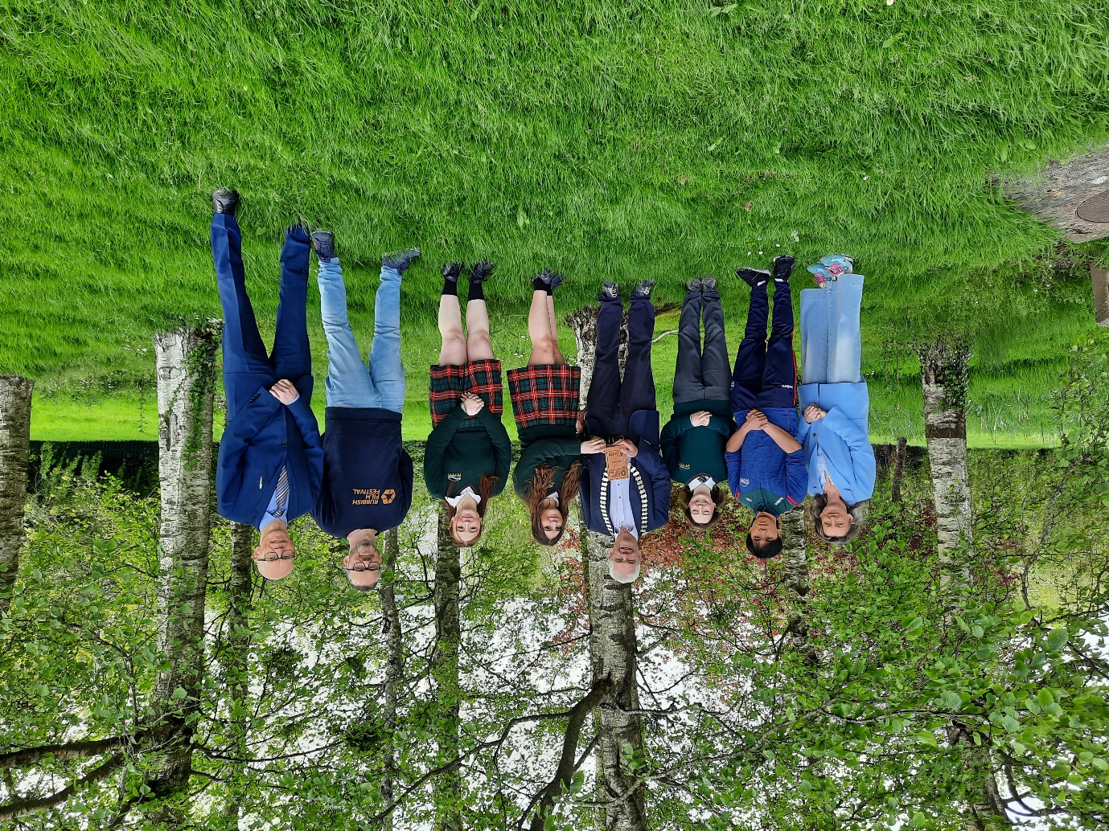
Presentation of trophy for Best Film to Gorey Community School
(L to R): Cliona Connolly, Environment Section, Josh Tuan Tu O Reilly, Geneviene Fleming, Councillor Pip Breen, Cathaoirleach of Gorey Municipal District, Alannah Nc Craith, Faerne Zahra Jade Hammon, Justin Cullen Createschool and Michael Finn , Principal Gorey Community School

