PRESS RELEASE 8 April 2024

Clonroche Amenity Park planted as part of The 100 Million Tree Project.

On 5th April, Clonroche Amenity Park, was planted with 2500 native trees as part of ‘The 100 Million Trees Project’ which is a community driven initiative to plant 100 million native trees across Ireland.

Councillor John Fleming, Cathaoirleach Wexford County Council, Councillor Michael Sheehan, New Ross Municipal District, members of Clonroche Development Association, members of the local community, Richard Mulchay and representatives from Forestry Services were in attendance on the day.
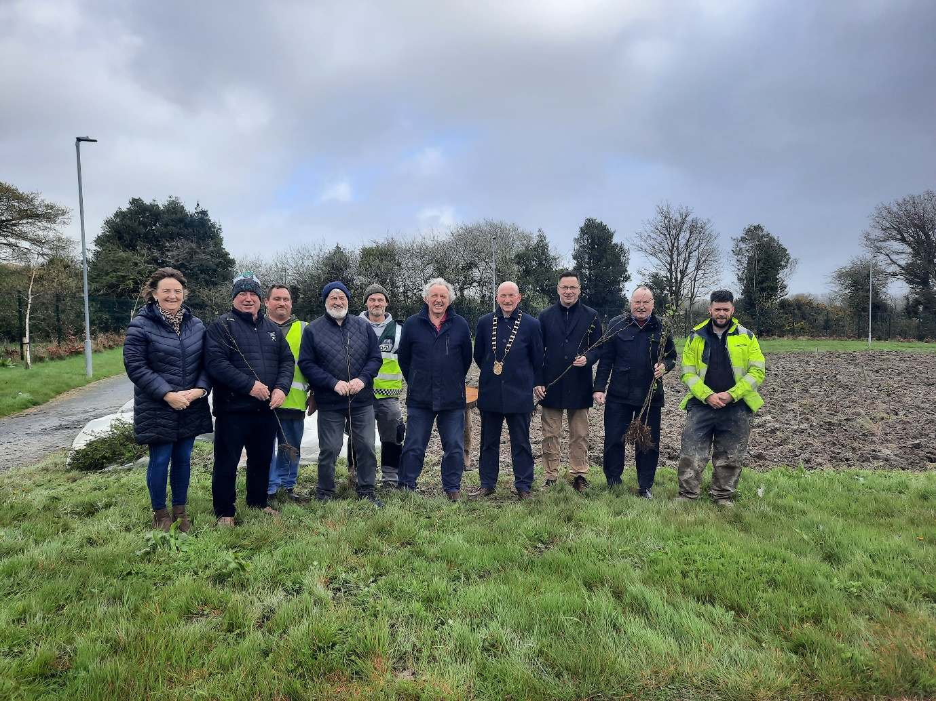

Image: Front row (L to R) Kay Stafford,(Anchor) Jim Redmond, (Clonroche Development Association) Tom Furlong, (Clonroche Development Association) Richard Mulcahy, Councillor John Fleming, Cathaoirleach Wexford County Council, Councillor Michael Sheehan, New Ross Municipal District, Martin Kelly, (Clonroche Development Association), Robert O’ Connor, Forestry Services.

Back row (L to R)Philip Rossiter, (Anchor) John Fitzpatrick (Anchor)

Cathaoirleach of Wexford County Council, Councillor John Fleming welcomed all and said ‘it was great to see Clonroche Amenity Park planted with native trees as part of the 100 million trees project. He thanked the Clonroche Development Association, Richard Mulcahy, Wexford County Council and Uniphar for making this project happen. He paid a special word of thanks to all in the local community for their commitment and dedication in keeping the park and the village of Clonroche looking so well’.

Richard Mulcahy said “We are delighted to partner with Clonroche Development Association and bring the total number of young native trees planted to just over 200,000 across 99 sites. He thanked Uniphar for their sponsorship for the 2023 / 2024 planting season and stated that the planting in Clonroche Amenity Park will provide so many benefits to the local community and for biodiversity”.

Background Information

The 100 Million Trees Project is a national initiative developed by brothers, Richard and David Mulcahy in 2023 with sister Tina coming on board in 2024. The project aims to see the planting of 100 million native Irish trees across the island of Ireland over the next decade, as a community-driven initiative.

The project’s ambitious aim will be achieved through densely planting between 500 and 2,500 native Irish trees at a time across small areas of land using ‘the Miyawaki method’. Named after Japanese Botanist, Professor Akira Miyawaki, who developed the technique in the 1970s as a means to restore degraded land, the Miyawaki Method of overplanting trees, has been successful in creating over 1,700 forests worldwide.

By planting excess trees together these grow 10 times faster, 30 times denser, create an area 100 times more biodiverse and most importantly create a very rapid carbon sink. This inexpensive approach requires significantly smaller planting areas and can be carried out on unused or fallow land across Ireland.

ENDS

Notes to Editors:
- For further information on The 100 Million Trees Project, check out the website here www.100milliontreeproject.ie or email the project at info@100milliontreeproject.ie.

