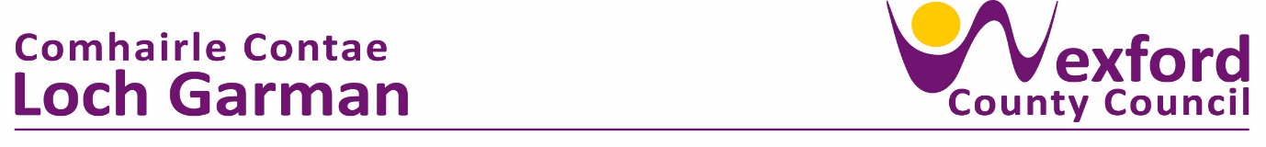

**PRESS RELEASE**  **07 September 2023**

**The Local Enterprise Office Wexford Launches Owner-Manager Programme**

*This program is ideal for business owners who are looking to grow their companies and enhance their management capabilities.*

The Local Enterprise Office (LEO) Wexford is launching an Owner-Manager Programme to support entrepreneurs and business owners looking to grow their businesses. The programme is designed to provide business owners with the skills and capacity for development of long-term strategic plans to transform their businesses and drive profitability.

Blaise Brosnan, Management Resource Institute (MRI) will be delivering the Owner Management Development Programme (OMDP) on behalf of LEO Wexford which is certified by the South East Technological University (SETU). Blaise has a unique blend of practical top management experience gained over 25 years in his capacity as Chief Executive of a portfolio of business types.

This programme is targeted at business owners who want to improve their management skills and drive their business forward. MRI will work closely with owners to help identify areas of weakness and develop bespoke solutions to address them.

The programme seamlessly integrates both in-person and online meetings, commencing on October 2nd and spanning a duration of 15 weeks at a cost of €250 per person. The program will commence with identification of specific training needs for each participant and modules will be tailored to meet their needs.

**Modules;**

The following are the core modules of the programme;

* Self-development/Motivation.
* Analysis of Business Problems
* Marketing Management
* Operations Management
* Control/Accounts Management
* Human Resource Management
* Team Building
* Communication Skills
* Financial Management
* Economic Analysis
* Social and Political Environment of Business
* Organisational Learning
* Business Strategy
* Business Ethics
* Change Management
* Business Law

**Follow up Consultancy Support.**

The programme is highly interactive and is also backed up by one-on-one consultancy support and a dedicated “Help Line”.

**Networking.**

Participating in the OMCDP allows each participant to establish a new network from within the group plus linkages into each of the others immediate networks.

Breege Cosgrave Head of Enterprise and Economic Development said ‘LEO Wexford is delighted to launch our Owner Management Programme which commences on the 2nd October. This programme will allow business owners to enhance their management capability and bring their businesses to the next level. In addition, participants on the programme will gain from an in-depth analysis of their business operations, strategic planning support, project management training and professional development workshops.’ Through taking control and honing their management skills, owners will be better equipped to achieve their business goals and navigate challenges in a constantly evolving global marketplace’ continued Breege.

We understand the challenges that business owners face in today's competitive environment, and the Owner Management Programme is designed to help companies to get to the next level," said facilitator, Blaise Brosnan. With our team of experienced consultants, we're confident that we can provide business owners with the guidance they need to succeed."

To book this program, please visit the LEO Wexford website or contact us directly for more information on how to register. Don't miss out on the opportunity to learn from one of the best in the industry. Register for OMDP today!

Innovate co-founder and CEO, Jim Hughes said ‘If I was to use one word to describe the OMP and Blaise’s contribution to our business to-date it would be, ‘Pivotal’. How does one find true north without a compass? Blaise and the OMP continues to supply this compass to direct our business.’

Anna Wickham owner of Oven Door Catering stated ‘Like eating porridge for Breakfast …. a constant slow release of inspiration, skills and tools that energised my business every day’

For more information about our Owner - Manager Programme and other Local Enterprise Office services, please visit our website at [Local Enterprise Office - Wexford](https://www.localenterprise.ie/Wexford/)

ENDS

Local Enterprise Office

Wexford County Council,

Contact: 053 9196023

Email; [breege.cosgrave@wexfordcoco.ie](mailto:breege.cosgrave@wexfordcoco.ie)