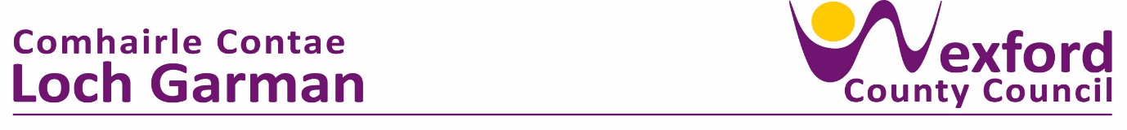

**PRESS RELEASE 5th APRIL 2024**

**COMMEMORATING THE 108TH ANNIVERSARY OF THE 1916 RISING IN ENNISCORTHY**

The Annual Easter Monday commemoration organised by Enniscorthy Municipal District took place on Monday, 1st April. The ceremonies began with a Special Mass in St. Aidan’s Cathedral at 10am with readings, prayers and recitals read by Cathaoirleach of Enniscorthy Municipal District Cllr. John O’Rourke, Martin Whelan, Keith Doyle and Bridget O’Brien. The Mass concluded with a beautiful rendition of Boolavogue sang by Niall Wall.

The Reserve Defence Forces provided a Colour Party that led the parade to the Market Square. “It is an honour to speak with you this Easter Monday morning as we commemorate the 108th Anniversary of the 1916 Easter Rising” said Cllr John O’Rourke. “Today we remember the sacrifices of the Irish rebels for us. We remember the unsung heroes, men and women who believed in the cause for Irish Freedom. These heroes blazed a trail for our freedom as an Irish nation. Today we owe it to the rebels of the past to honour the legacy of the Easter Rising to make Ireland a place where we honour the interest of our communities well into the future.”

The event was attended by the Ballindaggin Pipe Band, Enniscorthy Historical Re-Enactment Society, Martina Leacy’s School of Dance who performed and brought up the gifts, Judy Heffernan read the Proclamation, Anthony Nolan played the Last Post and the proceedings were concluded by the Ballindaggin Pipe Band playing Amhrán na bhFiann.

Cllr. John O’Rourke, laid wreath at the 1798 monument with a second wreath being laid by Cllr. O’Rourke and Martin Whelan at the Seamus Rafter monument in the Abbey Square.

ENDS

(L to R) Claire Lawless,Enniscorthy District Manager, Cllr. Aidan Browne, Cllr. Barbara-Anne Murphy, Minister James Browne, Deputy Paul Kehoe, Cynthia Ní Mhurchú, Cathaoirleach Cllr. John O Rourke, Layla O’Rourke, Cllr. Jackser Owens, Deputy Johnny Mythen, Cllr. Kathleen Codd-Nolan, Senator Malcolm Byrne, Cllr. Cathal Byrne