PRESS RELEASE 04 July 2023
Wexford Women’s Coalition ‘Flip-It’ Photo event
Members of the Wexford Women’s Coalition organised an event based on a ‘flipping great idea’ and for one day only there was a complete reversal of the gender balance in Wexford County Council chambers on Monday 26th June 2023.
The novel idea of a ‘gender reversal’ of the council chambers is just one of many initiatives being used by Women’s Coalition Groups across the country to highlight the gender imbalance in politics by having a complete reversal of the existing gender make-up of the chamber.

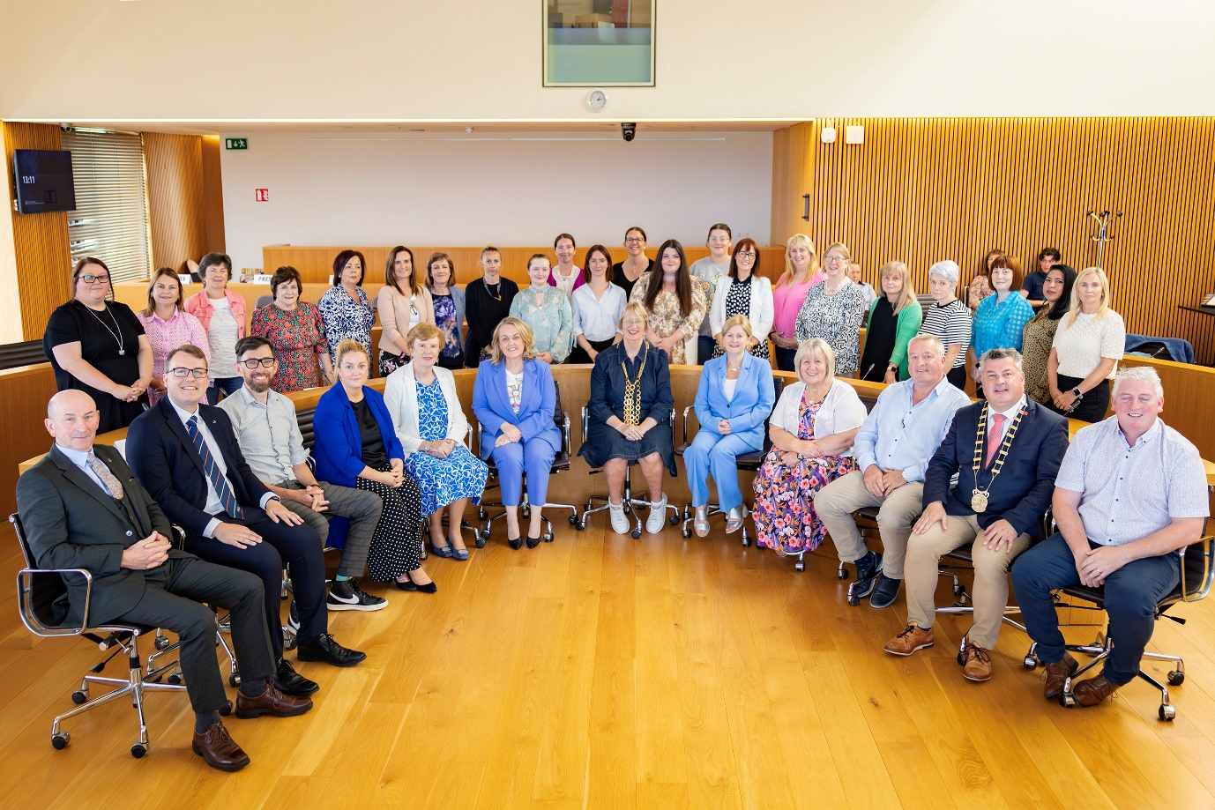
The Coalition Members are very aware that only 26% of councillors in Ireland are women and there is a major difficulty with an under representation of women in local politics in rural Ireland. For example, there are only six women out of 34 councillors on Wexford County Council: 4 out of 32 in Waterford and only 2 out of 18 in Carlow. In almost one hundred years there have only been 15 women elected to Wexford County Council (since 1925).
See Her Elected is a feminist, community led rural initiative to support women to become county councillors and to provide a supportive environment for more women to consider running in the local elections and the Wexford Women’s Coalition collaborated with this group to bring a Secondary School Roadshow to the county earlier this year.
Communications Manager with See Her Elected, Mairead O’ Shea said: “We want to see more diversity in our rural county council chambers. As it stands, there are very few women councillors and virtually no representation of minority communities. Our aim is to increase the numbers of women in local politics in rural counties where anything from 78% to 95% of the elected local authority councillors are men. We need our chambers to be more reflective of society and we need to see more women in politics in order to have more balanced decision making.
In recent months See Her Elected published ‘A Guide to Running in the 2024 Local Elections’ which is a user-friendly guide to running for election. This guidebook is available to download free of charge from the website or participants of online workshops can receive a free hard copy of the publication.
See Her Elected run regular online Election workshops to support women who may be planning to run for election in 2024 or indeed women who want to become part of a team to help another woman get elected. A new Fast Track to Election series of workshops will begin on the week beginning Monday, September 18th, 2023. See Her Elected will also run a SHE Summer School series this July and August with topics and subjects including Resilience and Confidence Building, Organising your Campaign Finances and understanding SIPO, Staying Safe Online, Using the Headliner App to promote your radio interviews, basic graphic design with Canva plus lots more.

More information is available from info@seeherelected.ie or by logging onto www.seeherelected.ie

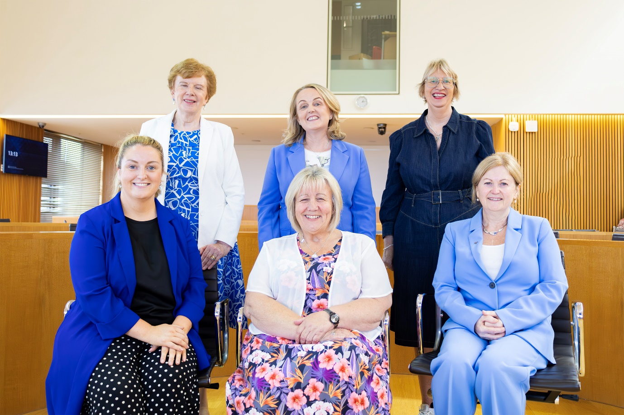
Wexford Women’s Coalition members:
Back row L to R: Cllr Kathleen Codd-Nolan, Cllr Lisa Mc Donald, Cllr Maura Bell ( Chairperson of the Women’s Coalition)
Front row L to R: Cllr Bridín Murphy, Cllr Mary Farrell, Cllr Barbara-Anne Murphy

The Wexford Women’s Coalition organised this ‘flip it’ gender reversal photo event in the Council Chamber with the assistance of staff and fellow Elected Members of the Council to draw attention to the stark under-representation of women in local government etc.

Councillor Maura Bell, Chairperson of the Women’s Coalition said “There was a great buzz around the Council Chamber during the event and in reality, seeing is believing so here’s hoping we can encourage more women to become involved in politics. “

ENDS

