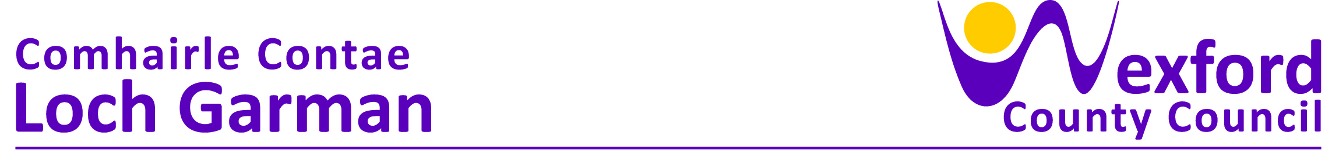
PRESS RELEASE 03 July 2023

Rosslare District Strategic Development Plan outlined at meeting with local community groups.

The Rosslare Municipal District Strategic Plan for 2024 – 2030 was recently outlined to community groups at a well-attended event at Johnstown Castle by the Cathaoirleach Cllr Lisa Mc Donald. The Rosslare Municipal District Strategic Plan is being prepared to establish a vision that will inform the development of the district over the term of the plan. The first phase of the plan is now nearing completion and at the event on 27th June Dr Yvonne Byrne, Rural Consultant, presented the findings of the data gathering and mapping process stages recently completed and that have informed the identification of high-level goals set out in the document presented to the audience. Phase 2 of the programme will see the development of a work plan that proposes to inform the development and delivery projects and initiatives under a number of specific headings, and which will see communities and the Rosslare MD working together to contribute to the positive development and growth of the villages and settlements in the district.

The consultation process for the Rosslare MD Strategic Plan 2024 - 2030 remains available to those still wishing to make a submission. You can make a written submission up to Friday 1st September. After that date we will be finalising the plan and progressing to the implementation stage.

If you do want to make a submission you can do so in one of the following ways:
- Via Wexford County Council’s Online Consultation Portal
- By email to rosslaremunicipaldistrict@wexfordcoco.ie
- In writing to the District Manager, Rosslare Municipal District, County Hall, Carricklawn, Wexford, Y35WY93.

ENDS

