
PRESS RELEASE 03 July 2023
225th Anniversary of 1798 Rebellion commemorated in Kilmore Quay

On Saturday last in Kilmore Quay the latest event in a series of events to commemorate the 225th Anniversary of the rising of 1798 took place.
The wonderful day began with music by the Danescastle traditional group in the sunshine on the quay with the Saltee Islands as the poignant background. The audience was enthralled by the oration of Cathaoirleach of Rosslare Municipal District, Cllr Lisa McDonald, who outlined how the ideals of the United Irishmen of 1798 are so relevant and meaningful to this day.
There followed the Last Post and Reveille performed to perfection by trumpet soloist Anthony Nolan, the raising of the United Irish Flag and the playing and singing of Amhrán na bhFiann.
The Cathaoirleach also laid a wreath at the memorial stone commemorating the bicentenary of the 1798 rebellion.
The audience on the quay then adjourned to the Stella Maris for refreshments before settling to listen and take part in what turned out to be a magnificent Summer School based on the theme of Three Landlords, Three Castles, Three Leaders which examined the roles played by Beauchamp Bagenal Harvey, Cornelius Grogan and Dr. John Colclough in the rising of 1798.
Wonderful talks were given by historians Ray Corish dealing with Beauchamp Bagenal Harvey, Bernard Browne informing the audience of Dr John Colclough and Eamonn Barrett gave a wonderful insight into Cornelius Grogan. These were all landed gentry who gave their lives for their ideals and deserve to be honoured and remembered.
The audience interest in the three brilliant personalities was reflected in the length of the question-and-answer session following the presentations. Indeed, the conversations generated continued over the lovely lunch prepared by the staff of the Stella Maris.
Following the conclusion of formalities and refreshments in Kilmore Quay, the attendees travelled to the cemetery in Mayglass where a wreath was laid at the grave of Beauchamp Bagenal Harvey and a poem was read by the Bard of Mayglass, Fintan Murphy.
The Summer School played to a full audience in the wonderfully appointed Stella Maris where MC for the event Cllr Jim Moore acknowledged the participation of his fellow Councillors, Cllr Ger Carthy and Cllr Frank Staples, District Manager Nóirín Cummins, Wexford County Council, the musicians and all who helped to make the event so successful, not least the three excellent speakers.

ENDS

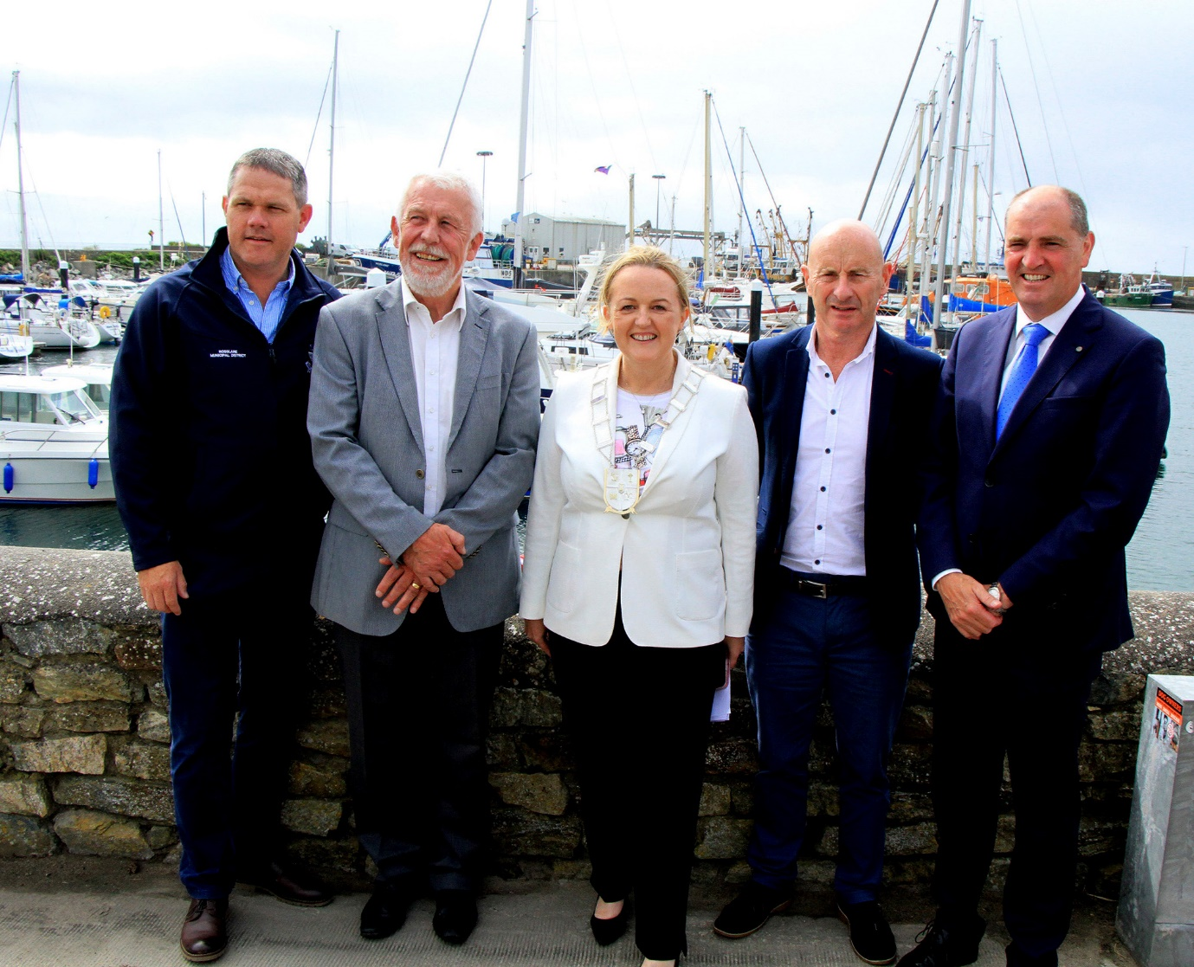
(L-R) Cllr Ger Carthy , Cllr Jim Moore,Cathaoirleach of Rosslare Municipal District, Cllr Lisa McDonald,Cllr Frank Staples ,Deputy Paul Kehoe
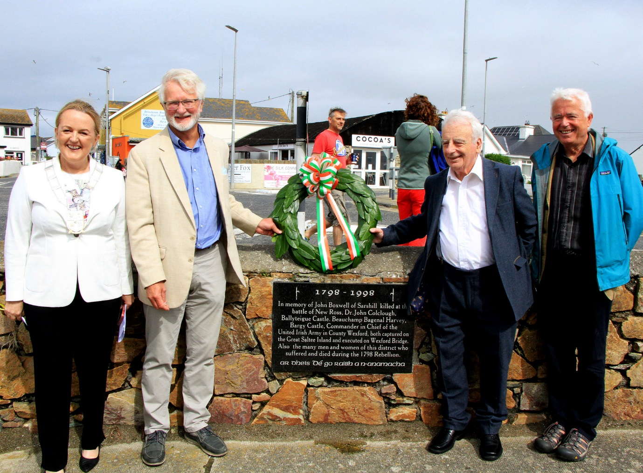
L to R : Cathaoirleach of Rosslare Municipal District, Cllr Lisa McDonald, Bernard Browne, Ray Corish, Eamonn Barrett (speakers at the Summer School)

