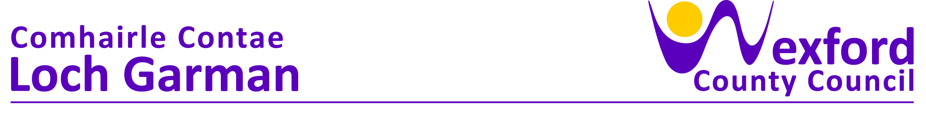

**PRESS RELEASE 02.06.2023**

**COUNTY WEXFORD BUSINESSES ENCOURAGED TO AVAIL OF NEW ENERGY EFFICIENCY GRANT**

Small businesses in County Wexford are being encouraged to check their eligibility for a new support that could help them reduce their energy output. The Energy Efficiency Grant to aid small businesses on their sustainability journey was announced last week by Simon Coveney, T.D. Minister for Enterprise, Trade and Employment.

The new support, available through Local Enterprise Office Wexford, will enable small businesses to invest in technologies and equipment to make their businesses more energy efficient. The grant will be available to companies who through participation in the Green for Micro, GreenStart or SEAI Energy Audit programmes have identified the technology and equipment need & benefits.

The grant will cover up to 50% of the costs to a maximum amount of €5,000. The scheme will reduce the impact of small businesses on the environment and may help them to reduce costs over time to enable them to become more competitive.

***Minister Coveney said;*** *“The Energy Efficiency Grant is another significant step in helping our small businesses to become more sustainable and to make a significant contribution to reducing their energy output.  Everyone must make changes as we aim to become a more sustainable country and small businesses are no different.  This grant will make it more feasible for small businesses to engage in this process and hopefully set them on a more sustainable path.  The Local Enterprise Office’s Green for Micro programme has enabled many small companies to take those first steps and now with the Energy Efficiency Grant they can continue that journey.”*

***Breege Cosgrave, Head of Enterprise, Local Enterprise Office Wexford said “****The Local Enterprise Offices are continually looking at ways to help their clients increase productivity and competitiveness. The new Energy Efficiency Grant is the natural next step for all those companies that have identified their needs around energy reduction and this will enable them to make those changes in their business. We are seeing a huge shift in the mindset of small businesses in recent years around sustainability. Sustainability is not just a word anymore but sits at the heart of business objectives and we must continue to help businesses in reaching those objectives.”*

***Carol Gibbons, Manager of Regions and Local Enterprise, at Enterprise Ireland said;*** *“This new financial support will enable small businesses to take the next step on their sustainability journey.  Increasingly, sustainability is seen as a core driver of future growth for small businesses, aligning them to changing consumer demands and ensuring access to business-to-business supply chains.  It is important that business supports match this fundamental change and I am confident that the new Energy Efficiency Grant will assist companies across the country on their sustainability journey.”*

***An Cathaoirleach, Cllr. George Lawlor;*** *“It is great to see this grant join the suite of practical and impactful supports offered by Local Enterprise Offices. It has been a very difficult year for businesses facing high energy and input costs. I would encourage any eligible business to investigate this grant, which offers a real opportunity to reduce your operating costs and boost resilience, while also lowering emissions and helping Ireland to meet our climate action targets.”*

The Energy Efficiency Grant is another support from the Local Enterprise Offices for small businesses that enables them to increase their competitiveness and productivity. Small businesses are also able to avail of the Lean for Micro, Digital Start and Green for Micro programmes through their LEO that will all help small businesses to become more competitive and increase their productivity. [www.localenterprise.ie/energy](http://www.localenterprise.ie/energy) for more information on the new grant.

Established in 2014, the Local Enterprise Offices are the essential resource for any entrepreneur looking to start a business or any small business that is looking for support or advice to help them grow. Since their inception eight years ago, the Local Enterprise Offices have helped create over 25,000 jobs across the country. The LEOs work with thousands of client companies across Ireland in a diverse range of sectors offering mentoring, training, expert advice, and financial supports to small businesses. For more information see [www.LocalEnterprise.ie](http://www.LocalEnterprise.ie)

**Ends**

Local Enterprise Office

Wexford County Council,

Carricklawn,

Wexford Y35 WY93

Contact: 053 9196023

Email; [breege.csograve@wexfordcoco.ie](mailto:breege.csograve@wexfordcoco.ie)

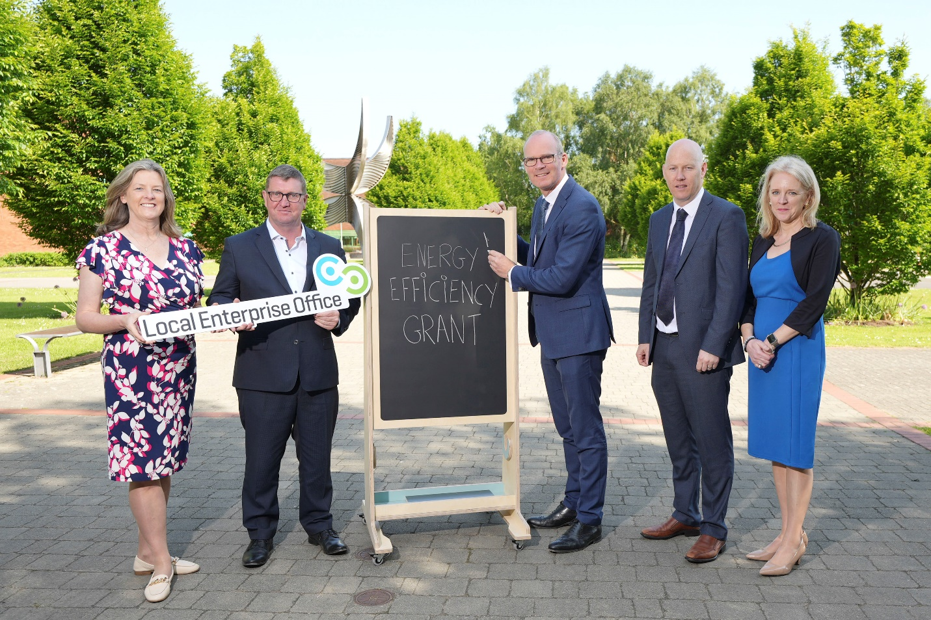

Carol Gibbons, Enterprise Ireland, Mike Cantwell, Local Enterprise Offices, Gordon Daly, CCMA Business Committee and Pauline Mulligan, Dept of trade, enterprise and employment pictured with Minister Simon Coveney at the launch of the new Energy Efficiency Grant for small businesses.

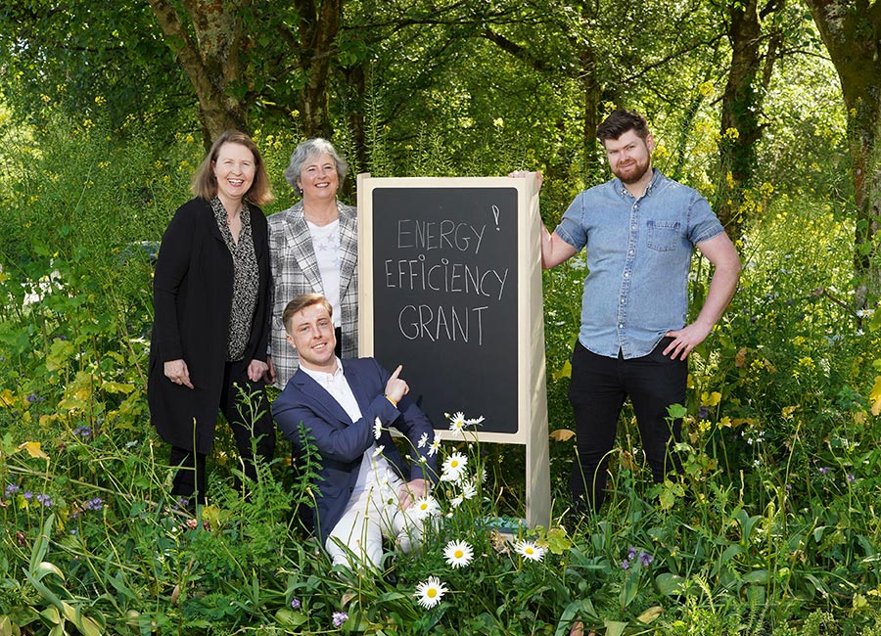

Patricia Farrell, Wilde Irish Chocolates, Michelle Mulleavy, AIP Thermoform, Shane Ryan, Ryan's Timber Products and Michael Mcloughlin, Monaru. Pic: Don Moloney