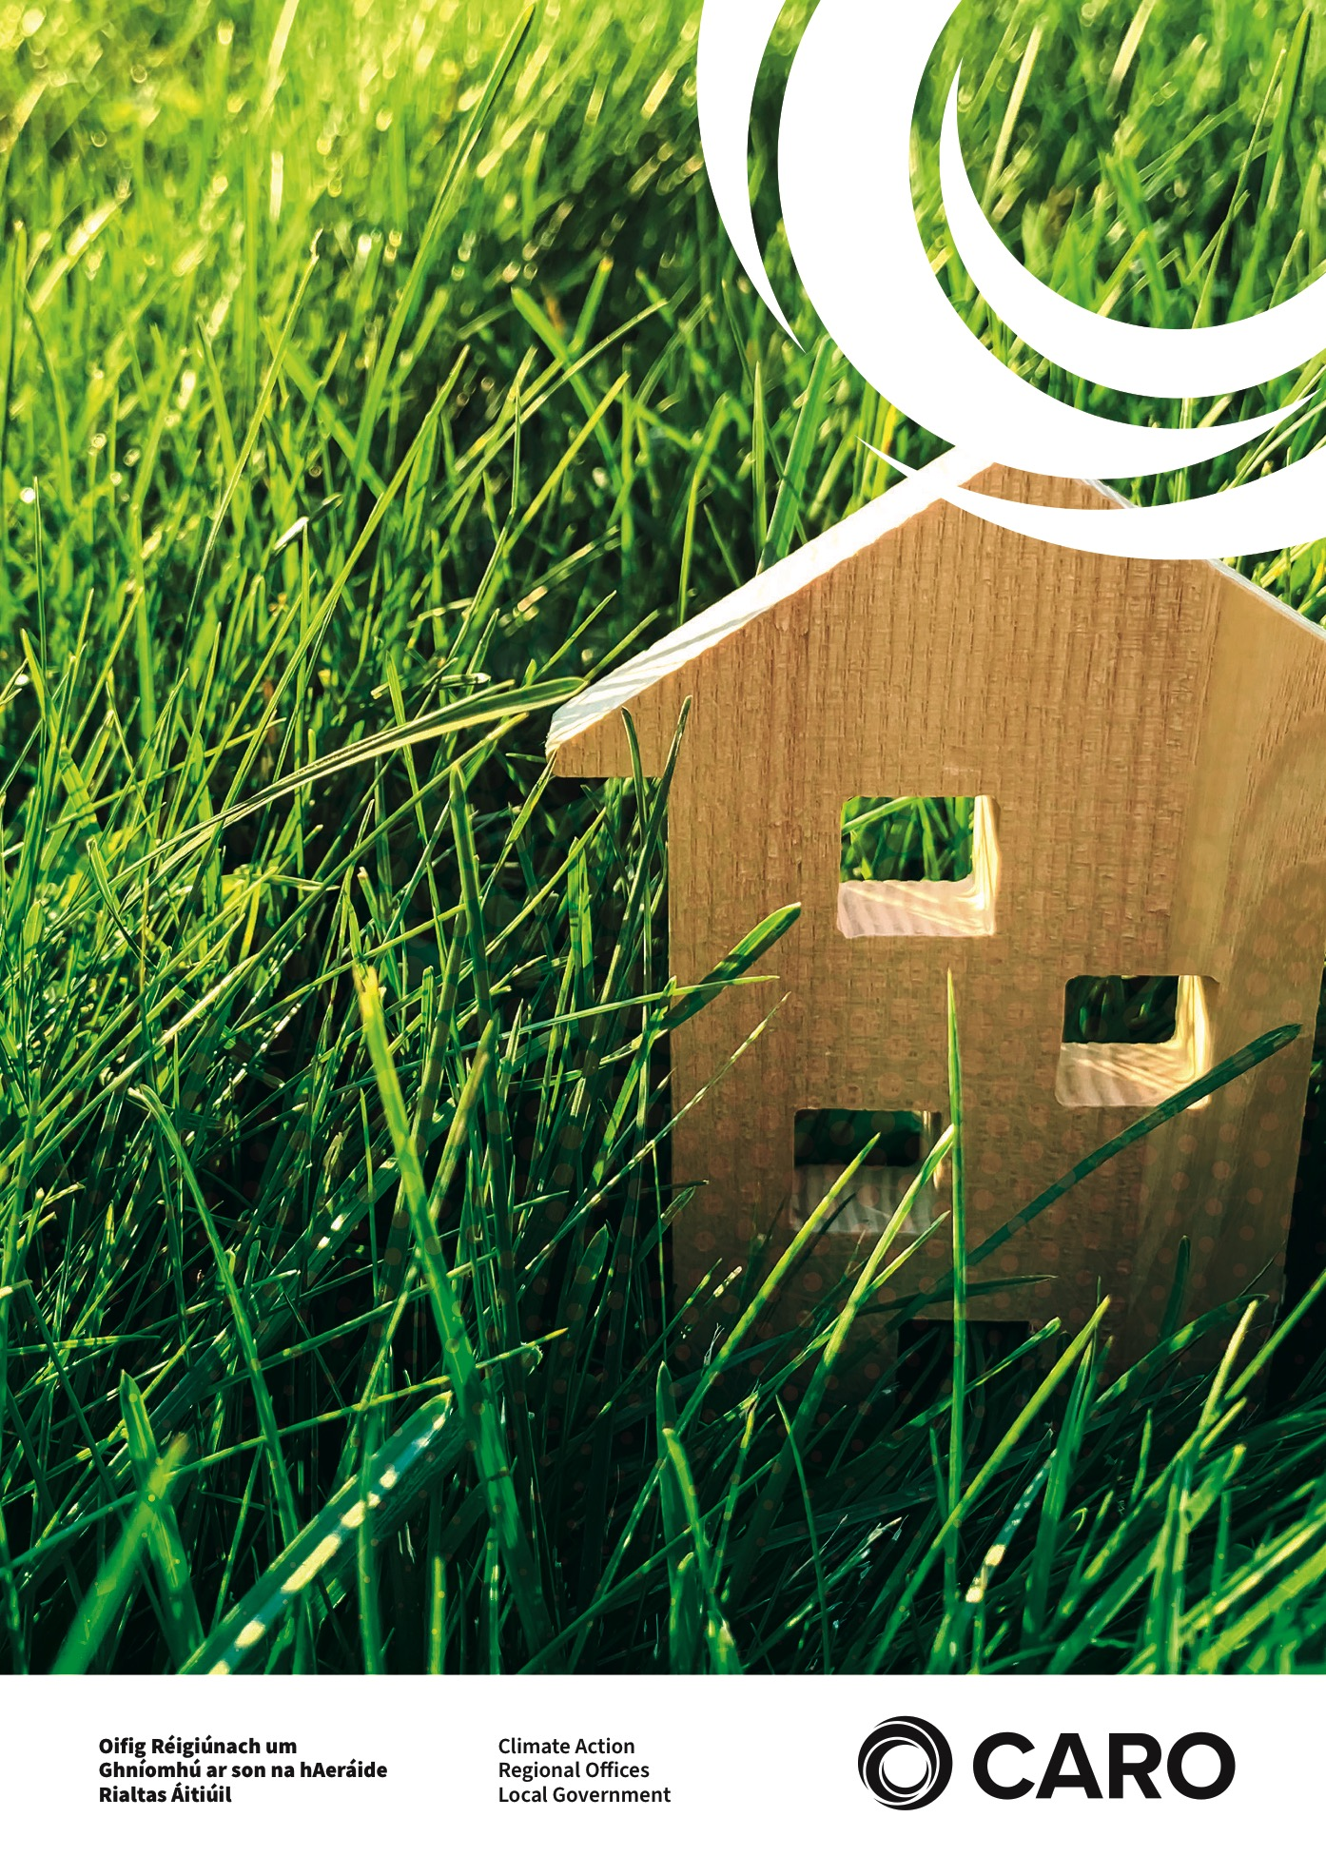

**Climate Action Information Note for Local Authority Housing Departments**

**A set of inserts for Local Authority Tenants’ Handbooks covering areas of energy efficiency, emissions reduction and preparing for extreme weather events**

**March 2022**

Table of Contents

1 Introduction 3

1.1 CLIMATE CHANGE 3

1.2 CLIMATE ACTION 3

2 CLIMATE ACTION - MITIGATION 4

2.1 Energy Efficiency in the Home 4

2.2 Energy Saving Tips for Heating 5

2.3 Saving tips for Domestic Hot Water 6

2.4 Energy Saving Tips for Lighting 6

2.5 Energy Saving Tips for Appliances 7

2.6 Energy Saving tips for Cooking 9

2.7 Managing Your Electricity Meter 10

2.8 Conserving Water 11

3 CLIMATE ACTION - ADAPTATION 12

3.1 Tips for Severe Weather Events 12

3.2 Tips for Flooding 13

3.3 Evacuating your home in the event of an emergency 15

3.4 In the Event of a Snowstorm 16

3.5 In the Event of a Heatwave 17

Case Study 1: Energy Rated Appliances 19

Appendix 1: Which appliances are leading to high energy bills? 20

Appendix 2: Home Energy Saving Kits 21

USEFUL CONTACTS 22

SOURCES 22

# Introduction

## CLIMATE CHANGE

Climate change is understood to be a largescale, long-term shift in the planet’s weather patterns and average temperatures. The evidence includes changing rainfall, changes in nature, sea level rise, higher temperatures, melting glaciers, melting ice sheets etc. There are lots of factors that contribute to the Earth’s climate. However, scientists agree that the Earth has been getting warmer in the past 50 to 100 years due to the human activities of extracting and burning fossil fuels (peat, gas, coal & oil).

## CLIMATE ACTION

Climate Action means urgent measures to tackle climate change and its impacts. It falls into two broad categories: Climate Change Mitigation & Climate Change Adaptation.

**Climate Change Mitigation** means all action taken to prevent, reduce, slow down, stop or reverse climate change. This is achieved by cutting emissions through energy efficiency, utilising renewable energy, using public transport, electric vehicles, and tree planting for example.

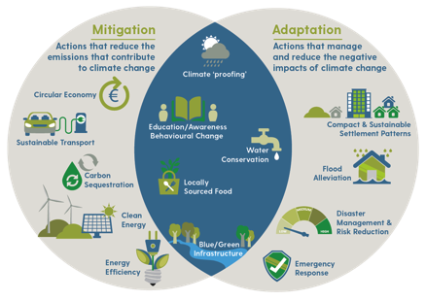**Climate Change Adaptation** means taking action to prepare for and adjust to both the current effects of climate change and the predicted impacts in the future. An example of this is the provision of flood protection and associated defence systems.

**Fig 1: Mitigation V Adaptation (CARO)**

# CLIMATE ACTION - MITIGATION

## Energy Efficiency in the Home

Most of Ireland’s energy comes from imported fossil fuels like oil, coal, peat and gas. We use these fuels to heat our homes and to power our electrical appliances. While these fuels provide us with heat and electricity, they are also a major contributor to climate change. Figure 2 shows where we typically use energy in the home.



## Energy Saving Tips for Heating

Approximately 60% of the energy used in Irish homes goes towards heating it.

|  |  |
| --- | --- |
|  | Turn down your thermostat. If you turn the thermostat down by just one degree, you can reduce your heating bill by 10%. The thermostat for your living/kitchen area should be set at 18-20°C, while hallways and bedrooms can be cooler, ideally between 15-18°C. |
|  | Close doors between rooms that are heated and unheated to keep the heat in. |
|  | Move furniture away from radiators. When trying to stay warm at home during winter be strategic about your furniture placement. Place your desk, bed or sofa around any heat sources, without blocking them. |
|  | Avoid drying clothes on your radiators. This lowers the quantity of heat released by the radiators, so the boiler must run for longer to achieve the same room temperature, thereby using more fuel overall. |
|  | Tackle draughts. Cold air can come up through the floor and from around your skirting board. Close the curtains in the evenings to keep heat in. You can purchase a relatively cheap draft stopper/draught excluder for external doors. |
|  | Bleed your radiators on a regular basis. If there is air in your radiator your boiler burns longer. |
|  | Consider installing an immersion timer to ensure you have hot water only when you need it. |

## Saving tips for Domestic Hot Water

Approximately 25% of the energy used in Irish homes goes towards heating domestic hot water.

|  |  |
| --- | --- |
|  | Take a shower rather than a bath. A regular shower uses only 20% of the energy it takes to heat the water for a full bath. |
|  | Pumped electric showers are one of the biggest energy users in the home. By reducing your shower time, you could save a lot of energy and water. |

## Energy Saving Tips for Lighting

Lighting accounts for 10-15% of the electricity bill. To help reduce this energy use, it is good to maximise natural daylight when we can.

|  |  |
| --- | --- |
|  | Always turn off lights when you leave a room and adjust your blinds or curtains to let in as much light as possible during the day. |
|  | Replace old light bulbs with LED energy efficient options, which can use 90% less electricity and last 10- 20 times longer than ordinary light bulbs. |
|  | Select the lowest wattage bulb needed to light the room/area and consider the size of the space and how much natural light the space gets. |
|  | Position your furniture so you make the most of natural light. |
|  | Using task lighting for reading or at your office desk can significantly reduce the energy consumption of general lighting in a room. |
|  | Keep lights clean. A dusty light bulb or a dirty lampshade can obstruct as much as half the light. Dust the bulb and wipe or wash the shade regularly. |

## Energy Saving Tips for Appliances

Many homes use modern automated electrical appliances which consume considerable amount of electrical power.

|  |  |
| --- | --- |
|  | About 90% of the energy used for washing clothes is spent on heating the water. Unless you are dealing with clothes that are heavily stained, run your washing machine on a low temperature. Only run full loads in your washing machine and dish washers. |
|  | Using the clothesline is the most energy- efficient alternative for drying clothes. If you do not have adequate outdoor space or live in an apartment, place a dryer rack by an open, sunny window. |
|  | Adjust your fridge/freezer temperature. Your fridge should be between 3-5°C and your freezer should be between -15-18°C. |
|  | Defrost the inside of your freezer at least every 6 months to help it run efficiently. |
|  | Turn off all appliances at night or when not in use. They can use a lot of energy on standby mode (e.g., TV, computer). |
|  | When purchasing electrical devices, ensure you upgrade appliances to A+++ rated. Low- cost devices may not work out cheaper over their lifetime. |
|  | Only fill your kettle with as much water as you need. |

## Energy Saving tips for Cooking

One way you might not have considered, is to conserve energy while cooking and preparing meals at home. Not only will this make a big difference over time, but it will also save you quite a bit of money.

|  |  |
| --- | --- |
|  | Do not open your oven door too often during cooking times, as you can lose 20% of the accumulated heat. |
|  | For energy-efficient cooking, match your pan or pot with the right sized ring on your stove. |
|  | Always cover your pots and pans – the water will boil faster and use less energy to heat your food. |
|  | Boil water in a kettle rather than heating water on the stove for cooking purposes. |
|  | A dirty stove top prevents pans from sitting flush to the surface, making it much less effective when heating. |
|  | Never put hot food directly into the fridge or freezer.  Allow it to cool first. |
|  | Where re-heating small portions of food, it is advisable to use the microwave rather than the oven or grill. It can save 80% of the energy used to cook or warm them up in the oven. |

## Managing Your Electricity Meter

Reading your electric meter regularly will assist you in controlling your electrical usage and help you to budget for the year.

|  |  |
| --- | --- |
|  | Electricity is at highest demand between 7am- 9am in the morning and 5pm-7pm at night. Electricity is at peak production during these times and is typically more carbon intensive. Try to use electricity outside these times. |
|  | Many new appliances have delay start timers and this can help avoid peak time usage. |
|  | **Meter Reading**  Ensure your bill is accurate. Some suppliers may send you reminders to submit an accurate meter reading. Sometimes electricity bills are estimated. This is denoted by “e” on your bill. It is important that you send actual reads “a” to your supplier. If you receive an estimated bill and it is significantly higher or lower than your actual meter reading you can submit a meter read after your bill issue date and the supplier will adjust the next bill for you. Make a note of the number, reading from left to right. Please ignore the figures in red or surrounded by a red box. And remember, if you have night storage heaters, you’ll have two of these meters. |
|  | Make sure you shop around for the best electricity prices for your needs. Check out price comparison websites to do this. |

## Conserving Water

Water is a precious, natural resource. Water conservation requires governments, local authorities,

industries, the agricultural sector and householders to get involved in the process. It must be a

combined effort to preserve our largest natural resource.

|  |  |
| --- | --- |
|  | Flush the toilet only when necessary - depending on the age and size of your cistern one flush can use up to 9 litres of water |
|  | Keep a bottle of tap water in the fridge for nice cold water instead of running the tap. |
|  | Use a basin in the sink. It is useful for washing dishes and collecting the water you use to rinse off fruit and vegetables – this can then be used for watering plants. |
|  | Turn off taps while brushing teeth or shaving. |
|  | If you need to wash your car, use a bucket and sponge, instead of a hose. |

# CLIMATE ACTION - ADAPTATION

## Tips for Severe Weather Events

|  |  |
| --- | --- |
|  | Have an adequate supply of fuel for heating and cooking. |
|  | Have a water container to ensure a supply of drinking water. |
|  | Check local news and weather forecasts and heed all weather warnings issued. Be aware of weather events – Status Yellow, Orange, Red. |
|  | Stay away from the sea and coastal areas during severe weather events. |
|  | Keep your home warm: Minimising all draughts and leave your heating on low for longer periods. |
|  | Have batteries for torches and alternative light sources in the event of power cuts. |
|  | In the event of a flood, the local authorities and emergency services will provide the principal emergency response. |

## Tips for Flooding

|  |  |
| --- | --- |
|  | If possible, avoid contact with floodwater as it may be contaminated or polluted, for example with sewage. |
|  | If you must walk, cycle or drive through floodwater, take care of underwater hazards that you may not see, for example, open manholes. |
|  | If you must leave your vehicle, be wary of strong currents and debris. |
|  | Remember 150mm (6 inches) of flowing water can sweep you off your feet and 600mm (2 feet) of water can float your car. |
|  | Move valuables and other items to safety above the flood level or upstairs if possible. |
|  | Put sandbags or other suitable flood resistant barriers at any openings where the water could enter your house. |
|  | Do not park your car in a flood risk area - have a prearranged place that you can safely move your car to if you have time. |
|  | Find out if you live in an area at risk of flooding by speaking to neighbours and the Local Authority. The OPW flood maps also shows areas that may be at risk of flooding.  (See www.floodinfo.ie) |
|  | Emergency numbers – have a print-out and store electronically on your phone. |
|  | Have medication to hand (if needed). Make up a flood kit and ensure everyone knows where to find it. A flood kit should include a torch, some warm and waterproof clothes, a battery or wind-up radio, a mobile phone, rubber gloves, rubber boots, a first aid kit, blankets, and children’s essentials, if required. |

## Evacuating your home in the event of an emergency

|  |  |
| --- | --- |
|  | Always cooperate with instructions from emergency services and local authorities. |
|  | Keep any chemicals or fuel in watertight containers and if possible, move to above flood level to ensure that they do not spill into the flood water and cause an additional hazard. |
|  | Turn off electricity and water at the mains. |
|  | Switch off gas or oil boiler at the control panels or mains. |
|  | Always be careful when re-entering your property after a flood as there may be structural damage or contamination because of floodwaters. Electric, gas or home heating fuels-should be checked by a professional before re-entry following a flood. |

## In the Event of a Snowstorm

|  |  |
| --- | --- |
|  | Listen to the weather forecast regularly and check your emergency supplies, whenever you are expecting a winter storm or extreme cold. |
|  | Check that you have sufficient home heating fuel for your home. |
|  | Protect yourself from frostbite and hypothermia by wearing layers of warm, loose-fitting, lightweight clothing. |
|  | Get out your flashlights, batteries, first aid kit and other emergency supplies. |
|  | Stay away from fallen power lines. |
|  | Use a shovel to remove snow from your driveway. You can prevent ice forming by spreading salt on the area that you have cleared. Never use boiling water to clear snow as it may re-freeze and cause the formation of black ice. |
|  | If you will be using a fireplace or wood-burning stove, you should have a good supply of dry, seasoned wood. |
|  | Have warm clothing and blankets on hand, and stock non-perishable food items and necessary medications to last you and your family for several days. |
|  | Drive only if you absolutely must and be sure your car has adequate fuel and an emergency supply kit. This can include one gallon of water (4.5 litres), flashlights with extra batteries, extra clothing, blankets and a first-aid kit. |

## In the Event of a Heatwave

|  |  |
| --- | --- |
|  | Drink more water than usual and do not wait until you are thirsty to drink more. Muscle cramping may be an early sign of heat-related illness. |
|  | Check on a friend or neighbour. |
|  | Limit your outdoor activity, especially in the afternoon when the sun is hottest. |
|  | Limit your exposure to the sun by staying in the shade. If you must go out in the sun, wear sunscreen as indicated on the package. |
|  | Wear loose, lightweight, light coloured clothing. |
|  | Schedule workouts and practices earlier or later in the day when the temperature is cooler. |
|  | Check the local news, social media for health and safety updates. |

# Case Study 1: Energy Rated Appliances

David decided to replace his tumble dryer with a newer model. He went to his local electrical appliance store to see what deal he could get. He looked at a “B” rated dryer for €260 and an A++ rated one for €470.

|  |  |  |  |  |
| --- | --- | --- | --- | --- |
| Energy Rating Tumble Dryer | Cost per Load | Annual Electricity  Cost (€) | Typical cost of the Appliance | Total cost over a 5-year period |
| A++ | 65c | €65.00 | €470.00 | €795.00 |
| B | 143c | €139.75 | €260.00 | €958.00 |
| Savings over 5 years by purchasing the A++  dryer | - | - | - | **€163.00** |

As seen below, the A-rated tumble dryer was €74 cheaper to run per year than the B-rated dryer. Comparing costs over just 5 years, if David bought the cheaper B rated tumble dryer – his total cost including electricity over 5 years would be approximately €958. Buying the A++ model for €470 would end up costing round €795 over 5 years. Therefore, David could expect to make a saving of €163 over the 5-year period.

# Appendix 1: Which appliances are leading to high energy bills?

The calculations below are based on your energy provider charging you 26cent per kWh.

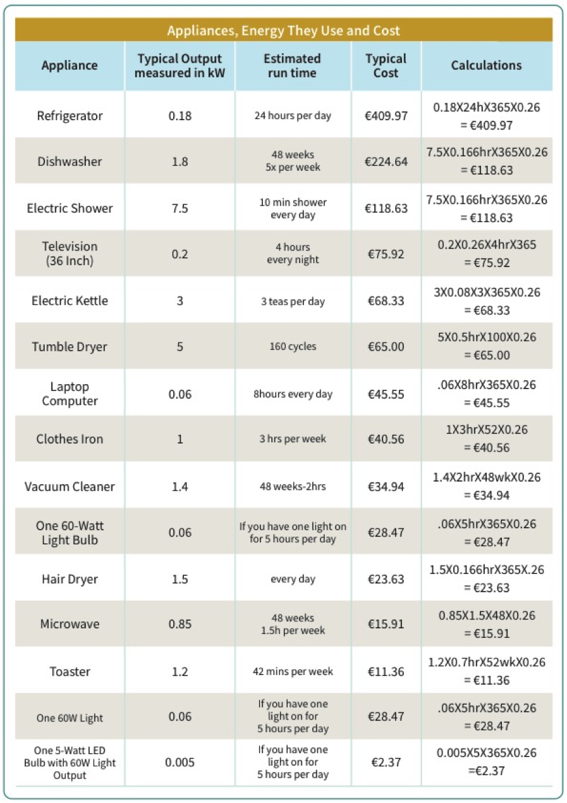

# Appendix 2: Home Energy Saving Kits

The City of Dublin Energy Management Agency (CODEMA) has developed a “Home Energy Savings Kit” for householders. The kit contains a thermal leak detector, a stopwatch, a plug-in energy monitor, a temperature and humidity sensor, a fridge and freezer thermometer, a radiator key and a user guide manual. The kits allow householders to get a better understanding of their energy usage in space heating, hot water and electrical appliance use in their homes. They can isolate problems such as poor ventilation, insulation quality and appliances that are heavy on electrical usage.

A step-by-step manual is also provided, which guides the householder through the use of the equipment so they can get an accurate assessment of their home energy usage. This is the first step to, becoming more energy efficient, saving money on your bills and understanding your current energy consumption.

These kits are now available to borrow free-of-charge from a number of libraries throughout the country. Please click on the link below to see an updated list:

[**www.codema.ie**](http://www.codema.ie)

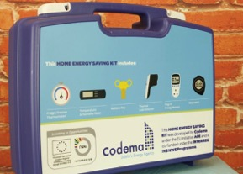 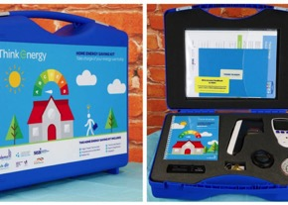

# USEFUL CONTACTS

[Climate Action Regional Offices (CARO)](https://www.caro.ie/)

[Climate Ireland](http://www.climateireland.ie)

[Green home- An Taisce](http://www.greenhome.ie)

[Sustainable Energy Authority of Ireland (SEAI) Triple E List](http://www.seai.ie/Your_Business/Triple_E_Product_Register/)

[Stop Food Waste](http://www.stopfoodwaste.ie/food-we-waste/how-can-i-stop-food-waste/)

# SOURCES

[Bord Gais](https://www.bordgaisenergy.ie/)

[CODEMA](http://www.codema.ie/publications)

[Electric Ireland](https://www.electricireland.ie/)

[Environmental Protection Agency (EPA)](http://www.epa.ie)

[Electricity Supply Board (ESB)](https://www.esb.ie/ecars)

[European Commission](https://ec.europa.eu/energy/en)

[Stop Food Waste.ie](http://www.stopfoodwaste.ie/food-we-waste/how-can-i-stop-food-waste/)



.