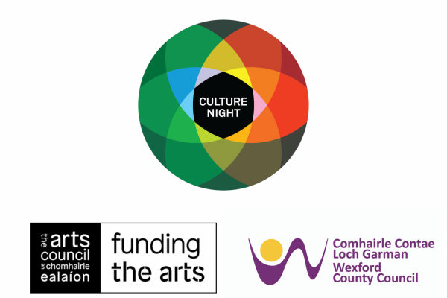

County Wexford Culture Night 2024
Expression of Interest

Deadline for application: Friday June 14th

Please return completed expression of interest form to:
wexfordculturenight@gmail.com

Wexford County Council are pleased to confirm that Culture Night/ Oíche Chultúir will take place on Friday September 20th, 2024 from 4pm till late and are looking for expressions of interest to participate. Culture Night is an annual all-island public event that celebrates culture, creativity, and the arts. On that night venues and events are available to the public free of charge.

The Ethos of Culture Night
- Encourages more people to visit cultural venues and experience culture in their locality
- Reminds us all of the fantastic cultural facilities and resources that we have locally and nationally
- Raises the profile of cultural organisations, activities and facilities
- Encourages people to try new things and to get into the habit of going more often to cultural venues and activities in their locality
- Makes it easier for people to play a role in their local cultural scene
- Helps create a sense of community and belonging
Events will be programmed throughout the districts of Enniscorthy, Gorey, New Ross, Rosslare and Wexford.

Areas of particular interest:

- A late-night programme of performance art, dance, literature, music, comedy, theatrical, heritage events and more (9pm till late).
- Heritage & Irish Language events- we are looking for specific proposals from organisations and creative practitioners operating in any discipline to propose an event that interacts with Co. Wexford's natural, built and/or cultural heritage.
- Events that celebrate new communities and underrepresented voices. Events should promote and connect artists from marginalised backgrounds and showcase the culturally diverse communities living in the County. We would love to hear from any community, particularly, but not limited to, the following often marginalised groups:
– asylum seekers, refugees and migrants
– D/deaf culture or arts and disability
– Irish Traveller culture
– those promoting gender equality
– under-represented group
- Events organised by or in collaboration with young people.

All events must embrace the following:

- Be free.
- Be registered through the relevant Arts Office/local authority and uploaded to the national programme/website.
- Embrace the Arts Council’s Pay the Artist policy and ensure that all engaged artists and practitioners are paid, unless participating in a voluntary capacity or as part of a community group
- Be open to all and seek to create a sense of community and belonging – and promote the belief that ‘I am part of this, and this is part of me.’

If you require support with the application, please contact wexfordculturenight@gmail.com who will be happy to provide assistance.

PART A: Group/Organisation/Individual Information
Group/Name
Main Contact
Email
Phone
Social media

Please note that in most cases we require those applying for funding to organise venues or work with host organisations for their events. We also encourage individual artists to work with a partner venue or community who can provide support on the night.

PART B: Event Information
Event Venue
Duration of event
Please give a full description of the proposed Project/Event (additional material can be attached as support material if needed):
Please describe your proposal in no more than 100 words (for promotional material)
Describe your approach/how will you encourage Cultural Diversity, Diverse Participation and Arts and Disability in your event:

Will your event include accessibility services for audiences with disabilities? If yes, please list.

FUNDING IS LIMITED – It may not be possible to offer funding to all applicants and it may also not be possible to offer the full amount requested to any individual applicant.
Proposals will be evaluated on quality, how they align with Culture Night priorities and a cost-efficient budget. It is expected that individuals will be in receipt of amounts €200- €600, and for cultural venues amounts of €800 to €1200.
PART C: Budget
Please provide a breakdown of costs that apply to your event(s). Please include in kind costs or other sources of funding/sponsorship where appropriate.
Please remember all culture night events must be free of charge to the public.

N.B The only method of payment of any grant will be by Electronic Funds Transfer and applicants will need to register as suppliers.

Artist Fees (Details, e.g. prep time, hours of work, travel)

Direct Activity Costs (Event Insurance, materials, transport, Admin)
Equipment Costs (including hiring of technical expertise and equipment)
Other Costs (Details, please)

In Kind costs

Total Costs

Amount of Funding Sought

Please also include:
- Additional support material that applies directly to your application should be submitted and can include, artists c.v., photos and video links (please do not attach large video files and only include a YouTube/Vimeo link).
The personal data supplied will only be used for the purposes of the Culture Night 2024 application process and your application details will be deleted once the application process is completed. Please contact us if you wish to obtain further information concerning our retention periods and you have the right to withdraw your application details at any time.

Deadline for application: Friday June 14th
Please return completed expression of interest form to:
wexfordculturenight@gmail.com

